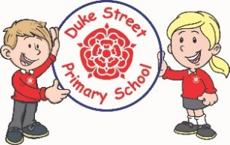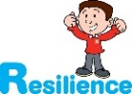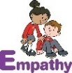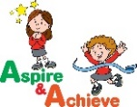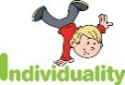

**History**

The Viking and Anglo-Saxon struggle for the kingdom of England to the time of Edward the Confessor.

Within this unit, pupils will learn about Viking raids and invasions and the resistance of Alfred the Great. Our learning will culminate with the battle of Hastings and the end of Anglo-Saxon rule in Britain.

**DT**

The children will develop their Understanding on how developments in D&T have helped shape the world and try to construct structures to include; Gears, Pulleys, Cams, Levers and Linkages. They will focus on construction, using metal, wood and plastics.

**Art**

This term, we will immerse ourselves in the artistic medium of sculpture, focussing on the local artist Antony Gormley. We will explore different materials to create brutalist sculptures and place these in and around the school environment highlighting the clash between man and nature.

**Mathematics:** Daily mathematics lesson

(Y5 & Y6 National Curriculum Objectives)

We will consolidate our previous learning on Place Value and the four operations in Mathematics.

We will learn about Fractions, Decimals and Percentages.

We will cover Statistics, Measures and Algebra (Year 6).

We will have a problem solving focus week on finding all possibilities to a range of maths problems.

**Early Bird Maths** continues every morning from 8:45 to improve arithmetic skills. These sessions are having a valuable impact on confidence and accuracy.

**Topic:** Raids and Invaders

**Year 5 and 6 Curriculum Plans**

Spring Term 2022

**English:** This term we will focus on reading an adaptation of **Beowulf by Michael Morpurgo**. We will look at his use of language and its impact on the reader. The children will then write a new adventure for the hero in the style of Morpurgo.

We will also look at an adaptation of **Shakespeare’s Macbeth**. The children will be engrossed in the tragedy of the events in the story. They will do lots of incidental writing based on the characters.

Our grammar focus will begin with creating complex sentences using relative pronouns and punctuating direct, blended with action to advance the story.

***Reading for a sustained amount of time, on at least 3 occasions a week, is now crucial to building reading stamina.***

**Science:**

This term, the children will be learning all about **forces** and how different forces affect our lives. They will look closely at gravity, air resistance and water resistance. They will conduct a range of experiments, developing their understanding of each force. They will develop their investigation, observation practical skills, in order to develop their scientific enquiry skills.

icare

**Curriculum Drivers:**

* We will develop our cultural capital and through learning about our heritage.
* We will develop our creativity through our Music and Art learning.
* We will further embed our ICARE values.

**Computing: Focus**:

1: repetition in games (scratch online)

We will use Scratch Coding Software to explore using repetition functions in games.

2: selection in quizzes (scratch online)

We will use Scratch to create quizzes and use selection functions to display multiple choice options and answers.

Our Core Values

**Geography**

Within our learning about the Anglo-Saxons, we will explore locational knowledge of England. We will look at different types of settlements and why this contributed to the Anglo-Saxon invasion.

We will learn about place names and their meanings and origins and continue to develop our geographical skills including mapping skills and investigation and enquiry.

**French:**

**New Year’s Celebrations**

**Pantomime Verse**

**Healthy Eating**

We will work on our conversation skills, learning the necessary vocabulary to carry simple conversations on the above topics in French.

**PE:**

Yew class will continue **swimming** until February half term. Year 5 children in Poplar class will begin weekly swimming lessons after February.

**Focus: Gymnastics**

Pupils will develop their fundamental movement skills through gymnastics. They will learn how to travel, balance and roll on a mat in sequence to choreograph their own performance.

**Music:**

Poplar class will learn to play the Glockenspiel through Charanga. Yew Class will learn Make You Feel My Love and Sycamore class will learn You’ve Got a Friend by James Taylor.

We will build on our understanding of the building blocks of music.

**RE:**

**Islam:** What is Hajj and why is it important to Muslims?

We will reflect on the personal journey a Muslim will make both physically and spiritually and focus on the five pillars of Islam and how this impacts the life of Muslims.

**Christianity:** Why do Christians believe Good Friday is Good?

We will learn about Christian beliefs about Easter and the death and resurrection of Jesus and why this brings comfort to Christians.

**PSHE:**

**Core Value:** Community

**Core Theme:** Keeping Myself Safe and Rights and Responsibilities.

We will further develop our knowledge of living in the wider world and how we thrive in society. Children will develop skills to keep themselves safe and be a good citizen. We will think about community and how to make a positive contribution to society.

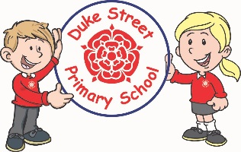

**Enrichment:**

We will be visited by the Life Education Caravan. This will develop pupils Spiritual, Moral, Social and Cultural awareness. We are also expecting a visit from Repeating History to enhance our learning on Anglo Saxons

**School Aims:**

Duke Street Primary School aims to:

* provide a secure, caring and stimulating learning environment,
* promote self-discipline, moral values and self-esteem,
* set challenging yet realistic goals in order to allow each child and member of staff to reach his or her potential
* Encourage an enthusiastic attitude to learning through a well-balanced and varied curriculum.
* work in partnership with parents to provide the best for each child in order to get the best from each child
* Offer colleagues an enjoyable, positive environment in which to work, fostering both team commitment and the well-being of everyone within our school.

**School Expectations**

* We are kind and helpful
* We listen
* We are honest
* We work hard and take pride in our work
* We look after property

**British Values:**

Our work throughout the curriculum will promote the British Values of:

* Democracy
* Rule of Law
* Mutual Respect
* Individual Liberty
* Tolerance & harmony
* Responsibility/positive contribution
* Public Institution