icare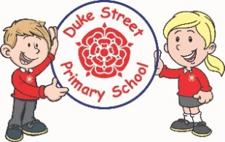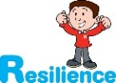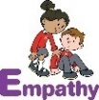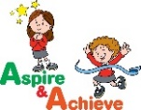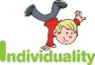

**Geography**

Human Geography and Physical Geography

We will be learning about Global aspects of human geography from an economic perspective and will learn about Antarctica fieldwork. We will recap and build upon our understanding of climate and biomes. We will make links with farming and transport and think about how one impacts the other. We will be having an exciting visit from a real-life Polar Explorer.

**DT**

The children will be focussing on combining different fabric shapes to create a chair sleeve, which will be tailored to their specific needs and requirements. The children will apply their understanding of sewing from their art unit from spring 1.

**Art**

The children will develop their knowledge on textiles, colours, pattern and texture. The children will create a self -portrait using fabric which represents them. These will be in the style of Jamie Fingle, an American artist.

**Year 5 and 6 Curriculum Plans**

Spring Term 2022

**Science:** Earth and Space

Pupils will be taught to describe the movement of the Earth, and other planets, relative to the Sun in the solar system; describe the movement of the Moon relative to the Earth and describe the Sun, Earth and Moon as approximately spherical bodies. We will also use the idea of the Earth’s rotation to explain day and night and the apparent movement of the Sun across the sky.

**Mathematics:** Daily mathematics lesson

(Y5 & Y6 National Curriculum Objectives)

We will consolidate our previous learning on Place Value and the four operations in Mathematics.

We will learn about Fractions, Decimals and Percentages.

We will cover Statistics, Measures and Algebra (Year 6).

We will have a problem-solving focus week on finding all possibilities to a range of maths problems.

**Early Bird Maths** continues every morning from 8:45 to improve arithmetic skills. These sessions are having a valuable impact on confidence and accuracy.

**Times Tables** fluency continues to be a focus and we would encourage pupils to access TTRS regularly.

**English:**

**The Adventures of Odysseus**

We will be looking at an adaptation of The Odyssey written for children and using this to inspire our writing. We will complete short burst writing practice on setting and character descriptions building up to writing our own Greek Myth.

Our Grammar focuses will be Fronted Adverbials for cohesion and Relative clauses, with and without relative pronouns

***Reading for a sustained amount of time, on at least 3 occasions a week, is crucial to building reading stamina.***

***In addition, children are expected to practice their spellings at home.***

**History**

Ancient Greece

We will be learning all about the Ancient Greek civilisation with a focus on religion.

We will learn what beliefs the ancient Greeks held, how they demonstrated their beliefs and how that compares with modern-day religious beliefs and ceremonies.

This will link with our English lessons in Spring 1.

**Computing:**

learners will use physical computing to explore the concept of selection in programming through the use of the Crumble programming environment. The unit begins with a simple program for pupils to build in and test within the new programming environment, before transferring it to their micro:bit. Pupils then take on three new projects in Lessons 2, 3, and 4, with each lesson adding more depth.

**Curriculum Drivers:**

* We will further embed our ICARE values.
* We will remind ourselves show feel grateful and show gratitude to those around us.
* We will continue to work on being our best selves.
* We will learn how to make sustainable choices in our lives to help the planet.

Our Core Values

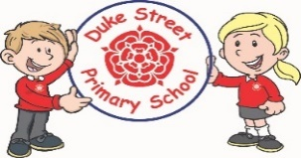

**Enrichment:**

* We will have a Whole School Enrichment Day celebrating world culture and linking with our geography skills and knowledge.
* We will have a visit from a Polar Explorer.

**School Expectations**

* We are kind and helpful
* We listen
* We are honest
* We work hard and take pride in our work
* We look after property

**Music:**

Sycamore class will learn to play the Guitar with weekly lessons!

Poplar class will learn about composing using chords and Chestnut class will learn about musical styles.

We will discuss different elements of music and musical notation.

**School Aims:**

Duke Street Primary School aims to:

* provide a secure, caring and stimulating learning environment,
* promote self-discipline, moral values and self-esteem,
* set challenging yet realistic goals in order to allow each child and member of staff to reach his or her potential
* Encourage an enthusiastic attitude to learning through a well-balanced and varied curriculum.
* work in partnership with parents to provide the best for each child in order to get the best from each child
* Offer colleagues an enjoyable, positive environment in which to work, fostering both team commitment and the well-being of everyone within our school.

**French:**

We will recap personal information, numbers, colours and days /months in French and then we will learn how to talk about sport! We will be asking how to play a sport, give a simple explanation of a sport and learn the names of equipment.

**PSHE:**

In our My Happy Mind sessions we will be focussing on Gratitude and appreciating what we have.

In Spring 1, our Core PSHE lessons will focus on Keeping Safe and in Spring 2 we will be focussing on Rights and Respect.

**RE:**

**Hindu Dhama:** This unit enables pupils to examine how Hindu truths are transmitted using stories from revered literature.  The focus includes beliefs about Brahman, Vishnu, Avatar (especially Krishna) and Scriptures.

**Christianity:** This unit enables pupils to explore what the Christian belief in Jesus as ‘fully human and fully divine’ means. They will build on their prior learning about the incarnation and to consider why some people regard the miracles of Jesus as signs of his divine nature.

**British Values:**

Our work throughout the curriculum will promote the British Values of:

* Democracy
* Rule of Law
* Mutual Respect
* Individual Liberty
* Tolerance & harmony
* Responsibility/positive contribution
* Public Institution

**PE:**

**Focus: Basketball**

We will learn how to work as a team to attack and defend. We will practice different throws and catches and build up to game play.

**Focus: Dance**

We will work in groups to choreograph routines inspired by our learning in History.