Duke Street Primary VE DAY 2020- Family Activities.
The activities this week aim to provide opportunities for you to learn more about VE Day. Try to do as many as you can. Be creative about how you present your work. Then host your own’ stay at home, socially distanced street party’ on Friday – Be sure to send us lots of pictures
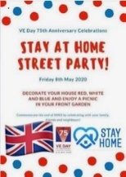  ‘Stay At Home’ Street Party  Read this article on Newsround and look closely at the photographs. How did people celebrate in 1945? Plan your own ‘stay at home’ street party.  What games could be played? What decorations would be put up? What food would be eaten? Who would be there? Is there anyone in your family who went to a VE Day party you could speak to?  For something more simple, you could design your own VE Day party invitation to encourage your neighbours to join in,or create your own Union Jack flag bunting or make a Union Jack flag out of Lego! | Postcard task  Write a ‘Postcard from the Past’. Imagine you were at the first VE day and heard the news that the war had ended.  What might you tell your family about what you heard? What did you do? What did you eat? Who else was there? What games did you play? What decorations were made and hung up? Use the link below find out more about VE Day  https://www.bbc.co.uk/teach/class-clips-video/history-ks2-ve-day/z7xtmfr  https://www.bbc.co.uk/teach/ve-day-How-did-the-british-plan-to-celebrate/zndn7nb | Wartime Recipes  Can you have a go at following one of the wartime recipes below?  Wartime Carrot Cake  Scones  Jam Tarts  Wartime Loaf  Other recipes  Take a photo of your delicious creation. Try to write a review of how easy it was to make and how it tasted!  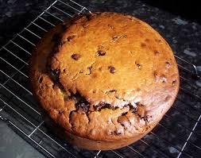
Crack The Codes  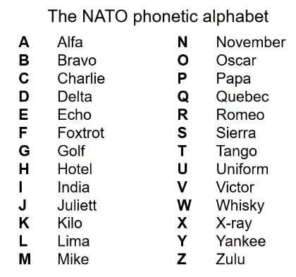  Phonetic Alphabet  The phonetic alphabet that was used in RAF transmissions during the war. Learn to spell your name using the phonetic alphabet e.g.  Ted = Tango Echo Delta  Morse Code  Morse code is a communication system that represents the alphabet and numbers with a series of dots, dashes or a combination of both as shown here. Watch this video to find out more about Morse Code.  Can you write a secret coded message for your family to crack? | VE Day Songs  Try and learn the Horrible Histories VE Day song and perform it to your family.  Create your own motivational song. Listen to some of the following clips for inspiration. Click here to listen to some more traditional war time songs as well as the links below.  Wartime song lyrics  Run, rabbit, run!  Long way to Tipperary/ Pack up your troubles  We’ll meet again  The White Cliffs of Dover  Learn step-by-step how to Swing dance (The Lindy Hop) which originated in the late 1920s and early 1930s in Harlem, New York City. | 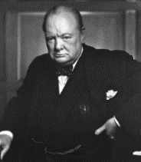  Winston Churchill  Who was Winston Churchill? Why do we remember him today? Produce a fact file/ poster displaying your information.  Create a mind map or list of facts about Winston Churchill.  What was his job?  Why was he so important during WW2?  What was one of his famous phrases?  Can you describe his characteristics?  Why he was important?  You can read more about Churchill using these links from Twinkl and Ducksters. You may present this information in any way you choose or use this template.  CHALLENGE: Can you learn Winston Churchill’s Victory speech and record yourself presenting it?
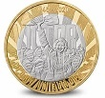  Design your own VE coin or medal  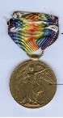  8 May 1945, now known as VE Day, saw the beginning of the end of the Second World War – the conflict that claimed the lives of millions and reshaped the future of countries and continents. The Royal Mint have designed a commemorative coin to remember VE Day. Your task is to design your own commemorative coin or a VE Day medal. You could think about the following ideas when designing yours: the years of the war; the colours of the ally flags or a reference to how the war was fought (land, air and sea). | Celebrations!  To celebrate the end of WW2, people held large street parties. They decorated the street using bunting and flags. Can you have a go at making your own VE day flags or bunting? You could use it to decorate for your own VE day party at home!  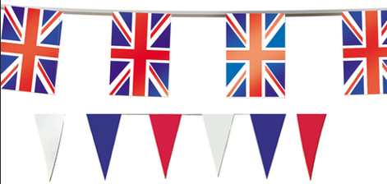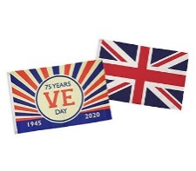 | 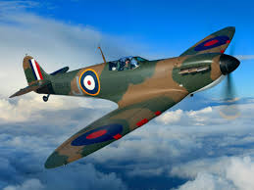  Spitfire Science  Design and make your own Spitfire. You could make it out of paper, wood, recycled materials, etc. Test out your design. How far does it glide?  Does the material used for a paper plane affect the distance it travels? Try using newspaper, card, tinfoil, etc and carry out a test. Remember, only change ONE thing to make it a fair test.

