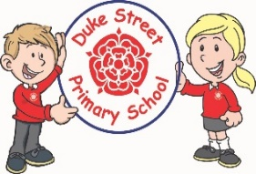

**History:**

**Focus:** Ancient Maya

We will be learning about the civilisation of the Ancient Maya. We will look at how their society was structured, how they recorded their history, marked time with their calendars and much more.

**Geography:**

**Focus: Biomes and Vegetation**- Where our food comes from.

We will learn about different biomes, what their features are, what grows there and why we get different foods from different biomes.

Our Core Values

Autumn Term 2023

**Year 5 and 6 Curriculum Plans**

**Science:**

**Focused Investigation:** Outdoor Keys/Fossil Habitats.

**Living things and their habitats (Autumn 1)**

We will be learning how to group and classify animals according to complex classifications

**Evolution and inheritance including adaptations (Autumn 2)** We will learn about how we inherit our genetic traits from our parents, grandparents etc. and how mutations contribute to evolution of a species. We will learn about how species adapt to different environments.

**Computing:**

**Focus**: Communication

In this unit, we will learn about the World Wide Web as a communication tool. We will learn about how search engines work and what influences the results of a web search.

**Focus**: 3D modelling

During this unit, we will learn how to use computer programmes to produce 3d models.

**Mathematics:** Daily mathematics lesson

**(Y5 National Curriculum Objectives)**

Numbers to 1 million and decimal numbers. Four rules of number. Angles. Area and perimeter. Fractions.

**(Y6 National Curriculum Objectives)**

Four rules of number, Place Value, Fraction.

Weekly times tables test- now expected that children have rapid recall of **all tables facts.** Weekly arithmetic tests.

Please encourage children to access TT Rockstars at home.

**English:** Daily English lesson (Y5 & Y6 National Curriculum Objectives)

**Focussed Text: Leon and the Place Between**

**Fiction:** Portal story – character enters a new world, explores and returns.

**Focussed Test: Journey to Jo’Burg.**

**Fiction –** letter writing

**Non-fiction-** persuasive argument

Weekly grammar lessons, daily spelling sessions.

Spellings sent home Monday and tested Friday.

**Art:**

Autumn 1: Drawing – we will develop our portrait skills by building on the skills we have developed LKS2 including sketching, shading, tones, texture etc. Pupils will practice creating a range of portraits in different styles before creating their final piece.

icare

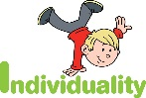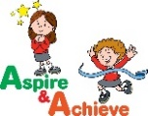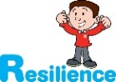

**DT:**

We will be assessing, designing and making our own pizzas this term! Pupils will taste some products currently available, gain technical skills and then create their own pizza. We will then evaluate our work.

**PSHE:**

**Meet the Brain:**

Pupils will learn all about how their brains work and how to keep their pre-frontal cortex working at its best through happy breathing.

**Celebrate:**

We will learn all about our character strengths and learn how to use these to be their best selves.

**Curriculum Drivers:**

* **Community**– Learn about different locations around the world and how they compare to us.
* **Aspiration-** Being healthyand making healthy choices.
* **Independence**- We want the children to be more responsible for their own behaviour, learning and possessions.



**School Expectations**

* We are kind and helpful
* We listen
* We are honest
* We work hard and take pride in our work
* We look after property

**Enrichment:**

**Trips / Visitors**

We are looking into a visit to Chorley Magistrates as part of our learning about Crime and Punishment.

We will hold whole-school enrichment days.

**PE:**

**Hockey –** we will be learning how to travel, pass and score!

**Health Related Fitness – we will look at how we can achieve better health through exercise.**

**School Aims:**

Duke Street Primary School aims to:

* provide a secure, caring and stimulating learning environment,
* promote self-discipline, moral values and self-esteem,
* set challenging yet realistic goals in order to allow each child and member of staff to reach his or her potential
* encourage an enthusiastic attitude to learning through a well-balanced and varied curriculum.
* work in partnership with parents to provide the best for each child in order to get the best from each child
* offer colleagues an enjoyable, positive environment in which to work, fostering both team commitment and the well-being of everyone within our school.

**French:**

Autumn 1 - Talking about us / school. We will learn French vocabulary to talk about ourselves. Autumn 2 - Time in the city. We will learn how to describe destinations in the city.

**RE:** In what ways is life like a journey?

**Christianity** (Church)

We will learn about Christian rites of passage and differences between different denominations.

**Hindu dharma** We will learn about reincarnation, karma and the 4 Ashramas.

**Music:**

We will be developing our understanding of Interesting time signatures within music. Year 6 will be completing their guitar unit with the Lancashire Music Service, combining elements to make music.

**British Values:**

Our work throughout the curriculum will promote the British Values of:

* Democracy
* Rule of Law
* Mutual Respect
* Individual Liberty
* Tolerance & harmony
* Responsibility/positive contribution
* Public Institution

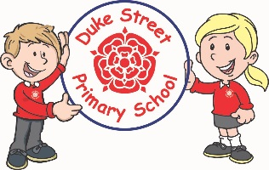

**Home learning:**

**Weekly expectations**:

* Home reading at least **3 times** to an adult for at least 10 minutes. Reading book in school daily.
* Spellings learned for testing on Friday.
* Tables facts learned and practised on TT Rockstars at least **twice a week**.
* Make sure that PE kit or swimming kit is in school on the correct days.