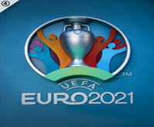
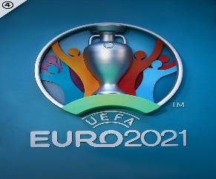
Durham Johnston Euro Competition 2021

This week at Durham Johnston pupils in Y7 and 8 have been competing in a house competition, ‘Euro fever’ has truly begun. Each house have been assigned a country from this year’s UEFA Euro 2020 competition and have been busy during form period creating banners, flags, baking cakes and making their own personalised strips.
The competition has been played in very good spirits during their lunchtime and all students involved have been excellent at representing their countries.
After a full week of competing the year 7 final on Monday will be Switzerland Vs Spain (grass pitch) and the year 8 final will be Turkey Vs France (3G pitch). On Tuesday the 3rd and 4th place for year 7 will be Finland Vs Germany (grass pitch) and the 3rd and 4th place for year 8 will be Ukraine Vs Italy.
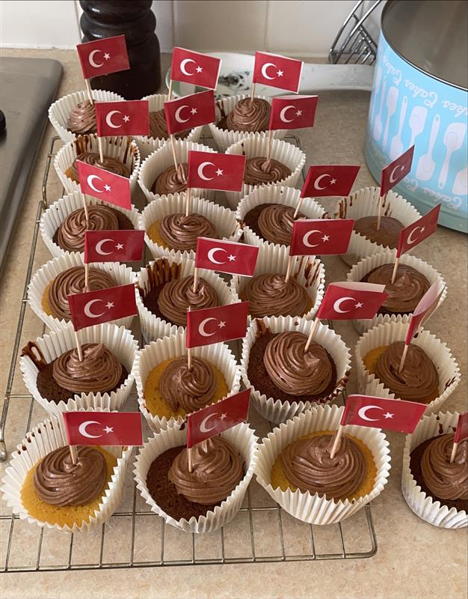
Good luck.
Mr Kidd

