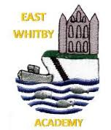
Genies: Our story this week has been Commotion in the Ocean and we are getting very good at knowing sea creature names. We made some lovely biscuits together on Tuesday in Pixie class and on Wednesday had a great day in the woods. We especially enjoyed having our picnic up there.

Date 12.7.24
Newsletter
East Whitby Weekly News

Pixies We have had an amazing week in Pixie Class starting with our trip on Monday. We all had a brilliant time, and I was so proud of our super well behaved Pixies! Thank you to all the parents that joined us. Then Wednesday was our full day of Forest School fun including a picnic in the woods. Thank you to Mrs White for organising this. Back in class we have been singing the nursery rhyme A Sailor Went to Sea and discussing Captain Cook.

Sprites: Sprites have been reading 'Somebody Swallowed Stanley' this week and thinking about how rubbish gets into the sea and damages marine life. On Wednesday, we had a wonderful day up at the woods; pounding petals to make prints on fabric, shaping mud into characters and having a picnic- thank you Mrs White for your lovely ideas! We had a visit from RNLI who told us how to stay safe near water and we got to try on the clothes they wear on the lifeboat - thank you to them for their time.

Elves This week in Year 1 we have looked at odd and even numbers and researched if we add together two odd numbers do we always get an odd number or an even number. In literacy, we have looked at the main components of writing a story: character, setting, problems and a resolution. We have also been enjoying our ICT and French sessions. We all can not believe we are approaching the last week of term together, before the children all become Year 2s!! xxx

Phoenixes: Year 2 are continuing work very hard They 2have been learning about the story of 'The Good Samaritan' this week. In maths they have been learning about position and movement. In Literacy they have been planning a story. They enjoyed meeting their year 3 teachers too.

Unicorns Another stunning week for Year 3! We have investigated different typers of rocks and learnt their scientific names, examined what soil is made of and started looking at different types of forces. We have continued to make and create 3d shapes and learnt about their properties; we have then applied this knowledge to our DT zoo enclosure projects, which are now taking shape! On top of all this, the class thoroughly enjoyed the visit by the author Justin Somper and many are now earnestly reading his books. Great week Year 3!

Centaurs: What a week! This week we had a great time with the RAF STEM Lego session, we built moon buggies and then programmed them to travel using coding! We then had a fab time finishing off our light up signs in DT, we used our knowledge of circuits to make them work. We really enjoyed meeting Justin Somper, his book Pirate Academy is great and the session was brilliant!

Griffins Year 5 have really enjoyed working on the RAF Lego STEM session this week and made some great moon buggies. They loved meeting Justin Somper and found lots out from his session.
The children were super stars on move up day and will be an amazing Y6 class in September

Dragons Year 6 have been out of school this week. We’ve heard how well they have done and are really looking forward to seeing them all next week.
Gnomes
This week in Gnomes we have been enjoying lots of sensory play throughout the week with cornflour and having foam. In maths, we have been looking at the properties of a circle, triangle and rectangle. We have been working on our social skills, this has been very positive!

Pegasus This week in Pegasus our Maths group have identified and drawn perpendicular lines as well as starting to use pictograms to answer questions. Our Literacy group has been working on a shared retelling of the story Wild and this will continue next week. Our Emotions group has thought of examples of when they've felt a range of different emotions and our Collaboration group continued to make their robots and thought about how we express ourselves when we're feeling proud of our achievements.

It’s been very quiet in school this week without Year 6! We hear they have all had a fantastic time and have been an absolute credit to school and themselves. The children all had a lovely day with their new teacher or teachers this week and we welcomed some new faces into classes too which is always really nice. We know the children will make their new friends feel really welcome in September. EYFS had a fantastic day up in the woods this week, the weather didn’t stop the fun, in fact it made it even better! We loved seeing how happy the children were, covered in mud and loving it! They also had a fab time at the beach this week too! We were really lucky to be joined by Justin Somper this week, Year 3, 4 and 5 had a blast hearing all about his job and how he goes about writing his fabulous books. We also loved that he spent most of the morning with a cutlass in his hand! Year 4 and 5 were also involved in an RAF STEM Lego activity, Steve from the RAF joined us and worked with the children to create amazing moon buggies which they then programmed using iPads. There were flashing lights, music, voice commands and all sorts! An amazing day of learning! It's crazy to think that we are now approaching the last week of term! There is so much going on over the coming days, please keep an eye on the school Facebook page for any updates.


This weekend, we know it very may well be “coming home!” however, school will be open as normal on Monday. Children will be in at normal time in order to support our working families. Thank you.
Attendance this week
Sprites | 97%
Elves | 96%
Phoenixes | 95%
Unicorns | 92%
Centaurs | 93%
Griffins | 95%
Dragons
Pegasus | 91%

Star of the week!
Pixies | Annie
Sprites | Micky
Elves | Ziva
Phoenixes | Jasmine
Unicorns | Charlie
Centaurs | The whole class
Griffins
Dragons
Pegasus | Freddie
Gnomes | Jack and Harry

Dates
- Tuesday 16th July 5pm Pride of East Whitby Awards (invites have been sent out)
- Wednesday 17th July Year 5 and 6 performance
- Thursday 18th July Year 6 crucial crew
- Thursday 18th July Year 6 Sleep over
- Friday 19th July End of the school year! School closes 1 hour earlier!
- Wednesday 4th September School reopens.
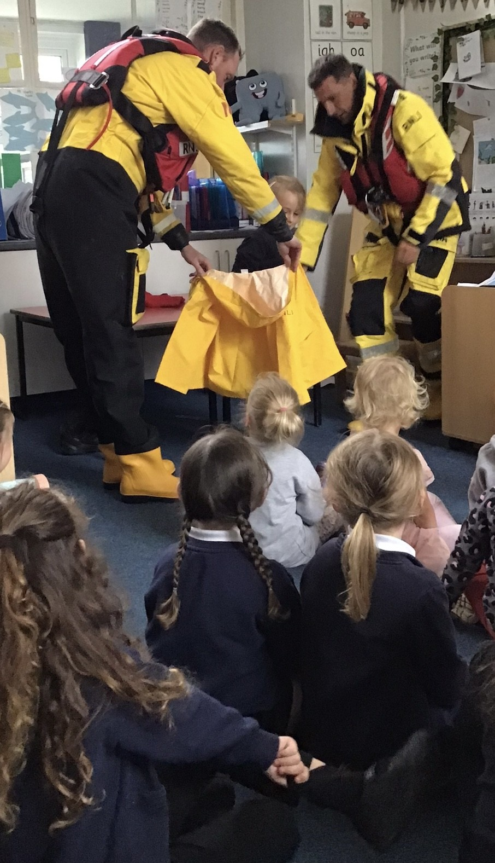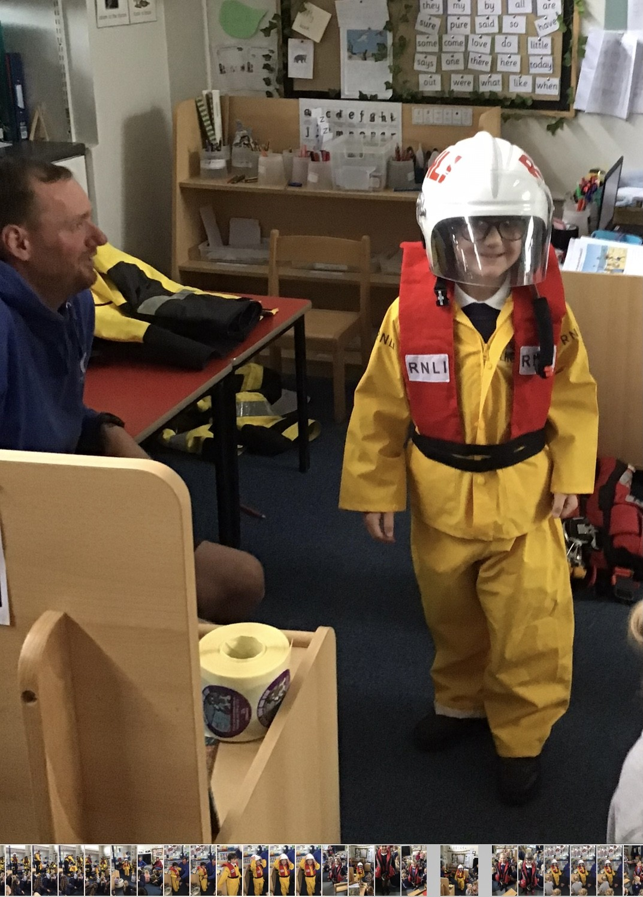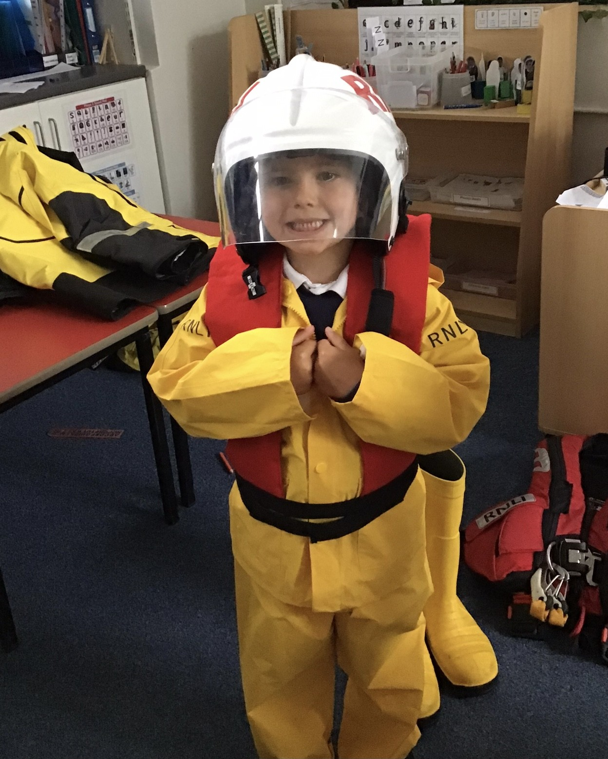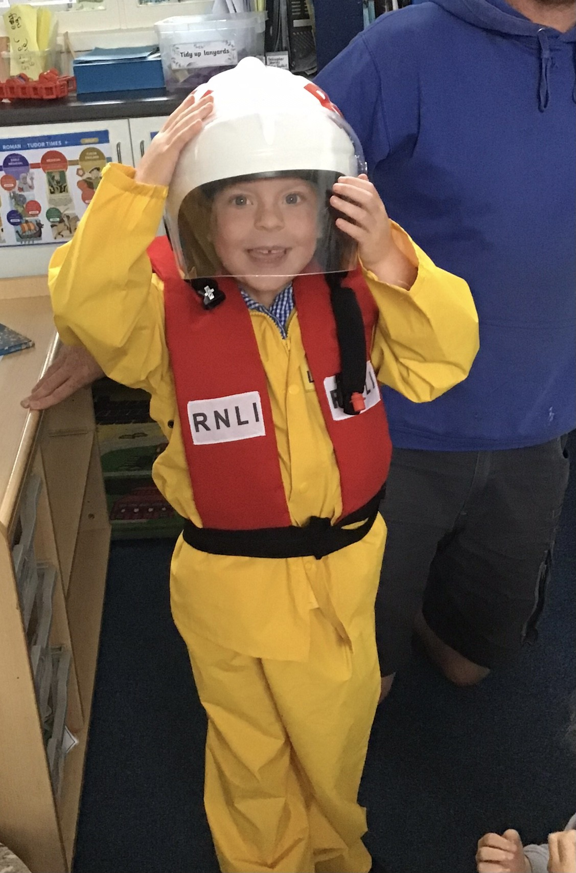
EYFS were joined by the RNLI this week, they found out about staying safe near the water and got to try on some fabulous outfits!
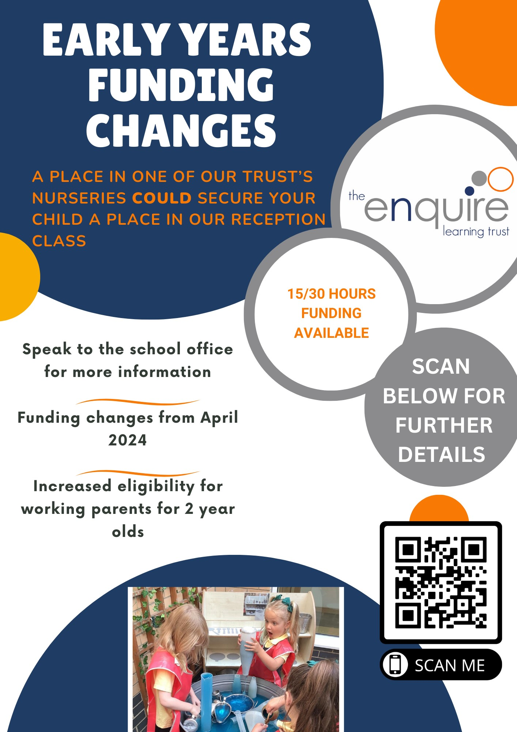

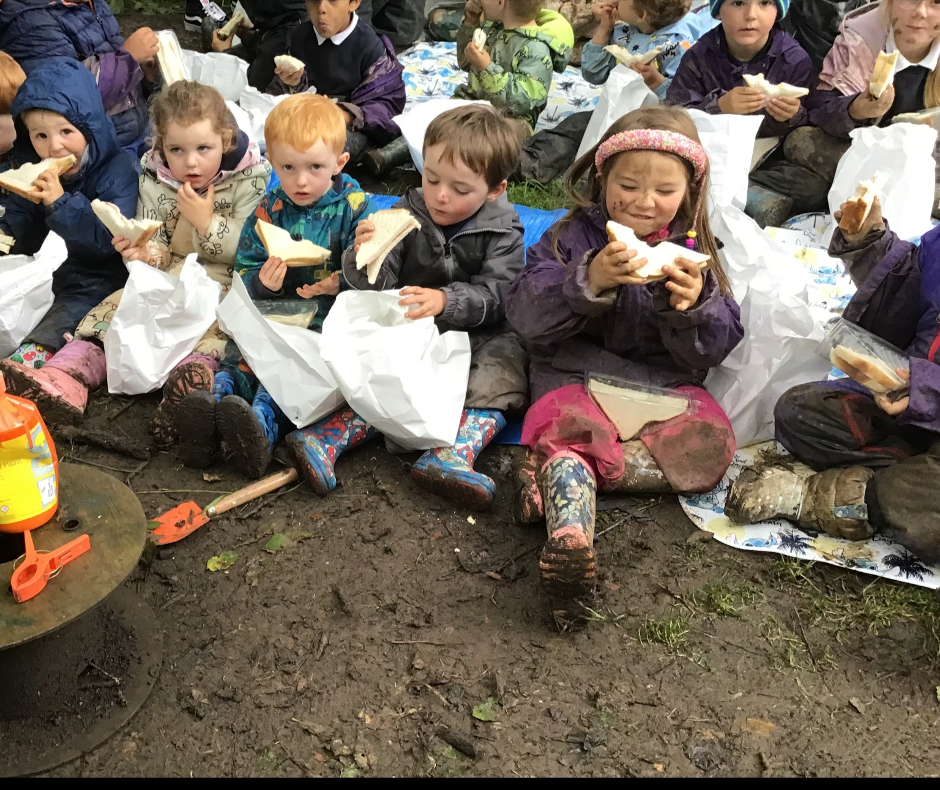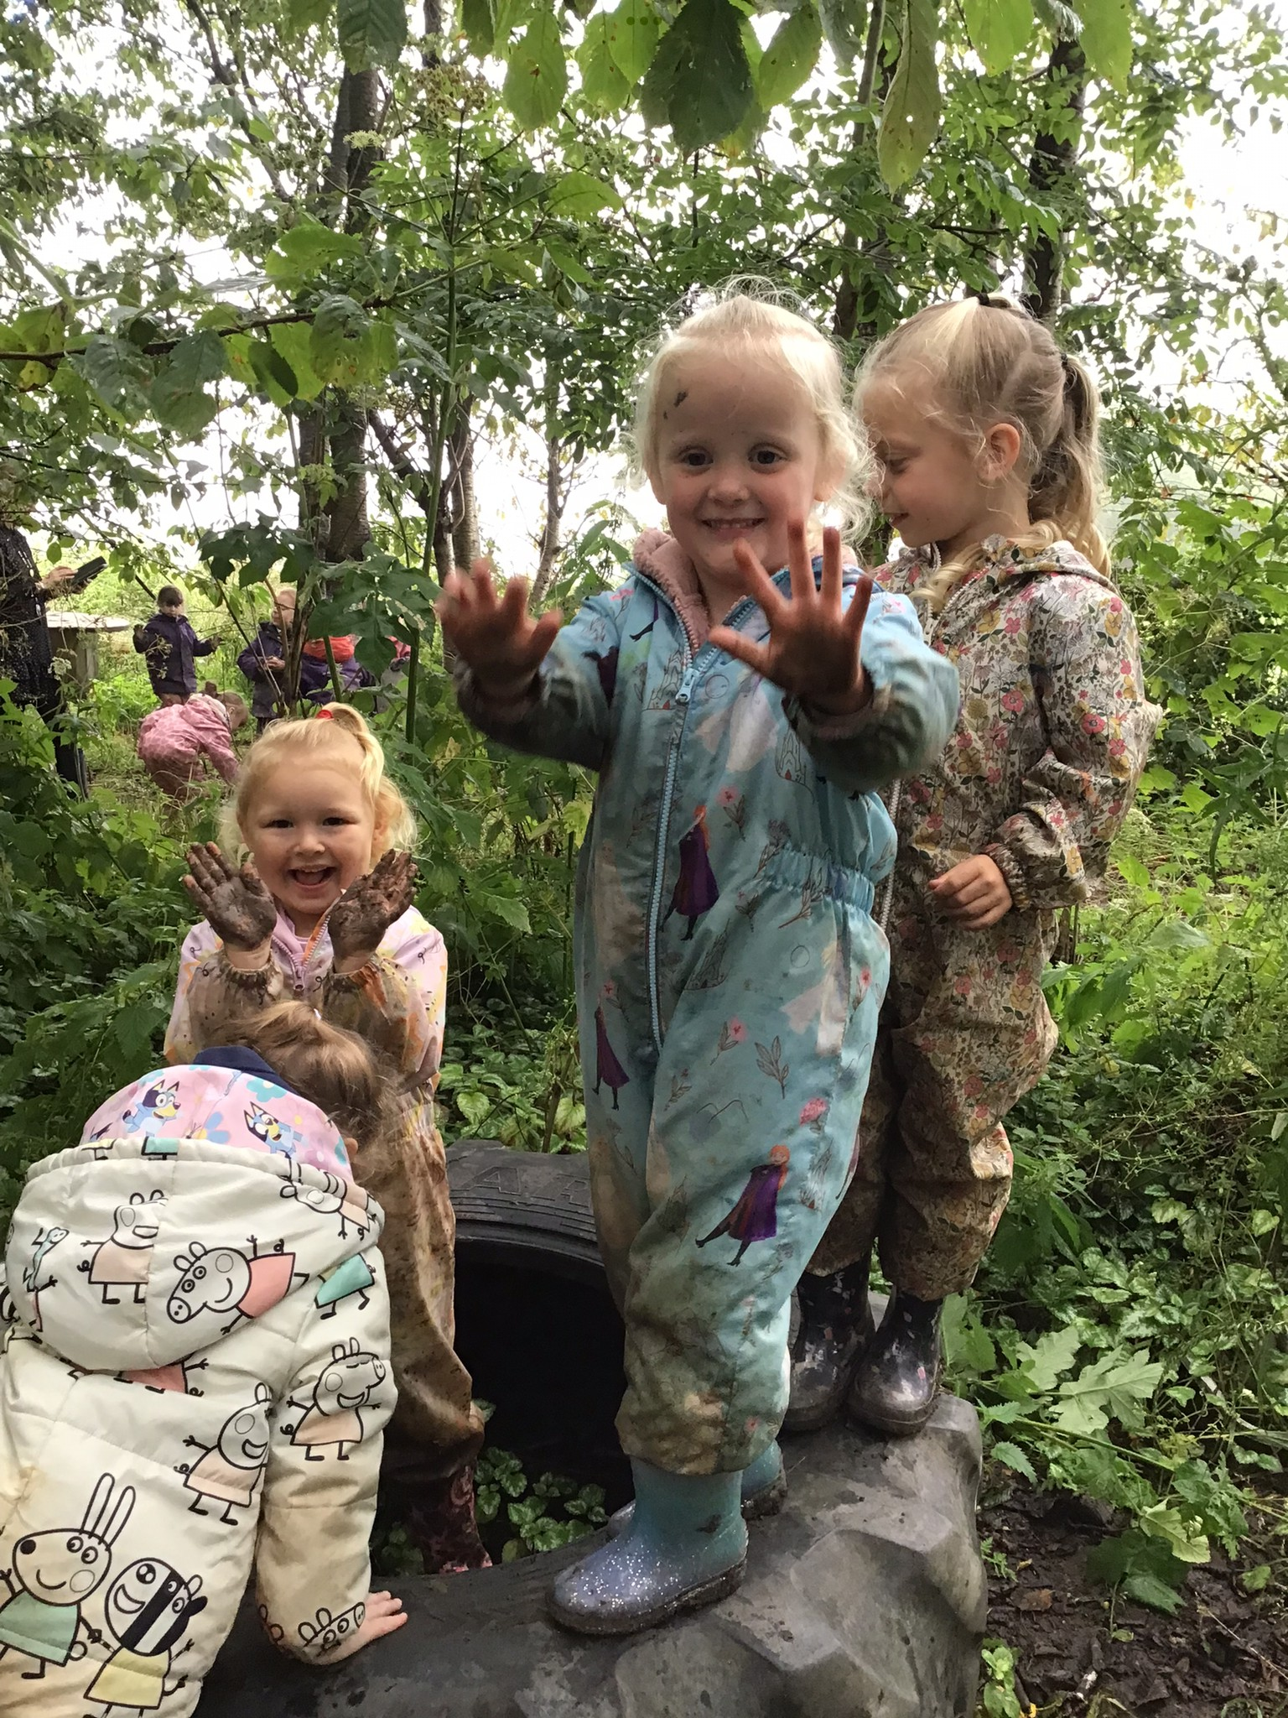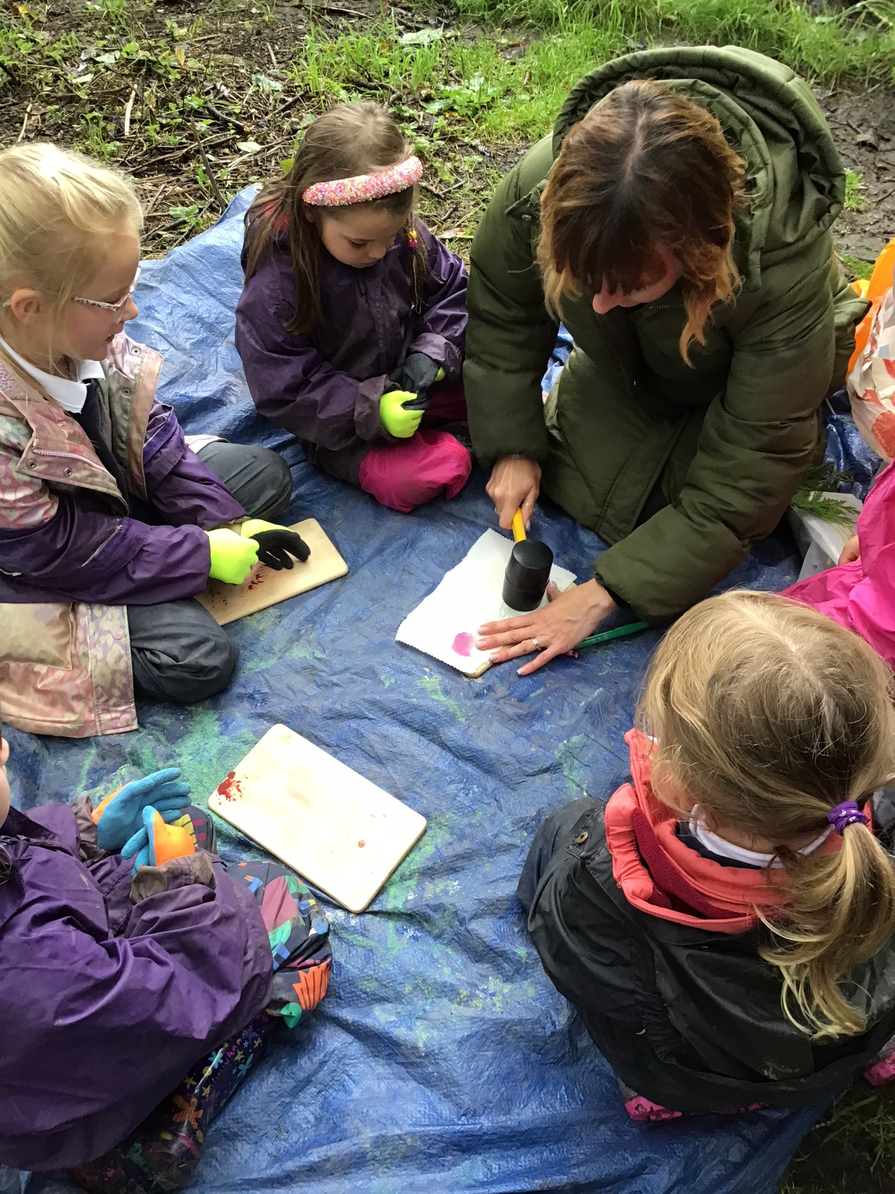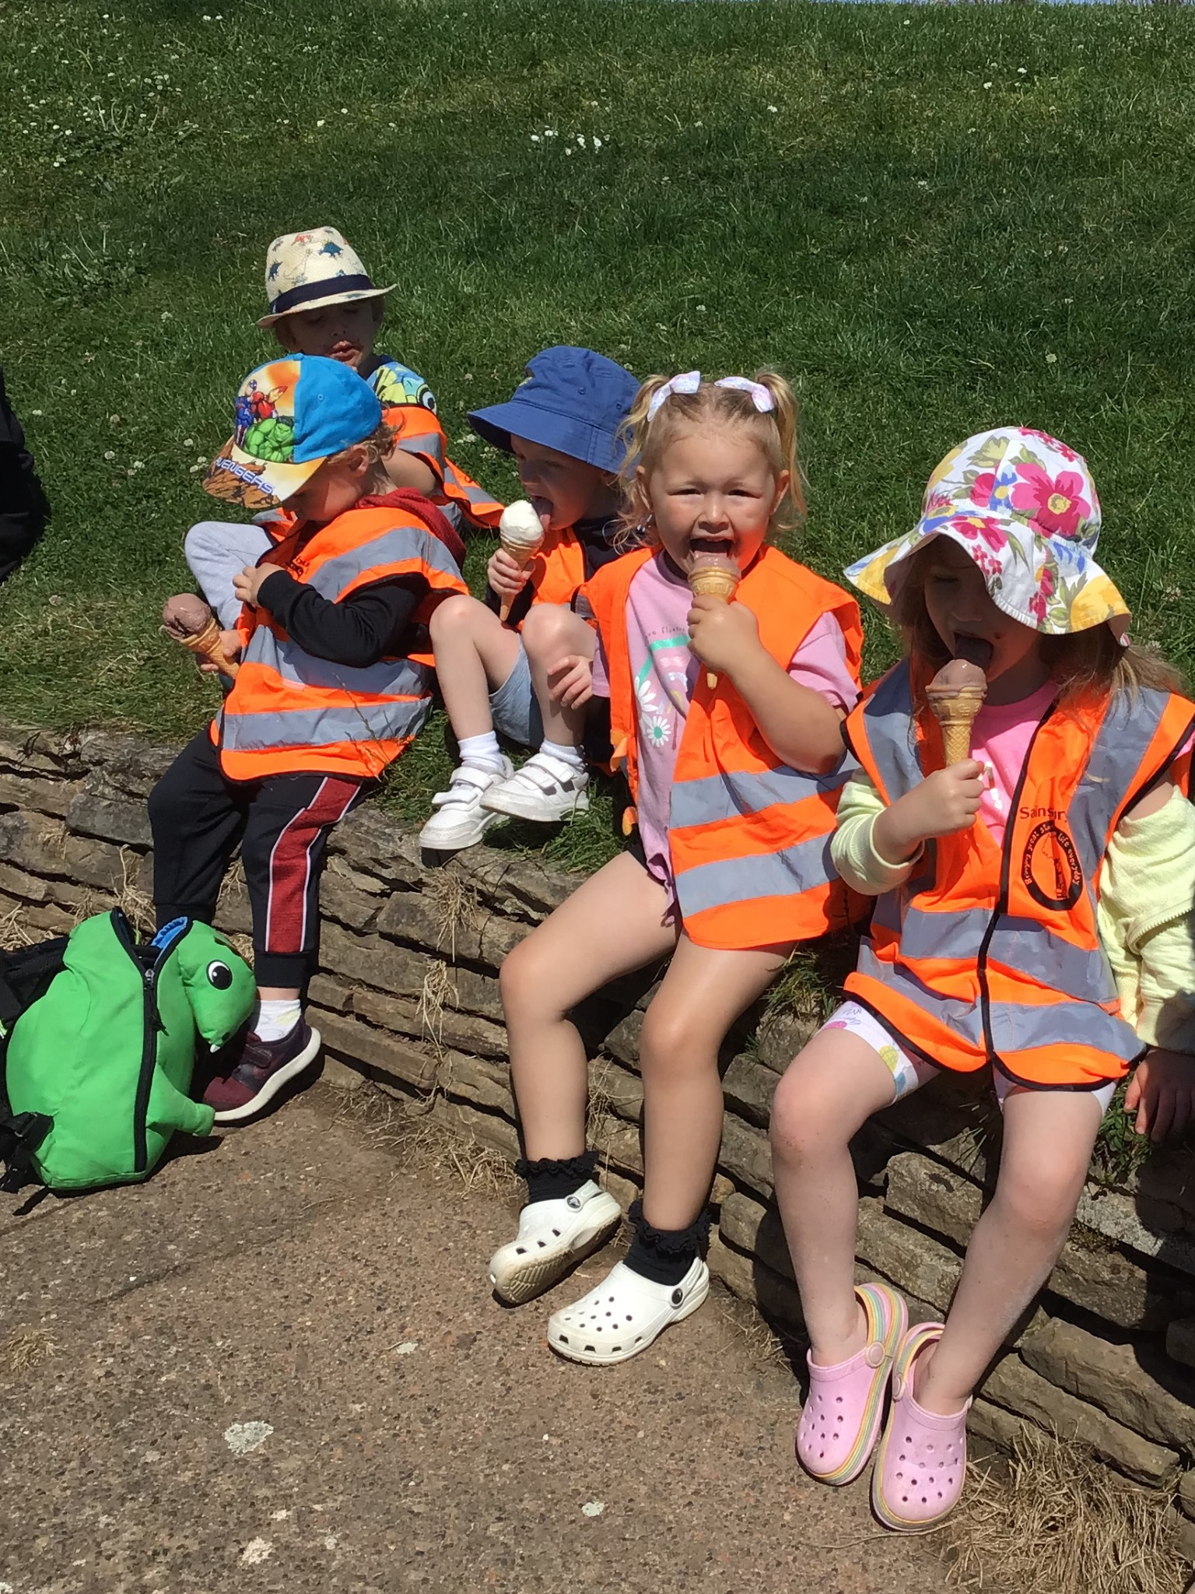
Its been a busy few days for EYFS! An amazing day in the woods with some great, muddy, messy fun and a trip to the beach! Thank you to the adults who made this possible, outdoor learning is the best

