Our Vision:
We promote achievement by:
- Holding the highest expectations for all
- Striving for every child to make the very best possible progress
- Being restless in our pursuit of excellence
We develop as confident and independent learners by:
- Providing learning which excites passion and curiosity.
- Embracing challenge and not giving up
- Trying our best without fear of failure
- Speaking knowledgeably about our strengths and areas of improvement
We value supportive and positive relationships by:
- Bringing out the best in each other
- Showing pride in one another’s achievements
- Creating strong partnerships between home, school and the wider community
We appreciate others by:
- Valuing and respecting the rights of others
- Making sure everybody feels listened to
- Promoting good manners and caring attitude

Enquire Learning Trust
Academy improvement plan 2022-2023
East Whitby Primary Academy

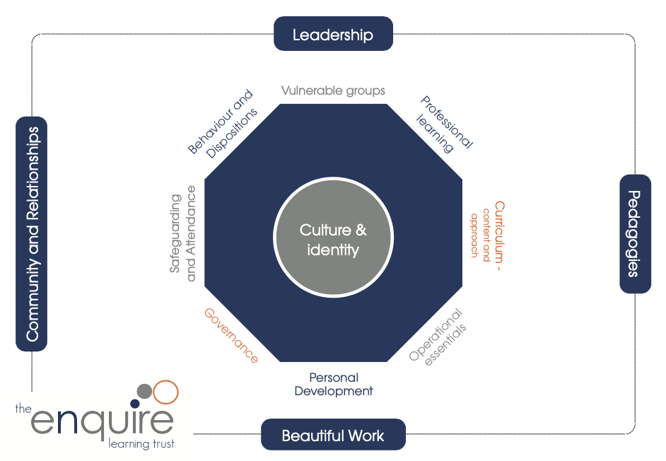

Improvement Plan 2022-2023

Priority 1: Early Writing/Writing. Deepening opportunities for Early Writing in all areas , exploring transition of phonics knowledge in Early Writing to increase Writing GLD. Creating writing for purpose across school to increase writing at GD

Priority 2: Developing agility in Maths by improving mental recall and application in problem solving to increase pupils achieving at Greater Depth

Priority 3: Memory/Retention/Retrieval. Supporting ALL pupils to know and remember more to deepen learning and application of knowledge across the curriculum

Priority 4: Character Development. Creating a Character Development program that provides opportunities and supports young people in their journey through East Whitby and nurtures talents and skills to allow pupils to shine

Enquire Learning Trust  Primary Academy  Improvement Plan  2022/2023 | Priority 1  Early Writing/Writing. Deepening opportunities for Early Writing in all areas , exploring transition of phonics knowledge in Early Writing to increase Writing GLD. Creating writing for purpose across school to increase writing at GD |  | Impact – What is the desired outcome for this priority?  - Writing in Reception will match Reading and will be close the gap to national. (currently 63%)  - ARE and Greater Depth Writing in Y1-Y6 will increase to be in line with the national picture
Leadership Activities |  |  | How will practice and provision look if we are successful in this priority?
- Explore Transition of Phonics knowledge into writing during Phonics. (EY /Reading Lead)  - EY Lead/Writing Lead monitor and explore writing provision in school and compare/contrast with target trust school (EY Lead)  - Investigate writing across entire Early Years, define challenges/ barriers  - Create weekly writing opportunities in EY provision and ensure all pupils engage with opportunities each week. (EY team)  - Review writing development and core writing skills in Nursery against Launchpad for Literacy benchmarks, explore intervention to support pupils to be Reception ready.  - Work with Academies who have successful EY writing to explore writing opportunities in the wider curriculum.  - Review writing opportunities in KS2 to create purposeful writing for targeted audiences, utilise stage and space to create presentation opportunities for writing building on writing development in 2021 (Writing Lead )  - Monitor Writing teaching and fidelity to approach across KS1/2 (writing Lead termly))  - Create increased Internal moderation opportunities KS1/KS2 (Assessment staff meeting SLT)  - Enhance external moderation opportunities to secure assessment judgements and target feedback and teaching. (Trust Hub Level |  |  | - Children will have an improved attitude to writing and will engage more with writing activities in EY.  - There will be a range of writing opportunities for pupils to engage with.  - Pupils engagement in EY with writing is monitored and impact reviewed.  - Writing for purpose will be inherent in writing task design creating increasingly tight frameworks for writing.  - Children will craft writing to match purpose.  - Children will understand purposes for writing  - Modelling and crafting will be focused to support children writing at greater depth
Autumn Milestones (What needs to happen this term to be on track with the priority?)  - Data review and baseline for pupils entering EY and KS1  - Review EY curriculum  - Visit Rosewood Academy and explore EY writing offer  - Curriculum planning for spring to include writing tasks (Purpose and audience key focus) |  | Spring Milestones  - Review writing provision in EY and monitor impact of work.  - Create a defined writing approach and pathway for EY (2YO-Reception) Implement  - Monitor and review impact of grammar work carried out previously and purpose and modelling work.  - Review and moderate writing with other schools. (KS1/KS2 | Summer Milestones  - Review Impact in EY and action plan further development  - Review impact on attainment in writing at GD  - and ARE
Collaborative Advantage

Work with Rosewood Academy to investigate and action plan writing approach/ Moderate writing with North hub schools

Enquire Learning Trust  Primary Academy  Improvement Plan  2022/2023 | Priority 2  Developing agility in Maths by improving mental recall and application in problem solving to increase pupils achieving at Greater Depth |  | Impact – What is the desired outcome for this priority?  - No of pupil achieving GD in KS1 and KS2 will move closer to National figure  - Increase no of pupils scoring 20+ in TTC currently 68%
Leadership Activities |  |  | How will practice and provision look if we are successful in this priority?
- Define/ Review key mental recall knowledge and clarity of teaching them. (eg multiplication knowledge and recall of answers to question eg 5x7=35 as well as pattern counting) (Maths lead/SLT)  - Audit Pupil Mental methods (Maths Lead)  - Staff CPD on mental methods (Maths Lead)  - Introduce Mental Maths Friday in Maths starter sessions, include opportunities for exploring alternative methods and looking at how pupils use mental strategies to balance reduce method reliance and improve estimation and use of mental shortcuts to problems. (Maths Lead/All staff)  - KS1 My Mental Maths every morning moving to mini maths Spring Year 2  - Monitor/Assess/Review/Audit pupils mental Methods (Maths Lead/SLT)  - Create mental strategies and expectations framework across KS2. (Maths Lead)  - Monitor teaching of Mental strategies in main maths sessions and pupils use in non-context dependent situations. (Maths Lead/SLT)  - Assess use of mental strategies in problem solving.  - Introduce Mental recall Assembly challenge |  |  | - Children will be able to recall key maths facts.  - 80% children with get scores of 20+ in the Multiplication Tables Check.  - The % of GD at the end of KS1 and KS2 will increase  - Clearly defined mental recall objectives across school.  - Children will more fluently recall key mental facts and skills and use them to solve problems more diligently
Autumn Milestones (What needs to happen this term to be on track with the priority?)  - Introduce Mental Maths Friday to KS2 Mini-maths  - Deliver Mental Maths CPD  - Introduce Mental Maths in Mini-maths session/recall to KS1  - Audit Mental Maths knowledge  - Define Key Recall knowledge and define the How? |  | Spring Milestones  - Monitor Mental Maths teaching  - CPD to apply Mental approach to problem solving  - Share key knowledge and expectations | Summer Milestones  - Re- Audit assess mental maths knowledge  - Analyse data and assessment re impact of approach.
Collaborative Advantage

Enquire Learning Trust  Primary Academy  Improvement Plan  2022/2023 | Priority 3  Memory/Retention/Retrieval. To develop a whole school retrieval strategy that Supports ALL pupils to know and remember more to deepen learning and application of knowledge across the curriculum |  | Impact – What is the desired outcome for this priority?  - Children will recall and retain increased key knowledge as defined in the declarative knowledge progressions for foundation subjects.
Leadership Activities |  |  | How will practice and provision look if we are successful in this priority?
- Create staff Memory/retention/Retrieval team to explore and implement research informed memory approaches. (SLT)  - Baseline pupil memory of key learning from 21/22 (Memory team)  - Feedback loop for impact of approaches trialled. Implement most effective approaches.  - Review assessment in foundation areas tied to recall and application of key declarative knowledge as defined in schemes of work.  - Explore most effective approaches for pupils with SEND (SENCO TMP team)  - Review highlighted key learning and knowledge for curriculum areas (Subject leaders)  - Implement Teacher Toolkit to develop key recall and retention strategies  - Align approach with central offer Re Dr Robert Coe/ Teacher Toolkit/ Kate Jones  - Define effective strategies for use in all East Whitby classes (Memory/learning team)  - Deliver CPD to all staff on key defined Recall/Retention approaches.  - Monitor use and impact of strategies |  |  | - Key defined recall strategies will be consistently implemented across school.  - Children will know and remember more and create better links for further learning  - Key knowledge reviewed and assessed  - Staff will have a toolkit of memory retention techniques to support learning within their classrooms
Autumn Milestones (What needs to happen this term to be on track with the priority?)  - Develop use of the teacher toolkit  - Highlight 8 key retrieval and trial in class. (action research)  - Trial highlighted approaches  - Review impact of techniques  - Deliver CPD for whole staff on approaches  - Attend trust Central training with Kate Jones  - Plan Implementation of teacher toolkit |  | Spring Milestones  Implement targeted techniques  - CPD/Implement most effective approaches to all staff  - Monitor /review impact of memory and retrieval work  - Implement key aspects of the Great Teacher toolkit | Summer Milestones  - Review /Assess pupils retentention of key knowledge and learning  - Review and enhance key knowledge documents
Collaborative Advantage

Trust work with Teacher toolkit. Developing working with other schools. Hub level working together on developing working memory.

Enquire Learning Trust  Primary Academy  Improvement Plan  2022/2023 | Priority 4  Character Development. Creating a Character Development program that provides opportunities and supports young people in their journey through East Whitby and nurtures talents and skills to allow pupils to shine |  | Impact – What is the desired outcome for this priority?  Children will have a deep understanding of the way in which the world they live in is changing. They will be prepared for life in the future and will understand themselves in a confident way. They will articulate learning confidently and will have access to a phenomenal bank of extra-curricular resources.  British values and the protected characteristics will be taught so well in school that they are part of the daily make up of school life.
Leadership Activities |  |  | How will practice and provision look if we are successful in this priority?
- Purchase and develop a PHSCE curriculum which works for us as a school. Cross reference protected characteristics and British values within this. Train staff in delivery of this and monitor it.  - Inform parents of the PHSCE curriculum and their rights hold parent workshops on this area  - Develop the cross curricular offer with team. Ensure there is a wide range of activities and that all children across school can access it  - Look into external providers and use of pp money to find disadvantaged children  - Map and track disadvantaged children across the year.  - Share OFSTED criteria, what do we need to do next  - Develop an awards scheme and set a date for the end of year celebration.  - Develop careers week in UKS2 for the summer term.  - Look at aspirations  - Link with secondary school to look at how we maintain children’s aspirations. |  |  | - There will be a successful PHSCE scheme across school which is relevant to current world events and trends  - School will have a wider curriculum offer in place  - Children will be confident, caring, well rounded members of the school and wider community  - There is a strong take up of opportunities by those from disadvantaged backgrounds.  - School demonstrates consistently that children are prepared for life in modern Britain. The children understand and behave in a way which demonstrates understanding of British value and cultural differences.  - Protected characteristics are taught and embedded within the curriculum.
Autumn Milestones (What needs to happen this term to be on track with the priority?)  - Jigsaw PHSCE scheme in place, mapping across school completed and highlighting of the protected characteristics teaching taken place.  - Launch the Citizenship awards scheme.  - A whole school extra curricular package is in place and across the year as many children as possible will benefit.  - Citizenship awards ceremony 1  - Parents meeting to explain the PHSCE curriculum  - Meet with secondary schools  - Meet with local community hub RE issues in the community and how we can work together on them  - Arrange assemblies with Police/Lifeboat/Firebrigade/NSPCC/healthy child team |  | Spring Milestones  - Monitoring of PHSCE teaching and the areas covered so far.  - Whole school celebration of citizenship level 2  - Group activities based on work from meetings with community groups  - Second round of extra curricular offers in place  - Tracking of children in groups attending clubs. | Summer Milestones  - Careers week to take place  - Citizenship level 3 awards  - Assemblies in place for the next year  - Audit of Jigsaw  - Gap analysis
- Collaborative Advantage Working with Eskdale and Caedmon to look at how PHSCE can feed through the schools
- Working with the local community on problems such as anti-social behaviour
- Working with local business to promote career aspirations
- Collaboration across school to develop talents in children
- Working with external club providers
- Citizenship awards schemes.
- Working with parents
- Working with the Early Help team on wider support available.
- Character team to meet regularly to audit school and establish next steps

