Our Vision:
We promote achievement by:
- Holding the highest expectations for all
- Striving for every child to make the very best possible progress
- Being restless in our pursuit of excellence
We develop as confident and independent learners by:
- Providing learning which excites passion and curiosity.
- Embracing challenge and not giving up
- Trying our best without fear of failure
- Speaking knowledgeably about our strengths and areas of improvement
We value supportive and positive relationships by:
- Bringing out the best in each other
- Showing pride in one another’s achievements
- Creating strong partnerships between home, school and the wider community
We appreciate others by:
- Valuing and respecting the rights of others
- Making sure everybody feels listened to
- Promoting good manners and caring attitude
Enquire Learning Trust
Academy improvement plan 2021-2022
East Whitby Primary Academy

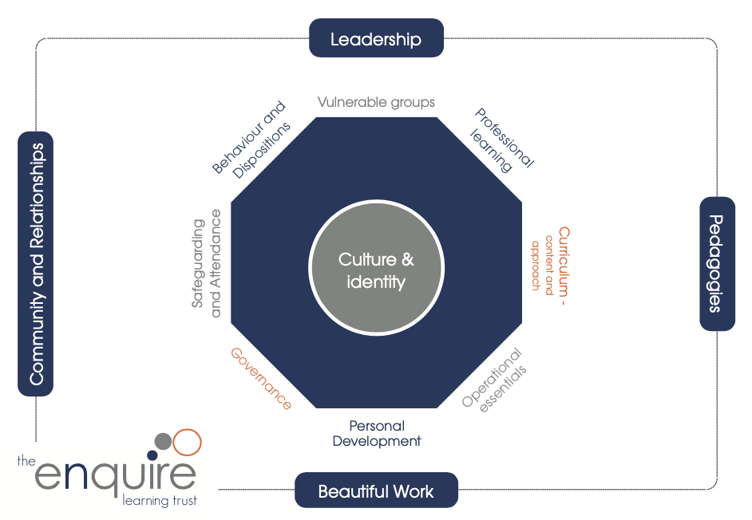
Improvement Plan 2021-2022

Priority 1: Writing: To develop a consistent writing approach ensure that we increase the number of children reaching ARE and GD across school

Priority 2: Curriculum Implementation through Development of Subject Leaders

Priority 3: Early Years: To implement an ambitious curriculum in line with the New Early Years Framework so that it supports the needs of the East Whitby students and allows them to achieve their potential. To create an effective assessment system in EY that drives learning

Priority 4: Assessment: to create a system of assessment that informs and develops teaching in order to drive forward learning

Enquire Learning Trust  Primary Academy  Improvement Plan  2020/2021 | Priority 1  Writing,  To develop a consistent writing approach ensure that we increase the number of children reaching ARE and GD across school |  |  | Impact – What is the desired outcome for this priority?  - There will be significantly more children reaching GD by the end of KS2  - There will be more children reaching ARE across school (especially borderline children).
Leadership Activities |  |  |  | How will practice and provision look if we are successful in this priority?
- Introduce daily handwriting and ensure teaching is consistent throughout school (from September)  - Introduce spelling lessons and ensure the teaching of spelling is consistent across school (via phonics in KS1 and Twinkl spelling in KS2. (from September)  - Explore and define our key approaches and principles in the teaching of writing in school. (exploration Autumn, CPD and implementation Spring /Summer)  - Ensure children are getting plenty of opportunity to see great models, draft and write (one larger piece of writing every two weeks minimum).  - Create a list of non-negotiables in each year group for the teaching of SPAG. (Autumn term)  - Ensure that these techniques are embedded so that this frees up working memory to focus on content in children’s writing as the year progresses. (CPD and then ongoing)  - Provide training and support for teachers not confident teaching the SPAG curriculum. (Autumn /Spring)  - Ensure children are writing to real audiences that are linked to projects often. (Project review half-termly)  - Develop use of the hall and the stage to support pupils’ oracy by focusing project writing into presentation |  |  |  | Children’s writing and presentation will have noticeably improved.  Children will have increased confidence with their spelling ability.  Staff will feel confident at delivery consistent teaching approaches within writing.  Children will move into new year groups confident with their writing and ability and have an understating of the basic SPAG terminology and also able to incorporate it into their work.  Children will have had plenty of opportunities to write for different purposes and audiences.
Autumn Milestones (What needs to happen this term to be on track with the priority?)  - Create a non-negotiables list for the teaching of SPAG (staff meeting).  - Explore a range of approaches for the teaching of writing  - Visit other schools and look at their approaches.  - Introduce handwriting teaching approach  - Introduce spelling teaching approach |  | Spring Milestones  Monitor handwriting and spelling to ensure consistency and review impact made.  Implement the non-negotiables  CPD around our writing approach and possibly having teachers’ trial in lessons. |  | Summer Milestones  - See impact made via book scrutiny’s, learning walks, assessment date, children’s voice and national testing.  - Ensure all staff are happy and confident at delivery the new content.
Collaborative Advantage  Visit other schools to help develop our writing approach.  Moderation support |  |  | Resources – budget planning  Pen pals books for any year groups who need it.  Purchase class reading books sets (£2000)  Training for the teaching of SPAG and our approaches to witting  Release time for subject leader.  Resources to aid the teaching of writing.
Enquire Learning Trust  Primary Academy  Improvement Plan  2020/2021 | Priority 2  Further develop Curriculum implementation through development of effective subject/middle leaders.  Curriculum area focus 21-22 cycle Art/ ICT/ D and T/Music |  |  | Impact – What is the desired outcome for this priority?  - High quality of curriculum in all subject areas that builds knowledge from year to year  - Improved staff knowledge through effective CPD  - Confident subject leaders effectively monitoring standards and leading subjects  - Children making clear progress in all subject areas
Leadership Activities |  |  |  | How will practice and provision look if we are successful in this priority?
- Introduce Curriculum blocking timetable (HT/SLT)  - Ensure all staff are confident in using the curriculum documentation given to them, delivery of staff training and facilitation of planning discussions (Curriculum Area Leads SLT)  - Monitor the MTP’s and objective coverage taking place, ensure lessons are progressive (Curriculum lead)  - Set up a concise monitoring timetable which is blocked and progressive. Ensure these dates are set in the diary and supply is arranged (Curriculum lead/HT)  - Carry out monitoring cycle (Curriculum subject Leads/ HT to support leads)  - Establish working links with other schools in the trust on the priority areas Curriculum lead/ trust  - Work with curriculum leads to support them in their monitoring and confidence in giving feedback to colleagues Curriculum team  - Timescale actions following monitoring  - Equip subject leads to lead enquiry process. Curriculum lead/HT  - Support staff in the new catch up and intervention models. Curriculum lead/HT  - Develop effective/useful curriculum assessment across the foundation subjects Curriculum lead/HT  - Hold pupil progress meetings and create bespoke plans for those who need it. Curriculum lead/HT  - Work with the new staff in school on their understanding of the curriculum. Curriculum lead  - Work 1:1 With the staff moving to a new year Curriculum lead  - Challenge on children not making expected progress. Curriculum lead/HT  - Subject leads will lead CPD for their subject improving staff understanding. Subject Leads |  |  |  | - There will be a consistency in approach across school defined by the use of the Subject on a page documents  - All staff will be able to discuss approaches within school  - Curriculum team monitoring will reflect the school ethos and protocols  - Subject Leads will feel confident in their monitoring.  - ARE will be in line with national and there will be an increase in pupils achieving GD  - All pupils will make at least expected progress across each year  - Transition between classes will be supported through the use of the progression documents.  - A bank of monitoring evidence will support the judgement that school makes  - All classrooms will be as good as today’s best and as good (if not better) than any in the world.  - The gap created by CV-19 will be minimal and children will be secure in their learning.  - Sequences of lesson in specific subjects will be clear and progressive. Deep dives into specific subjects will show clear and defined progression.  - Concepts and ideas will be embedded into the long term memory of the children and will have a true impact on them as learners  - Increase focus on subject specific teaching
Autumn Milestones (What needs to happen this term to be on track with the priority?)  - Curriculum timetable blocks in place  - Monitoring timetable in place linked to blocks.  - Art/Music space ready to be implemented  - Music lead sharing practice in team-teach sessions  - RE Scheme purchased  - ICT ready to be implemented  - Subject monitoring by leads /Half termly (Geography/Science/Art term 1)  - Science/History CPD |  | Spring Milestones  - History/ICT Monitoring  - Art/ICT/D and T/Science CPD |  | Summer Milestones  - RE/DT monitoring  - Geography/Science CPD
Collaborative Advantage  - Visit school with effective practice.  - Collaborate in joint curriculum review through the enquiry process  - Attend subject Lead training |  |  | Resources – budget planning  Staff time to monitor./ Staff meeting planning time  Books and resources for subjects (£3000)

Enquire Learning Trust  Primary Academy  Improvement Plan  2020/2021 | Priority 3  Early Years: To implement an ambitious curriculum in line with the New Early Years Framework so that it supports the needs of the East Whitby students and allows them to achieve their potential. To create an effective assessment system in EY that drives learning. |  |  | Impact – What is the desired outcome for this priority?  - More children are Year 1 ready, regardless of starting points  - Early Years curriculum provides basis of learning across school  - Children are excited about learning and know how to be learners
Leadership Activities |  |  |  | How will practice and provision look if we are successful in this priority?
- Support the EY in the monitoring of baseline data, establish the roles of the different members of the team and where they are best placed to support the needs of children HT/DHT  - Ensure staff are deployed appropriately. HT/DHT/EYLead  - Implement New Early Years Framework  - Introduce and Implement updated EY Curriculum  - Develop assessment procedures for Reception in line with trust expectations and the new EY framework. Use assessment effectively to identify pupils and their barriers to learning.  - Develop Nursery and 2 year old assessment benchmarks using key strands from “Launchpad for Literacy”  - Investigate, redesign and plan effective outdoor space for EY phase.  - Effectively monitor teaching and learning within the provision (2yr-Reception) HT/DHT  - Carry out monitoring of new EY staff. HT/DHT/EYLead  - Further develop effective Phonics practice through working with Literacy Hub and Little Wandle  - Develop the provision further to match the environment and needs of the children HT/EYLead  - Establish links with other trust schools with similar demographic and ethos. EYLead  - Identify the approach we want to see and develop the “do it” document for EYFS EYLead/DHT  - Audit the way planning and delivering of provision takes place, assess the impact of the teaching and learning we do. EYLead  - Carry out regular analysis of “data” including in class tracking to ensure all children are being catered for at all times. HT/EYLead  - Create systems that support early identification of SEND pupils. |  |  |  | - Broad, balanced, ambitious curriculum implemented daily  - Learning creates solid foundations that are built on by the rest of the school  - Early identification of children’s needs and barriers to learning  - Provision will support purposeful learning and be welcoming and exciting  - Staff confident about next steps for class and individuals based on teacher knowledge  - Good communication across EYFS team and school  - Children excited to learn, exhibiting good learning behaviours  - Accelerated progress for learners  - EYFS is an integral part of the school and recognised as the starting point for every child’s learning journey
Autumn Milestones (What needs to happen this term to be on track with the priority?)  - Visit and review outdoor provision spaces  - Introduce New EY framework and Curricululm  - Staff training for EY assessment  - Staff training for Little Wandle Phonics  - Monitor and assess framework data  - Monitor EY Curriculum |  | Spring Milestones  - Monitor EY curriculum and Impact  - Review 2YO provision and curriculum  - Analyse Autumn EY data and adapt provision accordingly  - Purchase EY outdoor materials |  | Summer Milestones  - Analyse Spring EY Assessment data and adapt provision  - Introduce EY outdoor revised provision
Collaborative Advantage  - Visit outdoor provision spaces, to help design/redesign process  - Trust Early Years Networks  - Visit outstanding EY provisions |  |  | Resources – budget planning  Outdoor provision/ fencing/ outdoor furniture resources (£4000, more if financially supported from the trust)  Sets of Phonics materials linked to Little Wandle. (£2000)
Enquire Learning Trust  Primary Academy  Improvement Plan  2020/2021 | Priority 4  Assessment: to create a system of assessment that informs and develops teaching in order to drive forward learning |  |  | Impact – What is the desired outcome for this priority?  - Better outcomes for children – more children achieving age-related expectations or better or making good progress from their own starting point  - Increased focused, informed teaching
Leadership Activities |  |  |  | How will practice and provision look if we are successful in this priority?
- Ensure all staff receive training on BromCom system. Allow time for practise on the new system and questions.  - Staff training about “The Engagement Model” for children not accessing subject specific study. This will only be 3 children across the school in the first instance.  - Staff training for Pivats (Trust version) for children who are working 2 or more years below their academic year. Again, this will only be a small number of children.  - Subject leaders monitor data regularly and discuss with staff.  - SLT to meet and analyse data and identify trends. Share with staff. Act upon any areas of weakness. SENCO to review use of The Engagement Model.  - Pupil progress meetings to discuss children who are not on track or who could achieve Greater Depth and strategies for moving them on.  - Use data as a lens to explore work in school.  - Conversations with staff to identify common problems, ease of use etc.  - Moderation of data across the school. Compare data across classes and key stages.  - Look at how East Whitby data compares with other Trust schools. How is it being used?  - Ensure data is informing teaching and useful. Assessment informs teaching and learning. |  |  |  | - Teaching will be focused and address gaps in learning on a class and individual basis  - Teachers will be well-informed about the children in their class and know how to make sure the maximum number of children achieve ARE.  - More children will achieve ARE and GD.  - Teachers will know the next steps for children working 2 or more years below their age group, including those not engaged in subject specific study. They will be able to accurately assess their progress.  - SEND children will be well-supported to make progress at their own level and pace.  - Assessment data forms an important part of the graduated approach system for SEND (assess, plan, do, review) and informs next steps.
Autumn Milestones (What needs to happen this term to be on track with the priority?)  - Bromcom system installed and all staff to have received training  - Staff training on “Engagement Model” and Pivats for those children 2 or more years below ARE  - First data collection and analysis by SLT |  | Spring Milestones  - Evidence of teachers using assessment data to inform practice (as seen in classrooms and in planning documents)  - Comparison of data across the school and key groups  - Moderation across classes and key stages/schools  - Second data collection and analysis by SLT  - Review of Pivats/Engagement Model |  | Summer Milestones  - Curriculum planning for 2022/23 informed by data from 2021/22  - Clear evidence of progress for all key groups and individuals  - Majority of children at ARE or higher  - Review of data system – feedback to Alison Semley/Trust
Collaborative Advantage  Communication with other schools re data systems and how they are using BromCom  Moderation opportunities |  |  | Resources – budget planning  BromCom and Pivats  Staff meeting time, release time for moderation and monitoring

