Our Vision:
We promote achievement by:
- Holding the highest expectations for all
- Striving for every child to make the very best possible progress
- Being restless in our pursuit of excellence
We develop as confident and independent learners by:
- Providing learning which excites passion and curiosity.
- Embracing challenge and not giving up
- Trying our best without fear of failure
- Speaking knowledgeably about our strengths and areas of improvement
We value supportive and positive relationships by:
- Bringing out the best in each other
- Showing pride in one another’s achievements
- Creating strong partnerships between home, school and the wider community
We appreciate others by:
- Valuing and respecting the rights of others
- Making sure everybody feels listened to
- Promoting good manners and caring attitude

Enquire Learning Trust
Academy improvement plan 2024-2025
East Whitby Primary Academy

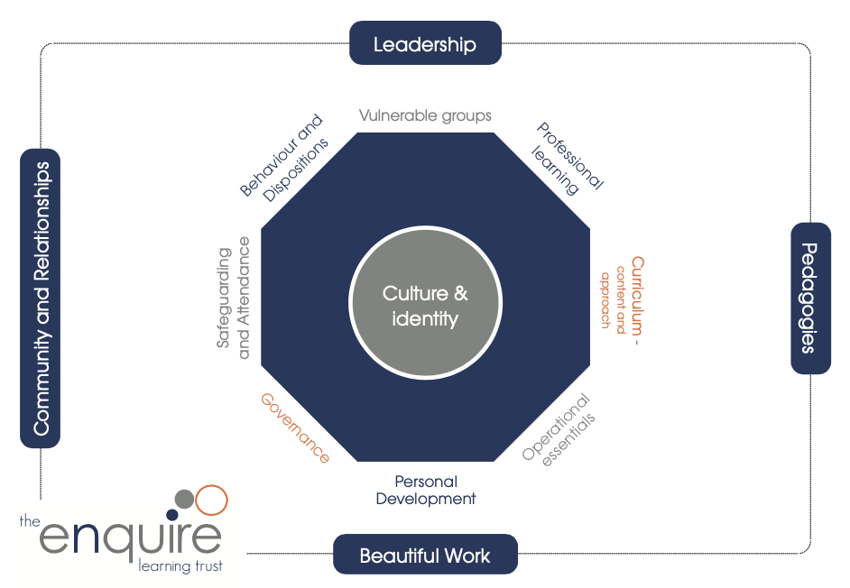

Improvement Plan 2024-2025

Priority 1: Oracy: Oracy assessment and planning for Oracy to move pupils learning forward. Embedding Oracy across the curriculum

Priority 2: Maths. Developing pupil confidence to apply learning

Priority 3: SEND Further develop staff expertise and confidence in supporting children with a wide range of SEND. Ensure processes and systems are robust and effective.

Enquire Learning Trust  Primary Academy  Improvement Plan  2024/2025 | Priority 1  Oracy: Oracy assessment and planning for Oracy to move pupils learning forward. Embedding Oracy across the curriculum |  | Impact – What is the desired outcome for this priority?  - Children to confidently, independently and effectively articulate knowledge and understanding of learning through a variety of approaches.  - Children develop the skills that support them in communicating, confidently, clearly and appropriately in a range of situations
Leadership Activities |  |  | How will practice and provision look if we are successful in this priority?
- To Audit Oracy work completed in Year 1 (aut 1 CK/SS)  - To further enhance staff knowledge about Oracy and how to effectively plan in in their classrooms.  - Introduce Oracy grouping and explore how to plan effective Oracy Sessions (aut CK/SS)  - Work with Voice 21 to explore Oracy in the curriculum (07/10/24)  - To work with staff to Assess class/pupil needs and adapt Oracy work to pupils need (CK/LW)  - To support staff in planning effective oracy work to move pupils Oracy skills forward. (CK/SS/LW)  - Create opportunities to showcase Oracy work  - To see Oracy development as area in it’s own right not just as a delivery tool for other curriculum area.  - To embed the oracy framework  - To develop oracy approach in a range of curriculum areas supporting the delivery of a broad robust curriculum (CK/SS/Subject Leaders) |  |  | Children to gain confidence around speaking to a wider range of people. –Curriculum enquiries/ Presentation sessions  Children will be able to articulate their learning and understanding in a range of different ways. – Curriculum enquiries/ Monitoring/ Conversations with pupils  In school, evidence collected, will show children will have been given the chance to participate in a wide range of Oracy opportunities. -  Targeted club opportunities to support developing Oracy eg/ Drama-attendance lists  Children will be use a range of structure to support conversation and responses- Curriculum enquiries/ Monitoring/ Conversations with pupils
Autumn Milestones (What needs to happen this term to be on track with the priority?)  - Grouping CPD and planning session  - Voice 21 Oracy in the Curriculum session  - PPA staff oracy planning session  - Observe Oracy Lessons  - Review pupils Oracy needs |  | Spring Milestones  - Write Curriculum Oracy statements to create curriculum approach  - Plan Oracy in different curriculum areas  - Share Oracy practice  - Adapt Oracy planning to address targeted class/pupil needs  - Coaching and Review Process introduced | Summer Milestones  - Review Oracy in school as part of the enquiry process  - Monitor Impact  - Action plan for the following academic year.
Collaborative Advantage
Work with other Cohort 1 Trust school to develop curriculum approach and explore good practice

Enquire Learning Trust  Primary Academy  Improvement Plan  2023/2024 | Priority 2 Maths.  Developing pupil confidence in applying their mathematical knowledge and understanding independently. |  | Impact – What is the desired outcome for this priority?  - Children will be confident to apply their mathematical knowledge independently in any situations. They will talk confidently about their learning and be able to work through any problems/questions.  - Children will not get upset when faced with challenges.  - Children will talk confidently about their learning.
Leadership Activities |  |  | How will practice and provision look if we are successful in this priority?
The EEF’s ​‘Improving Mathematics in Key Stages 2 and 3’ guidance report defines problem-solving as ​“a situation where pupils lack a well-rehearsed and readily available method”  - Develop an “Heuristic Checklist” to highlight traits of effective problem-solvers (Aut JK)  - Develop routines for children to articulate and share process (Aut)  - Produce worked examples of different ways to approach a problem(Aut)  - Developing Effective teacher modelling of worked examples (Aut all staff)  - Develop and introduce Mathematical discussion session using Oracy frameworks to support pupil exploration of approaches (Spr CK/SS)  - Introduce Open problems that support pupils in exploring approaches to understand optimal solutions. (Spr SS/JK)  - Introduce reflection and feedback time to allow pupils to explore their approach (Spr)  - Look to create real world cross curricular problem that link Maths into other curriculum areas |  |  | - Pupils will be able to articulate the steps and their approach to solving a problem  - Pupils will be confident in approaching problems  - Effective consistent teacher modelling.  - Pupils will be able to review their strategies and approaches  - Pupils will have increased understanding of problem language  - Pupils will have increased resilience and confidence when approached with unfamiliar challeneges
Autumn Milestones  - Create Model approaches to open ended problems  - Develop “Hueristic” Checklist  - Explore what effective modelling of open ended problems with multiple approaches looks like  - Develop routines to share and articulate process |  | Spring Milestones  - Introduce Mathematical discussion session  - Develop bank of cross-curricular problems  - Introduce reflection approaches to support pupils in reflecting on their approach  - Monitor/ Review open ended problem solving | Summer Milestones  - Audit pupils approaches to solving problems  - Review problem solving as part of the Summer enquiry
Collaborative Advantage

Highlight schools that have achieved Greater Depth success and explore approaches to problem solving and applying knowledge

Enquire Learning Trust  Primary Academy  Improvement Plan  2023/2024 | Priority 3  SEND : Further develop staff expertise and confidence in supporting children with a wide range of SEND. Ensure processes and systems are robust and effective. |  | Impact – What is the desired outcome for this priority?  - Increase staff knowledge and awareness of SEND (from an already high starting point).  - Review SEND provision across the curriculum to ensure children are well supported in every class in every subject and provision is consistent across subjects and school  - Clarify and embed C&I TMP model, including transitions between lessons in the TMP and mainstream class.  - Complete SEND review.  - Consistency and effectiveness of the graduated approach documentation.  - SEND children achieve both academically and in the wider curriculum to their potential.  - High needs SEND pupils are well supported and receive the correct provision to enable them to make progress for them.
Leadership Activities |  |  | How will practice and provision look if we are successful in this priority?
- Organise training for teachers/teaching assistants for key areas of SEND for school (for example, Autism, PDA, anxiety and Speech, Language and Communication)  - Regular staff meetings to update on SEND priorities and updates. Invite support staff to relevant updates and meetings  - Ensure good SEND practice is shared across the school. Utilise expertise of Specialist C&I teacher to provide advice and training to colleagues.  - Discussion and sharing of TMP model and gather team views and suggestions/frustrations  - Regular sharing of TMP timetables with the wider school team  - Complete SEND review (templates shared at SENCO Network summer term 2024). Invite Trust colleagues to contribute.  - Use SEND review to inform next steps for SEND in school and identify gaps in provision  - Moderation across Trust of graduated approach documents. Seek opportunities to compare school documents with known positive examples from Trust  - Review data and achievement of children on the SEND register across the school to identify any gaps in provision or trends in the progress of children with SEND  - Monitor clubs and wider curriculum offer for SEND children and engagement of SEND children in the extra-curricular offer  - Look at “Pride of East Whitby” data and criteria to ensure it continues to be inclusive for all learners in school and is adapted when necessary, so that children on the SEND register are able to succeed  - Meet with subject leaders to discuss SEND across the curriculum. Ensure shared understanding of SEND and what SEND provision looks like across the curriculum  - Further conversations with the Local Authority about the high needs children in school and the local area and the provision that can be created/continued to support these children  - Consideration with Trust of increasing the TMP offer from an 8-place provision to 12-place provision |  |  | - All children with SEND will be able to make progress (at their own level and from their own starting points) in every class in every subject  - SEND provision will match needs in all circumstances  - Staff will be confident in their knowledge of SEND, relevant to their class and role  - Subject leaders will have knowledge of SEND relevant to their subject  - Good practice will be embedded across the school  - Identified problems with the TMP model will be addressed leading to more efficient running of the model and smoother transitions between the TMP and mainstream classes  - The quality of graduated approach documents will be consistent across school and in line with good examples from across Trust  - Engagement in the club offer for children with SEND will increase from 66% in Summer Term 2024  - Participation of children with SEND in extra-curricular activities will be regularly reviewed  - Children with SEND will be fully included and represented in the Pride of East Whitby awards
Autumn Milestones (What needs to happen this term to be on track with the priority?)  - SEND review to identify development areas  - Audit of staff skills and training  - Staff meeting to elicit views on the TMP model – positives and challenges  - Moderation of graduated approach documents (in school and with Trust)  - Review data of children with SEND from across the school. Compare 2023/24 data with national results.  - Review club offer and any issues with accessibility. Identify steps to redress any problems with children with SEND accessing the club offer.  - Use of staff meeting time for SEND.  - Further discussions about the possibility of a “Special School @” model with the Local Authority  - Decide whether to approach the Local Authority about increasing the TMP model from 8-place to 12-place.  - Liaison with subject leaders. |  | Spring Milestones  - Organise staff training in line with the results of the audit  - Share updated TMP timetables and review previous term  - SEND monitoring to check any issues identified with plans and provision have been rectified.  - Review club data and percentage SEND attending clubs.  - Staff meeting time for SEND.  - If increasing TMP, work to ensure this is successful and a positive addition to the school.  - Further discussions about the possibility of a “Special School @” model with the Local Authority  - Target specific identified children where there is under achievement in any part of the curriculum. | Summer Milestones  - Review staff training and any areas to take forward to the new academic year.  - Transition for new pupils with SEND joining in September 2025.  - Share updated TMP timetables and review previous term  - SEND monitoring to check any issues identified with plans and provision have been rectified.  - Review club data and percentage SEND attending clubs.  - Staff meeting time for SEND.  - Further discussions about the possibility of a “Special School @” model with the Local Authority
Collaborative Advantage

Visit TMPs in other Trust schools
Visit other Trust schools with above average SEND pupils
Liaise with local Special Schools for specific training and advice. (Possibility of

Enquire Learning Trust Causal Chain - Impact of leadership on AIP Priority 1

Impact of leadership

What was the impact on:
Quality of Education | Behaviour and Attitudes | Personal Development | Early Years
Further reflection/next steps:

