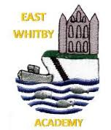
Personal Development at East Whitby Academy
Here at East Whitby Academy, our curriculum extends far beyond the academic, to allow pupils to develop in many diverse aspects of life. We strongly believe we have a curriculum offer, which celebrates our unique identity and community and allows every child to achieve in a way that enthuses and excites all learners. This is all brought together in our Personal Development Curriculum.
Through our carefully thought out curriculum offer we have ensured that, over their time at East Whitby Academy, children receive a Personal Development programme that gives them the skills and knowledge they need to make the right and best decisions. We work hard to strengthen them personally and support them to develop their character and personality, with our “be strong, be fearless, be you” approach and aim to ensure that children are ready to face their future and be ready for a world that does not yet exist. We provide these rich experiences in a coherently planned way, in the curriculum and through extra-curricular activities.
Within the personal development curriculum at East Whitby, four key areas underpin our work:
- Being healthy and safe
- The world around us
- Character development
- British Values
Being healthy and safe includes our PSHE curriculum, Relationship Education, Sex Education, Physical Health, Mental Wellbeing and Wider Aspects of Safety. The majority of our work is delivered through the Jigsaw Curriculum, which we adapt to suit our school context, but there are additional aspects planned in across the year to allow a more personalised and prevalent curriculum.
Awareness of the world includes Economic Understanding, Understanding Media and Technology and Spiritual, Moral, Social and Cultural development.
Character development includes development of children’s own character and personality, within school we use Commando Joe’s to develop resilience with the children and adopt the values of this throughout our curriculum. We also have a great extra-curricular offer in place and our “East Whitby Way” pledges which open the wider world up to the children and allow their character and personality to grow and shine.
British Values includes Democracy, Rule of Law, Respect & Tolerance and Individual Liberty. This is woven into all aspects of school life and is part of the fabric of our school.

What is SMSC?

It is the Spiritual, Moral, Social and Cultural development of the children in our school. This is not a separate subject that is taught explicitly, but an aspect of learning that should be present in lessons and behaviour in school. All schools in England are required to promote the spiritual, moral, social and cultural (SMSC) development of their pupils. Through our provision of SMSC, we aim to:
- enable students to develop their self-knowledge, self-esteem and self-confidence;
- enable students to distinguish right from wrong and to respect the civil and criminal law of England;
- encourage students to accept responsibility for their behaviour, show initiative, and to understand how they can contribute positively to the lives of those living and working in the locality of the school and to society more widely;
- enable students to acquire a broad general knowledge of and respect for public institutions and services in England;
- further tolerance and harmony between different cultural traditions by enabling students to acquire an appreciation of and respect for their own and other cultures;
- Encourage respect for other people; and
- Encourage respect for democracy and support for participation in the democratic processes, including respect for the basis on which the law is made and applied in England.

How do we develop SMSC?
Spiritual Development: We teach children about themselves, others and the world around them in order to inspire and develop a sense of awe and wonder. We explore values and beliefs in which to inform their perspective on life and respect for other people. Creativity is a key part of our curriculum and we encourage a willingness to reflect on their own experiences.
Moral Development: We provide opportunities for children to investigate moral and ethical issues in order to develop their ability to recognise the difference between right and wrong, with a readiness to apply this understanding in their own lives. We develop their understanding of consequences of their actions.
Social Development: We learn to cooperate well with others and resolve conflicts effectively. We develop social skills through working and socialising with and alongside others from a variety of different backgrounds. We teach children about the way their own community as well as wider society and other communities function.
Cultural Development: We celebrate diversity and inclusivity within our school and share knowledge and experience within the community. We explore and develop an understanding and respect for cultural diversity. We provide opportunities to explore a variety of art, music, sport, science and festivals. We also develop an appreciation of cultural influences that have shaped the children’s own heritage.

We are fiercely proud of the young people we help to shape at East Whitby Academy and aim for each children to leave our school as a strong, resilient learner ready to be part of the wider world and community.
A child leaving us will be:
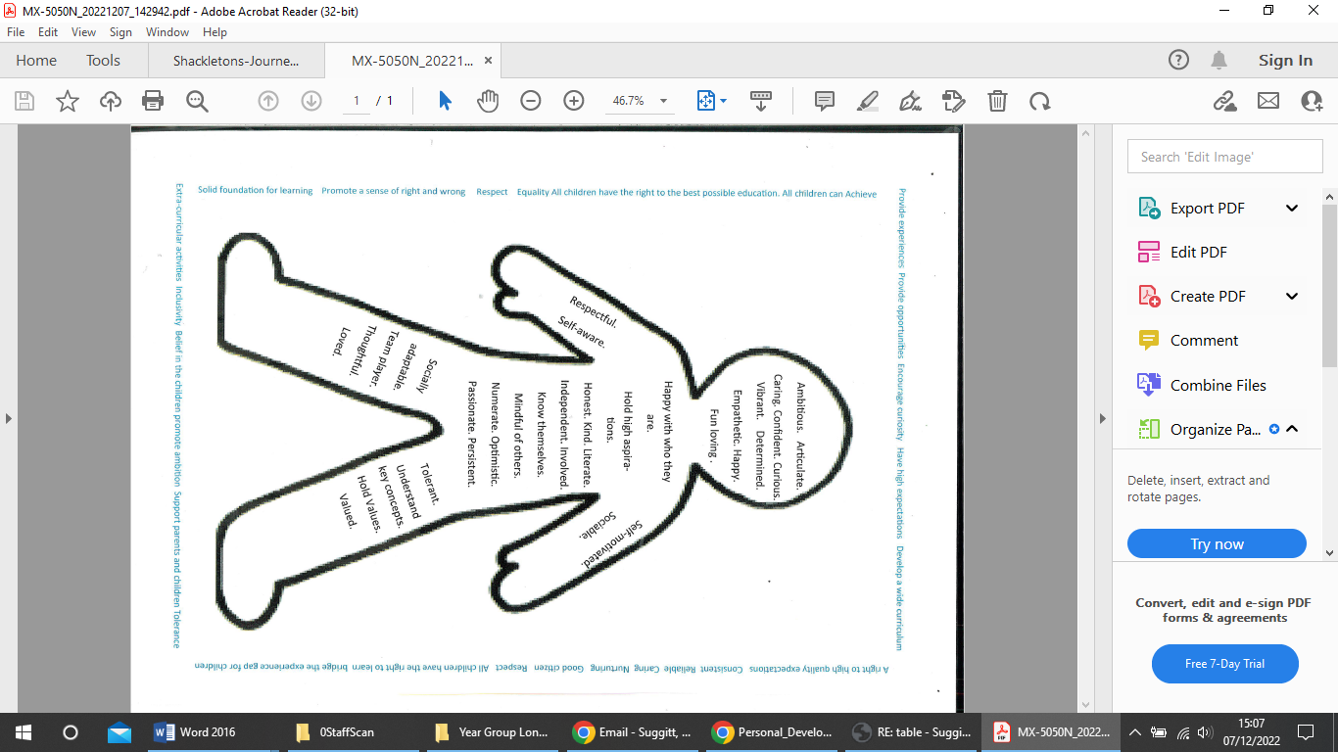

What is meant by “British Values”:
All schools in England are required to ensure that key ‘British Values’ are taught to pupils. The Government set out its definition of British values in the ‘Prevent Strategy.’ These values are democracy, the rule of law, individual liberty, mutual respect and tolerance of those of different faiths and beliefs. At East Whitby Academy, these values are reinforced regularly and in the following ways:
Democracy: Children have the opportunity to have their voices heard through our School Council and through pupil questionnaires. Children have a say in what goes on in school, from clubs to playground designs. They take part in debates and votes regularly as part of their curriculum learning.
The Rule Of Law: Throughout the school day, the importance of laws, are consistently reinforced. Our children are taught the value and reasons behind laws that govern and protect us, the responsibility that this involves and the consequences when laws are broken. We use a 5 hands behaviour system should the need arise and all children are aware of the rule of law within school and within the wider world. It is, however, incredibly rare that any of our teachers have to use the behaviour system in school.
Individual Liberty: When in school, our pupils are encouraged to make choices, knowing that they are in a safe and supportive environment. We encourage our children to know, understand and exercise their rights as children and when they enter adulthood.
Mutual Respect: our school Behaviour Policy revolves around core values such as ‘respect, collaboration and nurture’, children have been part of discussions and assemblies related to what this means, and how it is shown. Relationships are incredibly important at East Whitby Academy; these are based on mutual respect and trust.
Tolerance of those of Different Faiths & Beliefs: This is achieved through enhancing our children’s understanding of their place in a culturally diverse country and by giving them opportunities to experience such diversity such as through assemblies and visitors to school. We also have a dedicated lesson per week of Religious Education, through our scheme of work 'Discovery RE'. You can read more about our RE curriculum by clicking on the RE tab. Pupils of different faiths or religions are encouraged to share their knowledge to enhance learning within classes and the school.
In addition to being woven across the curriculum, British Values are explicitly taught through our PSHE scheme of work, Jigsaw.

What are “Equality, Diversity and Protected Characteristics”.

At East Whitby we ensure that all elements of the Equality Act of 2010 are taught and adhered to.

Equality
We pride ourselves on being a welcoming and inclusive school. For us, equality means that everyone is able to participate and feel welcome and safe in the activities of our school. This includes pupils, parents & carers, staff and visitors. Everyone should be able to achieve the best possible outcomes as a result of their participation. We believe that equality should permeate all aspects of school life and is the responsibility of all members of the school and community

Diversity
At our school diversity means acknowledging that there are differences between people that should be recognised, respected and celebrated. We promote respect of each other’s differences and identities. We celebrate and raise awareness of diversity in the school and in the wider community and believe that teaching children about diversity prepares them for life in modern Britain.

The Equality Act 2010
We want our children to learn that we all belong together regardless of different races, religions, sexualities, genders, abilities and ages. We encourage children to be proud of their differences and to understand the importance of not discriminating against, or being unfair to others, because of their difference
The Equality Act 2010 - The Protected Characteristics
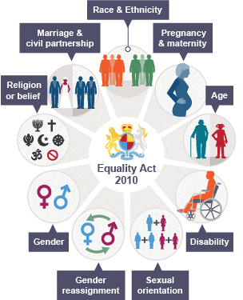
The 9 Protected Characteristics are actively promoted in school through:
- Our school mission statement
- Our school core values
- Our school behaviour policy and curriculum
- Conscious role modelling by all adults in the school community
- Active engagement and communication with parents and carers
- Assemblies linked to British Values & the protected characteristics
- Discussion within curriculum subjects, taking a cross-curricular approach to the Equality Act
- Promoting articulation by building appropriate language and a coherent vocabulary
- Personal, Social, Health and Economic education (PSHE) sessions (see the mapping document below)
- Religious Education (RE) lessons, RSE lessons and Protected Characteristic talks
- Sporting, Art and Cultural Events
- Pupil Voice,
- Educational visits
- Real-life learning outside the classroom
- Guest speakers
- Developing links with local, national and international communities
- Extra-curricular activities, after-school clubs, charity work and work within the local community
Below is a table showing where Protected Characteristics are specifically taught as part of our Jigsaw PHSCE program.

Protected Characteristic | What this refers to | Links to Jigsaw PHSCE
Age | Where this is referred to, it refers to a person belonging to a particular age (for example, 32-yearolds) or range of ages (for example, 18- to 30-yearolds). | Celebrating Difference Age 8-9 Piece 1: Judging by Appearance Age 8-9 Piece 2: Understanding Influences Age 10-11 Piece 2: Understanding Difference Ages 10-11 Piece 3: Power Struggles
Gender reassignment | The process of transitioning from one gender to another. | Celebrating Difference Age 6-7 Piece 5: Gender Diversity NB: there is no direct reference to transgender or the concept of transitioning in this lesson. Ages 10-11 Piece 2: Understanding difference NB. In Jigsaw the focus is on accepting all people as unique individuals, not on transitioning itself.
Being married or in a civil partnership | Marriage is no longer restricted to a union between a man and a woman but now includes a marriage between a same-sex couple. Same-sex couples can also have their relationships legally recognised as ‘civil partnerships’. Civil partners must not be treated less favourably than married couples (except where permitted by the Equality Act). | Celebrating Difference Ages 7-8 Piece 1: Families Age 10-11 Piece 2: Understanding Difference Relationships Age 5-6 Piece 1: Families Ages 6-7 Piece 1: Families
Being Pregnant or on Maternity leave | Pregnancy is the condition of being pregnant or expecting a baby. Maternity refers to the period after the birth, and is linked to maternity leave in the employment context. In the non-work context, protection against maternity discrimination is for 26 weeks after giving birth, and this includes treating a woman unfavourably because she is breastfeeding. | Celebrating Difference Ages 3-4/4-5 Piece 3: Families Ages 7-8 Piece 1: Families Age 10-11 Piece 2: Understanding Difference
Disability | A person has a disability if she or he has a physical or mental impairment which has a substantial and long-term adverse effect on that person’s ability to carry out normal day-to-day activities. | Celebrating Difference Ages 10-11 Piece 5: Celebrating difference Age 6-7 Piece 4: Standing up for Myself and others Age 8-9 Piece 1: Judging by Appearances Age 8-9 Piece 6: Celebrating Differences: How We Look Age 10-11 Piece 2: Understanding Difference
Race including colour, nationality, ethnic or national origin | Refers to the protected characteristic of Race. It refers to a group of people defined by their race, colour, and nationality (including citizenship) ethnic or national origins. | Celebrating Difference Ages 9-10 Piece 1: Different Cultures Ages 9-10 Piece 2: Racism Age 7-8 Piece : Families Age 10-11 Piece 2: Understanding Difference
Religion, belief or lack of religion/belief | Religion has the meaning usually given to it but belief includes religious and philosophical beliefs including lack of belief (such as Atheism). Generally, a belief should affect your life choices or the way you live for it to be included in the definition. | Celebrating Difference Ages 9-10 Piece 1: Different Cultures Age 10-11 Piece 2: Understanding Difference
Sex | A man or a woman. | Celebrating Difference Ages 6-7 Pieces 1&2: Boys and Girls Age 8-9 Piece 1: Judging by Appearances Age 10-11 Piece 2: Understanding Difference Changing Me Age 7-8 Piece 5: Family Stereotypes
Sexual orientation | Whether a person’s sexual attraction is towards their own sex, the opposite sex or to both sexes. | Celebrating Difference Age 6-7 Piece 4: Standing up for Myself and others Age 7-8 Piece 1: Families Age 9-10 Piece 3: Rumours and Name Calling Age 9-10 Piece 4: Types of Bullying Age 10 – 11 Piece 2: Understanding Difference Relationships Age 8- 9 Piece 5: Girlfriends and Boyfriends Changing Me Ages 10-11 Piece 4: Boyfriends and girlfriends

We have a broad and varied Extra-curricular offer in place which develops interests and talents and also offers an additional teaching element too. Children are consulted on what types of clubs they would like and are able to sign up to these each half term.
The types of clubs on offer changes depending on the time of year and uptake is good, with children having good attendance at the clubs they sign up to.
An example of the offer in place for spring term 1
From | Lunch time | After school
Monday  9th January | - Lego Club 12:30-1  Reception, year 1,2 and 3 (20 spaces) with Mr Marsden  - Loom bands mixed open to all 12:30-1pm with Mrs Waterfield | - Gymnastics KS2 3:30-4:15 20 spaces  - Y6 Boosters
Tuesday  10th January | - Mindfulness club. With Mrs Fusco 12:30-1 | - Rugby KS2 20 places 3:30-4:15  - Singing club 3:30-4:15 all ages 25 places with Mrs Suggitt
Wednesday  11th January | - Craft club open to all year groups all across lunch time with Mrs Suggitt | - Chris Colebrook Drama Club KS 2 3:30-4:30 KS2 children Not already attending Colebrook.  - Y6 Boosters
Thursday  12th January | - Year 3 and 4 music club  - Ukulele club years 5 and 6 10 places
Friday 13th January | - Year 5 and 6 music club  - Games club years 1 and 2 with Mrs Foster | - Film club 3:30-4:15

At East Whibty Academy we also continue to develop the children’s character through a range of pledges known as “The East Whitby Way” these are learning experiences from outside the classroom and are really important to us as a school community. Throughout their time here, all children will be able to carry these out multiple times, developing wider life skills, resilience, confidence and respect.
We will get to:
Plant a flower, tree or plant. Look after it and watch it grow and change. Eat it if its edible | Cook on a fire | Make a picnic and eat it together | Go sledging or mud sledging in a sack
Share our work with a real audience using a stage | Go out to sea on a boat or board. | Visit a big city | Pay for something in a shop
Spend time on the beach, dig, swim and build. | See a show at a theatre | Climb a tree | Go fossil hunting
Forage for food | Arrange and go on a journey | Cook a meal for our family and share it | Go fishing
Take part in a competition | Perform in a production | Build dens and hide in them drinking hot chocolate we make using a Kelly kettle. | Have a water fight
Follow a map and go on an adventure | Go rock pooling and see what we can find | Face a fear and beat it | Spend a night camping
Spend a night away from home | Make lifelong friends and deal with fall outs | Keep ourselves and others safe by learning first aid. | Learn about another culture and experience some of this culture ourselves.

The pride of East Whitby Awards scheme:
The purpose of the new awards are:
- to recognise and acknowledge the active role pupils play in the life of the school and the wider community
- to encourage children to make positive choices which will benefit their class, school and community
- to encourage children to become responsible, informed and active members of their class, school and wider community
- to encourage children to learn about aspects of citizenship education, including topical issues, rule and law-making, democracy, human rights, diversity.
- To develop the character of the children in school
There will be three levels of awards available each year the idea is that each child will achieve at least bronze level each year.

For year 1-6 Bronze level: children to meet 10 of the criteria this is within the classroom
- I am well presented and wear the correct school uniform for each lesson including PE
- I look after my belongings, including my Jumper/Cardigan, PE kit and cloakroom peg
- I arrive at school punctually
- I take care with my hand washing and sanitising and show respect when people want to distance
- I hand in my reading journal and home learning punctually and have completed it as requested
- I frequently go the extra mile with my reading
- I frequently go the extra mile with my home learning
- I actively involve myself with learning
- I put myself forward to help in school doing monitor jobs and school council
- I make healthy food choices
- I play cooperatively at break and lunch and line up well
- I take part in a school club before, during or after school
- I get a star of the week certificate.
Silver level
This is for work within the school.
To achieve the silver award you must complete one from this section:
- I support lunchtimes as a playground buddy
- I represent the school in an intra-school event (sport, music, art, class competitions, school council, supporting a club, shows etc
- I represent the school in an inter-school event (sport, music, art, Junior safety, pupil parliament)
- I read with a younger pupil once a week for at least half a term.
- I run a school Club for other children
- I set an amazing example of how a member of the school community should behave.
- I get the Star of the term certificate
To achieve the silver award you must also complete two tasks from this section:
- I volunteer as a litter picker once a week for half a term
- I volunteer as a lost property monitor once a week for half a term
- I volunteer as a library monitor once a week for half a term
- I volunteer as a dining room monitor once a week for half a term
- I volunteer as a playground helper once a week for half a term
- I volunteer as an office monitor for a half term
- I do any classroom monitor job
Gold Level This is to for work within the community.
To earn the gold award, you must complete three of the following tasks.
- research a topical local, national or global issue and present to the class or in an assembly
- I represent school in the community e.g. I deliver food hampers at Harvest
- Raise money for my school through a cake sale, sponsored event or any other initiative of my choice;
- Raise money for another charity of my choice.
- Contribute to the wider community through initiatives run by my clubs (cubs, brownies, place of worship for example);
- I look after the local environment e.g. joining beach cleans etc.
- My family and I involve ourselves in a local initiative which benefits the community (litter pick for example);
- I learn a new skill out of school.
- Do something for someone else e.g. donate toys to hospital etc.

Platinum level:
- I am nominated for the East Whitby Endeavour award. An award given to children who strive to be the very best they can be, who achieve amazing things as part of the East Whitby family and who are just East Whitby through and through!
For Genies, Pixies and Sprites the criteria are:
Bronze level – children to consistently meet all criteria
- I look after my belongings – hang up my coat/Jumper/PE bag
- I wash my hands independently before snack and lunch and after I've been to the toilet
- I help to tidy up every session
- I clean my teeth daily at school
- I try hard to use a knife and fork
- I use aprons for paint and water and hang up after use

Silver level – children to consistently meet all criteria
- I help other children whenever I can
- I am kind and take turns
- I help in the school garden whenever I can
- I sit at group time and take an active interest in our discussions
- I try lots of different foods and understand about healthy choices
- I make green choices with my behavior
- I line up and walk sensibly around school

Gold level
- I regularly share news from home
- I learn a new skill out of school
- I take part in initiatives out of school – reading challenge

