Year 4
Dear Parent/Carer,
Please find attached an access code to look at the Jigsaw PHSE puzzle piece we will be working on after half term.
If you wish to discuss this further please contact us at school.
Please note we will also be “making a noise about bullying” for Anti Bullying Week (13th-17th November 2023), more details to follow
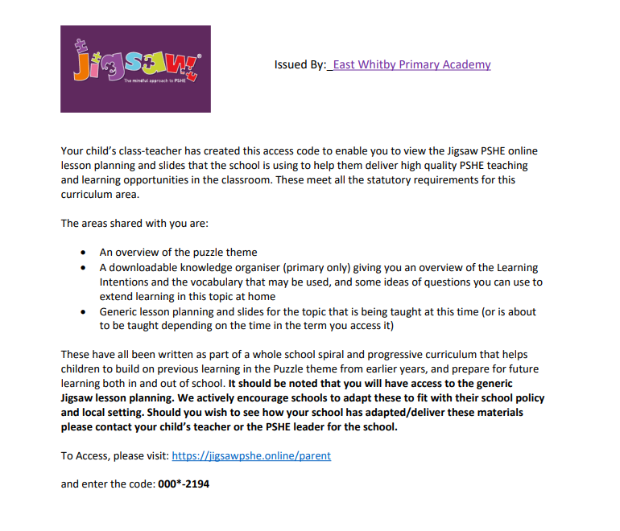

Nursery
Dear Parent/Carer,
Please find attached an access code to look at the Jigsaw PHSE puzzle piece we will be working on after half term.
If you wish to discuss this further please contact us at school. Please note we will also be “making a noise about bullying” for Anti Bullying Week (13th-17th November 2023), more details to follow

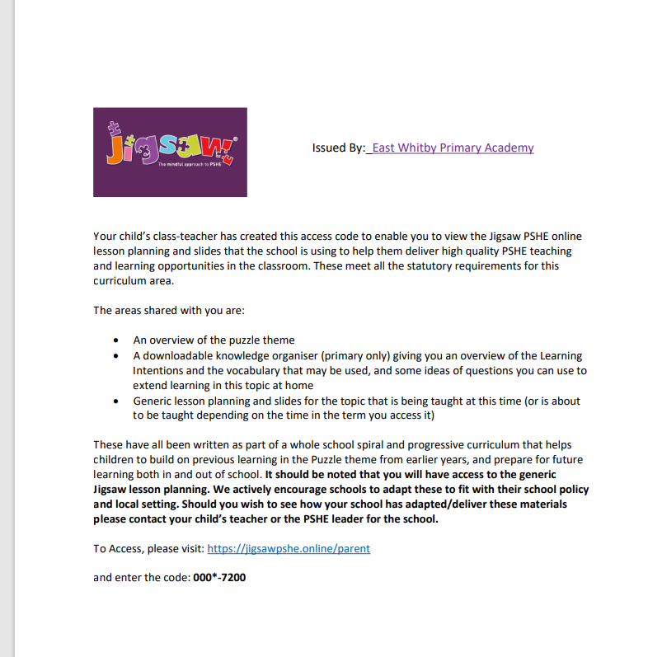

Reception
Dear Parent/Carer,
Please find attached an access code to look at the Jigsaw PHSE puzzle piece we will be working on after half term.
If you wish to discuss this further please contact us at school. Please note we will also be “making a noise about bullying” for Anti Bullying Week (13th-17th November 2023), more details to follow

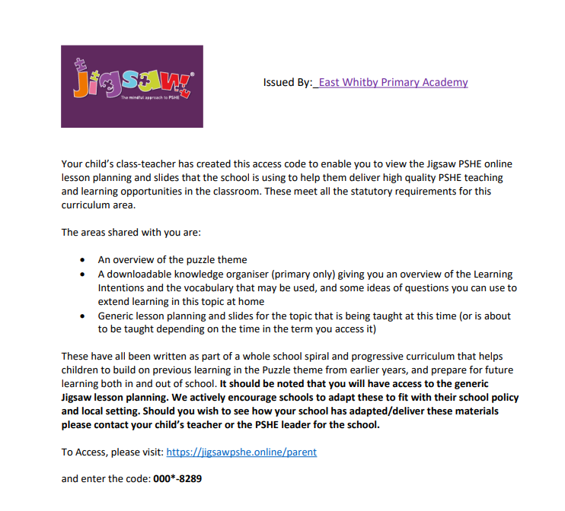

Year 1
Dear Parent/Carer,
Please find attached an access code to look at the Jigsaw PHSE puzzle piece we will be working on after half term.
If you wish to discuss this further please contact us at school. Please note we will also be “making a noise about bullying” for Anti Bullying Week (13th-17th November 2023), more details to follow

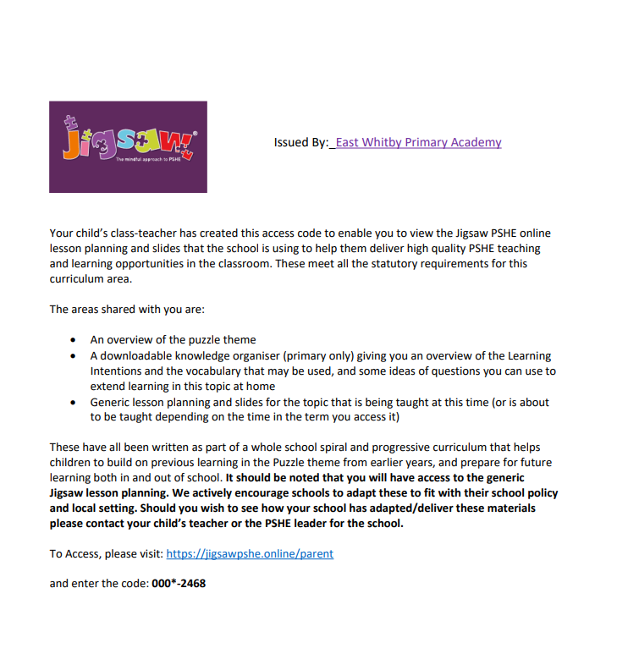

Year 2
Dear Parent/Carer,
Please find attached an access code to look at the Jigsaw PHSE puzzle piece we will be working on after half term.
If you wish to discuss this further please contact us at school. Please note we will also be “making a noise about bullying” for Anti Bullying Week (13th-17th November 2023), more details to follow

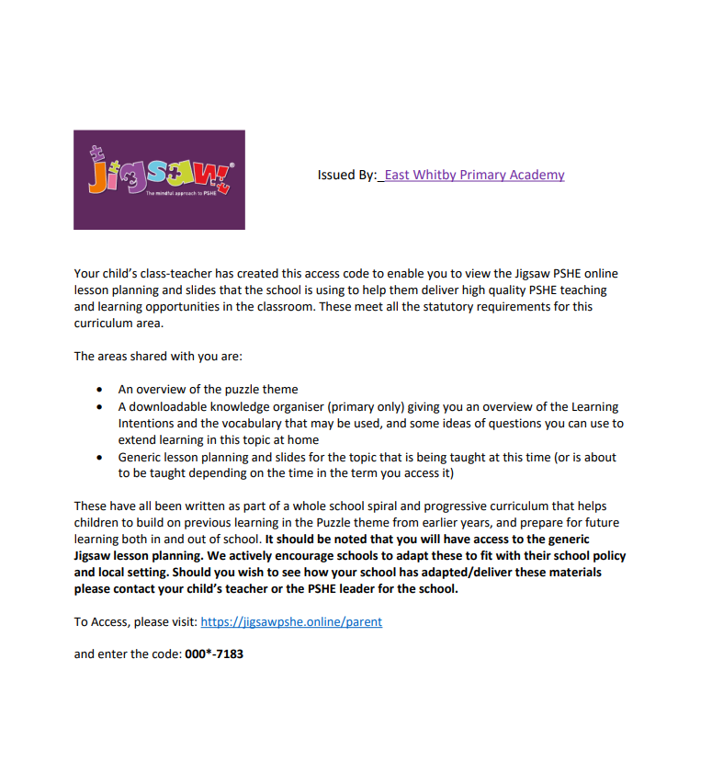

Year 3
Dear Parent/Carer,
Please find attached an access code to look at the Jigsaw PHSE puzzle piece we will be working on after half term.
If you wish to discuss this further please contact us at school. Please note we will also be “making a noise about bullying” for Anti Bullying Week (13th-17th November 2023), more details to follow

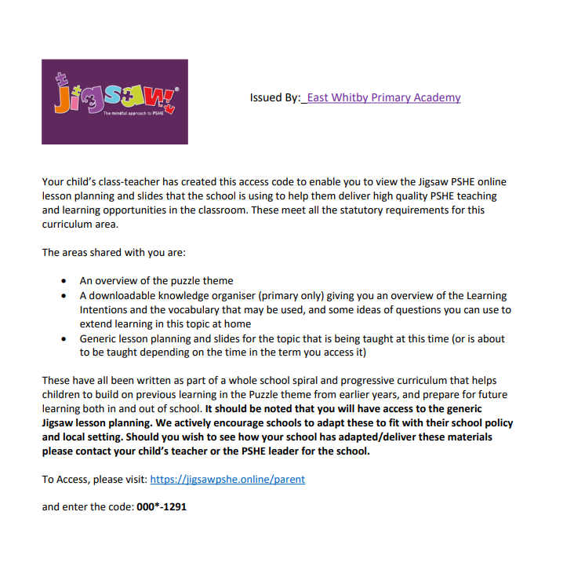

Year 5
Dear Parent/Carer,
Please find attached an access code to look at the Jigsaw PHSE puzzle piece we will be working on after half term.
If you wish to discuss this further please contact us at school. Please note we will also be “making a noise about bullying” for Anti Bullying Week (13th-17th November 2023), more details to follow

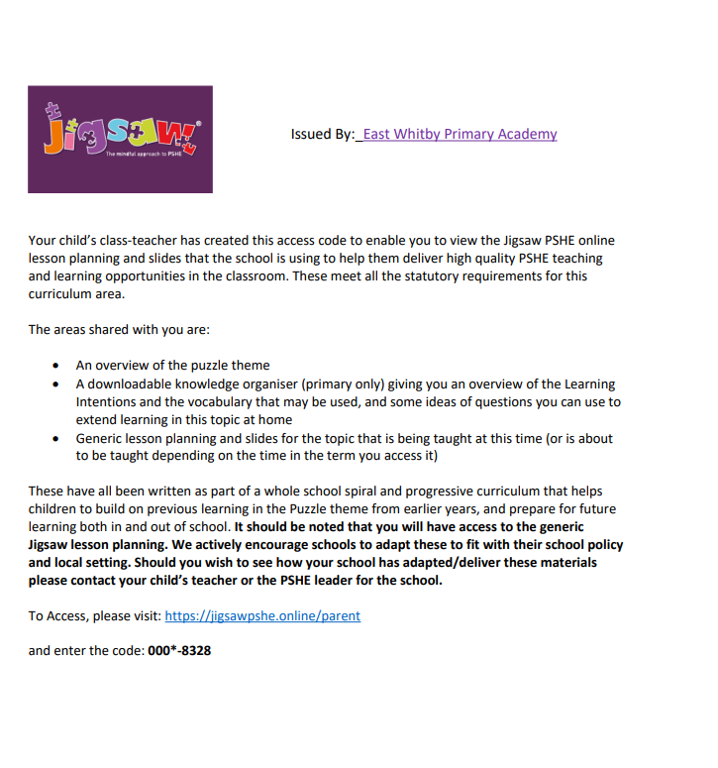

Year 6
Dear Parent/Carer,
Please find attached an access code to look at the Jigsaw PHSE puzzle piece we will be working on after half term.
If you wish to discuss this further please contact us at school. Please note we will also be “making a noise about bullying” for Anti Bullying Week (13th-17th November 2023), more details to follow

