

Date 15th September 2023

**Newsletter**

East Whitby Weekly News

**Genies:** Genies have had a wonderful first few days back at school. We have welcomed some new genies and everyone has settled lovely. We've had great fun with the mud kitchen, building, water play and lots more. We are enjoying our topic "super me”

**Pixies** This week we have continued with our story Hello Friend. We can retell the story and have made up a song with some of the important words. In Phonics we have been making different sounds with our voices, such as make your voice go down a slide, wheeeee!  In Maths we have focused on knowing and finding the colours red, blue and yellow.  Our first Forest School session was a huge success, we enjoyed hot chocolate and exploring our lovely woods area.

**Sprites:** Sprites Class have had their first ever full week of school and how amazingly well they have coped with it. We got straight on with starting our Phonics sessions and we’ve learnt 4 sounds already! We’ve also been talking a lot about being part of a class and how we can make sure that Sprites is a kind and caring place to be. Our first woods session was a perfect sunny afternoon for us to explore and notice changes

**Elves** Wow we have had our first full week together in year 1! We have continued our work on Francia Simon this week creating a fact file and sequencing events that happened to her. We experienced our first PE session by our sports coach and we welcomed Alice back to continue the work she started in reception with the children.

**Phoenixes:** Year 2 have been learning about children's rights. They have been focusing on the 'right to clean water' They have been learning about Ryan Hreljac's charity work to bring water to villages across Africa.  They  have written a biography about Ryan. In maths, the children have been working on developing their understanding of place value.  In PSCHE the children have been exploring rights and responsibilities

**Unicorns** What a fabulous start Year 3 have made! This week, we have been reading 'Malala's Magic Pencil' and have used it to create a list of our aspirations in Year 3. We have discussed the differences between our cultures and how important an equal education for both boys and girls is. On top of that, we have been learning to add using the column method and how to partition numbers. The pupils have weekly spellings to learn at home and thank you for reading with you child at home.

**Centaurs:** we are off to a brilliant start in year 4! We’ve enjoyed learning about our rights as a child and have really thought hard about how Emily-Anne Rigal helps children have a voice. We have also thought about our aspirations for the coming year and for the next 20 years and are determined to work to achieve them! Swimming was a huge success and so far everyone has been settled and hardworking. Next week we begin looking at the Tudors!

**Griffins** Year 5 have had a settled start to the term. We have been discussing our aspirations for ourselves, east Whitby, and the community this year. In maths we have been working on the place value of numbers up to 1 million. Our project for this term is the industrial revolution and how that connects with our local history.

**Dragons** We have had an amazing start back to school in Year 6! It has been wonderful to see all our friends again and hear about what a great summer they have had. We have cracked straight back on with our learning and have been inspired by Mayra Avellar Neves, who stood up for children's rights in Brazil. We are also loving our new book 'When The Sky Falls' and have written letters in role of Joseph.

Dates for your Diary:

* To follow

**Pegasus** This week in Pegasus our Maths group has completed making their set of place value Top Trumps and are looking forward to playing them next week. We have thought about our aspirations for our individual learning for the year. In Hands, Eyes and Brains Working Together we have continued to make our jelly fish birthday display. Our barrier games group is off to an excellent start listening to our friends, making sure we share all the information a listener needs and knowing what to say if we haven't understood or didn't hear. A huge well done to all Pegasus children for settling so well into their new timetables!

What a great start to the term here at East Whitby, so many amazing things happening and the work around children’s rights is astounding! Ask your children to tell you about them, I’m sure you will be amazed by their in-depth knowledge on these and on some influential children who have fought to keep these rights too. We have talked a lot about aspirations this week and the children have come up with some incredible ones, not only for themselves but also for school and the community. One in particular has really stood out… “My aspiration for East Whitby is for it to be seen as an amazing school by everyone in Whitby because it is!” As a staff, we aspire to making East Whitby the best place for your children and are always grateful to know you’re there to help us too.

Next week, most classes will be starting their main project for the term; all the class plans can be found on the school website on the individual class pages, look, and if you happen to be an expert on the industrial revolution or surviving a polar expedition please let us know, we’d love to work with you! We would also love to encourage you to help the children settle in further by talking to them about their successes at school in a positive way.



Well done everyone who took part! Once again showing Whitby how it’s done!!! ☺

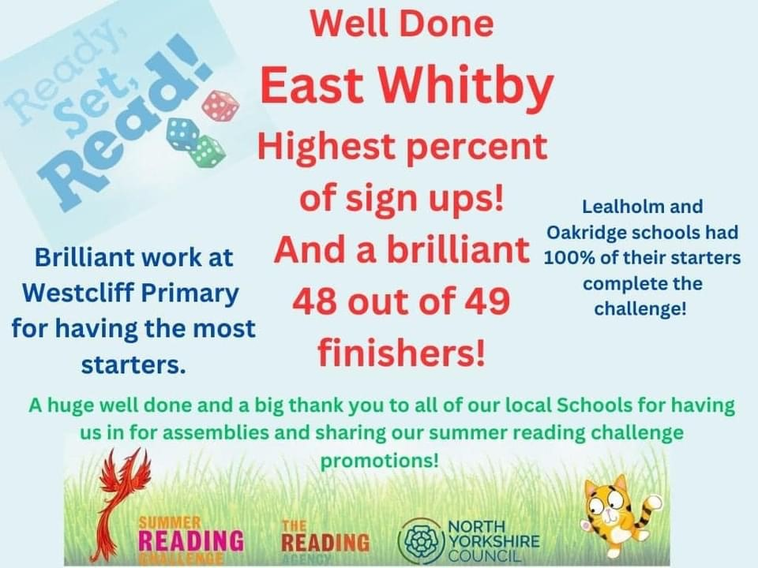

A very warm welcome to Miss Hodgkinson, who is joining the staff team this year! Be sure to say hi if you see her around, I’m sure she will love it here ☺

**Dogs. (and other animals)**

**There should be no pets on the school site at all.**

**Thank you**

**Parking.**

**There should be no cars using the school drive at the start and end of the school day without prior permission.**

A letter will be coming out next week to give parents the chance to apply for a school parking permit. But these are for extenuating circumstances only.

**Please do not use the entrance of the drive to park or turn at any time. As well as blocking access to the private road, the crossing has been blocked and the line of sight onto Helredale road impacted by inconsiderate parking. This is massively dangerous for your children. We have had a few near misses recently because of inconsiderate parking, consider how dangerous it makes it for the children.**

|  |  |
| --- | --- |
| **Star of the week**  Well done to all the children for an amazing week! | |
| **Pixies** | Suraya |
| **Sprites** | The whole class |
| **Elves** | Holly D |
| **Phoenixes** | Jakub |
| **Unicorns** | Eva |
| **Centaurs** | Albie |
| **Griffins** | Marley |
| **Dragons** | Jessica |
| **Pegasus** | The whole class |

|  |  |
| --- | --- |
| **Attendance** | |
| **Sprites** | 98% |
| **Elves** | 100% ☺ |
| **Phoenixes** | 91% |
| **Unicorns** | 96% |
| **Centaurs** | 94% |
| **Griffins** | 97% |
| **Dragons** | 96% |
| **Pegasus** | 86% |

We are seeing several children going off on holiday, please remember these will be classed as **unauthorised absences** and can lead to a fine. BUT more than that, if your child misses 5 days of school, that’s 30 hours of learning gone, it’s really hard for them to catch that time back up.

Clubs!

The club letter is coming out soon, in the mean time if anyone has a skill or would like to support with a club after school please let me know! Subject to DBS clearance, we would love to have you help us broaden our children’s horizons.

m.suggitt@eastwhitby.org.uk