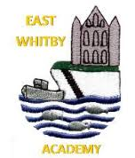

**Genies:** We've had a wonderful week in Genies celebrating all things Christmas, we have been busy doing lots of festive crafts, singing Christmas songs, reading the nativity story and of course having a brilliant time on our party day. Thank you for a lovely term Genies have a very Merry Christmas and we'll see you all soon!

Date 20.12.24

**Newsletter**

East Whitby Weekly News

**Pixies** For our final week of the term we have read Little Robin Red Vest which has taught us all about being kind to others. This was our Hope that we shared at the Hope assembly with the rest of school.  We have had a wonderful last week enjoying watching the KS1 nativity, the carol service and party day!  Thank you for all your support this term, have a wonderful Christmas and enjoy your family time. See you in January.

**Sprites:** Wow, what a busy week we've had! We enjoyed being the audience for KS1's brilliant Nativity performance. We've spent a lot of our week looking at different parts of the Christmas story and thinking about which characters we were in our nativity play. Thursday started off calm and thoughtful, with our Hope assembly - ours was that everyone is kind to each other. Then we had a fun filled afternoon with a very special visitor! Thanks to FOEW for our party food and the fantastic Snow globe. All the Sprites have had a brilliant term, we've been so proud of the effort they've put in every single day. Have a very happy Christmas!

**Elves** What an amazing week. On Monday,  Key Stage One performed our nativity, "It's a Baby" they did an incredible job and their happy faces said it all as they sang and danced their hearts out to Proud Mary at the end. On Wednesday afternoon, we enjoyed our carol service at St Mary's, a special mention to Noel and Ellie for reading in front of a packed out church. Thursday was party day, the giant inflatable snow globe was a great surprise which the children thoroughly enjoyed. Friday was Miss Ahmed's last day with us, she has been a fantastic asset to our classroom and we look forward to welcoming her back in the summer term for her final placement. A busy but brilliant week, the Year 1 Team would like to wish you all a very merry Christmas. We look forward to welcoming the children back in 2025.

**Phoenixes** Year 2 have had a fab week. Their performance and singing in the Key Stage 1 Nativity was spectacular.  They enjoyed going to church and singing in the church service.  The children had fun dressing up for the Christmas party, playing party games and dancing.  Have a lovely Christmas.

**Unicorns** What a week! We’ve been non stop and worked our socks off on our Arctic work as well as creating some stunning Northern lights work and having a whistle stop tour of the 4 seasons! The children were all super stars in the carol service and sang their heart out….looks good for the Panto next term! The children also really impressed me with their amazing hopes, it was hard to choose just one ! Have a wonderful Christmas break everyone I’ll see you in 2025!

**Centaurs:** This week the children have been investigating the work of Wassily Kandinsky and have created some beautiful artwork in his style. They were brilliant in the carol service and sang beautifully. We also spent some time looking at bus stop division this week which was a challenge but they children all gave it a really good go! We really enjoyed sharing our stories with y6 this week and to hear theirs too! Well done Y4, have a really lovely Christmas, we will see you next year!

**Griffins**  Wow, what a week and what an end to term! We've designed, baked and evaluated Christmas biscuits. We've made our Christmas cards and calendars. We've finished our stories ready to write up after Christmas. We've had the best time at the Christmas party and sang beautifully at the church. Thanks for a wonderful term year 5, have the most amazing Christmas break and I'll see you in 2025!

**Dragons** This week has been really lovely in y6, we shared stories we had written with the year 4 children and in turn they treated us to theirs too. Then we took on the special job of starting the carol service with our candle light parade too, its always a special time but even more special when it’s the last one you’ll do here. Hope assembly was very special and then the party, bouncy castle and Christmas lunch was just the right mix of chaos and fun! Well done for a great first term Y6 see you next year!

Gnomes

It has been a festive last week of term, the children have enjoyed lots of Christmas sensory activities and crafts. The children loved the inflatable snow globe Christmas treat in the hall, it was lovely to see the joy on their faces. Everyone also had a great time joining their year groups for the Christmas parties. We hope you all have a lovely break together and have a magical Christmas! See you in the new year.

**Pegasus** It has all been very creative, very messy and very wonderful in Pegasus class this week as we have been collaborating on our Modroc Angels. The children enjoyed getting stuck in to this task and the work they produced is lovely too. Well done Pegasus class! 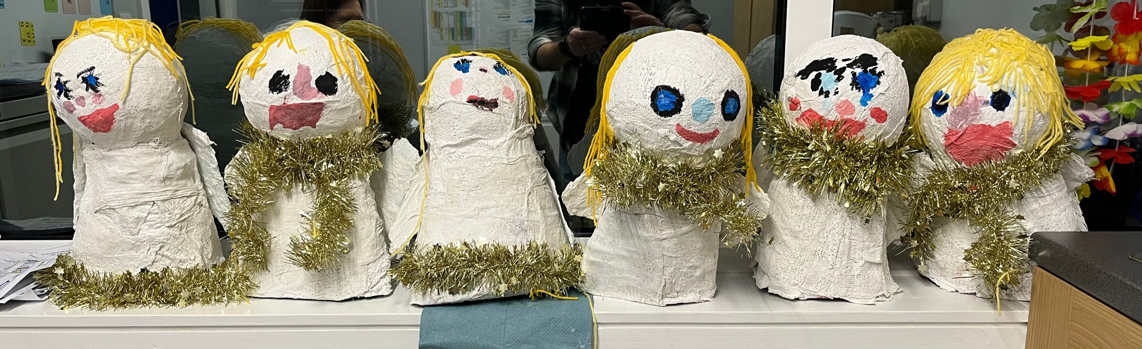

What an incredible last week to term we’ve had! So much has happened this week it’s hard to know where to start! Monday saw the most wonderful Key stage 1 Nativity, with a real highlight being the Tina Turner style song and an incredible set of moves from Ivy as Mary! 😊 Well done to all the children and staff involved it was great!

We then had the most beautiful Christmas service at Saint Mary’s, it was a beautiful afternoon and the children sang their hearts out. I always get a lump in my throat hearing Love shone down and This Christmas time, such a gorgeous way to start the real Christmas festivities. A huge well done to the readers who shared the Christmas story and to Year 6 for their candle walk, you were all brilliant.

Thursday saw us sharing our hopes for the world in the coming year, thank you to the parents who joined us for this really special assembly. The hopes were beautiful and the children really did us all proud. The school hope this year was focused on children getting every possible opportunity they deserve, I’m sure you’ll agree that’s something we really do well here. Then it all went a bit bonkers in school with the party atmosphere kicking in full force! Thanks to our amazing friends of school for the brilliant snowglobe inflatable and the party treats for all the classes- we had an absolute blast! Christmas dinner was also brilliant…who knew there were so many versions of Feliz Navidad! 😉 Thank you to the incredible Kitchen team for their hard work, the food was delicious and the atmosphere was electric!

Today we also Said a very sad goodbye or 2! More on that below!

Phew….it’s been a big old week! So all that remains to say is a massive MERRY CHRISTMAS! From the entire East Whitby Family! We hope you have a great time and that you have a wonderful new year too! 😊

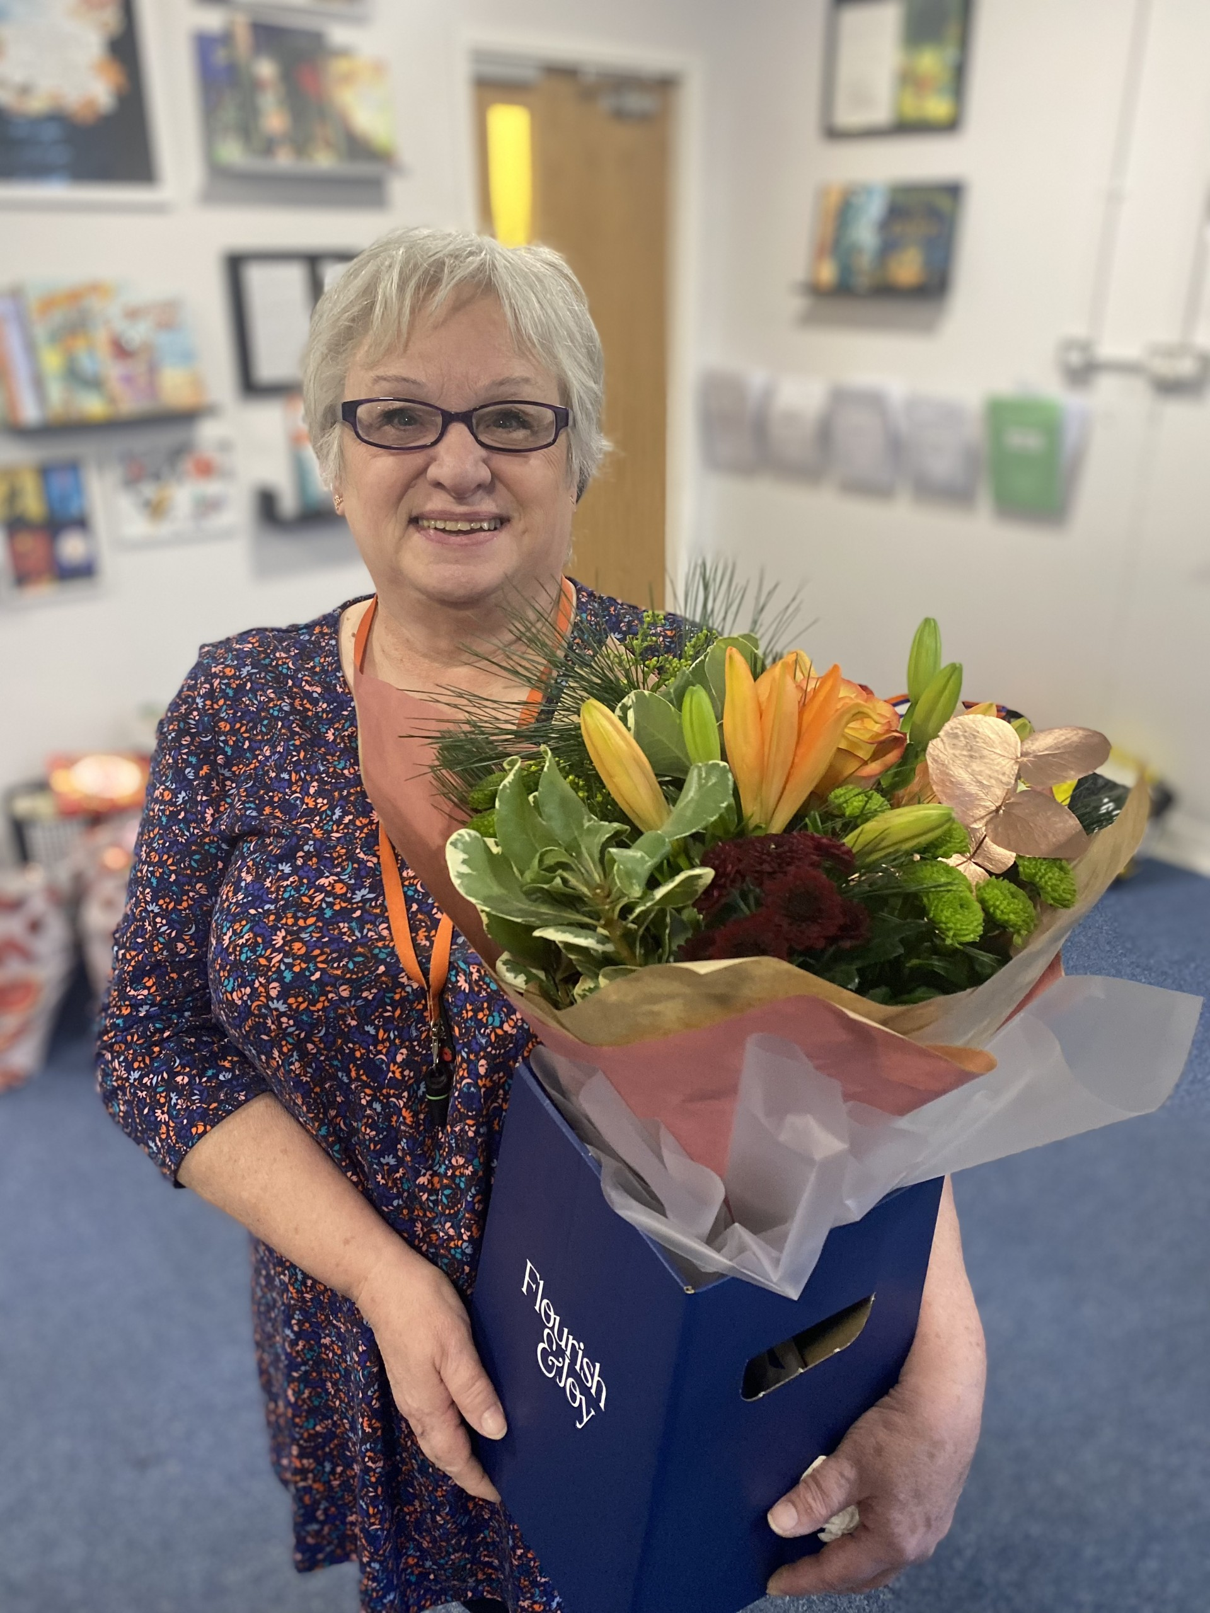

The wonderful Mrs Hutchinson has been part of our school family for the last 29 years and today she hung up her lanyard for the last time! We want to say a massive thank you for everything she has done for all of us in that time, most of it behind the scenes and for making the job we all do that bit easier. We’ll miss you Mrs H!

**Dates**

* Tuesday 7th January school reopens

|  |  |
| --- | --- |
| Star of the term! | |
| Pixies | Denny, Summer, Amber Rose |
| Sprites | Robert, Suraya, Nancy |
| Elves | Kane, Marni, Kingsley |
| Phoenixes | Ziva, Adley, Robyn |
| Unicorns | Finley, Luna, Mia |
| Centaurs | Alya, Layla, Harriet |
| Griffins | Jimmy, Renee, Scarlet |
| Dragons | Faye, Mason, Cass |
| Pegasus | Liliana, Freddie, Charlie, LJ |
| Gnomes |  |





**Larney in Y6! I’m sure you all visited Larney’s amazing crochet stall at the fair, well the final total donated to the friends of school was £175!!! What an amazing amount, thank you Larney 😊 you’re a star.**



Today, we collected lots of incredible PE equipment from Interactive. We can safely say this will get an awful lot of use here and we are really grateful.

We also want to say a massive thank you to Melissa and Andrew, Joel’s Mummy and Daddy who gave up their morning to help us move it all from the Spa to school. We are really grateful 😊

Today we also say a fond farewell to our friend Cass who is off to start a new adventure at a school in York. Cass we wish you all the very best in your next chapter, keep in touch Cass, we can’t wait to hear how you get on!

**Design a Toy Competition.**

Mr Laidler had some incredible entries in and finding the winner was a tricky job! A massive well done to everyone who took part but an extra big well done to our winners, Alexia, Tommy, Fern and Imogen. Special shout out to Fern though…she carved her bear…with a chainsaw!

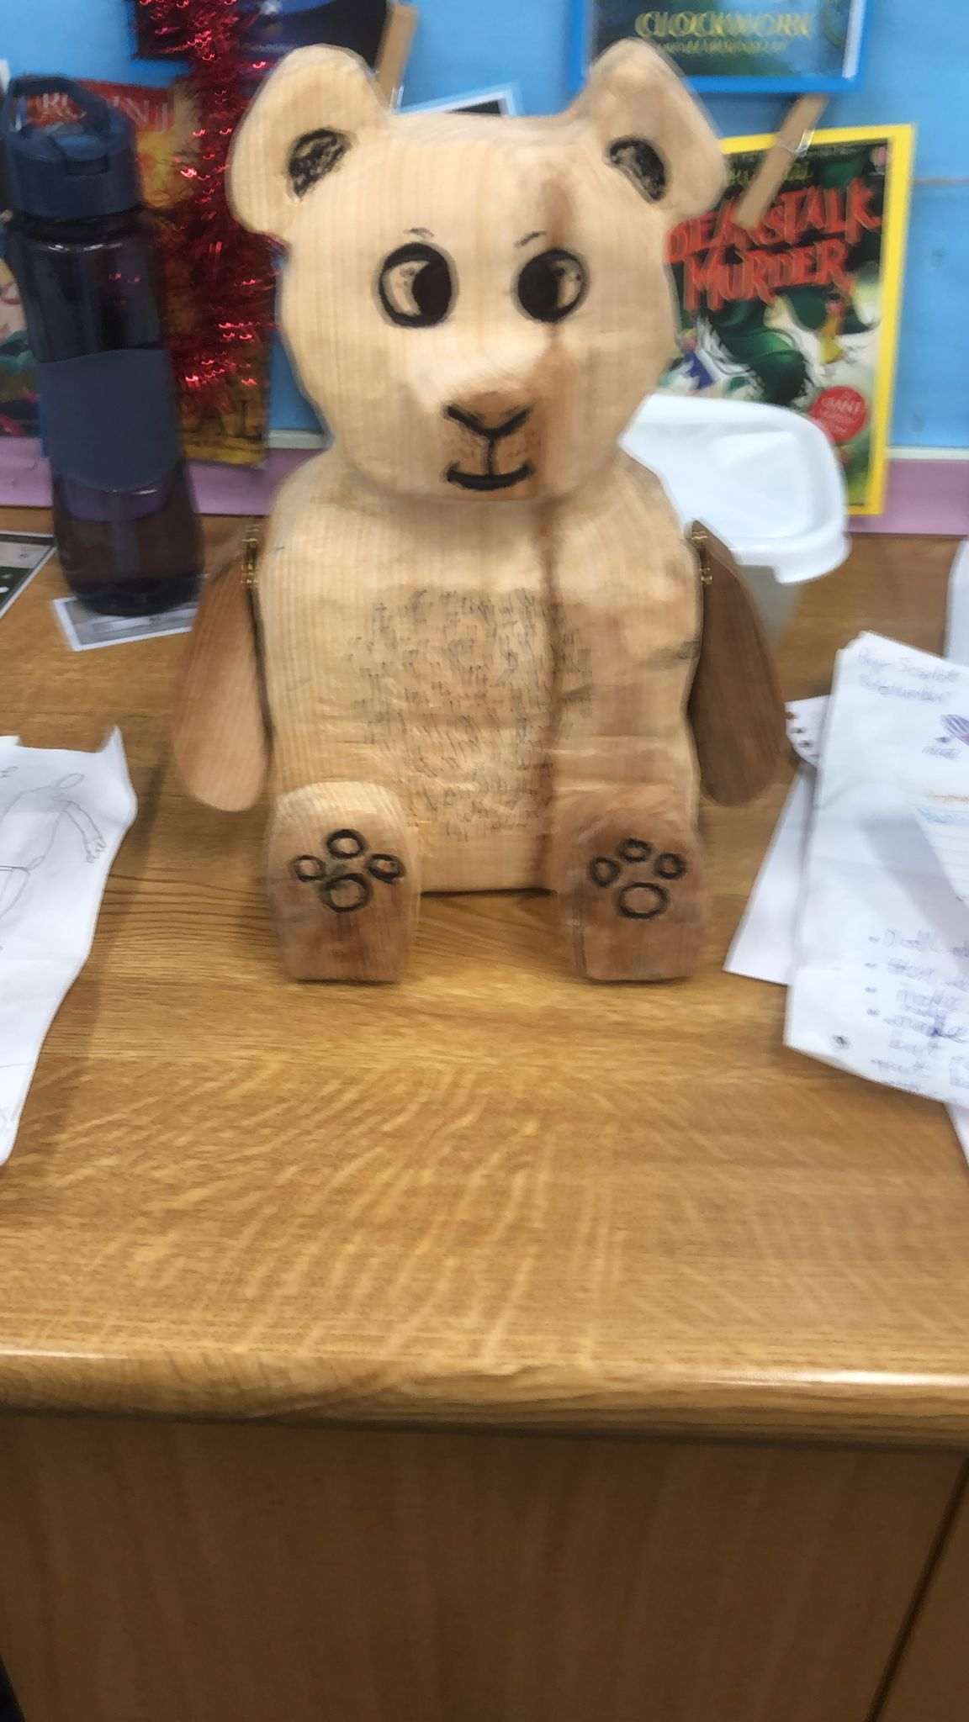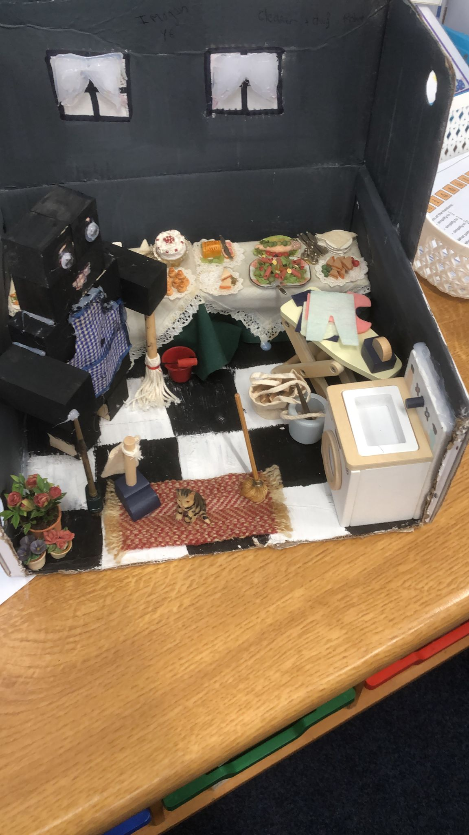

A huge well done and thank you to the lovely Miss Ahmed! She has been working in year 1 on Teaching practice and has had a really successful placement with us! We’d like to wish her luck in her next practice and are happy to say we get to welcome her back again in the summer 😊

