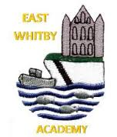

Date 22.12.23

**Newsletter**

East Whitby Weekly News

**Genies and Pixies**  We have read Snowball as our final book of the year. Snowball starts off very lonely but by the end he has lots of friends. We have talked about ways of making friends and also ways to stand up for ourselves. It was our Hope assembly yesterday and we have learned what the word hope means and decided that we hope all the boys and girls have a friend. Well done to Suraya and Nancy for sharing our hope with the rest of school.  Have a wonderful Christmas and we will see you in the New Year. Date for your diary - Stay and Play in our amazing outdoor space. Tuesday 16th January - 8.45am-10am.

**Sprites:** What a fabulous Christmassy week we've had in Sprites! We have been reading 'The Snowflake' and making clay snowflake decorations and mini Christmas trees just like in the story. We've had a good dance (with glowsticks!), played party games, had a time to think about others in our Hope Assembly, sung our hearts out at the Carol Service and had a very special visitor. Have a very happy Christmas and we'll see you in 2024!

**Elves:** What an amazing last week of term! We wowed our families with our Nativity at the start of the week and we have completed our RE project on Christianity. During the church service we sang amazingly well and a big shout out to our two readers as you blew us away. We have ended the week partying and having a great time with our friends. The Year 1 team wish you and your families a very Merry Christmas and A Happy New Year! See you all in 2024

**Phoenixes:** Well done to the children for an amazing nativity performance, despite the nerves you were incredible! We had a lovely week with a beautiful carol service and a fantastic party too! Have a lovely Christmas everyone and

**Unicorns** . Year 3 have had a fabulous week answering their project question 'How can we survive a Polar Expedition' and we are very proud of all Year 3 have achieved in one term. We have enjoyed making calendars and Christmas cards and our Christmas week has been full of fun, with parties and Carol Signing and Christmas puzzles.

**Centaurs:** What a brilliant end to a brilliant term! We finished the term with some amazing art based on the work of Wassily Kandinsky and created beautiful cards and calendars to send home. We had a fun session in swimming to say well done for the amazing progress we have made and did a fab job at the carol service too. We ended the week partying and having a fabulous time in the hall. Have a fantastic Christmas everyone and I will see you in 2024!

**Griffins** Year 5 have had a lovely Christmassy week.We finished off writing our Sci-Fi stories in our drafting books. We have made wreaths, decorations, calendars and Christmas cards. We finished the term making some Christmas biscuits. The children have all worked incredibly had this term and made a great start to year 5. It was so difficult to choose our stars of the term. Well done to Shay, Aaron and Imogen who won!

Gnomes ☺

We have enjoyed our festive activities in Gnomes this week, particularly the Christmas party's and movies!

Hope you have the most wonderful Christmas with your families and we will see you in the new year

**Dragons** Year 6 have had a busy final week of term! We started off my finishing our amazing ghost stories, that we have sent home for you to read. On Wednesday, we walked the candles through the church to start off a wonderful Christmas service. Then Christmas parties, Christmas cards and calendars on Thursday! We’ve worked so hard this term and really do deserve a long two weeks off! Have a great Christmas!!

**Pegasus** What a wonderful week we have had in Pegasus. Some of our KS1 children performed and wowed in their nativity! We sang so beautifully in our church service and then ended the week partying with our friends in our classes. Our 'Stickman' literacy finished with us completing a letter to Santa and we enjoyed some Christmassy crafts too. The Pegasus team wish you and your families a Merry Christmas and A Happy New Year! See you all in 2024!

Well, we made it! What an incredible last week we have had and what an incredible term it has been full stop! This week saw so many wonderful Christmas memories being made and the continuation of East Whitby traditions old and new. Well done Year 1 and 2 for your amazing Nativity, they really do bring the sparkle to school! Thank you to everyone who came along to the carol service, it was beautiful. Well done to Mrs Matthewson and all the staff for getting us ready and well done to Year 6 for starting the service with their candle walk, its always such a special time for the Year 6 children but also a little sad as it marks their last Christmas with us too. It was lovely to see Vivian and Viking our Christmas babies, we look forward to one day hopefully welcoming them to East Whitby too. 😊 We also had our Hope Assembly this week, this is a slightly newer tradition for us but a really special one too, it was so lovely to welcome parents along for the first time, we will definitely be doing this next time too I’m sure. Parties and Christmas lunch were great this week too, I hear the Early Years had a very special visitor this week too….turns out Mrs Kerr has a direct number for Santa! Who knew! All that’s left to say is from every member of the East Whitby Family, we wish you a very Merry Christmas and a fabulous New Year, we are looking forward to seeing what 2024 brings!

Have you seen our amazing EYFS area?! It is brilliant! Newby Leisure have done an incredible job in such a short space of time and we love it! We are having a family learning day for the families of our current EYFS children on 16th January from 8:45-10 am come along and have a play!

Don’t forget if you know of any small people looking for an incredible EYFS experience tell them to give us a ring!

A huge congratulations to Heather Hunter our amazing school cook, this week she made her 20th East Whitby Christmas dinner! It was delicious as are all the meals Heather and her team produce. Nevertheless, a huge congratulation to Heather on her 20th anniversary at our school.

|  |  |
| --- | --- |
| Star of the term! | |
| Pixies | Bobby Ava  Gracie |
| Sprites | Marnie, Kingsley, Ellie |
| Elves | Judith, Ziva, Freddie |
| Phoenixes | Jude, Jakob, Lily |
| Unicorns | Evie-Jo, Aoife, Ellie |
| Centaurs | Charlie, Betsy, Florance |
| Griffins | Imogen, Shay, Aaron |
| Dragons | Lottie, Phoebe, Izzy |
| Pegasus | Zach, Freddy, Laura-Jane |

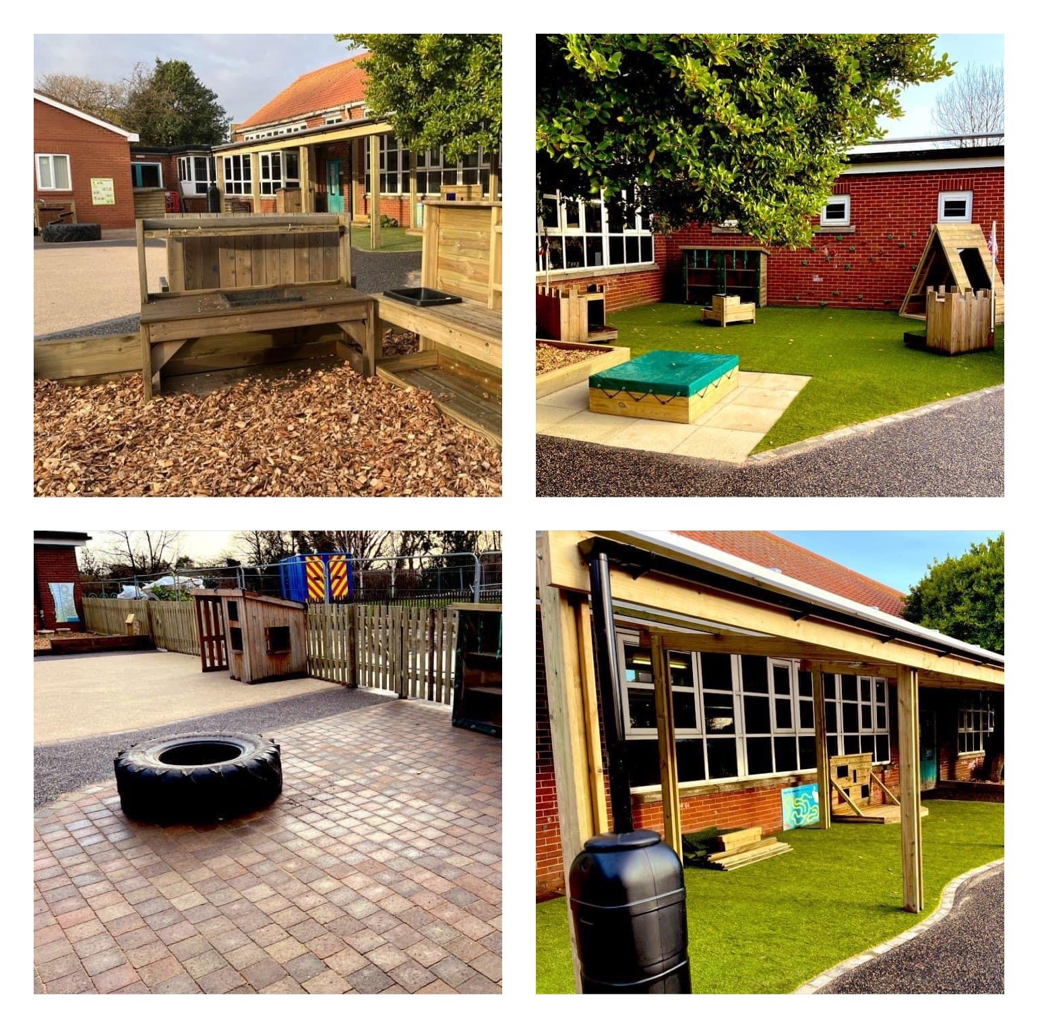

**Dates**

* 9.1.24 School reopens for the children

|  |  |
| --- | --- |
| Attendance this week | |
| Sprites | 86% |
| Elves | 94% |
| Phoenixes | 90% |
| Unicorns | 89% |
| Centaurs | 97% |
| Griffins | 97% |
| Dragons | 87% |
| Pegasus | 92% |

**Carol Service 2024**

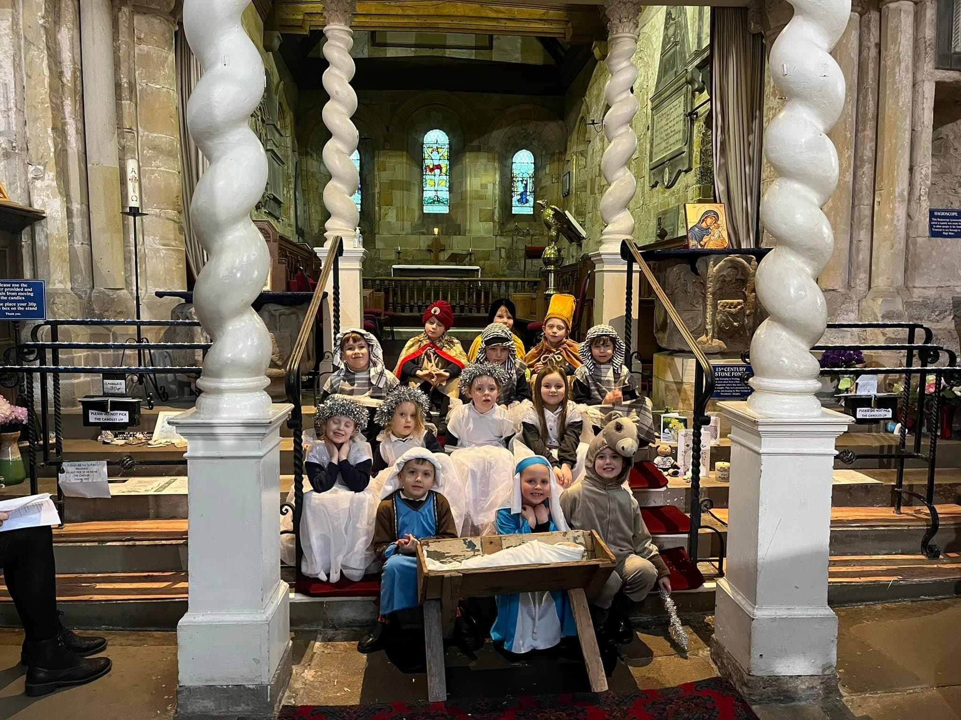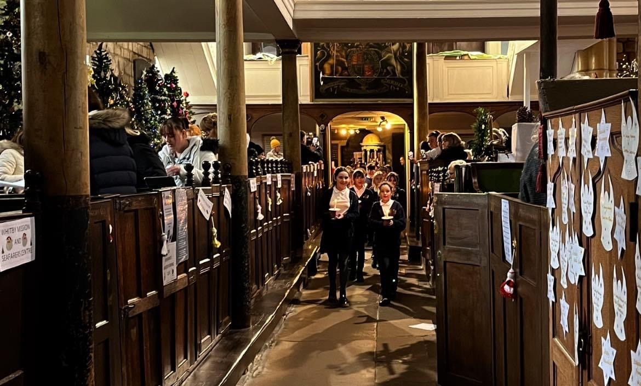

Such a special service, well done to the children who read for us, performed for us and to all who sang their hearts out. 😊

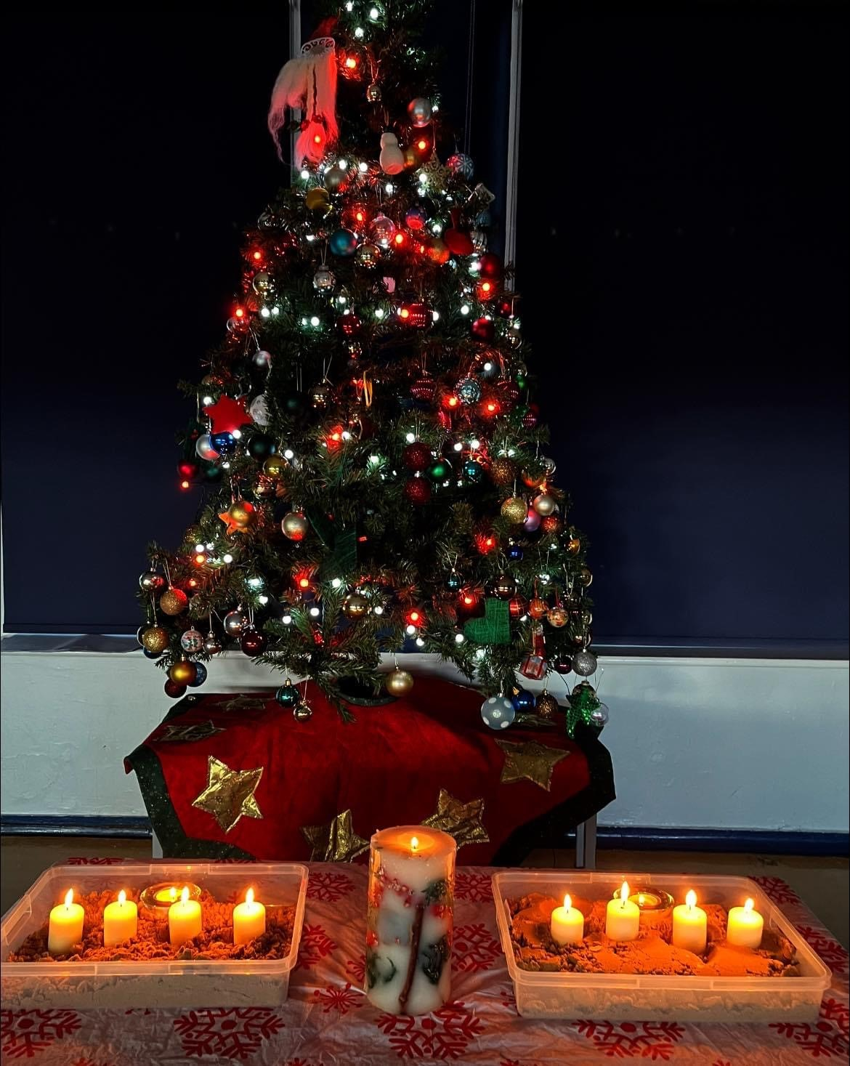

**Hope Assembly**

This special assembly takes place at the busiest time of the year, it helps us to stop and think of others. Thank you to those who joined us and to all the children who wrote hopes, read them out and lit candles 

Singers from East Whitby have been out and about in the community this week! It is always good to share our music with others and it's been a while...

Sessions at both Whitby Court & Larpool care homes gave the children chance to not only show off their singing and entertain the residents but then to stop and chat about Christmas with them as well - something which they all enjoyed immensely.

Friday night's Christmas Cracker Concert at Whitby Spa was an opportunity to hear a selection of the town's bands and choirs, as well as joining them in some traditional carols. Our children thoroughly enjoyed themselves and now we know what we'd be letting ourselves in for, we're keen to go back and perform for them at next year's event! Thanks to all the parents who came out on a Friday night to support us and your children

