Book progression per year
This document outlines the books that children will read during their time at East Whitby
As a school we have carefully looked at our reading offer and focussed on a range of texts we would like the young people to use and experience in their time in East Whitby.
These texts are supplemented by a broad range of other reading material from high quality picturebooks, graphic novels, a broad range of non-fiction texts as well as much more. These are all carefully chosen to provide the pupils with a broad reading diet that explores a range of purposes for reading.
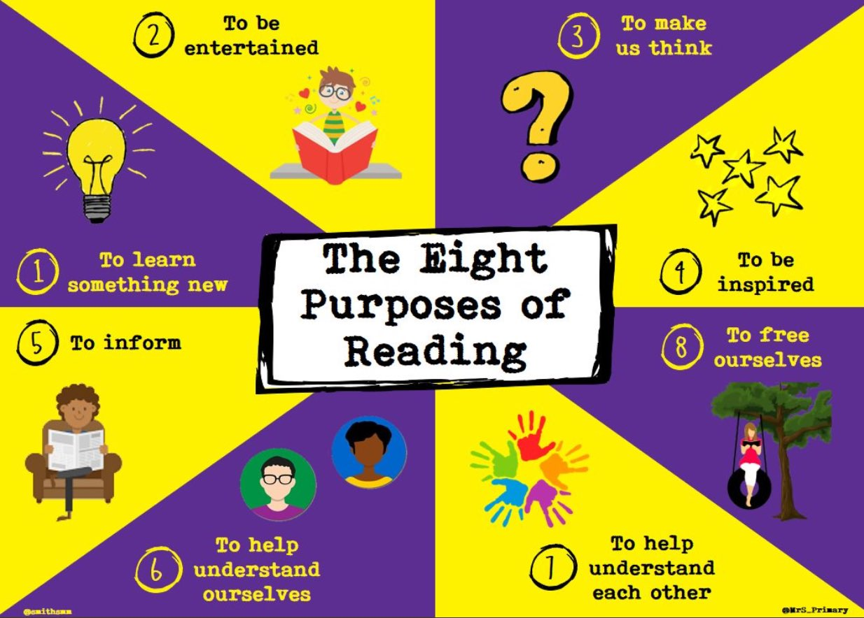

The books below are the books that every child in that year group at East Whitby will read.
Year 3 –
The One and Only Ivan by Kathryn Applegate
The HodgeHeg by Dick King Smith
Year 4 –
Edward Tulane by Kate DiCamillo
Varjak Paw by SF Said
Year 5 –
Once by Morris Glietzman
King of the Cloud Rorests by Michael Morpurgo
Year 6 –
Holes by Louis Sachar
When the Sky Falls by Phil Earle

Each year group will choose a book from the list below

Year 3 and 4
Podkin One Ear by Kieran Larwood
Charlotte’s web by E.B.White
The Iron Man by Ted Hughes
Oliver and the Seawigs Phillip Reeve and Sarah MacIntyre
Planet Omar by Zanib Main
Mayhem Mission by Burhana Islam

Year 5 and 6
Boy in the tower by Polly Ho Yen
Tom’s Midnight Garden Philipa Pearce
High-rise Mystery by Sharna Jackson
Graveyard book by Neil Gaiman
Pax by Sara Pennypacker
Clockwork by Philip Pullman
Tyger by SF Said

The other 1 – 2 novels each class will read will be based on children’s interest, project led or teacher choice.

Year 2
Year 2 will begin to increase familiarity of short novels as the year progress. They will read a selection of books taken from Pie Corbett’s reading spine.
Amazing Grace
Dr Xargle’s book of Earthlets
Emily Brown and the Thing
Fantastic Mr Fox
Flat Stanley
Frog and Toad Together
Gorilla
Meerkat Mail
Not Now Bernard
Pumpkin Soup
The Flower
The Giraffe And The Pelly And Me
Beegu

