East Whitby Primary Academy Anti-bullying Policy
This policy has been developed and implemented in consultation with the whole school community including pupils, parents/carers, staff, governors and partner agencies. It was written with reference to the Equality Act 2010.
East Whitby Primary Academy promotes values which reject bullying behaviour and promote co-operative behaviour. Tackling bullying matters.
This should be read alongside our policies on Special Educational Needs and Behaviour and Safeguarding
Approved and adopted: [January 24]
Review Date: [January 25] SIGNATURES
Pupils via the School Council ………………………………………

Senior member of staff with responsibility for Anti-bullying: ………………….
Governor with responsibility for Anti-bullying: ………………………..
Headteacher ……………………….
Chair of Governors ………………………

Statement of Intent
East Whitby Primary Academy is committed to providing a supportive, caring and safe environment in which all children are free from the fear of being bullied. As a school we take bullying and its impact seriously. Bullying of any form is not tolerated in our school, whether carried out by a child or an adult.
Staff, children and parents or carers will be made aware of the school’s position on bullying. Bullying behaviour is unacceptable in any form. The school has high expectations of outstanding behaviour and we consistently challenge any behaviour that falls below this. Anyone who knows that bullying is happening is expected to tell a member of staff.
Any child who is a victim of bullying will be dealt with in a sympathetic manner. If bullying is suspected or reported, the incident will be dealt with immediately by the member of staff informed, and then discussed with the headteacher. A clear account of the incident will be recorded in the CPOMs pupil database. All staff will be informed so that close monitoring of the victim and bully can begin. Parents of both parties will be informed.

What is bullying?
We recognise that many children and young people will experience conflict in their relationships with other children and young people and as a school we are committed to developing empathy and the skills to manage relationships in a peaceful way that does not harm others.
In East Whitby Primary Academy, our definition of bullying is:
“The repetitive, intentional hurting of one person or group by another person or group, where the relationship involves an imbalance of power. It can happen face to face or online”
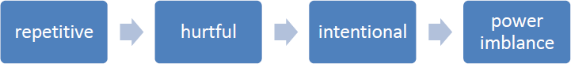

Why is it important to respond to bullying?
There is considerable evidence to show that bullying has both short term and longer term impact on pupils. Bullying impacts on pupils’ wellbeing, can impact on attendance and become a significant barrier to learning. Bullying is associated with lower levels of school engagement and achievement both in primary and secondary schools and can lead to mental health concerns such as anxiety and depression.

Bullying is unacceptable. Our school will respond promptly and effectively to reported incidents of bullying.
In our school community:
- Everybody has the right to be treated with respect.
- Everybody has the right to feel happy and safe.
- No-one deserves to be a target of bullying.
- Pupils who bully need to learn different ways of behaving.

National research has shown that some groups of pupils are particularly vulnerable to bullying these include pupils with SEND, looked after children, pupils from minority ethnic groups or faiths, young carers, LGBT pupils and those perceived to be LGBT.

Types of bullying behaviour
Bullying can take many forms:
- Emotional - being unfriendly, excluding, tormenting, threatening behaviour
- Verbal - name calling, sarcasm, spreading rumours, teasing, use of derogatory language
- Physical - pushing, kicking, hitting, punching or any use of violence
- Extortion - demanding money/goods with threats
- Online – use of social media, messaging and calls. Misuse of associated technology e.g photos and videos.
- Racist - racial taunts, graffiti, gestures
- Sexual - unwanted physical contact, sexually abusive comments
- Homophobic or biphobic - bullying because of sexuality or perceived sexuality
- Transphobic – because of gender identity or perceived gender identity

Preventing Bullying
We foster a clear understanding that bullying, in any form, is unacceptable. We believe that preventing bullying is the responsibility of our whole school community and when there are incidents of bullying we will work together to deal with the situation and to learn from what has happened.
In our school we do this by:
- Involving the school community in developing our policy including a child/ pupil friendly version of our policy.
- Using assemblies and circle time in class to ensure that pupils understand the differences between relational conflict and bullying.
- Building a positive ethos based on respecting and celebrating all types of difference in our school.
- Creating a safe and happy environment, with consequent positive relationships that have an impact on learning and achievement.
- Having a positive ethos that all pupils, staff and parents understand.
- Work in school which develops empathy, social skills and emotional understanding e.g. PSHE, Citizenship, social and emotional learning programmes, circle time, peer mediation and playground buddies.
- Secure the safety of the target of bullying Take actions to stop the bullying from happening again Whole school learning - reflection on what we have learnt
- Think about any safeguarding concern and report concerns to Designated Safeguarding Lead.
- Provide assurances to child that concerns have been listened to and action will be taken.
- Consider who else is involved and what roles they have taken.
- Send clear message that the bullying must stop.
- Work with both parties to find solutions. Identify the most effective way of preventing re- occurrence and any consequences.

- Reflect and learn from bullying episodes –consider what needs to happen next to prevent future bullying e.g. PSHE, training etc.
- Raising awareness of online bullying through regular e-safety lessons.
- Adopting a social model approach to bullying. Diversity is valued and everyone is included in our school.
- Focussed work with individuals and groups of pupils where required to support understanding and development of social skills e.g. social skills groups, ELSA (Emotional Literacy Support Assistant), Jigsaw4U worker and TaMHS worker.
- Ensuring playground and midday staff are trained and we have a range of activities at lunchtime to promote positive play.
- Offering training to all school staff around bullying, including specific guidance on those groups who are most likely to be bullied.

Reporting bullying
In our school pupils are encouraged to talk to staff when they are unhappy or have concerns. Pupils in our school understand that they have a right to feel and be safe and a responsibility to support others to feel and be safe.
Pupils are encouraged to report bullying to:
- A trusted adult
- Their class teacher/TA
- Peer mentors or buddies
Each class has a ‘worry box’ where children can report their concerns if they do not feel confident speaking to an adult.
Children are taught that it is important to talk to a trusted adult if bullying is taking place outside of school.
Parents are also encouraged to report concerns and bullying to named individuals. This is normally the class teacher / tutor.
When pupils report their concerns our staff are trained to LISTEN and to BELIEVE. We involve children as far as possible in finding solutions.

Responding to Bullying
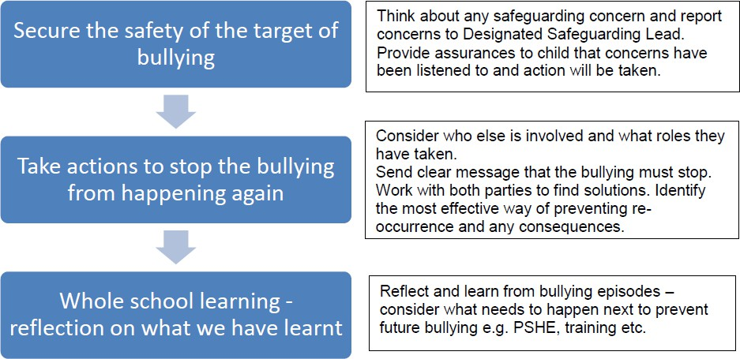

We monitor and review all bullying incidents to determine any patterns or trends that may require further action.
On a regular basis we give pupils the opportunity to feedback on how safe and happy they feel at school, we do this through pupil questionnaires and School Council meetings.
All staff are required to complete a bullying and prejudice-based incident reporting and monitoring form when dealing with incidents of bullying. This should be completed as soon as possible and given to the Designated Safeguarding Lead.

Procedures for parents:
•If a parent has any concerns about their child they should speak to the class teacher or headteacher immediately. If a parent thinks bullying is the issue, the matter will be referred to the headteacher. The headteacher is always informed of any bullying concerns at East Whitby and monitors the situation carefully.
•If a parent feels unable to talk to the class teacher, they can make an appointment to speak directly with the Headteacher.
•The school will work with both the child and the parents to ensure that any bullying is stopped and that support is given where needed.
- Parents should not confront the bully or their parents. This can complicate the situation and distress the pupil.
•The school will deal directly with all children involved and their parents directly. Parents will be kept informed of any actions the school is taking.
•If parents feel that their concern has not been dealt with appropriately they should follow the schools complaints policy.
All members of the school community, including pupils, staff, parents and governors, are expected to treat everyone with dignity respect at all times. This includes both face-to-face contact and online.
Policy written by: Simon Smith (December 24)

