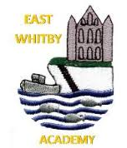

Dates for your Diary:

* 28th Nov, cake stall for all, bring 20p
* Friday 2nd Dec 1:30 Christmas Fair
* Thursday 8th Dec West Midlands Theatre group are in school doing a performance of “Sleeping Beauty” for all children
* Wed 14th Dec Carol Service details to follow
* 16th Dec End of term

**Genies:** This week we have been looking at the book Ten Terrible Dinosaurs and working on our counting. We’ve enjoyed finding out about dinosaurs and can tell you that they aren’t alive anymore. ☺

**Newsletter**

East Whitby Weekly News

**Pixies:** Our work this week has been all about dinosaurs! The children have had great fun thinking about dinosaur bones and fossils and understand that because of the fossils like the ones in Whitby Museum, we know what Dinosaurs would look like! We are super impressed with how well the children have listened to our class book, Dear Dinosaur, this week. ☺

**Sprites:** As well as being fabulous in the rehearsals for our Nativity, Sprites have been very enthusiastic in their learning about dinosaurs! We have looked at fossils and bones and thought about what they tell us. We have also found out that dinosaurs ate different things.

**Elves:** Year 1 had a fantastic day at Danby Moors Centre on Wednesday. They enjoyed learning about animals from the story, 'One Snowy Night' and being out in the woods playing games and searching for animals. To end the day, the children enjoyed a well-deserved cup of hot chocolate in a cosy yurt whilst listening to the story. The children were a credit to our school, we all had a wonderful day. We were also really lucky to have Finley’s mum in to perform an amazing story about a dragon! A huge thank you to Fiona, we hope to see you again soon!!

**Phoenixes:** The Year 2 children really enjoyed their trip to Danby Moors Centre this week, they loved finding out about the animals and having hot chocolate and smiled all day despite the weather! We have also been learning lots of new songs, I am sure you’ll hear them at home too!

**Unicorns** this week the children in year 3 have been so incredible! We had our very first attempt at column multiplication and they smashed it! They really enjoyed starting our new class book “The Beast and The Bethany” and wrote some really persuasive paragraphs to convince me that the dark is a good thing! They also made all the amazing decorations for our Christmas tree at Saint Mary’s Church.

**Centaurs:** This week Year 4 started off by writing up their digestive system explanation, they were incredible and determined to produce the very best work they can. Well Done everyone! We then moved on to investigating human and animal teeth and the children really impressed me with how much they knew!

**Griffins** Year 5 studied the different phases of the moon using Oreo biscuits this week, they really enjoyed this and were able to demonstrate a great understanding before eating them! The children have also been working hard on creating characters for our science fiction stories this week, we can’t wait to share their finished work with you.

**Dragons** This week, Year 6 have had the pleasure of making ‘blood smoothies’, with ingredients representing red and white blood cells, plasma and plateletts. We have written instructions for others to make it, too. Also, we have worked in groups to create and perform a shadow puppet play, with a moral! Well done for representing the school so well Year ^!

**Pegasus**   
This week in Pegasus we've had lots of fun making some very sparkly stars in preparation for East Whitby's Christmas Tree Festival entry. I don't think you'll be able to miss them! Our Literacy group were once again very excited to see what Sam and Jen were up to on the next page of Quest and have come up some super sentences about what they saw. Huge well done to all Pegasus children who went and thoroughly enjoyed the wettest trip to Danby Moors Centre on record!

It’s been a fantastic, but super busy week in school this week. The learning going on is phenomenal and we know this has been shared on class Facebook pages for you all to see. There are always lots of extra things going on at East Whitby, above and beyond the amazing curriculum offer we have in place we thought you’d like to see a few of the things we’ve taken part in this week ☺

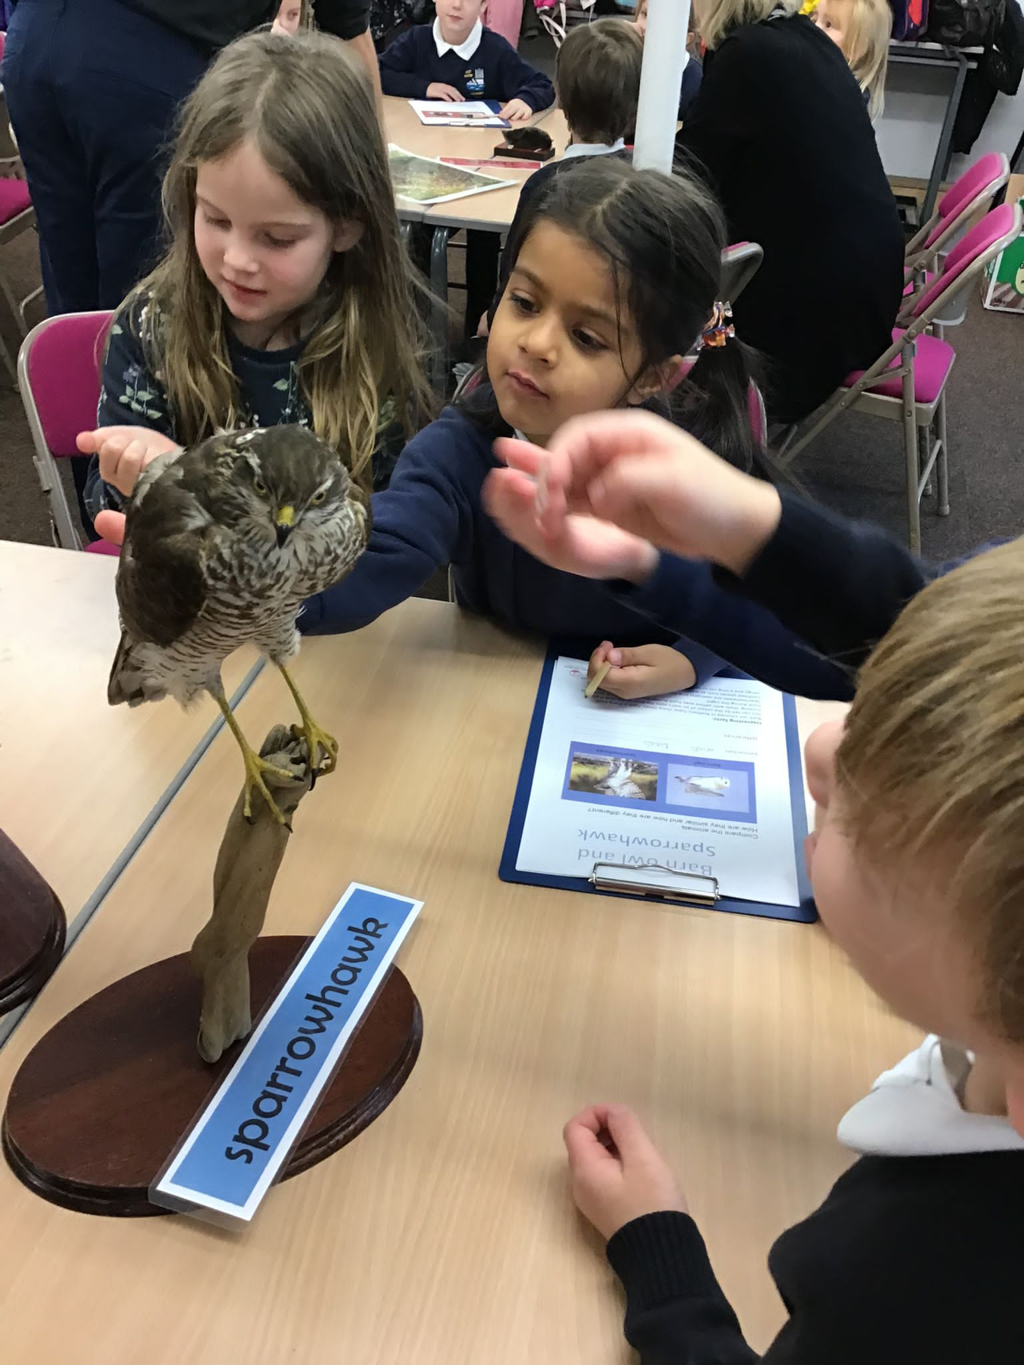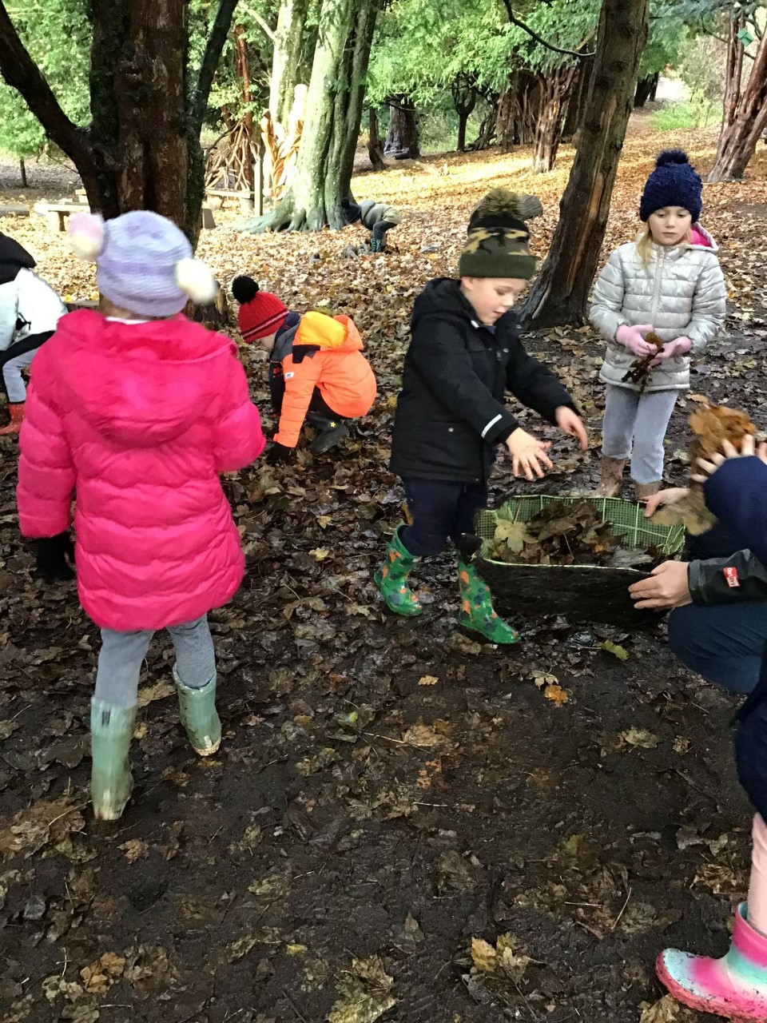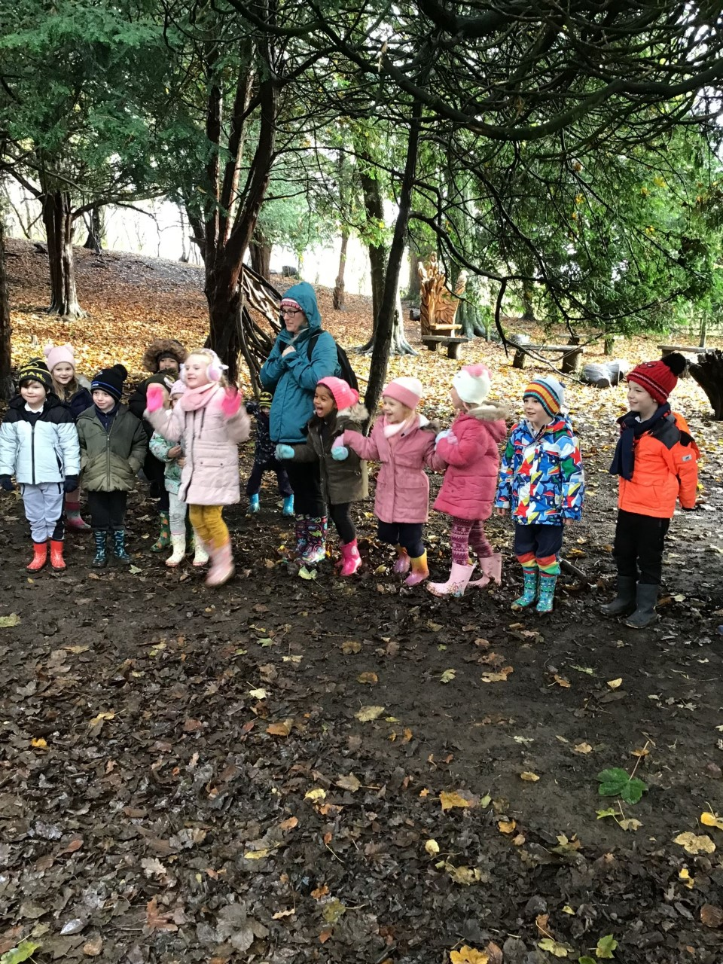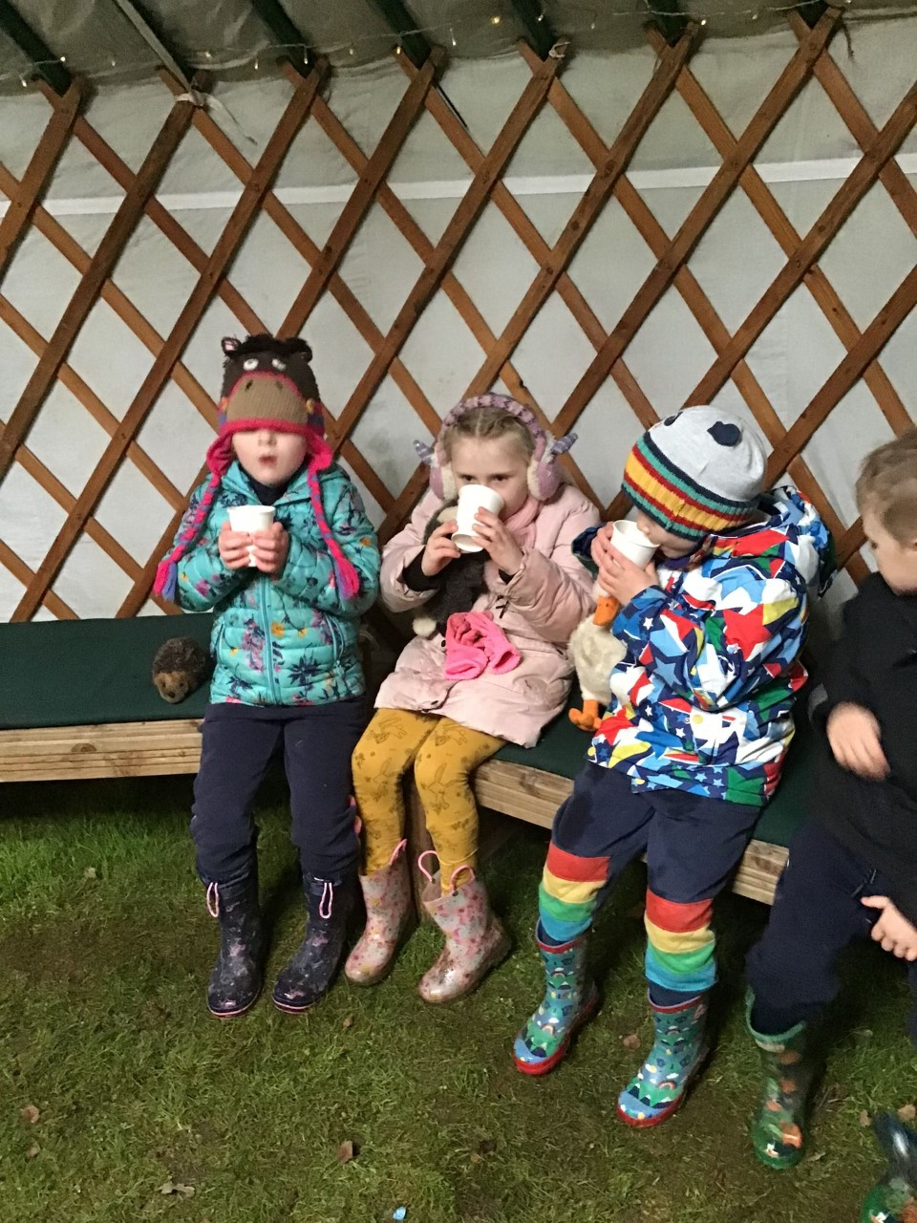

Years 1 and 2 had an amazing time at Danby Moors Centre, they were a credit to school and had some amazing wider learning experiences on the wettest day ever!

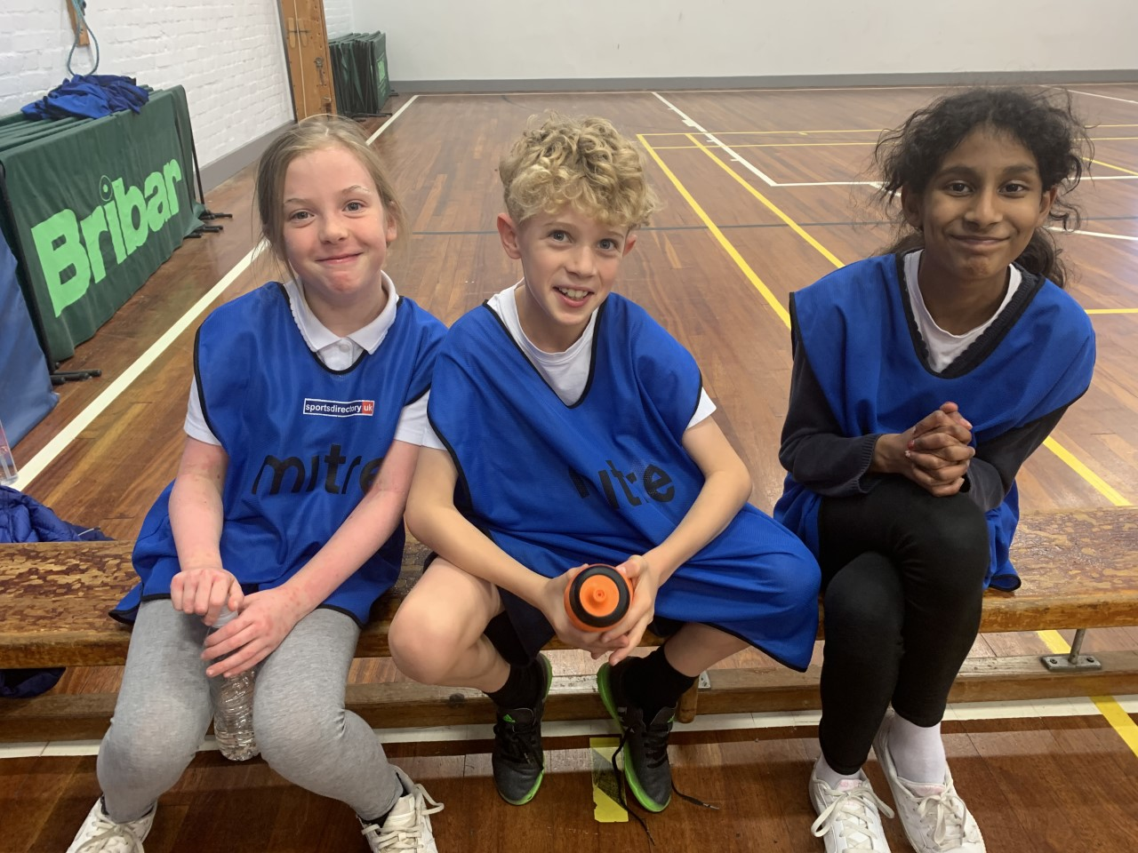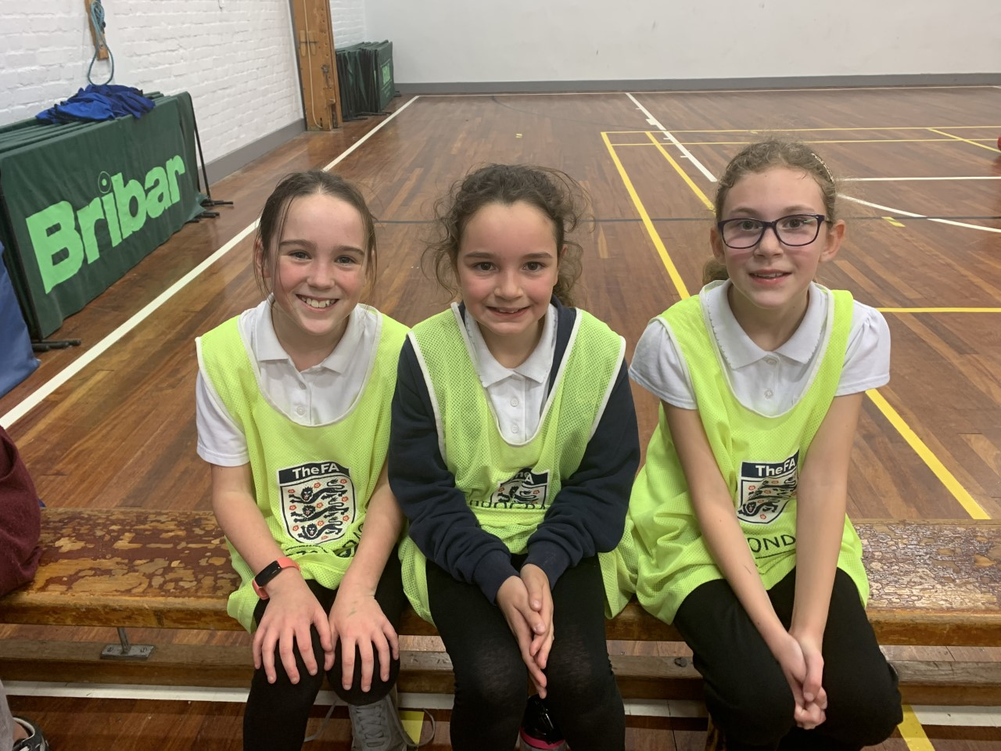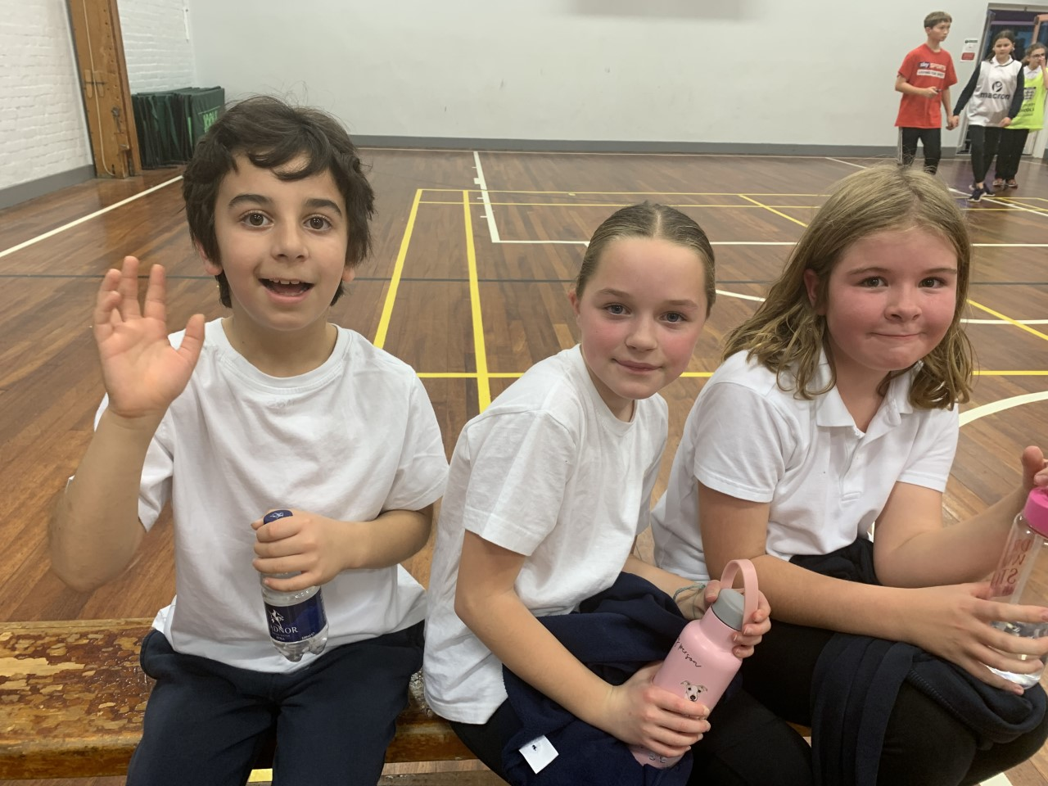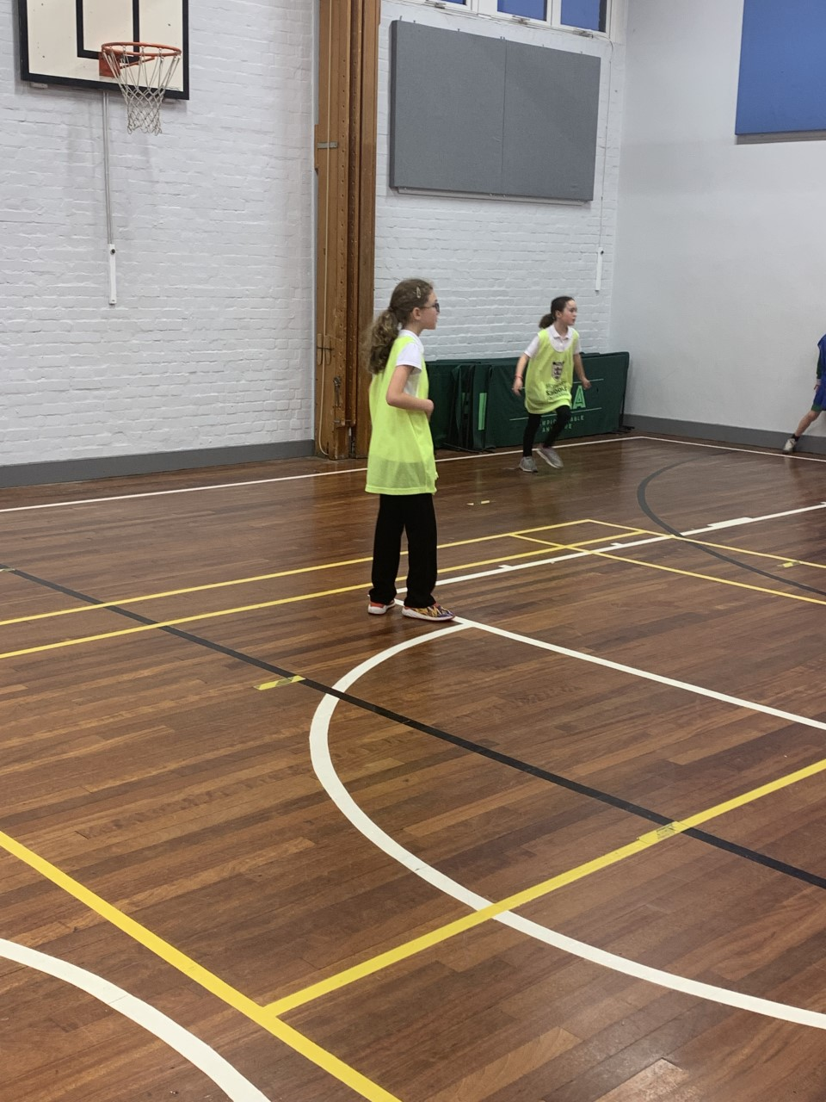

Year 5 and 6 attended a Basketball event this week, they were one of 2 schools who attended and had a fab time taking part in something new ☺ They were great ambassadors for East Whitby and did us proud. They really enjoyed working with children from Airy Hill and were amazing sports people. We encourage all children to take part in sporting events across the year and are really pleased to say that 65% of our children have already attended inter- school events this school year!

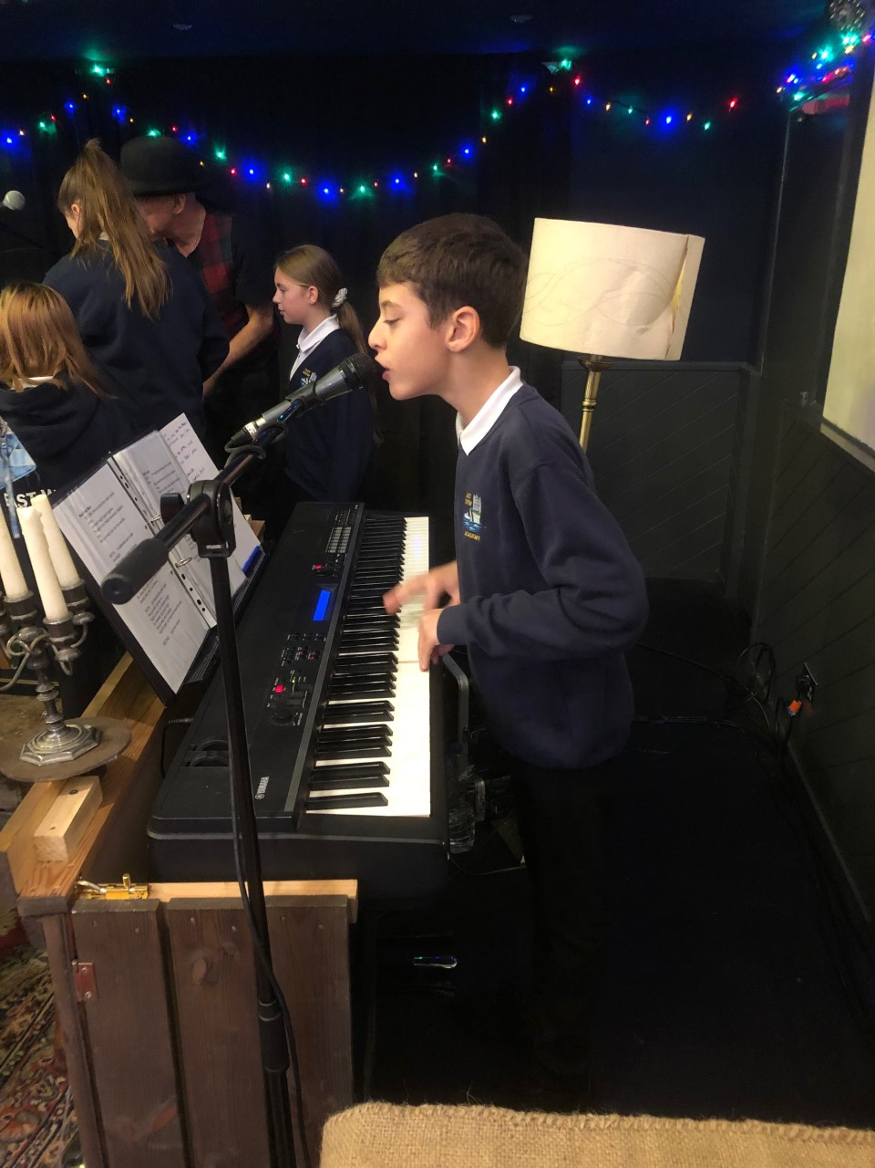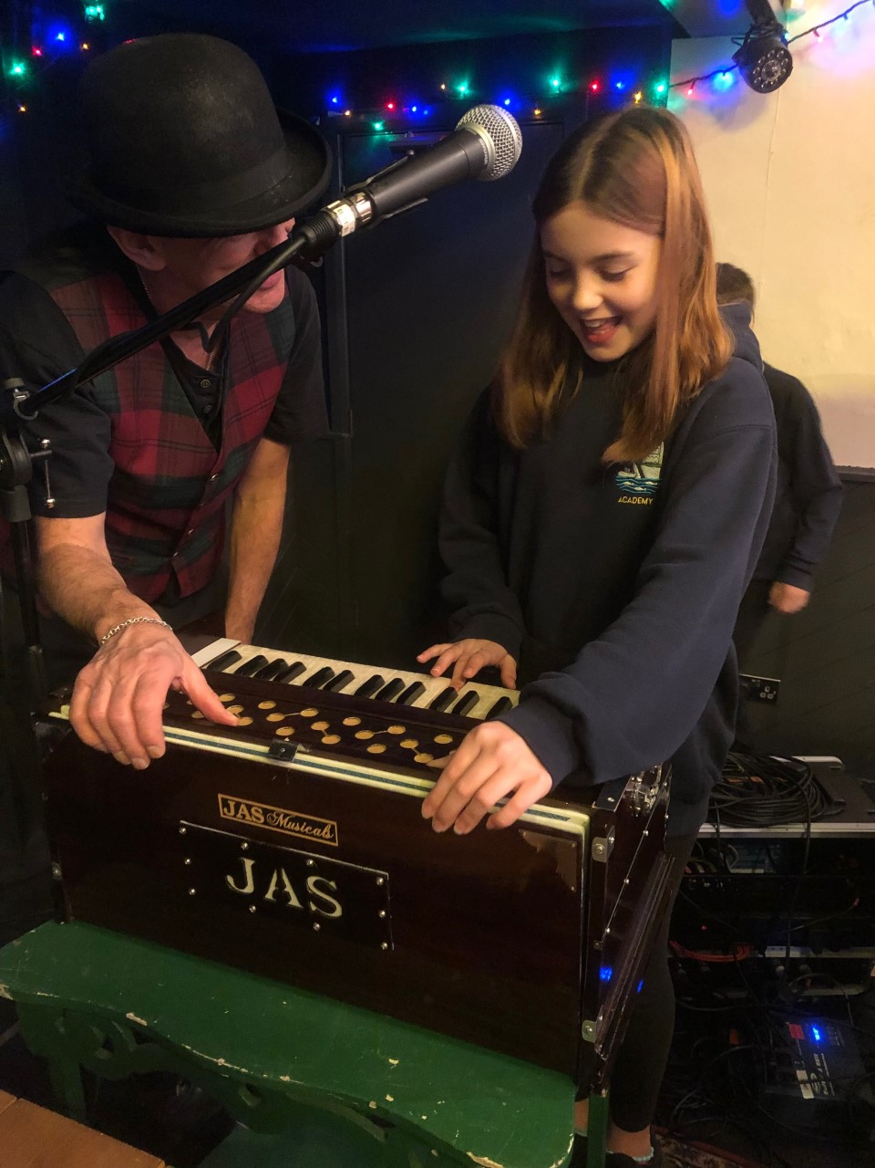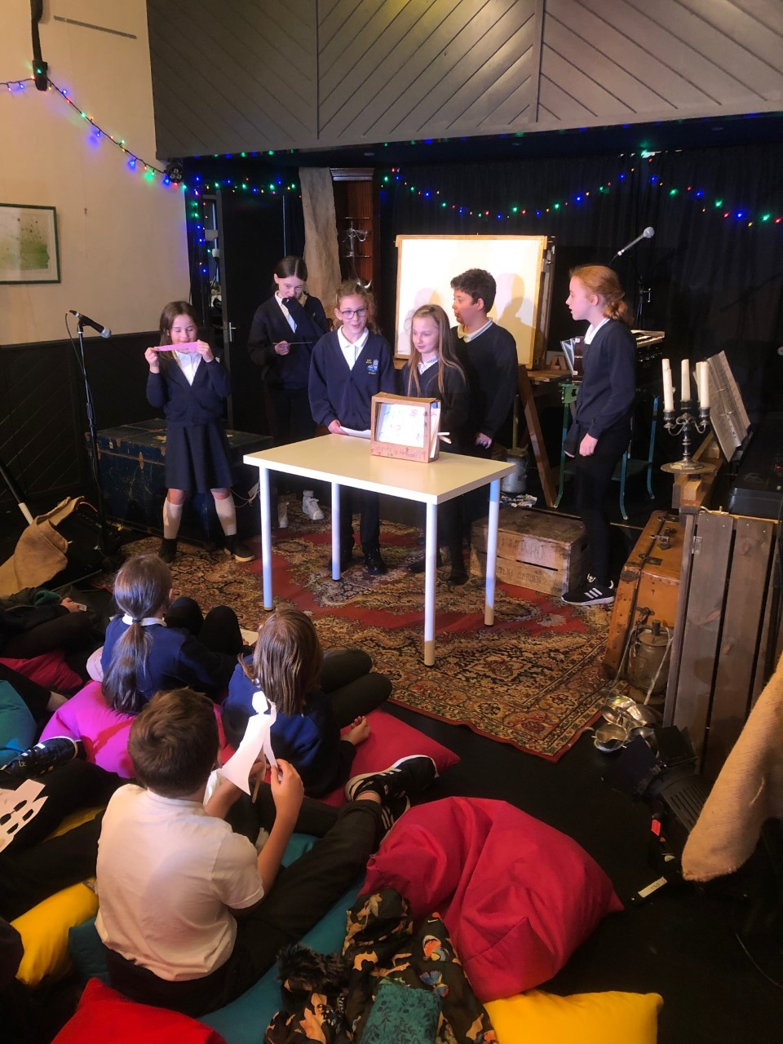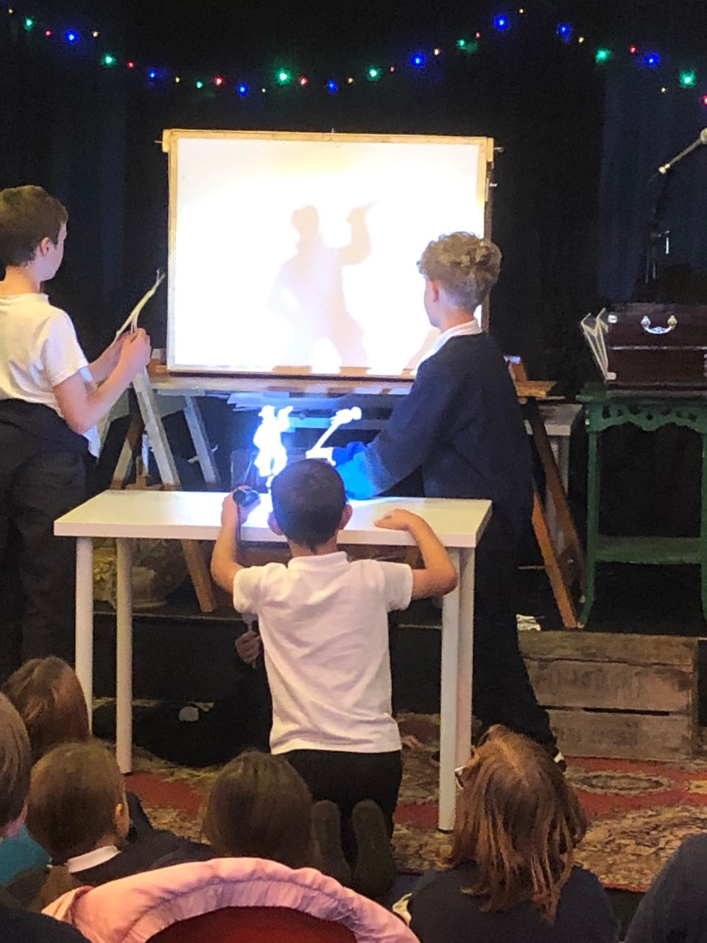

Year 6 went to Flowergate Hall this week to experience Japanese shadow puppetry. This was a great experience for them to see something really special and they really enjoyed themselves

**The Christmas post box will be in school from the 1st December. Children are welcome to bring Christmas cards in to post at school, please put a name and class on the envelopes. In other exciting news a letter will be coming out to share our clubs offer in the New Year, we are really lucky to be able to offer Colebrooke drama, rugby and gymnastics, plus lots more so keep an eye out in the next few weeks! Also a letter explaining a really exciting awards scheme is coming home too! We can’t wait to celebrate the “Pride of East Whitby” awards with the children.**

Have a wonderful weekend! We’ll see you all next week for the Christmas Fair!