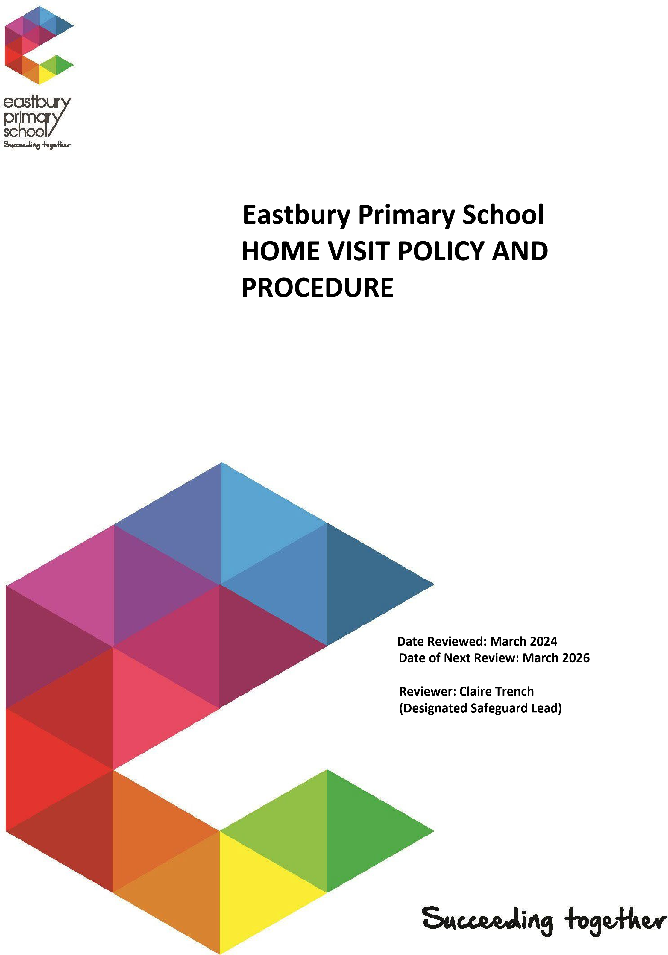
Date Reviewed: Summer 2026
Date of Next Review: Summer 2028

Home Visit Policy and Procedure

ALL HOME VISITS CONDUCTED BY STAFF MUST BE AUTHORISED BY THE SAFEGUARDING LEAD.

In addition, wherever possible parents/carers/guardians (Ps/Cs/Gs) should be informed of the home visit prior to arrival, there will be exceptions to this for example a visit to confirm that an absent child is at home when no communication has been made to telephone calls/text messages/emails or emergency safeguarding visits.

Home Visit Definition:

A home visit is a visit that requires member(s) of staff to visit/enter the home of a parent, carer, or guardian in the case of an emergency visit or a procedural visit.

Aims
- At Eastbury Primary School we recognise that Ps/Cs/Gs are children’s first and most enduring educators and we value the contribution they make.

The aim of a home visit is:
- To establish a partnership between Ps/Cs/Gs and staff at the start of their journey with the school, so that all parties share their knowledge about the child to enable the individual needs of the child to be met.
- To develop and strengthen relationships with Ps/Cs/Gs for the best interests of the child.

Reasons for home visits:
Home visits are important in helping the school to make contact with new or hard to reach Ps/Cs/Gs. They are particularly useful as they enable the Ps/Cs/Gs to still have contact with the school, but in their own environment. Home visits can be used when:
- Starting new to the school in Reception class.
- Students are refusing to come into school.
- When there are attendance issues/concerns.
- When all other means of contact with a family has failed.
- To meet with Ps/Cs/Gs to discuss an issue regarding their child where it is in the best interest of the child to have that discussion in their own home rather than at school or where it would be difficult for a Ps/Cs/Gs to attend school for a meeting and information needs to be shared in a face to face meeting in a timely manner.
- To try and establish that a child is safe if they are absent from school and attempts to contact Ps/Cs/Gs have not elicited a response and we have any welfare or safeguarding concerns for the student.
- To work with and support Ps/Cs/Gs in developing strategies to help their child attend school where attendance is an issue.
- To collect from or drop a child off at home where there are concerns for a child’s welfare if they travelled by other means.
- To drop off or collect work for a child when they are completing school work at home e.g.
following a fixed term exclusion or medical issue.
- To visit a child who has been off school for a period of time, for example due to a medical issue, so that they do not feel isolated from school.
To investigate situations when there are suspicions that someone may be on holiday contrary to earlier indications (for example when a child is not at school and reported as being ill during the same period for which a request for exceptional leave in term-time had been refused).

Each case will be decided on an individual basis for the appropriateness of a home visit by the DSL/Headteacher.

Benefits

Home visits have many benefits. For parents, carers, guardians and children, a home visit gives the opportunity to meet a key person in a setting that they are familiar and comfortable with. Other opportunities are to:
- Establish a positive contact with a key member of staff who is supporting the child.
- Meet family members that are important to the child.
- Talk about the child and their needs.

Procedures

The aim of the home visit policy procedure is to ensure good working practice and to provide guidelines in reducing risks to member/s of staff when undertaking home visits.

Before the Visit

- Be familiar with the school’s policy and procedure for home visits.
- Be clear about the purpose of the visit. Make sure that a home visit is really necessary. (If possible and/or practical, arrange for Ps/Cs/Gs to come into the school)
- Complete the Home Visit form.
- Arrange for an appropriate person to accompany you, home visits should be conducted in pairs. Clarify each person’s role.
- Make sure you are well informed about the subject of the visit. Collect any necessary documentation. Check on school’s policy and practice.
- Consider who you need to see, e.g. one or both Ps/Cs/Gs, with or without the child.
- Make sure you are well informed about the family and are aware of personal circumstances.
- Wherever possible make an appointment to establish a time convenient to the family and to ensure that everyone you want to see will be present. Either make a phone call or send a letter.
- Ensure you have or you take a mobile phone with you.
- Refer to the ‘Lone Working & Home Visits Step Analysis of Risk Assessment’ (appendix 1), and inform the Headteacher/Safeguard Lead of your intended location before departing for a home visit.

During the Visit
- Park in a well-lit area and in a position where you do not need to reverse on leaving.
- Dress appropriately.
- Ensure that there are no animals in the room where a meeting takes place.
- Introduce yourself, have identification available and explain again the purpose of the visit.
- Do not enter the premises unless invited in by a responsible adult.
- Do not enter the premises if invited to do so by a child that is on the premises unsupervised by a responsible adult.
- Only speak to an adult with parental responsibility (Ps/Cs/Gs) or another responsible adult whom a P/C/G has delegated to be there in their absence and they have given us permission to speak to about the student for whom we are making the home visit.
- Do not speak to siblings other than to ask if their P/C/G is available. Do not discuss the purpose of the visit with siblings or any other unknown young person or adult at the premises.

Do not go upstairs in a property unless accompanied by a responsible adult and then ONLY if you deem it completely safe to do so and necessary.
- Do not enter a child’s/young person’s bedroom.
- If you are concerned that a child/young person is in the home inappropriately alone/unsupervised contact the schools safeguarding team straight away to discuss your observations or to seek immediate advice from them if you are uncertain whether the child is alone/unsupervised. If appropriate the Safeguarding Lead will make a referral to social care.
- If you feel that a child/young person is in immediate danger contact emergency services 999.
- Assure P/C/G that you will treat anything they tell you sensitively and will only tell the head teacher or other appropriate staff. Explain that you may need to take notes during the meeting. Do not promise not to relay information to school. Remember that under the child protection procedures you must report disclosures or suspicions to the designated person for child protection.
- Be sensitive to the culture, religion etc of the home.
- Be professional; give professional advice and information rather than personal opinions.
- Be sympathetic, but remain neutral. Don’t get personally involved. Be discreet but assertive about the direction of the conversation; do not gossip about the school or staff.
- Do not stay too long. Keep to the point.
- Do not carry large sums of money when making a home visit.
- Complete Home Visit Form to evidence visit.
•

No Contact at the Home
- If no contact is made at the home, complete a visit slip informing the parent/carer you have made a visit to the property.
- Home visit slip (appendix 2)

After the visit
- Report back to the school and hand in the completed Home Visit Form to the Attendance Lead/Safeguarding Lead in line with school policy.
- If you are not returning directly to school, telephone the school after the visit to say you have left the home visit.
- Any Child Protection concerns arising from home visits should be discussed with the Safeguarding Lead or team on arrival back to school and recorded on the Safeguard system.
- At school do not discuss individual home visits with staff who are not involved with those particular children.
- All home visit details to be recorded on the safeguard system.
- All attendance home visits to be recorded on the safeguard system.

Home Visit Form (see Appendix 1)
- It is essential that staff write a short report on every visit they make.
- If an incident does occur the visitor should record all details as soon as possible after the incident, before precise recollection of events fall from their memory.
- If an accusation of abuse is made against the visit/visitor advice should be sought from the head teacher as soon as possible.

Summary

Making Safe Home Visits:

Before:
- Complete/hand in, ‘Lone Working & Home Visits Step Analysis of Risk Assessment’
- Be clear about the purpose of the visit.
Arrange for an appropriate person to accompany you.
- Be well informed about the subject of the visit.
- Always make sure that the school knows where you are going.

During:
- Carry a mobile phone with you.
- Consider who you need to see.
- Make a prior appointment to establish a time of visit (where possible).
- Carry identification.
- Do not stay too long.
- Introduce yourself.
- Be professional.
- Don’t carry large sums of money.

Action to take if you are threatened:
- If you are threatened or prevented from leaving stay calm and try to control the situation. Try to appear confident, speak slowly and clearly and not be enticed into an argument. Try to diffuse situation by saying you will seek advice from a senior member of staff or colleague.
- Keep your distance, never touch or turn your back on someone who is angry.
- If staff attend as a pair wait outside the property until all staff involved have arrived. Consider whether sending out two members of staff may escalate the difficulties.
- If working as a pair agree a code word (safe word) or phrase to alert a colleague that you need assistance or should leave.
- The same code word should be used if you contact school to alert them that you are in danger and need support.
- Staff must leave the property and reach a place of safety if you have any concerns about personal safety and inform school immediately.

After:
Report back in school, or if you are not returning directly to school, telephone the school after the visit to say you have left the residence.
If you are concerned about your safety do not visit. It is strongly recommended that no one makes an evening home visit.

Safe word: To be agreed and recorded on the ‘Lone Working & Home Visits Step Analysis of Risk Assessment Intent to Visit’.

Community Lone Working Risk Assessment Appendix 1
WORK ACTIVITY RISK ASSESSMENT
Task being undertaken: - Lone Working Risk Assessment – out of office Occupations:- All Staff
Any vulnerable persons particularly at risk: - Safeguarding team aware of named visit Date of assessment: - Any

Hazards | People | Severity of harm | Likelihood | Risk Level | Controls
Aggressive or violent  parent/student/family member | Member of staff may be harmed | Major injury may occur | Remote possibility | low | Refer to home visit policy Risk reduced by informing safeguarding team prior to visit  2 person visit if aware of home circumstances  Inform reception and sign out so others aware Take mobile phone for communication
Driving | Member of staff may be harmed | Vehicle breakdown  Accident  Intruder in vehicle when unattended Use of mobile phone  Fatigue | Remote possibility | Low | Maintain vehicle properly Belong to a breakdown organisation  Carry torch, phone etc for emergency  Advise team or partner where  you are going  Phone in if plan changes  Do not leave valuables in car  (e.g. laptop)  Avoid risky areas where

Movement through public areas e.g. to/from car parks | Member of staff may be harmed | Attack Theft of property | remote | Low | Back down from  confrontation Call for help Use attack alarm Keep valuables secure and out of sight or disguised Surrender valuables if personal safety is at risk Use staff bus or public transport if available Post incident support
Illness or injury/ accident | Member of staff may be harmed or injured | Illness or injury Take  mobile communications | Remote | low | Alert Emergency services if appropriate  Alert team members if able to Ensure access to phone Take prescribed medication as directed or as needed Complete injury at work protocol on return
Attack by dog or other animal | Member of staff may be harmed or injured | Major injury may occur | Remote | Low | Avoid contact with animals Seek local advice before entering premises with animals Appropriate behaviour near animals – avoid alarming them, e.g.  sudden movements


Appendix 1

Person visiting
Job Role

Visited Home Address
Student Name

Reason for calling

On (date) at (time)

Comments

Signed (Staff Name)

Signed (Parent/Guardian Name)

Visit authorised by Safeguarding Lead: Date: Time:

A copy MUST be placed on the pupil’s file.

Action required

Appendix 2



Dear Parent/Carer

We attempted a home visit to you today to make contact with you. Unfortunately, we have been trying to get in touch with you by phone; alternative contacts you gave us and listed emails. As this has not been possible we have visited you today……………………………………………….
at…………………………..
Please contact the school on: 0208 477 9910 to let us know you and your family are well.
Dear Parent/Carer

We attempted a home visit to you today to make contact with you. Unfortunately, we have been trying to get in touch with you by phone; alternative contacts you gave us and listed emails. As this has not been possible we have visited you today……………………………………………….
at…………………………..
Please contact the school on: 0208 477 9910 to let us know you and your family are well.
Dear Parent/Carer

We attempted a home visit to you today to make contact with you. Unfortunately, we have been trying to get in touch with you by phone; alternative contacts you gave us and listed emails. As this has not been possible we have visited you today……………………………………………….
at…………………………..
Please contact the school on: 0208 477 9910 to let us know you and your family are well.
Dear Parent/Carer

We attempted a home visit to you today to make contact with you. Unfortunately, we have been trying to get in touch with you by phone; alternative contacts you gave us and listed emails. As this has not been possible we have visited you today……………………………………………….
at…………………………..
Please contact the school on: 0208 477 9910 to let us know you and your family are well.

