
eqstbur
pnmar
school

-�•c:
:)'-•'.-
Partnership Learning





Monitoring of Learning Policy

Review: Spring 2026
Next review: Spring 2027

Contents

Introduction p3
Purposes… p3
Types of monitoring p4
Balanced view of performance p5
Key Monitoring Roles and Responsibilities p6
Appendix A: Strategic Planner (monitoring) p7
Appendix B: Teaching and Learning Review/Pupil Learning Week p9
Appendix C: TA/Cover Supervisor Observation Form p12
Appendix D: To support verbal feedback following Pupil Learning Week………………….. p14

2

- Introduction

The staff and Local Governing Board of Eastbury Primary School are committed to raising standards, establishing high expectations and promoting effective teaching and learning.

- Purposes

The main purpose of monitoring, evaluation and review is to ensure that all members of the school community perform their roles effectively to maintain high standards of learning and teaching and thereby raise achievement.

Effective monitoring enables the following:

  - To provide a clear and accurate picture of how effectively the school is achieving the highest standards possible in all aspects of its work
  - To provide pupils with a voice in improving the quality of teaching and learning
  - To feed into the performance management process, ensuring accountability for all staff
  - To identify areas for development and put in place CPD to address these
  - To ensure that the school's priorities are being achieved and that the targets of the School Improvement Plan are being met
  - To identify targets that will raise standards of achievement and improve pupil outcomes and the quality of teaching and learning
  - To ensure efficient and effective use of all our resources
  - To improve the efficiency and effectiveness of curriculum management and the overall management of the school
  - To ensure that all pupils benefit from a broad, balanced and differentiated curriculum
  - To identify children who may need intervention strategies, including specific groups – eg Pupil Premium, gender, SEN, G&T, ethnicity etc.

- Types of Monitoring

The following formal types of monitoring take place at Eastbury (see table below). The annual strategic planner sets out the timing and frequency of each of these annual strategic planner sets out the timing and frequency of each of these (Appendix A).

Eastbury Primary School, Monitoring of Learning Policy Page 3 of 16

Type of monitoring | Purpose | Responsibility | How recorded?
Pupil learning week and Inclusion learning walk | Termly review of the quality of teaching and learning across the school, in which SLT will review data and books, as well as observing pupil learning in all classes on several occasions during the week, in order to build a full and balanced picture.  Termly look at quality of inclusion provision throughout the school progression, challenge and quality of marking and feedback. | SLT/SENCo/ EAL  lead/Subject lead | Teaching and Learning / Pupil Learning Week Feedback form.  Feedback on strengths and areas for development provided to individual teachers, summary to year group leader. Emailed and save on Sharepoint.
Pupil progress meetings | Termly/half termly review of outcomes for pupils (assessment analysis), identifying priority areas and strategies for improving pupil progress | Year leader/ SLT/  Teachers SENCO EAL  Attendance  officer | Recorded on Pupil Progress Meeting document (PPM)
School Improvement Plan and action plans | Termly evaluation of progress against actions (RAG), identifying areas for further development. | SLT/ LGB/  Subject leaders | On School Improvement Plan and individual subject action plans
Pupil voice: School Council and pupil  questionnaires | To provide pupils with a voice in improving the quality  of teaching and learning | PSHCE  lead/SLT | School Council minutes Focus notes from SLT
Performance management meetings | To identify targets that will raise pupil outcomes; identify professional development needs; and provide accountability for staff performance linking to pay  progression | All line managers | Recorded using Partnership Learning performance management template
External quality assurance | As agreed. This will include Teaching and Learning Reviews conducted in phases once a year:  - KS1/EYFS/Nur/Sunshine Room/ARP  - KS2 | Headteacher/ Senior School Advisor/SLT/ Partnership schools | Reports from advisers
TA and cover supervisor observations | To improve the quality of teaching and learning provided by support staff (both 1:1s and  class TAs). Twice Yearly. | SLT/AHT/LoL/ SENCo | Feedback on strengths and areas for development
Book scrutiny | Half-termly to ensure coverage (a broad, balanced curriculum).  PPA book monitoring weekly by  Year groups lead by LoL. | SLT/AHT/LoL | Feedback on strengths and areas for development

In addition to the above, monitoring information (leading to support and relevant action) is gathered by leaders in several other ways, including:

  - Walks round the school – behaviour in corridors and on the playground
  - Weekly SLT meeting/weekly staff meetings/Fortnightly meeting with Leaders of Learning (LoL)/ Fortnightly Phase meeting with AHTs.
  - School Improvement Partner/Governor monitoring and reports (individual teachers or subjects)
  - Subject leader meetings (Curriculum Learning group meetings)
  - Planning – short, medium and long term
  - National Curriculum objectives and evaluations in books
  - Results from tests and assessment (data) analysis
  - Informal lesson drop-ins
  - Staff CPD and CPD evaluations
  - Staff questionnaires
  - Timetables
  - Displays (celebration of learning)
  - Writing and Maths moderation – internal and external
  - EYFS Profile
  - SEN files - individual children
  - Comparative data – FFT Aspire data dashboard and Annual Statistical Report
  - Governor monitoring

- Balanced View of Performance

The forms of monitoring above enable a full and balanced picture of staff performance without graded lesson observations. Accountability would be ensured by triangulating the outcomes from pupil learning weeks, book scrutinies and data. These are directly linked to the performance management targets. Feedback from pupil learning weeks will be recorded on the observation template in Appendix B. A prompt sheet to support verbal and written feedback from pupil learning week is in Appendix C (. A prompt sheet to support verbal and written feedback from pupil learning week is in Appendix C (based on the teacher standards). Feedback is given face to face orally. Written feedback is emailed to the staff member and saved on SharePoint.

The advantages of monitoring and observing without grading are:
  - It allows a focus on formative feedback as the discussion is focused on improvement, rather than on justifying a particular grade
  - Recognises that genuine pupil progress is made over time, rather than within a single lesson
  - Enables teachers to focus on the principles of great teaching, but to implement them in their own way
  - Moves away from checklists and/or frameworks which may narrow effective practice
  - Focuses on a cause-and-effect model of observations where effective strategies for learning and progress are identified by looking at the impact on pupils’ learning
  - Avoids looking at ‘poor proxies’ for learning (e.g. ‘the children looked busy’ or ‘the classroom was calm’)
  - Fits into the growth mindset philosophy

4. Key Monitoring Roles and Responsibilities

Class teachers – will be accountable for their own planning, teaching, assessment and record-keeping.
Subject leaders and year leaders - will monitor teachers' planning; and samples of pupils' work; they will look at curriculum coverage, appropriateness, match to pupils' abilities, progression and continuity, differentiation, quality, standards and presentation, display and resources.

The Headteacher and the Senior Leadership Team members (SLT) - will take an overview of all aspects of the school's work including the curriculum, teaching, quality of learning, standards of achievement and behaviour. SLT will monitor the School Improvement Plan (SIP) and update the School Self Evaluation Form (SEF) that is reviewed each term.

The Governors - will monitor the progress of the SIP; the management and leadership of the school; standards and efficiency and the budget. Link Governors will liaise with coordinators to monitor the subjects of the curriculum.

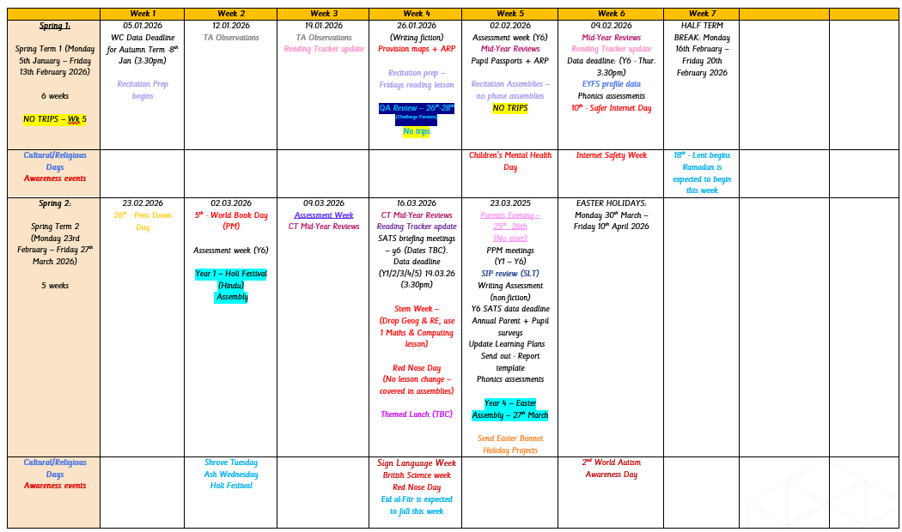
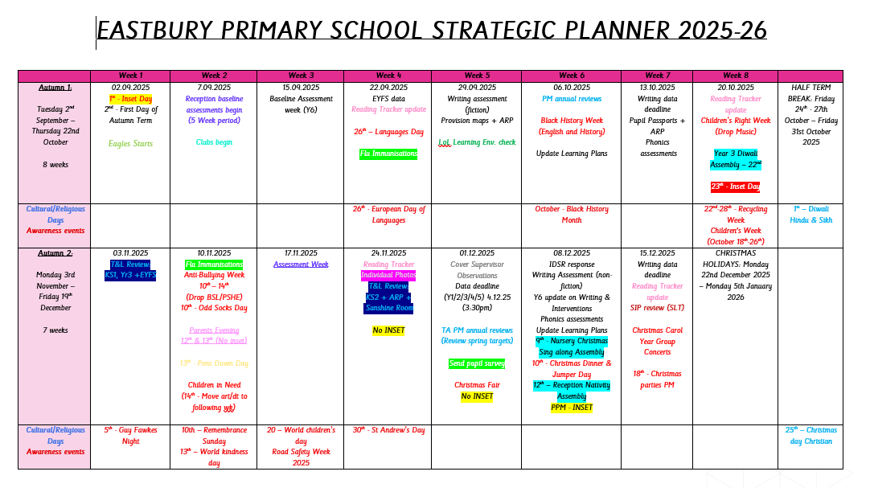
Appendix A EASTBURY PRIMARY SCHOOL STRATEGIC PLANNER 2025-2026

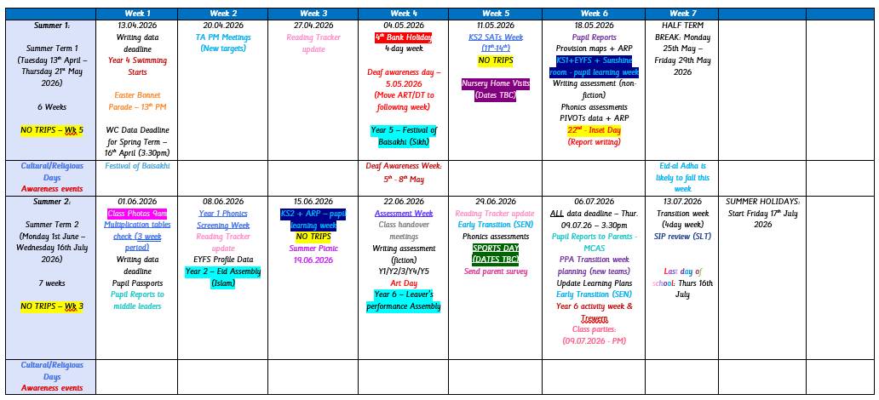


Appendix B

Teaching and Learning Review / Pupil Learning Week

Observer: |  | Observed:
Class: |  | Date:

Strengths in teaching and learning:

Areas for development in teaching and learning:

Strengths in books:

Areas for development in books:

Strengths in learning environment

Areas for development in learning environment

Are there any significant concerns?
Yes or no

Agreed strategy for improvement (if significant areas of concern):
Make clear what needs to be addressed and the timescale for doing this.

CPD needs:
What CPD would support the teacher in their areas for development above?

Give your Comments & Feedback

TA/Cover Supervisor Observation Form
Appendix c

TA/Cover supervisor name: Observer:

Class: | No. of ch.: | Term: | Date:
Lesson |  |  | objectives:

Strengths in teaching and learning:
Areas for development in teaching and Learning:
Evidence of children’s progress (e.g. talking to children, scrutiny of books, products and outcomes):

Additional notes:
Cause for concern? Yes / No CPD needs and next steps:

Give your comments and feedback:

TA / Cover supervisor signature:

Observer signature:

Date:

To support verbal feedback following Pupil Learning Week Appendix D

TEACHER STANDARD
1 | Set high expectations which inspire, motivate and challenge pupils
A | Establish a safe and stimulating environment for pupils,  rooted in mutual respect | Is there a purposeful learning environment within the room?  - Is there a positive working atmosphere within the classroom?  - Is there evidence of clear high expectations for every student?  - Do all students and staff act in respectful way towards each other and the learning? Do pupils love the challenge of learning and are resilient to failure?  - Are they curious, interested learners who seek out and use new information to develop, consolidate and deepen their knowledge, understanding and skills?
C | Demonstrate consistently the positive attitudes, values and behaviour which are expected of pupils.
B | Set goals that stretch and challenge pupils of all backgrounds, abilities and dispositions | Are the LO and success criteria clear?  - Are the LO and success criteria linked to achieving the NC objectives?  - Do students understand what the LO of the lesson is and are they able to articulate this?  - Do students have the opportunity to evaluate their understanding – eg through mini-plenaries; self and peer assessment?  - Can students identify the relationship between the activities in the lesson and the LO?  - Does the structure of the lesson establish a clear thread that works towards achieving the LO?  - Is it clear how this lesson fits into the wider sequence of learning?  - How do the teaching strategies challenge, enthuse, and motivate all students throughout the lesson?
2 | Promote good progress and outcomes by pupils
A | Be accountable for pupils’ attainment, progress and outcomes | What progress are the students making over time?  - Does class data indicate all students are making progress?  - What progress is being made by key groups – e.g. Pupil Premium, gender, SEN  - Does the learning taking place contribute to the overall progress a student will make over time?  - How does the design and delivery of the lesson help ensure students are stretched and challenged to make maximum progress?  - How are additional adults used to support students’ progress?  - Does the learning environment make an effective contribution to progress in students’ learning over time?
B | Be aware of pupils’ capabilities and their prior knowledge, and plan teaching to build on these | Does questioning support good progress in students’ learning?  - Are there effective question and answer exchanges?  - Is each student being sufficiently challenged by the questioning?
C | Guide pupils to reflect on the progress they have made and their emerging needs

D | Demonstrate knowledge and understanding of how pupils learn and how this impacts on teaching | - How is questioning used to link and build on previous learning?  - Does questioning encourage students to link ideas together?  - How is the design and delivery of the lesson adapted to support/increase student progress as required?  - Is there evidence of partner talk and group work to support progress?
E | Encourage pupils to take a responsible and conscientious attitude to their own work and study. | Are students encouraged to take responsibility for their learning?  - Do students have a sense of pride in their learning?
- Is this represented through the work students produce?
- Is there evidence of student self-evaluation and reflection?
- Is there evidence of effective learning routines?
3 | Demonstrate good subject and curriculum knowledge
A | Have a secure knowledge of the relevant subject(s) and  curriculum areas, foster and maintain pupils’ interest in the subject, and address misunderstandings | How does the teachers’ subject knowledge contribute to student learning?  - Is the content taught sufficient to stretch and challenge all students?  - Does teacher subject knowledge inspire confidence in the students?  - Does modelling contribute to students’ understanding of how things are to be done?  - Does the sequence and scaffolding of concepts, ideas and skills contribute to learning?  - Are key concepts established so all levels of students demonstrate understanding?
B | Demonstrate a critical understanding of developments in the subject and curriculum areas, and promote the value of scholarship
C | Demonstrate an understanding of and take responsibility for promoting high standards of literacy, articulacy and the correct use of standard English, whatever the teacher’s specialist subject | Are students’ literacy needs being addressed?  - Are support strategies used effectively so that all students might offer written responses beyond their expected level of attainment?  - Are students given opportunities to read appropriately challenging material as part of their lessons?  - Is time taken to explore the meaning of key words as they emerge and to develop students’ vocabulary?  - Are students offered opportunities to speak and encouraged to improve their speaking? (‘say it again, say it better’ approach)
D | If teaching early reading, demonstrate a clear understanding of systematic synthetic phonics | - Are students making good progress in phonics?  - How does the teachers’ phonics subject knowledge contribute to students’ learning?
E | If teaching early mathematics, demonstrate a clear understanding of appropriate teaching strategies. | - Are students making good progress in maths?  - How does the teachers’ maths subject knowledge contribute to students’ learning?  - Is students’ learning being enhanced through a concrete pictorial abstract approach?  - Do students have opportunities to develop their skills in mathematical fluency, reasoning and problem solving?
4 | Plan and teach well-structured lessons

A | Impart knowledge and develop understanding through | - Are students encouraged to practise until they get the skill or subject content correct?

 | effective use of lesson time | - How are students who struggle with key concepts supported?  - Is there evidence of suitable challenge for all students?  - Are students encouraged to master skills or subject knowledge at a level that is appropriate to the individual?  - Is feedback given to support students to master different and subject content?  - Do students have the opportunity to put their learning into practice on their own?  - Do the tasks set allow students to work independently, construct their own learning and practice the necessary skills to learn for themselves?  - Is the pace of learning challenging but suitable for all students?  - Do students demonstrate a love of learning and intellectual curiosity?  N.B. Some lessons can legitimately focus on input, with response and practice to follow.  - Is challenging homework set in line with the school’s policy and as appropriate for the age and stage of pupils that consolidates learning and deepens understanding?
B | Promote a love of learning and children’s intellectual curiosity
C | Set homework and plan other out-of-class activities to consolidate and extend the knowledge and understanding pupils have acquired
D | Reflect systematically on the effectiveness of lessons and approaches to teaching Evidence  through discussion & feedback.
E | Contribute to the design and provision of an engaging curriculum within the relevant subject area(s). Evidence  through planning
5 | Adapt teaching to respond to the strengths and needs of all pupils
A | Know when and how to differentiate appropriately, using approaches which enable pupils to be taught effectively | - Do all students participate in the lesson?  - How does the planning and delivery of lessons enable all students to access the learning?  - Is pupils’ learning supported through regular and constructive verbal feedback?  - How do interactions with each student differ according to their level of attainment and progress?  - How does planning accommodate for students with particular learning needs?  - Is questioning/resource/task design sufficiently open ended to allow students to produce responses at different levels of sophistication?  - How are all students challenged to make progress beyond their expected level of attainment?  - How are exceptionally & highly able students challenged to make more than expected progress?  - How does the teacher challenge/scaffold support appropriately to maximise progress?  - Does additional adult support result in accelerated learning for those students involved?
B | Have a secure understanding of how a range of factors can inhibit pupils’ ability to learn, and how best to overcome these
C | Demonstrate an awareness of the physical, social and intellectual development of children, and know how to adapt teaching to support pupils’ education at different stages of development

D | Have a clear understanding of the needs of all pupils, including those with special educational needs; those of high ability; those with English as an additional language; those with disabilities; and be able to use and evaluate distinctive teaching approaches to engage and support them. | N.B. Differentiation is a long-term process that mirrors the long-term nature of learning and progress for individual students. Differentiation does not always mean that you must have tiered resources and tasks in every lesson. It does not always mean you should have must-should-could learning objectives. It does not always mean that a lesson where every  student is doing the same task is fundamentally worse than one where students do have different tasks. Effective differentiation allows different students to achieve and make progress at their level of attainment. During pupil learning week, establish whether all students can effectively access the learning and that the ‘planning for learning’ allows each student to make progress according to or beyond their level of attainment.
6 | Make accurate and productive use of assessment
A | Know and understand how to assess the relevant subject and curriculum areas, including statutory assessment requirements | How is learning assessed?  - Is the system in place for assessing learning clear and systematic?  - Does assessment link with the work that is being done?  - Is assessment designed to allow students to make maximum progress?  - How does questioning probe student understanding?  - Is summative and formative assessment being carried out using Pupil Asset, termly tests and NC statements in backs of books according to school’s policy?  Are pupils’ common misconceptions identified and acted upon to ensure they are corrected?  - Do teachers identify and support any pupil who is falling behind, and enable almost all to catch up?
B | Make use of formative and summative assessment to secure pupils’ progress
C | Use relevant data to monitor progress, set targets, and plan subsequent lessons
D | Give pupils regular feedback, both orally and through accurate marking, and encourage pupils to respond to the feedback. | What does student work tell me?  - Is there a sensible level of selective marking and signs of feedback leading to improvement – redrafting, corrections and so on?  - Does student work demonstrate increased learning and knowledge over time?

Does student work demonstrate written feedback and how the students had the opportunity to act upon the feedback provided?
Are students encouraged to make links between their learning? Is marking/feedback following Eastbury policy?
Are students encouraged to take pride in their work? Is student work neat, tidy and completed? Is there evidence of effective use of self/peer assessment?
Does peer assessment demonstrate written feedback and how the students had the opportunity to act upon the feedback provide?
N.B. If lots of marking is observed that doesn’t yield a response and/or seems unsustainable in terms of workload, please ensure this is addressed with the teacher.

7 | Manage behaviour effectively to ensure a good and safe learning environment
A | Have clear rules and routines for behaviour in classrooms, and take responsibility for promoting good and courteous behaviour both in classrooms and around the school, in accordance with the school’s behaviour policy | Is the Eastbury behaviour policy being applied consistently in terms of rewards and sanctions?  Is the approach to behaviour non-confrontational, based on high expectations & positive teacher-student relationships? Are the qualities of an ‘assertive teacher’ demonstrated (see below)?  Are the expectations for behaviour and learning set sufficiently high?  Are students encouraged to think about choices about consequences of behaviour? Do positive behaviours for learning encourage good pupil progress?  In his book ‘A Practical Guide to Effective Teaching’, Bill Rodgers identifies three Teacher Styles:  Indecisive teacher: hoping for compliance but not insisting; being timid in the face of a challenge; pleading not directing. Autocratic teacher: using power relationships to demand compliance without any room for choice.  Assertive teacher: This teacher expects compliance but refuses to rely on power or role status to gain respect. The teacher plans for discipline, uses clear, firm direction and correction, but acts respectfully, keeping the aims of discipline clearly in mind.
B | Have high expectations of behaviour, and establish a framework for discipline with a range of strategies, using praise, sanctions and rewards consistently and fairly
C | manage classes effectively, using approaches which are appropriate to pupils’ needs in order to involve and motivate them
D | Maintain good relationships with pupils, exercise appropriate authority, and act decisively when necessary.
8 | Fulfil wider professional responsibilities
A | make a positive contribution to the wider life and ethos of the school | Are support staff being used effectively to support children’s learning?  Have areas for development from previous pupil learning week and other sources of feedback been acted on?
B | develop effective professional relationships with colleagues, knowing how and when to draw on advice and specialist support
C | deploy support staff effectively
D | take responsibility for improving teaching through appropriate professional development, responding to advice and feedback from colleagues
E | communicate effectively with parents with regard to pupils’ achievements and well-being.

