Special Educational Needs and
Disability Policy



Statutory Policy Name: Special Educational Needs & Disability
Date Reviewed: Summer 2026 Next Review: Summer 2028
Policy written by: Claire Trench

At Eastbury Primary School we believe that every pupil should achieve their potential, whilst feeling safe and happy every day.
Our core values are:

- Respect
- Teamwork
- Aiming High
- Creativity
- Enjoyment
- Resilience

Safeguarding Statement

Our policy is embedded into the general ethos of all the academies within the group forming Partnership Learning, which is to ensure that our pupils are treated with respect and dignity, taught to treat each other with respect, feel safe, have a voice, and are listened to. The governors and staff of our school fully recognise the contribution they make to safeguarding pupils. We recognise that all members of staff, including volunteers, have a full and active part to play in protecting our pupils from harm. All trustees, staff and governors believe that our school should provide caring, positive, safe and stimulating environments which promote the social, physical and moral development of the individual
Contents

Introduction 5
Principles 5
Aims 6
Definition of Special Educational Needs (SEN) 6
Identification and assessment of pupils with special educational needs 7
Intervention Identification Flow Chart 9
SEN Support 10
Education, Health and Care Plans 10
How Eastbury Primary School adapts the curriculum and learning environment for pupils with SEN 11
Additional support for learning available to pupils with SEN 12
Support for pupils with Social, Emotional and Mental Health Needs (SEMH) 12
How Eastbury Primary School evaluates the effectiveness of its provision for pupils with SEN 13
How Eastbury Primary School assesses and reviews the progress of pupils with SEN 13
Admissions 14
Roles and responsibilities 14
Governing Body Responsibilities 14
The Special Educational Needs Co-ordinator 14
Teachers – With support where required and requested from the school SENCO 15
Arrangements for partnership with parents 15
Pupil participation 16
Storing and Managing Information 16
Links with other mainstream schools and special schools 16
Links with other agencies and voluntary organisations 16
Complaints Procedures 17
Eastbury Primary School’s Local Offer 17
Legislation and guidance relevant to this policy 17

Special Educational Needs & Disability

Introduction

Our guiding principle is one of inclusion and we aim to provide Quality First Teaching for all our pupils. This includes appropriate adaptions for individual pupils, high quality resources and effective use of additional adult support. We aim to identify and break down possible barriers to learning so that all our pupils experience success. This does not mean treating all pupils equally; it means treating all pupils as individuals and ensuring they have the required provision to achieve the best possible progress. This Special Educational Needs (SEN) policy details how we ensure that the needs of all our pupils with special educational needs are met. When carrying out our duties towards our pupils with SEN, we have regard to the Special Educational Needs Code of Practice 2015.

Principles

- We value all pupils in our school equally
- All pupils are entitled to a broad and balanced curriculum which is adapted to meet their individual needs and abilities.
- All pupils are entitled to experience success.
- All pupils are entitled to have their particular needs recognised and addressed.
- All pupils should be helped to reach their full potential – we have high expectations for everyone.
- Good special needs practice is good practice for all pupils.
- Additional intervention and support cannot compensate for Quality First Teaching.
- Pupils and their parents/carers know their pupils best and should be full partners in planning and reviewing support for their pupils.
- Pupils with SEN have a unique perspective on their own needs and should be central to all decision-making processes about their support

Aims

- To ensure that we take the views of the pupils into account when planning and evaluating their SEN provision.
- To develop and maintain partnerships and high levels of engagement with parents.
- To raise the aspirations, resilience and expectations for all pupils with SEN.
- To ensure that every pupil has his or her individual needs recognised and addressed through Quality First Teaching and effective additional support.
- To ensure that (wherever possible) all pupils have equal access to a broad, balanced curriculum which is differentiated to meet individual needs and abilities.
- To ensure that pupils with SEN engage in all the activities of the school alongside pupils who do not have SEN

This policy will contribute to achieving these aims by ensuring that provision for pupils with SEN is a matter for the whole school and is a part of the continuous cycle of assessment and review.

Definition of Special Educational Needs (SEN)

- A pupil or young person has SEN if they have a learning difficulty or disability which calls for special educational provision to be made for him or her.
- A pupil of compulsory school age or a young person has a learning difficult or disability if he or she has a significantly greater difficulty in learning than the majority of others of the same age, or has a disability which prevents or hinders him or her from making use of educational facilities of a kind generally provided for pupils of the same age in mainstream schools.
- Pupils are not regarded as having a learning difficulty solely because the language of their home is different from the language in which they will be taught.

Identification and assessment of pupils with special educational needs

The identification of SEN is built into our overall approach to monitoring the progress and development of all pupils. This allows us to identify pupils who are making less than expected progress at an early stage.

Lower than expected progress might be that which:
- Is significantly slower than that of their peers starting at the same baseline
- Fails to match or better the pupil’s previous rate of progress
- Fails to close the attainment gap between the pupils and their peers
- Widens the attainment gap

We are aware that a number of factors may impact on a pupil’s progress and attainment, including having English as an additional language, attendance and punctuality, and family circumstances. Therefore, we do not immediately assume that a pupil has special educational needs. The first response to limited progress is high quality teaching targeted at the pupil’s areas of difficulty.
Most pupils will have their needs met through Quality First Teaching (Wave 1). This may include appropriate adaptions of learning tasks, adaptations to the curriculum and learning environment, the provision of additional practical or visual resources, and time limited interventions.
We focus on early intervention to ensure ‘gaps’ are targeted and an intervention is put in place at the earliest opportunity. To support best practice we aim (wherever possible) to use structured interventions with reliable evidence of effectiveness. Sessions are often brief (20– 50mins), occur regularly (3–5 times per week) and are maintained over a sustained period (8–20 weeks). Careful timetabling is in place to enable this consistent delivery.
Where less than the expected progress continues to be made, the teacher will work with the SENCO to assess whether the pupil has SEN. This may involve the SENCO carrying out observations and possibly assessments. The SENCO will gather information from the pupil, parents and class teacher. Discussions will be held with the pupil and their parents/carers in order to develop a good understanding of the pupil’s areas of strength and difficulty, the parents’ concerns, the agreed outcomes sought for the pupil and the next steps. Pupils who are identified as having SEN will be added to the SEN register. Parents will be notified of this and can choose to not have them added if they decide this is not what they would like. Details will be discussed, with all information relayed to the parent about the SEN register and that a pupil can be added and taken off at any time.

Teachers complete a class analysis throughout the year:
- Reception – Autumn 2, Spring 2, Summer 2
- Year 1 to 6 – Autumn 2, Spring 2, Summer 2

The teachers are then able to identify Wave 1, Wave 2 and Wave 3 support.
- Wave 1 - Quality First teaching (Universal support)
- Wave 2 – Support through specific resources/strategies/interventions (Targeted support)
- Wave 3 - Highly personalised interventions/referrals/EHCP (Specialist support)
If a pupil is identified as Wave 2 they will be assessed using the four broad areas (below) of SEN and a learning plan will be put into place with targets to work with to support their needs across the year.
Special educational needs can be categorised under four broad areas:

- Communication and interaction
- Cognition and learning
- Social, emotional and mental health difficulties
- Sensory and/or physical need

The class analysis is cross checked with the SEN register to ensure pupils have been identified and are receiving support for their area of need.

Intervention Identification Flow Chart
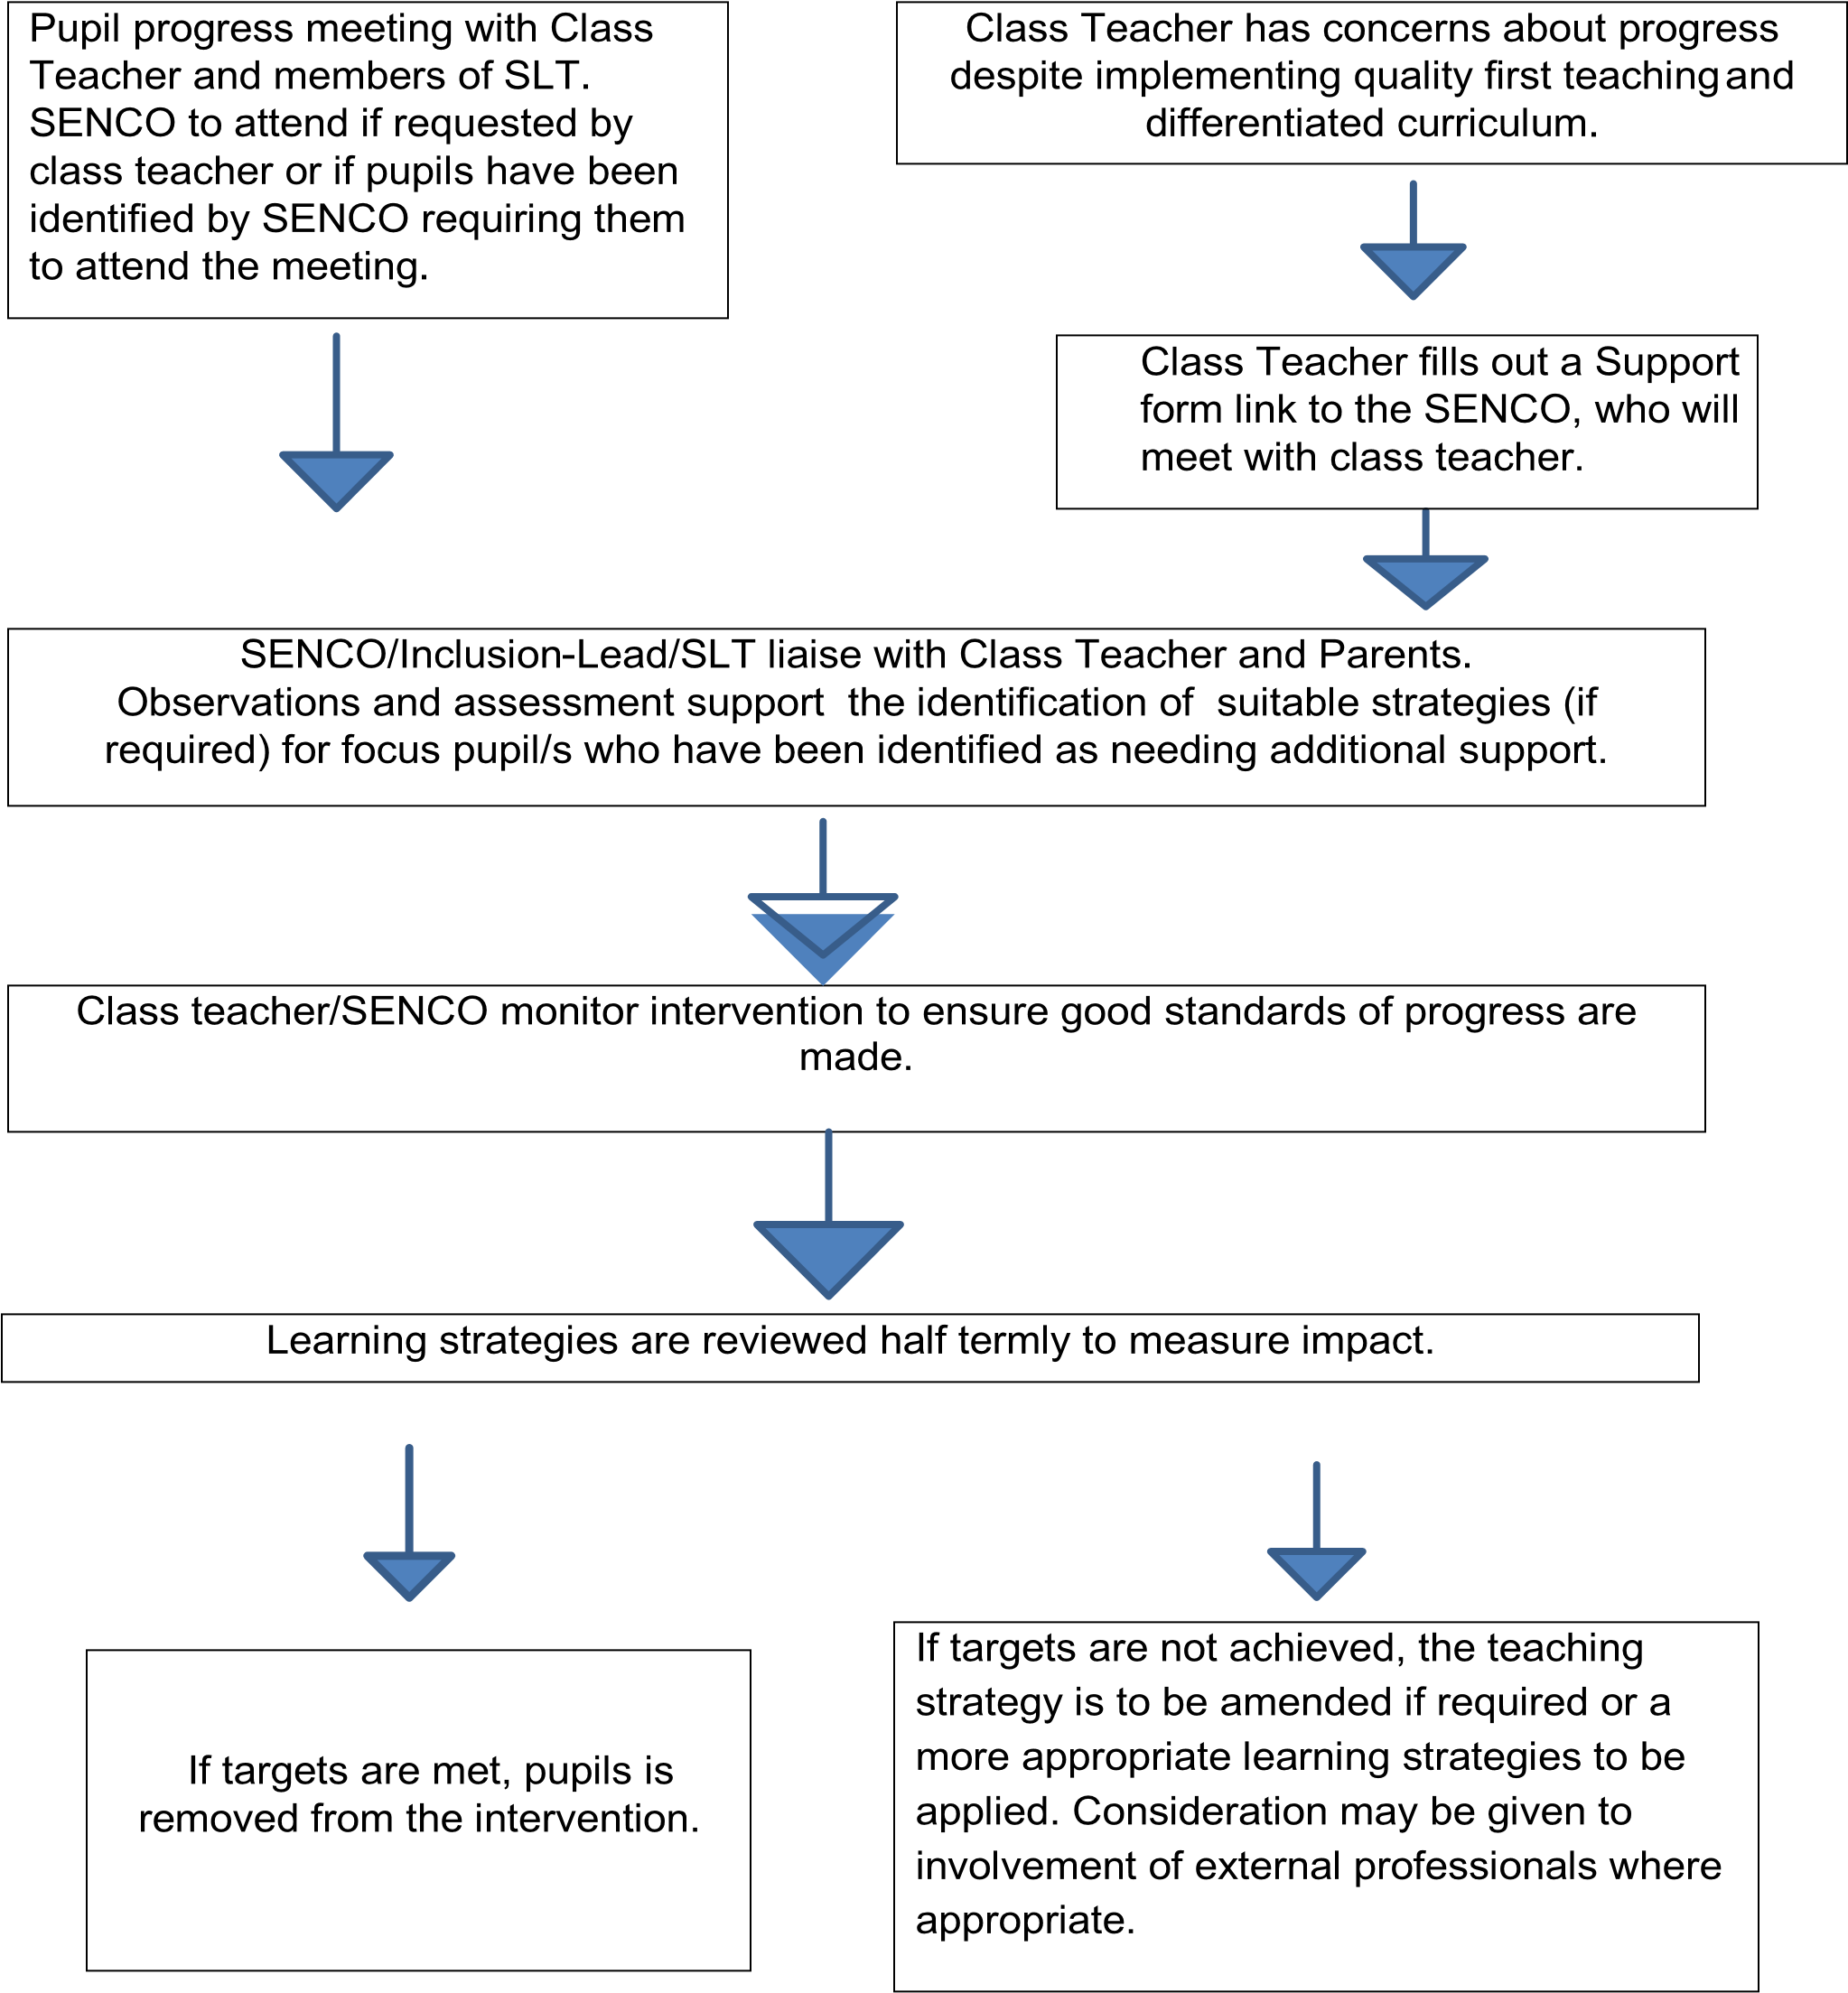

We recognise that, in practice, individual pupils often have needs which include more than one of these areas and that their needs may change over time. Our purpose is not to ‘label’ a pupil, but to work out what action the school needs to take. We consider the needs of the whole pupil and ensure that support is focused on individual need and personal outcomes rather than a classification/label.
Teachers are responsible and accountable for the progress and development of all the pupils in their class, including those who have or may have SEN and who access support from teaching assistants, specialist staff, or who attend a provision space.

SEN Support

When a pupil is identified as having SEN, we take action to remove barriers to learning and put effective special educational needs provision in place.
Quality First Teaching (Wave 1) remains our first response in relation to the identification of SEN, but we also ensure that the pupils receive high quality additional support and interventions are carefully matched to their needs.
We adopt the graduated approach and four-part cycle of ‘assess–plan–do-review’ as recommended in the SEN Code of Practice. In successive cycles the SEN Support received by the pupils is refined or revised depending on how effective it has been in achieving the agreed outcomes. Where a pupil continues to make less than expected progress despite the school’s best efforts, and with the agreement of the pupil’s parents/carers. We will involve appropriate specialists and outreach services.
Pupils who are identified as having SEN, as with all pupils, will have individual targets which will need to be met by the pupils. The targets will be discussed and generated by the pupils and class teacher. Information containing the type and level of support will also be documented.

Individual targets are regularly assessed and reviewed by the class teacher. Some pupils will make accelerated progress and cease to require SEN support after a period of targeted intervention and these pupils will then be removed from the school’s register of SEN pupils. However, we continue to monitor the progress of such pupils closely to ensure their progress is maintained.

Education, Health and Care Plans

A small number of pupils with the most complex needs may need the support of an Education, Health and Care Plan (EHC Plan) to enable them to achieve the best possible outcomes. All these pupils have individual Pupil Passports which state the termly targets and additional, individual and specific information relating to the pupils. If we believe that a pupil’s needs require provision and resourcing over and above that which we make available to our SEN pupils from delegated funding, we will request that the Local Authority conduct an assessment of the pupil’s education, health and care needs. Pupils who will need an EHCP will be identified by the school SENCO and they will complete the process of applying for, reviewing and updating all areas for the EHCP with support from the class teacher and parents of the pupils. Parents can

How Eastbury Primary School adapts the curriculum and learning environment for pupils with SEN.
Our curricular framework concentrates on four core Principles of Development, which have been linked to the SEND Code of Practice to facilitate and support the planning, delivery, monitoring and assessment of our curriculum.
- Understanding the Individual – every child/young person is a unique pupil.
- Positive and Effective Relationships – pupils learn to be resilient and independent through positive relationships.
- Enabling Environments – pupils develop in the context of the environments around them, in which their experiences respond to their individual needs and where strong partnerships between teachers, external professionals and parents/carers are paramount.
- Learning and Development – pupils learn in different ways, which is the reason why our practitioners provide engaging and challenging opportunities across the prime (personal, social and emotional development, Communication and
Language and Physical Development) and specific (Literacy, Cognition) areas of learning and development.
It is not the responsibility of the child to change to meet the demands of the curriculum; it is the responsibility of those writing the curriculum to ensure that it is flexible enough and adaptable enough to meet the needs of each child, which we do through careful consideration of each pupil’s learning styles and needs leading to distinct pathways which strive to be responsive to each learner, build on individual strengths and interests and enable every pupil to shine.
It is the responsibility of teachers to make the appropriate adaptations to the curriculum and learning environment to enable pupils with SEN access learning opportunities and experience success alongside their peers. Our teachers have a clear understanding of the needs of the SEN pupils in their class and know a range of strategies that can be utilised to support pupils.
They can draw on the expertise of the SENCO, who can support in the differentiation of learning to give access to the pupils through guidance and modelling.
Expertise from outreach teachers and professionals from other external agencies for advice will also be used. For example, the Speech and Language Therapy Service provides support programmes for pupils with speech and language difficulties.

Additional support for learning available to pupils with SEN

The SENCO works with teachers to ensure the school provides a range of intervention programmes to address the needs of groups of pupils and individual pupils within the school supporting teachers to identify which additional interventions are appropriate to meet their needs. Examples of interventions available include: Colourful semantics, speech and language programmes; Language Link, reading interventions targeting a variety of different needs, with others available.
The SENCO is able to discuss interventions in more detail, if needed. Interventions are delivered by SEN Learning Support Assistants (LSAs) under the direction of the teacher and/or the SENCO. Other interventions are delivered by teachers.

There is also an additional resource provision (ARP) for pupils who are deaf. Qualified communicators and Teachers of the Deaf support their additional needs and integration into mainstream classes. We also have a provision space (Sunshine Room) for some of our more complex needs pupils. They are supported by SEN Learning Support Assistants who are overseen by the SENCO with support from the Inclusion Lead. These pupils also have some time (where appropriate) in their mainstream classes with adult support.

Support for pupils with Social, Emotional and Mental Health Needs (SEMH)

Some pupils’ special educational needs relate to social, emotional or mental health difficulties. Whilst some display their difficulties through challenging or disruptive behaviour, other pupils may become withdrawn or isolated. These difficulties may reflect underlying mental health difficulties such as anxiety or depression. Some pupils may have disorders such as attention deficit disorder ADD), attention deficit hyperactive disorder (ADHD) or attachment disorder. Extra support to address the needs of these pupils can be individual or group interventions, liaising with relevant outreach services and health professionals as appropriate.
Teaching assistants understand the need to develop independence in the pupils with whom they work, and support is only assigned when it is needed.
There is a sensory room which encourages and supports pupils to learn through sensory exploration and is also an area of calming. There is a small play area provided for pupils who struggle with social interaction in the larger play areas of the school. It offers a more structured, adult led play environment designed to support pupils to develop their social interaction; sharing, forming relationships with peers in a more controlled environment.

Physical or medical Needs

If a pupil needs specialist equipment due to physical or medical needs, the SENCO will liaise with the relevant professionals to secure the equipment needed and any training for staff required in its use. E.g. physiotherapy or occupational therapy.

How Eastbury Primary School evaluates the effectiveness of its provision for pupils with SEN
Intervention programmes are time-limited and the progress of pupils taking part is tracked, with all interventions being recorded on the Edukey system where a profile around each individual pupil is built. If there is no evidence that an intervention is effective, we will either adapt the intervention to more closely meet the pupil’s needs or we will plan a different type of support. The success of the education offered to pupils with SEN will be judged against the aims of this SEN policy. The SEN policy will be reviewed by the Governing Body’s Annual Report will report on the implementation of the policy.

How Eastbury Primary School assesses and reviews the progress of pupils with SEN

We have a tracking system for monitoring the progress of all our pupils, including those with SEN.

Pupil Progress meetings are held termly, attended by the class teacher, and members of the Senior Leadership team, as well as the SENCO where class teachers have requested them to attend or the SENCO has identified pupils that need support at which action is planned to address any lack of progress identified.

The ‘assess-plan-do-review’ cycle ensures that we match provision closely to each pupil’s needs and that we respond quickly to any evidence of inadequate progress. The progress of SEN pupils in relation to the objectives in their Education and Health Care plan of Special Educational Needs or the outcomes in their Education, Health and Care Plan are reviewed annually. A pupil’s objectives or outcomes are broken down into smaller steps and recorded on the pupil’s Individual Pupil Passport. These shorter-term targets are reviewed at least termly. We involve the pupils and family fully in the planning and review process

Admissions

Pupils with SEN are admitted to the school on the same basis as any other pupils.
The Governing Body uses the LA admissions criteria.
The school SENCO will observe or meet all new pupils to the school to ensure an assessment of support can be completed on entry.
An email will be sent to all relevant staff to inform of a new pupil starting at the school for EAL, dietary needs, SEN etc.

Roles and responsibilities

Provision for pupils with special educational needs is a matter for the school as a whole. However, some key individuals and groups have particular areas of responsibility:

Governing Body Responsibilities
- To check that the school is complying with its legal responsibilities.
- Check and ask for reports on the steps being taken to ensure compliance
- To challenge leaders to ensure that SEND remains high on the school’s agenda

The Special Educational Needs Co-ordinator

The Special Needs Co-ordinator is Satvir Kaur.
She is in school full time. Her key responsibilities include:

- To work in collaboration with the Headteacher, Deputy Headteacher, school governors and staff to develop a clear strategic direction for SEN
- To liaise and feedback to the Inclusion Lead regularly
- To oversee the day-to-day operation of the school’s SEN policy
- To coordinate and develop high quality provision to meet the needs of pupils with SEN
- To work in partnership with parents/carers of pupils with SEN to develop and review effective support for their pupils
- To work with teachers to monitor the effectiveness of interventions and the progress made by pupils with SEN
- To liaise with the LAC Lead teacher where looked after pupils have SEN
- To advise on the deployment of the school’s delegated budget and other resources to meet pupils’ needs effectively
- To liaise with professionals from outside agencies, such as educational psychologists, outreach services, health and social care professionals, and
independent and voluntary bodies, ensuring that appropriate referrals are made and strategies are implemented
- To liaise with other schools to ensure that pupils make smooth transitions between school placements
- To work with the Head teacher and school governors to ensure that the school meets its responsibilities under the Equality Act (2010) with regards to reasonable adjustment and access arrangements
- To promote the inclusion of pupils with SEN in the school community, ensuring they have access to the school’s curriculum, facilities and extra-curricular activities
- To ensure that the records of pupils with SEN are maintained and kept up to date
- To support and advise teachers about differentiated teaching methods appropriate for individual pupils with special educational needs
- To coordinate the effective deployment of learning support assistants, providing support and training as needed
- To contribute to the in-service professional development of staff in relation to SEN

Teachers – With support where required and requested from the school SENCO

- To provide Quality First Teaching for all the pupils in their class
- To provide for the individual needs of all their pupils, adapting their teaching and the learning environment as appropriate
- To be accountable for the progress of all their pupils, including those who receive additional support from learning support assistants and specialist teachers
- To work with the SENCO to monitor the effectiveness of interventions and the progress made by pupils with SEN Learning Support Assistants
- To support pupils with their learning with the advice when needed from the SENCO or support and training in implementing strategies recommended, as well as knowledge and skills from professionals from external agencies
- To develop the independence of the pupils with whom they work
- To provide feedback to the pupils, parents, SLT on the progress of the pupils with whom they work to inform learning progress, planning and further support
- To be sensitive to the emotional and physical needs of pupils
- To analyse data/assessments to inform planning, reviewing, next steps and support

The school makes an annual audit of training needs for all staff taking into account school priorities as well as personal professional development. The school is allocated funding from the Standards Fund each year that it may use to meet identified needs. Particular support is given to Newly Qualified Teachers and other new members of staff.

Arrangements for partnership with parents.

We recognise the importance of working in partnership with parents.

Parents hold key information and have knowledge and experience to contribute to the shared view of a pupil's needs and the best ways of supporting them. All parents of pupils with special educational needs will be treated as partners and supported to play an active and valued role in their pupil’s education with the opportunity to approach the class teacher or school SENCO at any time. We will always tell parents when their pupils is receiving help for their special educational needs and will involve them fully in planning and reviewing any SEN provision. A pupil’s class teacher will work closely with parents at all stages in his/her education and if parents have concerns their first port of call should be the class teacher.
Parents of any pupil identified with SEN may contact the Parents in Partnership Service of Barking and Dagenham for independent support and advice.

Pupil participation

Pupils and young people with special educational needs often have a unique knowledge of their own needs and circumstances and their own views about what sort of help they would like to help them make the most of their education. They will be encouraged to participate in the decision-making processes, including the setting and evaluation of targets. We are committed to developing more pupils-centred ways of working to make it easier for our SEN pupils to express their views.

Storing and Managing Information

See Eastbury Primary School’s Data Protection Policy (on the school website).

Links with other mainstream schools and special schools

Advanced planning for pupils in Year 6 is essential to allow a smooth transition to secondary school. The SENCO will liaise with the SENCO of the Secondary Schools to ensure that effective arrangements are in place to support pupils at the time of transfer. When pupils move to another school their records will be transferred to the next school within 15 days of the pupil ceasing to be registered, as required under the Education (Pupil Information) Regulations 2000. Eastbury Primary School has good links with local special schools through the outreach services.

Links with other agencies and voluntary organisations.

External support services play an important part in helping the school identify, assess and make provision for pupils with special education needs. The school receives regular visits from the nominated Education Welfare Officer for the area. The SENCO works closely with the Educational Psychologist assigned to the school and meets with her at the beginning of each term to plan her work in the school for the term. Other agencies and outreach services that the school works with include:
- Speech and language therapy service

- Physiotherapy service

- Joseph Clark Service for the Visually Impaired

- Early Years Advisory and Support Service

- CAMHS (Pupils and Adolescent Mental Health Service)

- Barking and Dagenham Pupils Development Centre

- Virtual School for Looked After Pupils

- Social Care services

Complaints Procedures

The schools’ complaint procedures are set out on the school website.

Under the Pupils and Families Act 2014 parents may seek advice on resolving disagreements with the LA and/or the Independent Mediation Service.
The school will make further information about this process available on request.

Eastbury Primary School’s Local Offer

Further information on the school’s arrangements for supporting pupils with SEN can be found in the school’s Local Offer which can be accessed via Eastbury Primary School website: Our School Local Offer forms part of the local authority’s Local Offer, which is also available as a link on this site and provides information for parents/carers on SEN services available within Barking and Dagenham and neighbouring boroughs.

Legislation and guidance relevant to this policy

Pupils and Families Act 2014,

Part 3 Educational Needs and Disability Code of Practice: 0 to 25 years 2014
Equality Act 2010
Education Act 2011

Related school policies Equality Policy
Health and Safety Policy
Policy on Supporting Pupils with Medical Conditions

