Document History
CREATED: | September 2025
By: | Principal
Version: | 1
REVIEW FREQUENCY: | Bi-Annually
NEXT REVIEW DATE: | September 2027

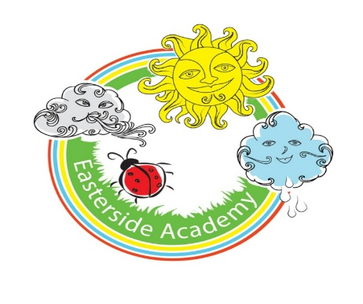

Art Policy

Curriculum Aims
Our Art and design curriculum aims to nurture pupils’ creativity, imagination and visual literacy, encouraging them to think like artists and designers. The intention is for pupils to develop the confidence to experiment, express ideas and communicate meaning through visual and tactile media.
Our curriculum promotes an appreciation of art as a powerful form of human expression, helping pupils to understand its role across different cultures, time periods and creative industries. It encourages children to value originality, take creative risks and reflect critically on their own work and that of others.
National curriculum
Our Art and design curriculum fulfils the expectations of the National Art and design Programmes of Study found here.
The strands
Our Art and design curriculum is structured around five strands that run through each unit:
- Generating ideas.
- Using sketchbooks.
- Making skills (including formal elements).
- Knowledge of artists.
- Evaluating and analysing.
These strands ensure a balanced coverage of the practical, theoretical and disciplinary knowledge pupils need to progress in Art and design, while supporting the development of both creative confidence and critical thinking.

Key areas
The National curriculum refers to pupils developing their mastery of art and design techniques, including drawing, painting and sculpture.
To support this, our Art and design curriculum returns to these three key areas in every year group. This approach enables pupils to see their progress with particular forms of media while also continuing to develop their broader making skills, building confidence and competence over time.
Our curriculum includes a fourth key area: Craft and design. This area focuses on giving pupils a broad range of opportunities to explore different craft and design techniques during primary school, rather than following a linear progression.
Progression
Our progression of skills document provides an overview of the skills and knowledge covered in each phase and strand. It explains how Art and design skills and knowledge are developed to support pupils in reaching the key stage outcomes as outlined in the National curriculum.
New learning is weighted toward the start of each key stage, allowing ample opportunity for it to be revisited and applied in later years. As a result, knowledge accumulation may appear heavier in some year groups than others.


Spiral curriculum
Our Art and design curriculum has been designed as a spiral curriculum with the following key principles in mind:
- Cyclical – pupils return to the key knowledge and skills again and again during their time in primary school.
- Increasing depth – each time a skill is revisited, it is covered with greater complexity.
- Prior knowledge – pupils build upon previous foundations rather than starting again.

Types of Knowledge
Knowledge is defined differently depending on the subject in question. Ofsted helps to define knowledge in Art and design as:
- Practical knowledge – the skills and techniques pupils use when making art, including methods, materials and formal elements.
- Theoretical knowledge – knowledge of artists, art movements and contexts that help pupils understand and interpret creative work.
- Disciplinary knowledge – understanding how art is studied, discussed and evaluated through critical reflection and questioning.

Practical knowledge
Practical knowledge refers to the hands-on, procedural knowledge that pupils develop through working with tools, materials and techniques.

Theoretical knowledge
Theoretical knowledge is the contextual and conceptual understanding that helps pupils make sense of art, how it is created, interpreted and situated within different cultures, time periods and artistic movements.
Disciplinary knowledge
Disciplinary knowledge is the understanding pupils develop about how art is studied, discussed and evaluated. It helps pupils think like artists, critics and curators, questioning what art is, why people create it and how meaning is communicated or interpreted.

Digital literacy
Our Art and design curriculum integrates technology through activities such as digital drawing and image manipulation. This helps develop pupils’ confidence in using digital tools to create, research and respond effectively to visual information.

The importance of oracy
Learning through talk
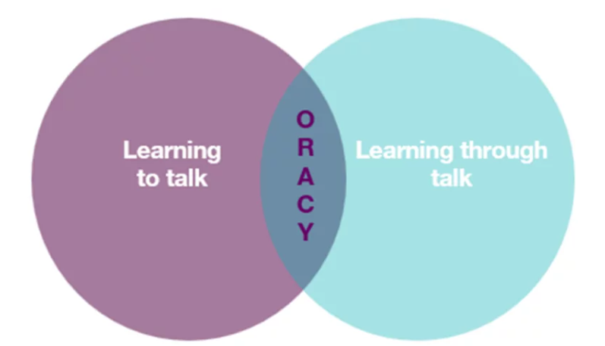
It is crucial to provide our pupils with opportunities for exploratory talk during their learning. This involves thinking aloud, questioning, discussing and collaboratively building ideas.
Learning to talk
Similarly, developing oracy skills is essential for pupils to express and articulate themselves effectively across various contexts and settings, including formal ones such as public speaking, debates and interviews.
Oracy skills in Art and design
Through our Art and design curriculum, pupils have opportunities to develop their oracy skills by:
- Explaining and justifying their choices of materials, methods and techniques.
- Engaging in paired and group discussions.
- Presenting and explaining their artwork and ideas to peers and the class.
- Analysing and critiquing the work of others, as well as established artists.
- Collaborating on group artwork.
- Responding to high-level questions such as ‘What is art?’ by articulating and defending their ideas.

Sustainability
Our Art and design curriculum supports sustainability education by encouraging pupils to reflect on their role as creative citizens.
Through exploring themes such as environmental art, waste and the use of natural and recycled materials, pupils develop an appreciation of how art can respond to and represent ecological concerns.
Art can be a powerful medium for expressing ideas about climate change, conservation and social responsibility.
By making and discussing artwork that addresses environmental themes, our pupils are empowered to think critically, act thoughtfully and see themselves as contributors to a more sustainable future.

Critical thinking
Pupils explore and evaluate artistic works, experiment with different techniques and reflect on their own and others’ creations. This helps them to question assumptions, develop their creativity and form thoughtful responses to artistic ideas and visual culture.
Personal development in Art and design
- SMSC
Our curriculum supports Spiritual, Moral, Social and Cultural (SMSC) development by encouraging pupils to:
- Explore different perspectives.
- Reflect on ethical issues.
- Collaborate with others.
- Appreciate cultural diversity through subject-specific content.

- British Values
Our lessons promote British values (democracy, the rule of law, individual liberty, mutual respect and tolerance) by incorporating activities that encourage debate, respect for differing opinions and an understanding of societal structures.
- Cultural capital
Art and design curriculum broadens children’s experiences by introducing them to a diverse range of artists, artistic traditions and cultural contexts. It ensures our pupils develop the knowledge, skills and visual literacy needed to engage meaningfully with the creative world around them.

Inclusion and diversity
Our curriculum has been designed to be inclusive and representative, ensuring all pupils see themselves reflected in the products, users and contexts they explore.
We feature a diverse range of design traditions, food cultures, materials and technologies from around the world and encourage pupils to design with empathy and respect to a variety of users.
This approach helps challenge stereotypes, broaden perspectives and celebrate design as a practical, creative and culturally-rich human endeavour.

Timetabling
Art and design and D&T are taught for 1 hour per week and alternate every 4/5 weeks.

SEND
Our curriculum is designed to be fully adaptable for pupils with SEND. Every lesson includes adaptive teaching to meet the needs of all learners.
Teachers at Easterside include a range of strategies to support and challenge every pupil, such as:
- Scaffolding – tasks are designed with flexibility in mind, allowing for additional support or challenge where needed.
- Multi-sensory approaches – lessons incorporate different elements to engage all learners.
- Clear instructions and structured tasks – ensuring clarity and reducing cognitive load for pupils who benefit from additional support.
- Opportunities for collaborative and independent learning – allowing pupils to work at their own pace while building confidence and independence.
By embedding adaptive teaching throughout, teachers ensure that all pupils, regardless of their starting points, can access and succeed in their learning.
In addition, the curriculum design supports pupils with SEND, avoiding sudden jumps in complexity at transition points and allowing for steady, manageable progression.

Knowledge Retention
Spiral curriculum
Our curriculum incorporates a spiral curriculum model, ensuring that pupils revisit and develop their understanding of key themes and concepts as they progress. This approach allows them to make meaningful connections, reinforce their learning and achieve mastery over time.
- Revisiting key concepts – pupils encounter the same ideas multiple times throughout their education, with each revisit adding more complexity.
- Progressive depth – concepts are not just repeated but expanded upon, helping pupils to make connections and develop a richer understanding over time.
- Knowledge retention – regular exposure to key ideas strengthens memory and prevents knowledge from being forgotten.
- Skill development – pupils refine and apply their skills in different contexts, improving their ability to think critically and solve problems.
- Adaptive learning – by building on prior knowledge, the curriculum meets pupils at their current level and supports all learners, including those who need extra reinforcement and those who are ready for greater challenges.

Knowledge organisers
Every strand has a knowledge organiser which is a structured document designed to support pupils’ learning by clearly outlining the key knowledge, vocabulary and concepts covered in a topic.
It serves as a reference tool for both teachers and pupils, helping to consolidate learning and support knowledge retention.
- Essential knowledge at a glance – summarises the most important facts, concepts and skills that pupils need to learn for a particular topic.
- Key vocabulary – provides a list of subject-specific terms with definitions to develop pupils’ language and understanding.
- Clear and visual layout – organised in a way that makes information easy to digest and revisit, often using diagrams, timelines or key images.
- Support for retrieval practice – helps pupils engage in self-assessment, recall activities and revision, reinforcing long-term memory.
- Teacher and pupil-friendly – acts as a quick reference for teachers when planning lessons and an accessible learning aid for pupils to develop independence in their studies.

Retrieval
Each lesson starts with a retrieval task.
- Activates prior knowledge – helps pupils make connections between new and existing learning, reducing cognitive overload.
- Strengthens memory pathways – retrieval practice has been shown to improve retention more effectively than passive review.
- Identifies gaps in understanding – teachers can quickly assess what pupils remember and address misconceptions before introducing new content.
- Builds confidence – regular recall activities reassure pupils that they can remember key concepts, improving engagement and motivation.
- Promotes spaced learning – revisiting prior learning at regular intervals supports long-term retention, rather than cramming information into a single lesson.

Formative Assessment
Formative assessment is embedded throughout our lessons to ensure that teachers can gauge pupils’ understanding in real time and adapt their teaching accordingly.
- Questioning – lesson plans include targeted and open-ended questions to check understanding, promote critical thinking and address misconceptions.
- Observation – teachers are supported to observe pupils during tasks, noting how they approach activities, collaborate and apply history skills.
- Discussion and peer interaction – pair and group discussions are built into lessons, providing opportunities for pupils to articulate their thinking and for teachers to assess understanding through dialogue.
- Lesson pauses –strategic pause points for checking comprehension, summarising learning and addressing any common errors before progressing.
- Retrieval practice – recap activities such as short recall tasks and oral explanations are embedded to reinforce prior knowledge and assess retention.
- Use of success criteria – success criteria are shared within lessons, allowing pupils to self-assess or peer-assess their work and reflect on their progress.

Summative Assessment
Summative assessment is carried out yearly to indicate if a child is working towards, at or above age-related expectations. Children are assessed against the relevant National Curriculum statements for Art and design which are listed in the subject overview document.

Cross-curricular learning
Our Art and design curriculum supports cross-curricular learning by making clear connections between subjects, helping pupils develop a broader understanding of key concepts and skills.

Produced by: SLT
Reviewed date: December 2025

