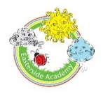

EASTERSIDE ACADEMY
Careers Curriculum
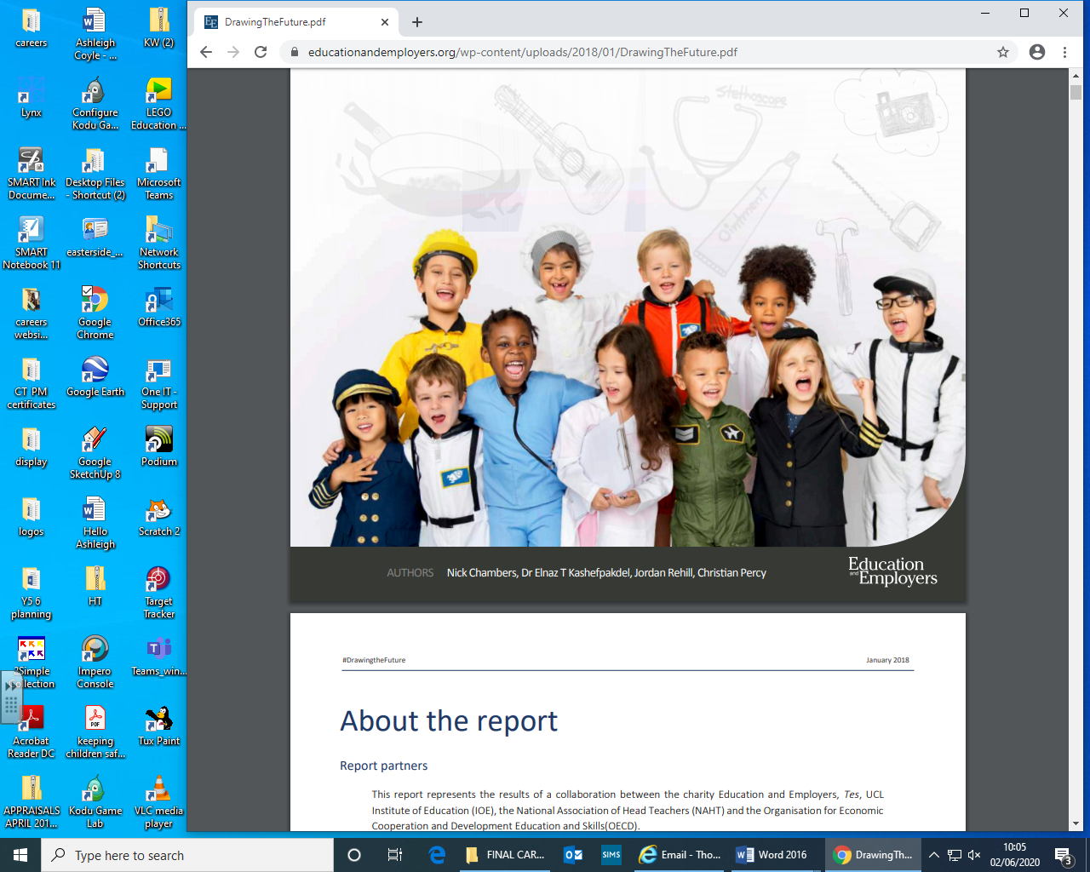
Whole School Plan

Team | Career  Focus | Cycle | Autumn 1 | Autumn 2 | Spring 1 | Spring 2 | Summer 1 | Summer  2
EYS | All about Me  Child –centred | Cycle 1/2 | Changes-Ourselves  - Role play –hands on activities ( taking on different roles) e.g. shop assistant etc.  - Use of areas to develop range of skills  - Equality of opportunity for all  - All about me- what do I want to do when I grow up?  - Pets-Looking after class pet-managing care needs- ongoing  - Stay and Play topics- ongoing | World of Work  - Visit to Care Home (ongoing)  - Use of LOTC- Keyworker focus (PSHE)- focus on rules, routines and feelings. Develop independence and collaboration | Once Upon a Time.  - Visits from local community-eg  - Dental service  - Roles of different characters- exploring through stories and role play. | World of Work  - Visit to Care Home (ongoing)  - Use of LOTC- Keyworker focus (PSHE)- focus on rules, routines and feelings. Develop independence and collaboration | Off We Go-Out and About.  - People who help us-visit Fire Service  - Local environment- different building and shops  - Local environment –road safety. | Visits to local places  - Visits may vary based on children’s interests - Farm- roles and responsibilities on the farm/animals/supermarket
KS1 | Emergency services/  School Roles/Enterprise | Cycle 1 | What is the same/different about us?  - Explore qualities and skills  - Enterprise -Class museum/  - Money making project-/ Class Budget |  | What helps us stay healthy?  - School nurse  - Dental Service | What can we do with money?  - Mrs Pennock- role of ABM and managing budgets. | Who helps to keep us safe?  - Great North Ambulance | How can we look after each other and the world?  - Red Cross  - Tollesby Home Care worker
KS1 | Emergency services/  School Roles/Enterprise | Cycle 1 |  | ^{Who burnt London down?}  STEM links- construction
KS1 | Emergency services/  School Roles/Enterprise | Cycle 2 | What makes us a good friend?  - Focus on qualities |  | What jobs do people do?  School Job Fair  - School Office/Site Manager/teacher-Principal /Vice Principal  - Catering incl. Mellors  - Staff/Cleaners/Lunchtime supervisors  Opportunities to visit/shadow staff based on pupils interests |  | What helps us grow and stay safe?  - Care Team  - IT leader  - JSOs( Junior Safety Officer)
KS1 | Emergency services/  School Roles/Enterprise | Cycle 2 | What makes a hero?  - Emergency Services, RNLI |  | What’s in Space?  - STEMlinks construction/astronomy
Y3/4 | Community Links/Role within the NHS | Cycle 1 | What is the same/different about us? 1  - Explore qualities and skills |  |  | What makes a community?  - Roles within the local community:  - Shop manager/ Librarian/Hairdresser/  - Beautician/Baker-Visitors/visit | Why should we eat well and look after our teeth?  - NHS Workers  - Stepping into the NHS  - ( refer to HHS careers website) | Why should we keep active and sleep well?  - Sports coaches
Y3/4 | Community Links/Role within the NHS | Cycle 1 | Where is the journey of the Cacao Bean?  STEM links- vehicles |  |  |  |  | What does it mean to be civilised?  - STEM –engineering
Y3/4 | Community Links/Role within the NHS | Cycle 2 | What makes us a good friend? 2  - Focus on qualities and skills |  | How do we manage our feelings?  - Head starters –Y5/6  - Thrive practitioners  - Care team | How do we grow and change?  - School Nurse  /personal hygiene/diet | How can our choices make a difference to others and the environment?  - Democracy-Parliament/elections-use of parliamentary boxes  - Governors  - Rotary club members/School Council | How can we manage risks ?  - Junior Safety Officers(JSO)  - Pedestrian trainers  - Police -e-safety officer
Y3/4 | Community Links/Role within the NHS | Cycle 2 |  |  | How did Pompeii become a lost city?  STEM links- Construction/Computing | How does the body work?  STEM links-doctor/biology lecturer/secondary teacher
Y5/6 | Wider World of Work/ International Links/Transition Further Education Links | Cycle 1 | What makes up a person’s identity?  - Job application process-focus on skills and qualities  - Y6 monitor roles/work experience-process of job application  - Adam Walker( recruitment)/D Elliott –( school governor) | What decisions can people make about money?  Enterprise opportunities  - My money week-Barclays  - Nat West  - Class budget | How can we help in an accident or emergency?  - St Johns Ambulance | Protected Characteristics- (Refer to National Equality Act) | How can drugs common everyday life affect health?  - Outside Agencies  Moving on/Money matters  - Secondary Transition Y6  - Enterprise -Fiver Challenge/Barclays/Game of Life Y6  - Life skills-Stepping Out together | What jobs would we like?  Jobs Fair-Various careers/  - Ex pupils  - Rotary Club-various jobs  - Emergency Services/Red Cross  - Architects/building trade  - Law/solicitors/lawyers  - Engineering/construction/gamer  - Creative sector  - Navy personnel ( HMS Protector)
Y5/6 |  | Cycle 1 | Could the Great Plague strike again?  - STEM links- scientist |  | Can we prevent the Frozen Kingdom from disappearing?  - HMS Protector –visits and ongoing | How safe were Victorian mines?  - STEM links-engineering  - MAP links- history project. | What makes things move?  - STEM links-engineering and computing
Y5/6 |  | Cycle 2 | Job application process- focus on skills and qualities  Y6 monitor roles/work experience-process of job application  Adam Walker( recruitment)/D Elliott –( school governor) | How can we keep healthy as we grow?  - Sports coaches/PTs/Sports Village/Visit by athlete/footballer  - Dementia Friends | - How can the media influence people?  - Visitors -journalists/ radio/TV  - Visits to TV, radio and newspaper  - E safety/IT links- |  | What will change as we become more independent?  How will friendships change?  - Preparation for the future- Secondary Transition Y6  - Enterprise -Fiver Challenge/Barclays/Game of Life Y6 | Where should we go on holiday?  Speed careers ‘dating ‘  - Ex pupils  - Rotary Club-various jobs  - Emergency Services/Red Cross  - Architects/building trade/Engineering/construction/gamer  - Law/solicitors  - Creative sector  - Navy personnel ( HMS Protector
Y5/6 |  | Cycle 2 | Is there anyone else?  - Bring it on’ exhibition -Sunderland  - STEM links-Space-IT moon buggies/astronomer |  | How important are rivers  STEM links- construction | How healthy is your heart?  - Dr R Spencer_ Middlesbrough College  - Community nurse | Where should we go on holiday?  - Film director  - Travel agent
**PSHE links STEM links Aspects of careers curriculum visited annually

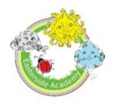
Additional Careers- Related Opportunities

- EYS-regular visits to Care Home /LOtC/Keyworker time-PSHE Focus/ Stay and play/ topics- people who help us/visit-local environment/trips to the farm
- Transition-EYs>KS1>KS2>Secondary school- Preparing children for the next phase of their education. Visits to new classes, meeting new staff, shared play times and lunchtimes, involvement of parents. Following transition teachers visit children in new classes.
- KS1/2- enterprise -class budgets, fundraising /links with Gambia/opportunities for debate-use of P4c/ News/elections/ recognising qualities and skills/LOTC/Twinning/Museum in the Classroom
- Head Starters/RPMs-training provided by external body
- Captains/ Vice Captain- speeches/elections
- Rota Kids-election of President, Vice President, Secretary, Treasurer and other Committee Members-Organise and hosting of Community Event with the Rotary Club-involving links with parents/grandparents and senior citizens from the estate/ local shops/social club/contact with the media/ Mellors School Catering Service
- School Council Members/Eco Warriors- election. Involvement in community. Visit to Town Hall to hold meeting/fundraising/Publishing Careers Newsletter
- Opportunities for different groups of children to experience World of Work- eg School librarians and book area monitors-visiting Middlesbrough Central Library
- Every visitor/ member of the wider community met during a visit should be requested –to discuss role including skills qualities skills needed / education and training/qualifications. Evidence (photographs, samples of written work, questions, answers etc.) placed in PSHE book. Any videos recording responses of careers are placed in Careers folders on network.
- Opportunities in Literacy- -author and illustrator visits/ Middlesbrough Roadshow Numeracy/ Involvement in NLT Reading Programme which included visits to various shops/restaurants at Teesside Retail Park.
- Opportunities in Maths-enterprise/LoTC/Visits to industry/FE/Ambassador Visits
- STEM-resources and ambassadors programme linked to Science, Technology, Engineering, Maths (see separate document)
- Links with Red Cross, Oxfam, Global Dimensions, Unicef
- Opportunities to find out more about performing arts/dance provided through Theatre Groups performances in school/Visits to theatres/workshop/involvement with dance schools-eg Urban Kaos
- Assemblies/workshop from outside agencies eg NSPCC
- Open mornings- Careers focus children draw an image of themselves in aspirational job.
- Y6 graduation/celebration assembly children share aspirational jobs with parents/carers, peers and staff.
- Links developed with HMS Protector-visits to ship, communication with ship throughout their voyages, visits to school by ships personnel.

