

Community Care Centre
Speech and Language Therapy Service
North Ormesby Health Village
2 Trinity Mews
Middlesbrough
TS3 6AL
Tel: 01642 944488
July 2020

CORONAVIRUS UPDATE

INFORMATION FROM THE SPEECH AND LANGUAGE THERAPY SERVICE

Dear Parents / Guardians

As you will be aware, many NHS services have been disrupted due to the Coronavirus (Covid-19) outbreak.

We have been making telephone calls to all of our families – offering advice and support and recently we have moved to offering video consultations where we have been able to complete assessments of progress and offer some therapy where appropriate. However, we recognise that video consultations are not suitable for all children and families so in these cases we have continued with telephone contacts.

Over the course of lockdown, we have developed our FaceBook page, our YouTube channel, Instagram and Twitter, where we offer advice, videos and strategies to help you support your children with their communication difficulties.

As you know, the government have been gradually easing lockdown restrictions and we are now in the position to begin a staged recovery of parts of our service. We’re being led by South Tees Hospitals NHS Foundation Trust to get approval to offer face to face appointments.

We’re working together with schools to look at how we might see your children in their school settings safely, following government recommendations on face coverings and personal protection equipment (PPE). We are also using guidance from our professional bodies to make decisions on where we should see your children.

We will be considering other locations for face to face appointments such as local clinics as well as schools and day nurseries. We are expected to follow infection control procedures in between each visit. This does mean we will not be able to see as many children each day as we did before lockdown. Please bear with us whilst we move through this process – we understand how worried and concerned you may be for your children’s communication difficulties but we MUST ensure we see your children safely.

We will continue to offer video consultations as the preferred option and face to face will only be offered where video contact is unsuitable.

If you have any concerns or questions about your child’s speech and language therapy please get in touch with us via TVCCG.speechtherapy@nhs.net. Please include your child’s name and date of birth so we can access their patient records.

(Please note that whilst NHS emails are secure, we cannot guarantee a secure link when forwarding information to private email accounts – we will not be in a position to send specific clinical information about your child in this manner but would willingly send anonymous resources and hand-outs).

You can also find general information and advice on our Facebook Page – South Tees NHS Speech Therapy, our Twitter page - South Tees NHS Speech Therapy and YouTube Channel - South Tees NHS Speech Therapy.

Many thanks for your patience and understanding at this time.

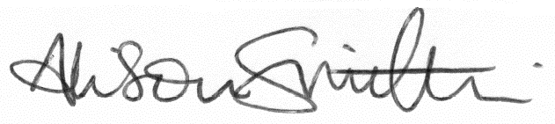

Alison Smithies
South Tees NHS Speech and Language Therapy Service Manager
on behalf of the Speech and Language Therapy Team

