Document History
CREATED: | September 2025
By: | Principal
Version: | 1
REVIEW FREQUENCY: | Bi-Annually
NEXT REVIEW DATE: | September 2027

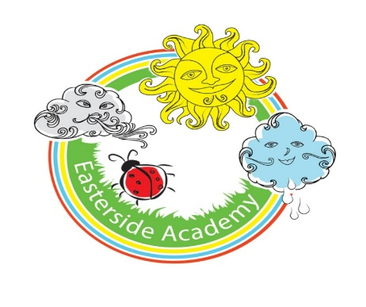

Design and Technology Policy

Curriculum Aims
Our Design and technology curriculum aims to inspire pupils to become curious, creative and innovative thinkers with a broad understanding of how products are designed and made, in other words, to think like designers and engineers. The intention is for our pupils to develop the confidence to identify problems, generate ideas, plan and create products and evaluate their outcomes.
We aim to raise pupils’ awareness of how design and technology shapes the way we live, work and interact with the world. It encourages pupils to become resourceful, enterprising individuals who have the skills to contribute to and improve the world around them.
National curriculum
Our D&T curriculum fulfils the expectations of the National Design and Technology Programmes of Study found here.

The four strands
Our curriculum is structured around four strands that run through every unit:
- Design.
- Make.
- Evaluate.
- Technical knowledge.

Key areas
The National curriculum for Design and technology sets out the importance of creativity through different contexts in the Technical knowledge strand, referring to structures, mechanisms and electrical systems. Cooking and nutrition are given their own heading.
To support this, our curriculum is organised into the following six key areas:
- Structures.
- Mechanisms/Mechanical systems.
- Textiles.
- Cooking and nutrition.
- Electrical systems.
- The digital world.
These areas are revisited across year groups to give pupils a broad and balanced experience of designing and making products using a range of materials, tools and technologies.

Progression
Our Progression of skills and knowledge document provides an overview of the skills and knowledge covered in each key stage and strand. It explains how D&T skills and knowledge are developed to support pupils in reaching key stage outcomes as outlined in the National curriculum.
New learning is weighted toward the start of each key stage, allowing ample opportunity for it to be revisited and applied in later years. As a result, knowledge accumulation may appear heavier in some year groups than others.


Spiral curriculum
Our D&T curriculum has been designed as a spiral curriculum with the following key principles in mind:
- Cyclical – pupils return to the key knowledge and skills again and again during their time in primary school.
- Increasing depth – each time a skill is revisited, it is covered with greater complexity.
- Prior knowledge – pupils build upon previous foundations rather than starting again.
Types of Knowledge
Our D&T curriculum, knowledge is defined using three interrelated categories:
- Disciplinary knowledge.
- Substantive knowledge.
- Procedural knowledge.

Substantive knowledge
Substantive knowledge in D&T refers to the factual and conceptual understanding pupils need to design and make effective products.
This includes knowledge of materials and their properties, mechanical and electrical components, nutrition and food sources and the purpose and features of existing products.

Disciplinary knowledge
Disciplinary knowledge in D&T refers to understanding the practices and thinking processes that underpin the work of designers and engineers.
It encompasses recognising what makes a product effective, approaching problems creatively and testing and refining ideas in response to real needs.

Procedural knowledge
Procedural knowledge in D&T is the knowledge of how to perform tasks: the hands-on skills, techniques and methods needed to design, make and evaluate products effectively.
It encompasses everything from how to cut, shape, join and finish materials to using tools, equipment and ingredients safely and accurately.

Digital literacy
Our D&T curriculum goes beyond basic digital literacy by giving pupils hands-on experience with digital tools and programmable technologies.
Through the Y5 & Y6 Digital world key area, pupils develop confidence in coding, Computer-Aided Design (CAD) and control systems. This supports building the skills to design, monitor and adapt real-world products in a digitally connected world.

The importance of oracy
Learning through talk
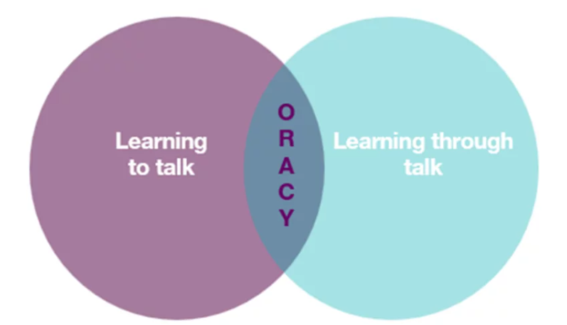
It is crucial to provide our pupils with opportunities for exploratory talk during their learning. This involves thinking aloud, questioning, discussing and collaboratively building ideas.
Learning to talk
Similarly, developing oracy skills is essential for pupils to express and articulate themselves effectively across various contexts and settings, including formal ones such as public speaking, debates and interviews.
Oracy skills in D&T
Lessons are designed to encourage discussion, debate and presentational opportunities on D&T topics, allowing pupils to articulate their understanding, justify design decisions and engage in collaborative problem-solving.
Pupils use oracy to enhance their learning by thinking aloud, questioning and discussing activities. They develop essential skills such as choosing appropriate technical vocabulary, organising their ideas clearly and listening effectively to others.

Sustainability
Our D&T curriculum embeds sustainability within the design process, encouraging pupils to consider the environmental impact of the products they design, make and evaluate. Where possible we grow our own fruits and vegetables for our Cooking and Nutrition strand.
Units across the curriculum explore material choices, food miles and digital solutions that reduce waste or energy use.
The curriculum develops practical problem-solving skills and a deeper understanding of sustainable thinking by engaging pupils with real-world challenges, such as designing for reuse or responsible sourcing.
Pupils learn that thoughtful design can lead to positive change, promoting a sense of agency and responsibility for the world they are helping to shape.

Critical thinking
Pupils analyse design briefs, explore different user needs and perspectives and evaluate materials and production methods. This helps them to question assumptions and make informed decisions when developing creative, functional and sustainable solutions.
Personal development in D&T
- SMSC
Our curriculum supports Spiritual, Moral, Social and Cultural (SMSC) development by encouraging pupils to:
- Explore different perspectives.
- Reflect on ethical issues.
- Collaborate with others.
- Appreciate cultural diversity through subject-specific content.

- British Values
Our lessons promote British values (democracy, the rule of law, individual liberty, mutual respect and tolerance) by incorporating activities that encourage debate, respect for differing opinions and an understanding of societal structures.
- Cultural capital
Our curriculum broadens children’s experiences by introducing them to key designers, inventors, historical and cultural contexts, and a variety of design traditions.
It ensures pupils gain the knowledge and skills needed to engage meaningfully with the designed world and contribute to society. This includes knowledge of the design cycle, a transferable skill applicable to many different disciplines beyond D&T.

Inclusion and diversity
Our curriculum has been designed to be inclusive and representative, ensuring all pupils see themselves reflected in the products, users and contexts they explore.
We feature a diverse range of design traditions, food cultures, materials and technologies from around the world and encourage pupils to design with empathy and respect to a variety of users.
This approach helps challenge stereotypes, broaden perspectives and celebrate design as a practical, creative and culturally-rich human endeavour.

Timetabling
D&T and Art are taught for 1 hour per week and alternate every 5 weeks.

The design cycle
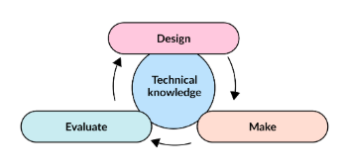
It is important that pupils begin to ‘think like designers and engineers’ by considering how designers identify problems, generate ideas and create solutions to meet real-world needs.
We use the design cycle to support planning and making. This encourages pupils to ask design questions and learn how designers and engineers develop and refine their ideas through research, testing and evaluation.

SEND
Our curriculum is designed to be fully adaptable for pupils with SEND. Every lesson includes adaptive teaching to meet the needs of all learners.
Teachers at Easterside include a range of strategies to support and challenge every pupil, such as:
- Scaffolding – tasks are designed with flexibility in mind, allowing for additional support or challenge where needed.
- Multi-sensory approaches – lessons incorporate different elements to engage all learners.
- Clear instructions and structured tasks – ensuring clarity and reducing cognitive load for pupils who benefit from additional support.
- Opportunities for collaborative and independent learning – allowing pupils to work at their own pace while building confidence and independence.
By embedding adaptive teaching throughout, teachers ensure that all pupils, regardless of their starting points, can access and succeed in their learning.
In addition, the curriculum design supports pupils with SEND, avoiding sudden jumps in complexity at transition points and allowing for steady, manageable progression.

Knowledge Retention
Spiral curriculum
Our curriculum incorporates a spiral curriculum model, ensuring that pupils revisit and develop their understanding of key themes and concepts as they progress. This approach allows them to make meaningful connections, reinforce their learning and achieve mastery over time.
- Revisiting key concepts – pupils encounter the same ideas multiple times throughout their education, with each revisit adding more complexity.
- Progressive depth – concepts are not just repeated but expanded upon, helping pupils to make connections and develop a richer understanding over time.
- Knowledge retention – regular exposure to key ideas strengthens memory and prevents knowledge from being forgotten.
- Skill development – pupils refine and apply their skills in different contexts, improving their ability to think critically and solve problems.
- Adaptive learning – by building on prior knowledge, the curriculum meets pupils at their current level and supports all learners, including those who need extra reinforcement and those who are ready for greater challenges.

Knowledge organisers
Every strand has a knowledge organiser which is a structured document designed to support pupils’ learning by clearly outlining the key knowledge, vocabulary and concepts covered in a topic.
It serves as a reference tool for both teachers and pupils, helping to consolidate learning and support knowledge retention.
- Essential knowledge at a glance – summarises the most important facts, concepts and skills that pupils need to learn for a particular topic.
- Key vocabulary – provides a list of subject-specific terms with definitions to develop pupils’ language and understanding.
- Clear and visual layout – organised in a way that makes information easy to digest and revisit, often using diagrams, timelines or key images.
- Support for retrieval practice – helps pupils engage in self-assessment, recall activities and revision, reinforcing long-term memory.
- Teacher and pupil-friendly – acts as a quick reference for teachers when planning lessons and an accessible learning aid for pupils to develop independence in their studies.

Retrieval
Each lesson starts with a retrieval task.
- Activates prior knowledge – helps pupils make connections between new and existing learning, reducing cognitive overload.
- Strengthens memory pathways – retrieval practice has been shown to improve retention more effectively than passive review.
- Identifies gaps in understanding – teachers can quickly assess what pupils remember and address misconceptions before introducing new content.
- Builds confidence – regular recall activities reassure pupils that they can remember key concepts, improving engagement and motivation.
- Promotes spaced learning – revisiting prior learning at regular intervals supports long-term retention, rather than cramming information into a single lesson.

Formative Assessment
Formative assessment is embedded throughout our lessons to ensure that teachers can gauge pupils’ understanding in real time and adapt their teaching accordingly.
- Questioning – lesson plans include targeted and open-ended questions to check understanding, promote critical thinking and address misconceptions.
- Observation – teachers are supported to observe pupils during tasks, noting how they approach activities, collaborate and apply history skills.
- Discussion and peer interaction – pair and group discussions are built into lessons, providing opportunities for pupils to articulate their thinking and for teachers to assess understanding through dialogue.
- Lesson pauses –strategic pause points for checking comprehension, summarising learning and addressing any common errors before progressing.
- Retrieval practice – recap activities such as short recall tasks and oral explanations are embedded to reinforce prior knowledge and assess retention.
- Use of success criteria – success criteria are shared within lessons, allowing pupils to self-assess or peer-assess their work and reflect on their progress.

Summative Assessment
Summative assessment is carried out yearly to indicate if a child is working towards, at or above age-related expectations. Children are assessed against the relevant National Curriculum statements for D&T which are listed in the subject overview document.

Cross-curricular learning
Our D&T curriculum supports cross-curricular learning by making clear connections between subjects, helping pupils develop a broader understanding of key concepts and skills.

Produced by: SLT
Reviewed date: December 2025

