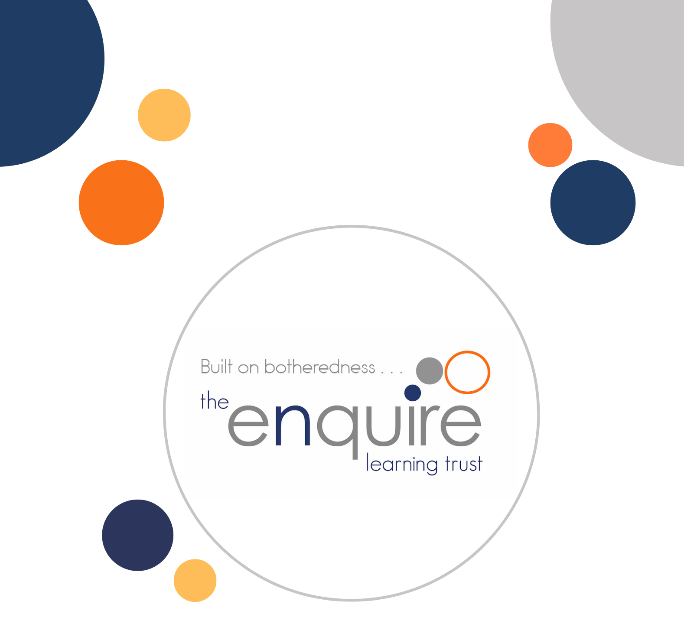

PSHE Policy

Contents

1 | Scope and purpose
2 | Aims
3 | Statutory requirements and guidance
4 | Curriculum intent
5 | Curriculum organisation and implementation
6 | Teaching and learning
7 | Assessment
8 | Monitoring and evaluation
9 | Pupils with SEND
10 | Equality, diversity and inclusion
11 | Safeguarding and managing sensitive issues
12 | Working with parents and carers
13 | Right to withdraw
14 | Roles and responsibilities
15 | Staff development and resources
16 | Policy review
Appendix A | Kapow-based year-group curriculum overview
Appendix B | Core vocabulary and safe learning principles

Version History

Approved by: | Governors
Last reviewed: | NEW POLICY
Next review due by: | September 2027

Date | Author | Version | Comment
August 2026 | HS | 1 | New policy

1. Scope and purpose
This policy sets out Easterside Academy’s approach to Personal, Social, Health and Economic education (PSHE), including statutory Relationships Education and Health Education and the school’s approach to non-statutory sex education. It applies to all pupils from Reception to Year 6 and should be read alongside the Safeguarding and Child Protection, Behaviour, SEND, Equality, Online Safety and Curriculum policies.
PSHE is an essential part of the academy’s provision for personal development and safeguarding. It equips pupils with the knowledge, skills and attributes needed to manage their lives now and in the future, to form respectful relationships, maintain their physical and mental wellbeing, recognise risk and seek help.

2. Aims
Our PSHE curriculum aims to enable pupils to:
• develop positive, respectful and safe relationships;
• understand how to protect their physical and mental health and wellbeing;
• recognise, assess and manage risk, including risks encountered online;
• communicate needs, boundaries and concerns confidently;
• recognise unsafe or harmful behaviour and know how to seek help from trusted adults;
• develop resilience, self-worth, responsibility and respect for others;
• understand equality, diversity, rights, responsibilities and fundamental British values;
• make informed decisions about money, work and their future;
• prepare successfully for the next stage of education and for adulthood.

3. Statutory requirements and guidance
As an academy, Easterside Academy must provide Relationships Education to all primary pupils and Health Education to all pupils. The academy has regard to the Department for Education’s statutory guidance for Relationships Education, Relationships and Sex Education and Health Education, effective from 1 September 2026.
This policy also takes account of the Children and Social Work Act 2017; the Relationships Education, Relationships and Sex Education and Health Education (England) Regulations 2019; the Equality Act 2010; the SEND Code of Practice: 0 to 25 years; Keeping Children Safe in Education; the national curriculum; and relevant guidance on online safety and personal development.
Primary schools are not required to provide sex education beyond the content contained within the science curriculum. Easterside Academy does not teach non-statutory sex education.

4. Curriculum intent
Easterside Academy uses the Kapow Primary RSE and PSHE scheme as the principal resource for curriculum planning. The scheme is aligned with the statutory guidance effective from September 2026 and provides clear progression from EYFS to Year 6. It is adapted to reflect the academy’s context, safeguarding priorities, pupils’ needs and prior knowledge.
The curriculum is ambitious for all pupils. It is designed as a spiral curriculum so that important knowledge, skills and attributes are revisited with increasing depth and maturity. Teaching makes links between relationships, physical and mental health, online life, personal safety, citizenship, financial understanding and preparation for adulthood.

5. Curriculum organisation and implementation
PSHE and RSHE are taught through a dedicated weekly lesson in every year group. Additional teaching may take place through assemblies, computing, science, physical education, wider curriculum subjects, enrichment, safeguarding work and responsive pastoral provision. Discrete weekly teaching remains the main vehicle for planned progression and is not replaced by assemblies or one-off events.
The Kapow 2026 curriculum is organised through recurring areas of learning:
• My healthy self;
• Connecting with others;
• The online world;
• Staying safe;
• Health protection;
• Growing up;
• Citizenship;
• First aid;
Teachers follow the agreed long-term plan while adapting examples, level of support and teaching approaches. Any substantial change to intended statutory content must be agreed with the PSHE leader to protect curriculum coverage and progression.

6. Teaching and learning
Teaching is age-appropriate, evidence-informed and responsive to pupils’ starting points. Staff establish clear ground rules so pupils can discuss sensitive content safely and respectfully. Lessons use accurate, factual and unambiguous language, including the correct terminology for body parts where required by the curriculum.
Approaches include:
• explicit teaching of key knowledge and vocabulary;
• retrieval of prior learning and regular revisiting of essential messages;
• structured discussion, role-play, stories and carefully selected scenarios;
• Voice 21 approaches that support listening, reasoning and respectful disagreement;
• modelling and rehearsal of help-seeking, assertiveness, boundary-setting and decision-making;
• individual reflection that does not require pupils to share personal experiences;
• signposting to trusted adults and appropriate sources of support.
Teachers avoid creating a classroom environment in which pupils feel pressured to disclose personal information. Questions are answered honestly and in an age-appropriate way. Staff may use an anonymous question box and may defer a question where it is outside the planned curriculum, requires consultation with a parent or carer, or raises a safeguarding concern.

7. Assessment
Assessment in PSHE is primarily formative and is used to identify what pupils know, understand and can apply. Teachers establish starting points, check understanding during lessons and evaluate learning at the end of a unit.
Assessment may include questioning, retrieval tasks, discussion, scenario-based responses, pupil reflection, work in books or journals, quizzes, observation and Kapow assessment opportunities. Teachers assess pupils’ understanding rather than their private beliefs, family circumstances or willingness to disclose personal experiences.
Misconceptions are addressed promptly and important knowledge is revisited. Assessment information informs adaptations, future teaching and additional support. It is not used to make assumptions about pupils’ home lives or safeguarding status.

8. Monitoring and evaluation
Leaders maintain oversight of curriculum intent, implementation and impact. Monitoring is proportionate and may include:
• review of the long-term plan, progression documents and statutory mapping;
• learning walks and lesson visits;
• scrutiny of planning and pupils’ recorded learning;
• pupil voice, including the views of pupils with SEND and other groups;
• staff discussion and review of professional development needs;
• review of assessment information and pupils’ retention of essential knowledge;
• analysis of relevant behaviour, safeguarding, attendance and pastoral themes to identify emerging curriculum needs;
• feedback from parents and carers following consultation or curriculum information events.
Monitoring focuses on whether statutory content is delivered, teaching is inclusive and pupils know more, remember more and can apply learning to keep themselves and others safe. Findings inform subject action planning, staff development and curriculum refinement.

9. Pupils with special educational needs and disabilities (SEND)
All teaching is developed to ensure these subjects are accessible for pupils with SEND and prepare pupils for adulthood, as set out in the SEND Code of Practice: 0 to 25 years.
We make adjustments in various ways. For example, teachers adapt content and language to meet individual needs; use visual supports, concrete resources and social narratives; pre-teach key vocabulary; break learning into smaller steps; provide structured discussion and rehearsal; offer additional processing time and adult support where required; use repetition, retrieval and overlearning; and apply personalised strategies identified in pupils’ support plans or Education, Health and Care Plans.
We are aware that pupils with SEND may be more vulnerable than their peers to harmful sexual behaviour, sexual abuse, exploitation and violence, bullying and other issues. RSHE can be particularly important for these pupils, particularly those with social, emotional and mental health needs or learning disabilities. Teaching therefore gives explicit attention to healthy relationships, consent, privacy, personal boundaries, online safety, recognising unsafe situations and seeking help from trusted adults.
Adaptation does not mean removing essential safeguarding knowledge. Where content requires further personalisation, the class teacher, SENDCo, PSHE leader and designated safeguarding lead work together, involving parents, carers and external professionals where appropriate.

10. Equality, diversity and inclusion
The curriculum is inclusive and taught in accordance with the Equality Act 2010. It promotes respect for difference and challenges prejudice, discrimination, bullying and stereotypes. Teaching is appropriate to pupils’ age and development and reflects that families and relationships may take different forms.
Staff do not promote any particular personal lifestyle or belief. They teach factual content respectfully, taking account of the school community while ensuring that pupils understand the importance of equality, dignity, respect and the law.

11. Safeguarding and managing sensitive issues
RSHE is an important part of the academy’s safeguarding curriculum. It helps pupils recognise when something is wrong, understand personal boundaries, identify trusted adults and report concerns. Themes may include online harms, harmful content, coercion, bullying, exploitation, abuse, unsafe secrets and personal safety around fire, water, roads and railways.
If a pupil makes a disclosure or a member of staff becomes concerned, the member of staff follows the academy’s safeguarding and child protection procedures immediately. Staff never promise confidentiality. Information is shared only with those who need it to safeguard the child.
Visitors and external agencies may enhance provision but do not replace the class teacher. Materials, expertise and safeguarding arrangements are checked in advance. The teacher remains present and responsible for the quality and safety of the lesson.

12. Working with parents and carers
The academy recognises parents and carers as the first educators of their children in relation to relationships, health and wellbeing. We seek to work openly and constructively with families.
The academy publishes this policy and provides information about curriculum content. Parents and carers are given reasonable opportunities to understand the resources used for sensitive content, ask questions and contribute to consultation when the policy is reviewed. Copyright and licensing conditions may affect how commercial resources can be shared or published, but the academy will provide clear information about lesson content and materials.

13. Right to withdraw
Parents and carers do not have the right to withdraw their child from statutory Relationships Education, Health Education or science curriculum content.
A parent or carer may request that their child is withdrawn from non-statutory sex education. Easterside Academy does not teach non-statutory sex education.

14. Roles and responsibilities
Role | Responsibilities
Governors | Approve and review the policy; ensure statutory duties are met; hold leaders to account for inclusive and effective provision.
Principal | Ensure the policy is implemented; secure appropriate staffing and training; respond to withdrawal requests and complaints.
PSHE leader | Maintain curriculum plans and statutory mapping; support staff; monitor quality, progression and impact; coordinate consultation and review.
Designated safeguarding lead | Advise on safeguarding content, contextual risks, disclosures and appropriate responses.
SENDCo | Support accessibility, reasonable adjustments and preparation for adulthood for pupils with SEND.
Teachers | Deliver the agreed curriculum; establish safe ground rules; assess learning; adapt teaching; follow safeguarding procedures.
Pupils | Participate respectfully, follow agreed ground rules and seek help when they are worried or unsafe.

15. Staff development and resources
Staff receive guidance and professional development appropriate to their role and the content they teach. Kapow lesson guidance, subject knowledge materials and statutory mapping support consistent delivery. Staff should raise any concern about subject knowledge, resources or sensitive content with the PSHE leader before teaching the lesson.
Resources are selected for accuracy, age-appropriateness, accessibility and alignment with the academy’s values, safeguarding duties and equality responsibilities. Commercial resources are used in accordance with licence and copyright conditions.

16. Policy review
This policy will be reviewed at least annually and earlier where legislation, statutory guidance, safeguarding priorities or the curriculum changes. The next scheduled review is September 2027.

Appendix A: Kapow-based year-group curriculum overview
The overview below summarises the intended progression within Easterside Academy’s Kapow-based curriculum. Teachers use the current Kapow long-term plan and statutory mapping for detailed lesson sequencing. The curriculum is taught weekly and revisits key learning with increasing depth.
Year group | Kapow-based curriculum emphasis | Expected development
Reception | Building relationships, identifying feelings, healthy routines, safe adults, privacy, simple online safety, managing change and belonging to a community. | Children begin to name feelings, identify trusted adults, follow safety rules and recognise kind, respectful behaviour.
Year 1 | Healthy routines; friendship and belonging; safe and unsafe situations; basic online safety; privacy; recognising change; citizenship and simple first aid. | Pupils explain basic ways to stay healthy and safe, describe kind relationships and know how to ask a trusted adult for help.
Year 2 | Managing feelings; cooperation and conflict; online communication; medicine and household safety; growing and changing; rights, responsibilities and money choices. | Pupils recognise respectful behaviour, identify risks in familiar contexts and use simple strategies for managing feelings and seeking support.
Year 3 | Physical and mental wellbeing; stereotypes and bullying; digital footprints and online influence; risk assessment; body changes; community participation and first aid. | Pupils apply safety strategies, challenge unkind or stereotypical behaviour and explain how choices can affect wellbeing and relationships.
Year 4 | Resilience and emotional regulation; respectful relationships and boundaries; online content and privacy; personal safety; puberty preparation; democracy and financial choices. | Pupils explain boundaries, evaluate common risks, identify reliable support and describe physical and emotional changes linked to growing up.
Year 5 | Identity and self-esteem; peer influence; online wellbeing and misinformation; risk, consent and personal safety; puberty and reproduction in statutory science; citizenship and future aspirations. | Pupils assess influence and risk, communicate boundaries, explain key changes during puberty and know when and how to seek help.
Year 6 | Healthy and unhealthy relationships; transition and mental wellbeing; online relationships, financial harms and critical evaluation; exploitation awareness; growing up; active citizenship; first aid. | Pupils apply knowledge to complex scenarios, recognise harmful or coercive behaviour, make informed choices and demonstrate readiness for secondary school and greater independence.

