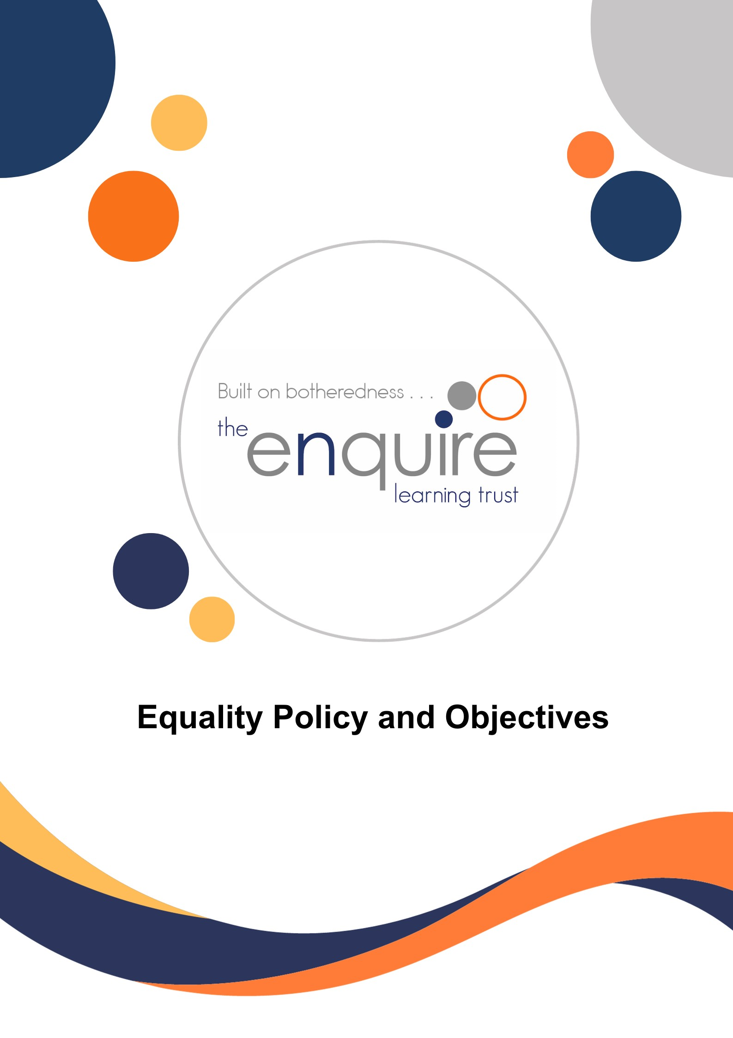

Contents

Section | Title | Page
1 | Introduction | 3
2 | Our Legal Duties | 3
3 | The Policy | 7

Version History

Approved by: | Trustees
Last reviewed: | August 2025
Next review due by: | August 2028

Date | Author | Version | Comment
July 2021 | LT | 2
October 2022 | LP | 3
August 2025 | LP | 4 | Reviewed – no changes

1. Introduction
This single policy replaces separate policies the Academy has on race, disability and gender to eliminate discrimination, advance equality of opportunity and foster good relations. It reflects the legal duties set out in the Equality Act 2010 and non-statutory guidance set out by the government in December 2011 and March 2012.
2. Our Legal Duties
The Equality Act 2010 was introduced to ensure protection from discrimination, harassment and victimisation on the grounds of specific characteristics (referred to as protected characteristics).

Protected characteristics

The Act defines protected characteristics as follows:
• race
• disability
• religion or belief
• gender
• sexual orientation
• gender reassignment
• pregnancy or maternity
• age
• marriage and civil partnership

These protected characteristics apply to pupils, prospective pupils, staff, prospective staff or anybody they are associated with, with the exception of ‘age’ and ‘marriage and civil partnership’ which do not apply to pupils and prospective pupils.

The Act requires all public organisations, including schools to comply with the Public Sector Equality Duty and two specific duties:

The Public Sector Equality Duty or ‘general duty’

This requires all public organisations, including schools to give due regard to the need to (in relation to the protected characteristics above):

1. Eliminate unlawful discrimination, harassment and victimisation
2. Advance equality of opportunity between different groups
3. Foster good relations between different groups

Two ‘specific duties’

This requires all public organisations, including academies to:

1. Publish information to show compliance with the Equality Duty
2. Publish Equality Objectives at least every 4 years which are specific and measurable

Unlawful behaviour
The Act defines four kinds of unlawful behaviour – direct discrimination; indirect discrimination; harassment and victimisation.
Direct discrimination occurs when one person treats another less favourably, because of a protected characteristic, than they treat – or would treat – other people.
Indirect discrimination occurs when a “provision, criterion or practice” is applied generally but has the effect of putting people with a particular characteristic at a disadvantage when compared to people without that characteristic.
Harassment has a specific legal definition in the Act - it is “unwanted conduct, related to a relevant protected characteristic, which has the purpose or effect of violating a person’s dignity or creating an intimidating, hostile, degrading, humiliating or offensive environment for that person”.
Victimisation occurs when a person is treated less favourably than they otherwise would have been because of something they have done (“a protected act”) in connection with the Act.
Discrimination arising from disability - treating someone unfavourably because of something connected with their disability (such as periods of absence from work or medical conditions) and failure to make reasonable adjustments. The law on disability discrimination is different from the rest of the Act. In particular, it works in only one direction, i.e. it protects disabled people but not people who are not disabled. This means that we are allowed to treat disabled pupils more favourably than non-disabled pupils, and in some cases are required to do so, by making reasonable adjustments to put them on a more level footing with pupils without disabilities.

Reasonable Adjustments and Accessibility Plans
The Trust is required to:
- Take reasonable steps to avoid disadvantage caused by a provision, criteria or practice or a physical feature that puts a disabled person at a substantial disadvantage compared to a non-disabled person. This involves removing or avoiding a physical feature, for example steps and lifts.
- Take reasonable steps to provide auxiliary aids/services
- Provide information in an accessible format.
- Develop and implement (by allocation of resources) Accessibility Plans which will;
  - Increase disabled pupils’ access to the academy curriculum and for all users of the academy
  - Improve the physical environment
  - Improve the provision of information
The duty is an anticipatory and continuing one that The Trust owes to all pupils with disabilities whether identified or not, and to those pupils who will be attending in the future. Our academies will seek relevant information regarding newly placed pupils to ensure as far as possible that their needs are anticipated under this Act. We will ensure that we work closely with professionals, parents and carers as appropriate to identify the challenges presented to us by new pupils under this Act.
Community Cohesion
The Education and Inspections Act 2006 inserted a new section 21(5) to the Education Act 2002, introducing a duty, applicable to the Trust, to promote community cohesion. Community cohesion encompasses promoting good relations between pupils from different races, faith /beliefs and socioeconomic backgrounds. The Trust policies and activities should all be promoting community cohesion and inclusion wherever possible to comply with and support these duties.

Roles and responsibilities
We expect all staff of the Trust and visitors to support our commitment to promoting equalities and meeting the requirements of the Equality Act. We will provide training, guidance and information to enable them to do this.

The Trust Board of Trustees
The board has overall responsibility for ensuring compliance with equality legislation and the effective operation of this policy and that action plans are implemented.
Every Board committee keeps aspects of the Trust’s commitment to the Equality Duty under review, for example, in terms of standards, curriculum, admissions, exclusions, personnel issues and the academy environment. The Board annually reviews the Equality Policy and evaluates the success of the Trust’s equalities work taking account quantitative evidence (e.g. data) and qualitative evidence.
The Principal along with the senior leadership team, are responsible for ensuring that:
- This policy is communicated and made readily available to staff, parents and guardians.
- This policy and its related procedures are implemented.
- Staff are aware of their responsibilities and are given appropriate training and support to enable them to effectively deliver this policy and Equality Plan
- Appropriate action is taken in any case of actual or potential discrimination
- All staff understand their duties regarding recruitment and provide reasonable adjustments to staff when appointed. All appointment panels give due regard to this plan, so that no one is discriminated against when it comes to employment or training opportunities.
- All staff and pupils are aware of the process for reporting and following up bullying and prejudice-related incidents
- All incidents of unfair treatment and any incidents of bullying or discrimination, including racist incidents, are treated with due seriousness.
- The principle of equal opportunity is promoted when developing the curriculum,

Teaching and support staff should:
- Enact all aspects of this policy, its commitments and procedures, and their responsibilities within it
- Deal with bullying and discriminatory incidents, and know how to identify and challenge prejudice and stereotyping
- Challenge any incidents of prejudice, racism or homophobia, and record any serious incidents, drawing them to the attention of the head of academy
- Promote equality and good relations and not discriminate on any grounds
- Attend training and information sharing opportunities as necessary to use this policy with confidence, and keep up to date with current equality legislation
- Promote equal opportunities through their words and actions
Pupils according to their ability and understanding should:
- Refrain from engaging in discriminatory behaviour, or any other behaviour that could cause offence to others under this policy.

Parents and Carers:
- Parents and Carers will be encouraged to participate fully in implementing the policy within the academy, particularly by reinforcing its ethos at home. They will be invited to comment on the Equality Objectives and will be regularly updated on progress.
All Visitors, Volunteers and Contractors should:
- Make themselves aware of, and comply with the expectations contained within this policy
- To refrain from engaging in discriminatory behaviour or language on academy premises
- Bring to the attention of a member of staff any act, or behaviour that concerns them with regard to this policy
Publishing the plan and links to other policies and documentation:
Although this policy is the key document for information about our approach to equalities in line with the Public Sector Equality Duty, we ensure that information about our responsibilities under the Equality Act are also included in our Trust and academy development plans, self-evaluation review. We will publish our policy and plan on the Trust website and raise awareness of the plan through the academies’ newsletter, assemblies, staff meetings and other communications;
This policy has links with the Behaviour, Admissions, SEN and Anti-bullying Policies as well as minutes of meetings involving Trust directors, Academy Improvement Committee, the whole staff, and the Leadership team, the Ethos committees and academy councils.
The Equality Act also applies to the Trust in its role as employer, and copies of the Recruitment Policy, Whistle Blowing Policy, Health and Safety, E- Safety and Acceptable Use policies.

3. The Policy
At the Trust we value the individuality of all our children and we are committed to enabling all pupils to take part as fully as possible in every part of academy life by developing each child’s self-confidence, recognising their strengths and encouraging them to achieve their full potential. We are also committed to safeguarding and promoting the welfare and wellbeing of our children and young people and expect all staff and volunteers to share this commitment.
The Trust will take steps to advance equality of opportunity, foster good relations and eliminate discrimination or harassment across all the protected characteristics (age, race, gender reassignment, disability, marriage and civil partnership, religion and belief, pregnancy and maternity, gender, sexual orientation) within the academy community.
This means:
- We will take reasonable and necessary steps to meet pupils’ needs by using a variety of approaches and planning reasonable adjustments for disabled pupils, enabling our pupils to take as full a part as possible in all the activities of the academy. We will make reasonable adjustments to ensure the academy environment and its activities are as accessible and welcoming as possible for pupils, staff and visitors to the academy. We are also committed to ensuring staff with a disability have equality of opportunity.
- We will actively encourage positive attitudes towards pupils and staff and expect everyone to treat others with dignity and respect.
- We will regularly consider the ways in which the taught and wider curricula will help to promote awareness of the rights of individuals and develop the skills of participation and responsible action.
- We will regularly consider the ways in which our teaching and the curriculum provision will support high standards of attainment, promote common values, and help students understand and value the diversity that surrounds them, and challenge prejudice and stereotyping.
- We will monitor the progress and achievement of pupils by the relevant and appropriate protected characteristics.
- This information will help the academies to ensure that individual pupils are achieving their potential, the academy is being inclusive in practice, and trends are identified which inform the setting of our equality objectives in the academy development plans or through any TISP that may be in place.
- We will collect and analyse information about protected characteristics in relation to staff recruitment, retention, training opportunities and promotions to ensure all staff have equality of opportunity. We will not ask health-related questions to job applicants before offering a job, unless it relates to an intrinsic function of the work they do. We will make reasonable adjustments such as providing auxiliary aids for our disabled staff.
- Staff will ensure the curriculum is accessible to all pupils with special educational needs and disabilities (SEND) or those for whom English is not their first language. Auxiliary aids and services will be provided for them, where reasonable adjustments are required. By planning ahead, staff will ensure that all pupils are able to take part in extra-curricular activities and residential visits, and the academy will monitor the uptake of these visits to ensure no one is disadvantaged on the grounds of a protected characteristic.
- We will seek the views of advisory staff and outside agencies and partnerships with other academies where this is needed. In planning the curriculum and resources the academy will take every opportunity to promote and advance equality.
- Bullying and Prejudice Related Incidents will be carefully monitored and dealt with effectively. Regular training will be given to both existing and new staff to ensure that they are aware of the process for reporting and following up incidents of prejudice-related bullying (see new DCC guidance).
- We expect that all staff will be role-models for equal opportunities, deal with bullying and discriminatory incidents and be able to identify and challenge prejudice and stereotyping.
- Throughout the year, The Trust academies will plan on-going events to raise awareness of equality and diversity. This may include a focus on disability, respect for other cultures, religions and beliefs, anti-homophobia/gay pride, gender equality, developing community cohesion and an understanding of the effects of discrimination.
- We will ensure pupil/parent/staff consultation is regularly sought in the development and review of this policy.
- We will regularly seek the views of pupils, parents, advisory staff and visitors to the academy, to ensure that the academy environment is as safe and accessible as possible to all academy users. We will regularly review our accessibility plans.

Equality Objectives
Our equality objectives are based on our analysis of data and other information. They focus on those areas where we have agreed to take action to improve equality and tackle disadvantage.
- To monitor and analyse pupil achievement by ethnicity, disadvantage and special educational need and act on any trends or patterns in the data that require additional support for pupils.
- To deliver a broad and balanced curriculum, that provides opportunities for all pupils to achieve the highest standards of education, using specialist programmes and dedicated resources to support pupils who need it the most. We will deliver a programme of assemblies, outside visitors and educational visits to promote the ethos of equality to pupils and help pupils develop good relationships with people of different characteristics.
- To raise levels of parental and pupil engagement in learning and academy life, across all activities including regular attendance to ensure equity and fairness in access and engagement.
The implementation and impact of these objectives will be monitored and reviewed by the Principal of each academy by:
- Reviewing pupil progress and attainment for different sub-groups (e.g. individual academies, boys vs girls, Pupil Premium, SEN and Children in Care) annually in the autumn term, to ensure that all groups of pupils are making the best possible progress, and take appropriate action to address any gaps.
- Reporting to the Academy Improvement Committee
- Taking advice from relevant parties such as the Trust HR Director
- Monitoring parental engagement and attendance.

