
abc

Contents

Section | Title | Page
1 | Legislation | 4
2 | Definitions used in the Policy | 4
3 | Context | 4
4 | Principles | 5
5 | The Power to Exclude | 5
6 | Informing parties about a Suspension or Exclusion | 7
7 | The Academy Improvement Committees duty to consider an Exclusion | 8
8 | The Trust’s duty to arrange an independent review panel | 8
9 | Independent review | 9
10 | Managed Moves | 9
11 | Procedure for Managed Moves | 10
 | - Appendix A - Prevention | 11
 | - Appendix B – Prevention – Analysing Behaviours | 12
 | - Appendix C – Exclusions – Transition Information | 14
 | - Appendix D – Ethical Decision Making Tool | 16
 | - Appendix E - Appendix E – The Academy Improvement Committee duty to consider a suspension or exclusion Flow Chart | 19

Version History

Approved by: | Trustees
Last reviewed: | May 2025
Next review due by: | May 2026

Date | Author | Version | Comment
September 2018 | JH | 1
July 2019 | JH | 2
September 2020 | JH | 3
July 2021 | JH | 4
July 2022 | RC | 5 | Changes from DFE for 2022
July 2023 | RC | 6 | Changes from DFE to come in to force Sept 2023
March 2024 | RC | 7 | Managed Moves added.
May 2024 | RC | 7 | Ethical Decision Framework added and the role of the development officer.
August 2024 | RC | 7 | Added link to Statutory guidance, Working Together to Improve School Attendance.
October 2024 | RC | 7 | Guidance on the Academy Improvement Committee duty to consider a suspension or exclusion change in terminology - and Flow Chart added.
May 2025 | RC | 8 | Page 7 - Added that an Early Annual Review be requested for children with an EHCP if PEX, prior to day 6

1. Legislation

This policy is compliant with the following legislation:
- The Education Act 2002, as amended by the Education Act 2011;
- The School Discipline (Pupil Exclusions and Reviews) (England) Regulations 2012;
- The Education and Inspections Act 2006; and
- The Education (Provision of Full-Time Education for Excluded Pupils) (England) Regulations 2007(as amended).
This policy also reflects the guidance written within Suspension and permanent exclusion guidance and with due regard to Behaviour in schools guidance (publishing.service.gov.uk).
This policy should be read alongside guidance in Working together to improve school attendance (applies from 19 August 2024) (publishing.service.gov.uk)
2. Definitions used in the Policy
Use of term ‘parent’ within this policy.
In addition to the pupil's birth parents, references to parents in this policy include any person who has parental responsibility (which includes the local authority where it has a care order in respect of the pupil) and any person (for example, a foster carer) with whom the pupil lives.
Use of the word ‘term’ within this policy
Where the academy year consists of 3 terms or fewer, a reference to a ‘term’ in this policy means one of those terms. Where the Academy’s academic year consists of more than 3 terms, then a reference to ‘term’ means the period falling between: 31 December to Easter Monday; Easter Monday to 31 July; or 31 July to 31 December.
3. Context
The Enquire Learning Trust (hereafter referred to as the Trust) recognises that in order to ensure a positive atmosphere based on a sense of community and shared values it may, on occasions, be necessary to suspend an individual or individuals either for a fixed period, not exceeding forty five academy days in any one academic year, or, in some circumstances, permanently exclude.
Such suspensions and exclusions will only be resorted to when the academy can demonstrate with adequate evidence that all reasonable steps have been taken (including education off site) and/ or that the presence of the learner is likely to be severely detrimental to his/herself, other learners or employees. There may also be occasions when a short-term is appropriate because of unacceptable behaviour.
Good discipline in academies is essential to ensure that all pupils can benefit from the opportunities provided by education. The Trust supports its academies in using suspension and permanent exclusion as a sanction where it is warranted. However, permanent exclusions should only be used as a last resort, in response to a serious breach, or persistent breaches, of the Academy's Behaviour Policy; and where allowing the pupil to remain in the academy would seriously harm the education or welfare of the pupil or others in the academy.

4. Principles
The academy will not discriminate against pupils on the basis of protected characteristics, such as disability or race and will give particular consideration to the fair treatment of pupils from groups who are vulnerable to exclusion.
Disruptive behaviour can be an indication of unmet needs. Where there are concerns about a pupil’s behaviour the first steps will be to identify whether there are any causal factors and intervene early in order to reduce the need for a subsequent exclusion. The Academy will give consideration to a multi-agency assessment that goes beyond the pupil’s educational needs.
When making the decision on when and if to suspend or exclude a pupil, the Principal will apply the ‘Ethical Decision Making Framework’ and inform their academy development officer.
All pupils who return to the academy following a suspension will be subject to a re-integration process that will include a meeting with the parent and where appropriate, the pupil prior to their return to class. This must always be in the best interest of the pupil and their individual needs catered for. This meeting will include an agreement with the pupil (where appropriate) on managing their future behaviour.
The academy will take reasonable steps to set and mark work for pupils during the first five Academy days of suspension and will arrange alternative provision from the sixth day.
Where parents dispute the decision of the Academy Improvement Committee / Trust not to reinstate a permanently excluded pupil, they can ask for this decision to be reviewed by an independent review panel to be arranged by Trust.
All parents have the right to request the presence of a SEN expert at an independent review panel. The SEN expert’s role is to provide impartial advice to the panel about how SEN could be relevant to the suspension or exclusion.

5. The Power to Exclude
Only the Principal of the academy can suspend or permanently exclude a pupil and this must be on disciplinary grounds.
A pupil may be suspended for one or more suspensions (up to a maximum of 45 Academy days in a single academic year), or permanently excluded.
Pupils whose behaviour at lunchtime is disruptive may be suspended from the academy premises for the duration of the lunchtime period. This constitutes a half day suspension.
The behaviour of pupils outside the academy can be considered as grounds for suspension or permanent exclusion.
The Principal may cancel a suspension or exclusion that has not been reviewed by the Trust.

When a suspension or exclusion is cancelled, the principal will without delay, notify parents, the AIC, the local authority and if relevant the social worker and/or virtual school head and also state the reason for the cancellation.

Parents will be offered the opportunity to meet with the principal to discuss the circumstances that led to the suspension or exclusion being cancelled.

The number of suspensions and exclusions that have been cancelled and the reason for the cancellation, will be reported to the AIC once a term.

The academy will take account of their legal duty of care when sending a pupil home following a suspension or exclusion.
The academy will use the civil standard of proof, i.e. ‘on the balance of probabilities’ when making judgments in relation to suspension and exclusion and apply the ‘Ethical Decision Framework’.
The academy will not make use of ‘informal’ or ‘unofficial’ suspensions, such as sending pupils home ‘to cool off’. Any suspension or exclusion of a pupil, even for short periods of time, will be formally recorded.
A decision to exclude a pupil permanently will only be taken:
- In response to a serious breach, or persistent breaches, of the academy's behaviour policy; and where allowing the pupil to remain in academy would seriously harm the education or welfare of the pupil or others in the Academy. The academy will take account of any contributing factors that are identified after an incident of poor behaviour has occurred. For example, where it comes to light that a pupil has suffered bereavement has mental health issues or has been subject to bullying.

All suspensions and exclusions must be recorded on Bromcom and with the Vulnerable Pupils Leader, Rachel Cooper or Vulnerable Pupils Offier, Jaimie Holbrook.

6. Informing parties about a suspension or exclusion
Whenever a pupil is suspended or excluded, the academy will notify parents of the period of the suspension or if permanently excluded, and the reasons for it as soon as is immediately practical. In addition, the academy will provide parents with the following information in writing:
- the reasons for the suspension/exclusion
- the period of the suspension or, for a permanent exclusion, the fact that it is permanent
- parents’ right to make representations about the suspension/exclusion to the Academy Improvement Committee and Trust and how the pupil may be involved in this
- the start date for any provision of full-time education that has been arranged for the pupil during the suspension/exclusion
- In addition, the Academy will draw attention to relevant sources of free and impartial information including:
- a link to DfE statutory guidance on exclusions: exclusions guidance (Exclusion from maintained Schools, Academies and pupil referral units in England from September 2012)

- a link to the Coram Children’s Legal Centre: www.childlawadvice.org.uk
- SENDIASS Stockton Borough Council

The Principal will, without delay, notify the Local Authority of any suspension or exclusion, regardless of the length of the exclusion.
If a pupil has a social worker, or if a pupil is looked-after, the Principal will, also without delay after their decision, notify the social worker and/or Virtual School Head, as applicable.
- The Principal will, without delay, notify the Academy Improvement Committee and the Trust of:
- a permanent exclusion (including where a suspension is made a permanent exclusion);
- suspensions which would result in the pupil being suspended for more than five Academy days (or more than ten lunchtimes) in a term; and
- suspensions which would result in the pupil missing a public examination or national curriculum test. For all other exclusions the Principal will notify the local authority, Academy Improvement Committee and the Trust once a term.
- For a permanent exclusion, if the pupil lives outside the local authority in which the Academy is located, the academy will also advise the pupil’s ‘home authority’ of the exclusion without delay.
For a permanent exclusion for a child that has an ‘Education and Health Care Plan’, the school must notify the SEND team and/or case worker and request an ‘Early Annual Review’ to be held, prior to day 6 of the permanent exclusion.

7. The Academy Improvement Committee duty to consider a suspension or exclusion
The Academy Improvement Committee, under delegated powers from the Trust, will consider parents’ representations about a suspension or exclusion.
In the case of a suspension which does not bring the pupil's total number of days of suspension to more than five in a term, the Academy Improvement Committee must consider any representations made by parents, but it cannot direct reinstatement and is not required to arrange a meeting with parents.

The requirements are different for suspensions where a pupil would be suspended for more than five but not more than 15 school days in a term. In this case, if the parents make representations, the Academy Improvement Committee must consider and decide within 50 school days of receiving the notice of suspension whether the suspended pupil should be reinstated. In the absence of any representations from the parents, the Academy Improvement Committee is not required to meet and cannot direct the reinstatement of the pupil.

The Academy Improvement Committee must convene a meeting to consider reinstatement within 15 school days of receiving notice of a permanent exclusion.
Those invited to this meeting will include:
- parents;
- the Principal
- 3 members of the Academy Improvement Committee
- If the pupil has a Social Worker, they must be invited to the meeting.
- The Virtual Head Teacher – If the pupil is looked after.
The Academy Improvement Committee will make every effort to arrange this meeting for a date and time convenient to all parties.
In reaching a decision on whether or not to reinstate a pupil, the Academy Improvement Committee will consider whether the decision to exclude the pupil was lawful, reasonable and procedurally fair, taking account of the legal duties of the Academy Leadership and the available evidence.
8. The Trust’s duty to arrange an independent review panel
If applied for by parents within the legal time frame, the Trust will arrange for an independent review panel hearing to review the decision of the Academy Improvement Committee not to reinstate a permanently excluded pupil.
The legal time frame for an application is:
- Within 15 Academy days of notice being given to the parents by the Academy Improvement Committee of their decision to uphold a permanent exclusion or
- Where an application has not been made within this time frame, within 15 Academy days of the final determination of a claim of discrimination under the Equality Act 2010, in relation to the exclusion
- Any application made outside of the legal time frame will be rejected by the Trust

9. Independent Review
- Parents should put in writing to the Clerk to the Academy Improvement Committee if they want an independent review of the Academy Improvement Committees decision. Details can be obtained from the individual academies.

10. Managed Moves
A ‘Managed Move’ is used to initiate a process leading to a permanent transfer of a pupil to another mainstream school, as part of a behaviour management process. Managed moves should be:

- Done strictly in the child's best interest.

- Voluntary and agreed by all parties involved including the parents and the admission authority of the new school.

- Offered as part of a planned intervention.

- Preceded by information-sharing between the current school, receiving school and supported by an effective integration strategy. This should include data on prior and current attainment, academic potential, a risk assessment and advice on effective risk management strategies. This Safeguarding Policy must also be followed in sharing information to safeguard the child.

The academy should evidence that appropriate initial intervention has been carried out, including, where relevant, multi-agency support, or any statutory assessments were done or explored prior to a managed move.

If a temporary move needs to occur to improve a pupil’s behaviour, then offsite direction should be used.
Where a pupil has an EHCP, the relevant statutory duties on the new school and local authority will apply. When contemplating a managed move the academy will notify the local authority prior to the managed move. If the local authority, both academy/school and parents are in agreement that there should be a managed move, the local authority will need to follow the statutory procedures for amending a plan.
If a parent believes that they are being pressured into a managed move or is unhappy with a managed move, they can address their concern through the academy/school formal complaints procedure with the Academy Improvement Committee of the Academy, governing board of the school and, where appropriate, the local authority.

11. Procedure for Managed Moves
A meeting will take place between the academy, parents and the child to discuss if a managed move is what all parties agree is in the best interest of the child, explore precvious intervention and plan the process moving forward.
The academy will contact the local authority to share that there is a request for a managed move.
(Generally a managed move will run for 12 weeks, this may depend on your local authority procedures. Whilst the managed move runs, the child will be dual registered at both schools with the academy remaining the main educational base).
If the child has an EHCP the academy will contact the relevant body within the local authority SEN department.
The academy will approach the new school to explore the possibility of a managed move.
Once the new school has agreed to being party to the managed move, the academy will contact the local authority of the new school and share that there has been an application of a managed move between the academy and new school.
The receiving school should also contact their local authority.
Both schools will need to discuss and agree the conditions of the move, considering what's best for the child, before they finalise arrangements. Think about the:

- Timings of the move.
- Induction to the new school.
- Agreed dates and times for 2 weekly reviews between all parties.
- Agreed terms if the move is unsuccessful

If the managed move is successful, on the first day the move becomes permanent, the new school:

- Must add the pupil to the admissions register and attendance register

- Should check that they have been removed from the roll at the previous school

Both schools must inform their LA admissions team of the change.

If the managed move is not successful, the academy will follow the local authority protocol (insert here).
Appendix A - Prevention
Any form of exclusion is a last resort. Principals and Academy Improvement Committees (AICs) must be assured that all reasonable measures have been taken to support every pupil. The following chart sets out a range of points to consider before administering any exclusion:

Preventing Suspension:
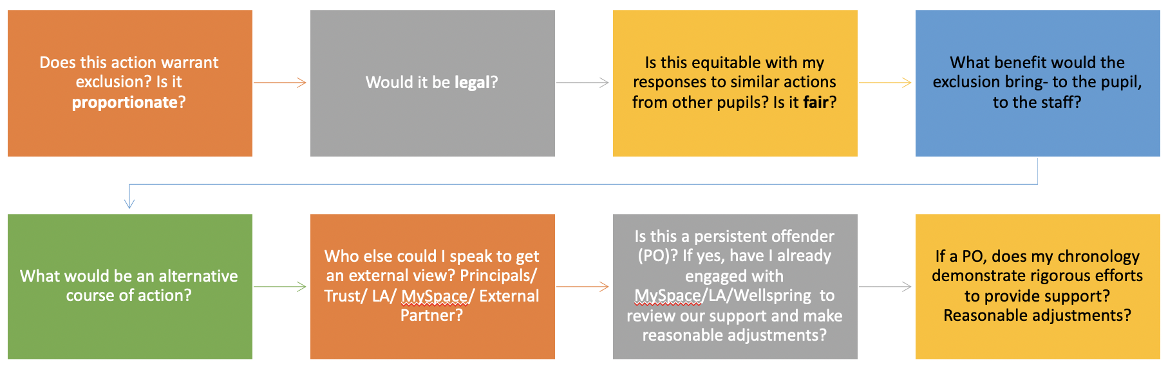

Preventing Permanent Exclusion:

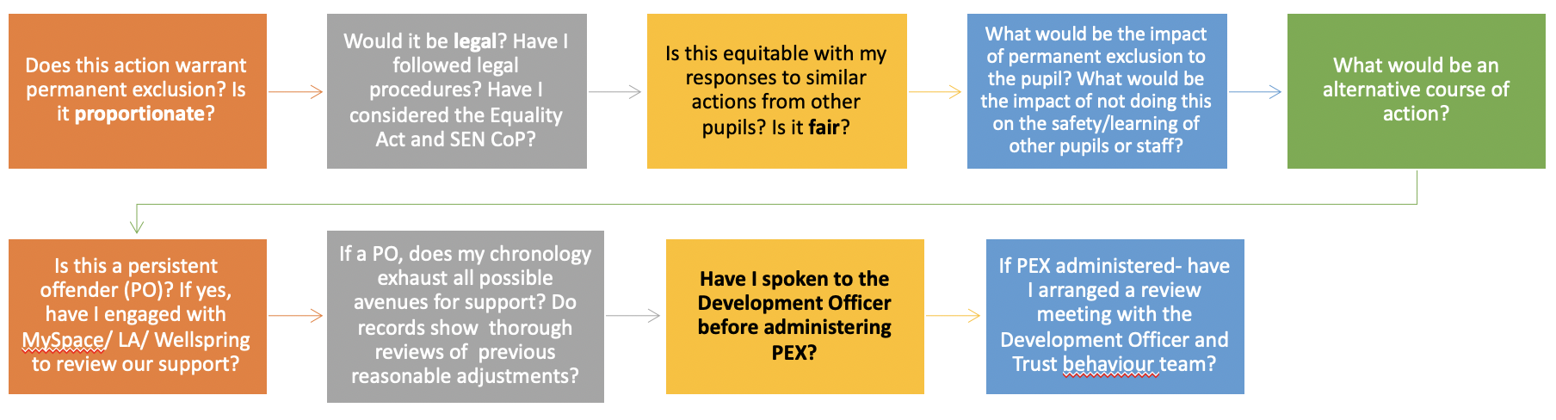

Appendix B- Prevention- Analysing Behaviours

The ABC of Behaviour

This is a useful way of thinking about why a child is behaving in a certain way. It starts with the premise that the majority of behaviour is rational. It is optimistic – if a behaviour has been learned, it can be unlearned. The ABC model suggests that behaviour can be understood in terms of:

Antecedents:

What happened immediately before the misbehaviour, the events that led up to it?
What was the provocation, who did or said, or did not say, what?
What was the setting for the behaviour? Is it always at the same activity, with the same child, or children?

Does it always happen at certain times of the day or on the same day of the week? (Does it happen regularly on a Monday after weekend visits with an estranged parent?)

Behaviour:

What precisely did the child do?

Consequences:

What happened as a result of the behaviour? How was the problem dealt with?
What did the others do?
How did they react?

Remember that the consequences might be reinforcing the undesirable behaviour, for example, gaining adults’ attention, peer approval, avoiding disliked activity.

The main question to ask is ‘what is the child getting out of behaving like this?’

Teaching incompatible skills

This should be the first strategy to consider when attempting to manage challenging behaviour. The most effective, and least restrictive, way of dealing with any kind of disruptive behaviour is attempting to increase the frequency of any kind of activity that is in opposition to the problem behaviour.

REMEMBER – Whatever strategies you use to manage inappropriate behaviour you must be consistent in your approach.
CPOMs should be used to develop a chronology of support. The narrative of this chronology should follow the Plan-Do-Review cycle and demonstrate that reasonable adjustments have been made to support improvements in behaviour. This should include evidence of seeking support beyond the immediate academy where possible.
The following charts may be useful when analysing the behaviour/s of specific pupils.

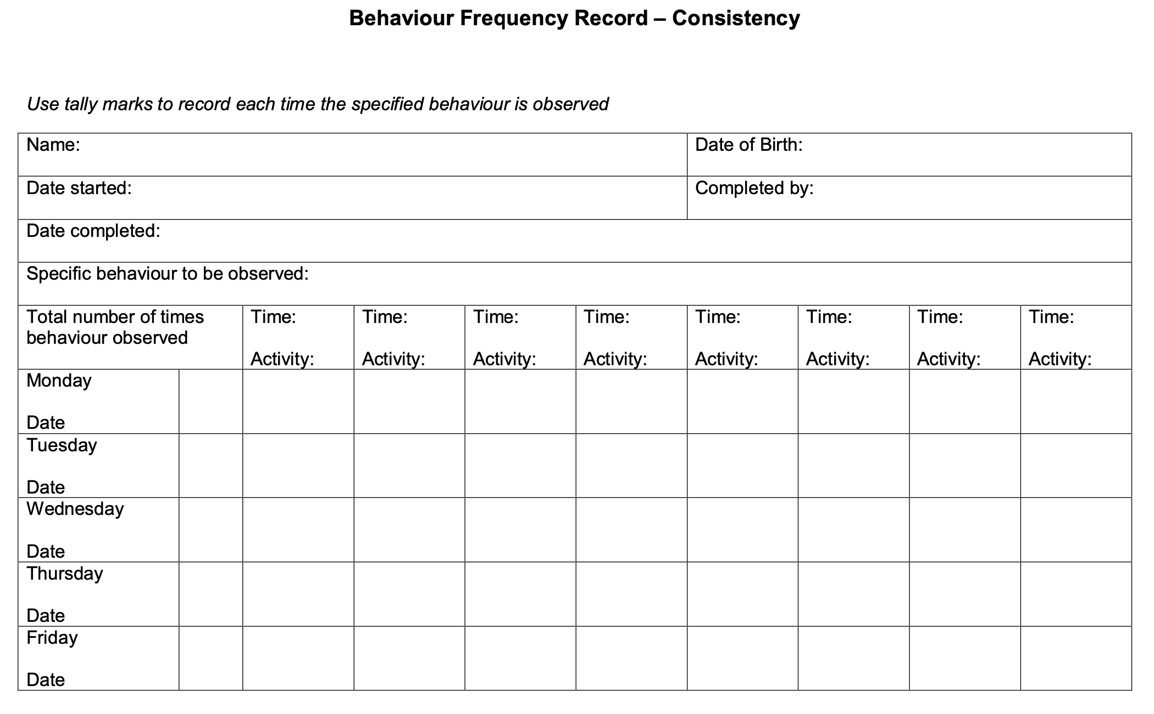
Appendix C- Exclusions - Transition Information

Behavioural Transition Information

Academy
Pupil’s full name
Date of PEX/FTE/s
Date of birth |  |  | Year group
If LAC which Local Authority? |  | Social Worker
Ethnicity
Language(s) spoken
Will the family require an interpreter for induction meeting? | Yes |  | No
FSM eligibility | Yes |  | No
In receipt of Pupil Premium | Yes |  | No
Attendance %
Punctuality
Name of Lead Professional if EHA in place |  |  | Date of CAF review:
CIN  C.P. | Yes  Yes | No  No | Comments:
Reason(s) for exclusion
Details of persistent disruptive behaviour (if applicable)
Identified triggers for behaviours
Details of relationships with peers
Details of relationships with staff
Full details of support strategies used to support the pupil and their effectiveness
What should staff avoid?
Pupils’ strengths and interests
What works?

Details of any SEN/Medical needs and any medication:
Hearing/visual
Speech, language, communication
Specific leaning difficulties
Autistic spectrum disorder
Attention Deficit Hyperactivity Disorder
other
Details of academic attainment:  Subjects | Reading: | Writing: | Mathematics:
Support services involved:
Educational Psychology
Social Care
Healthy Young Minds
Youth Offending Team
BLISS
MST
Other
Any other relevant information

Appendix D

Ethical Decision-Making Framework
Questions to guide decision-making when considering
suspensions and exclusions

Based on Seedhouse’s (1998) Ethical Grid

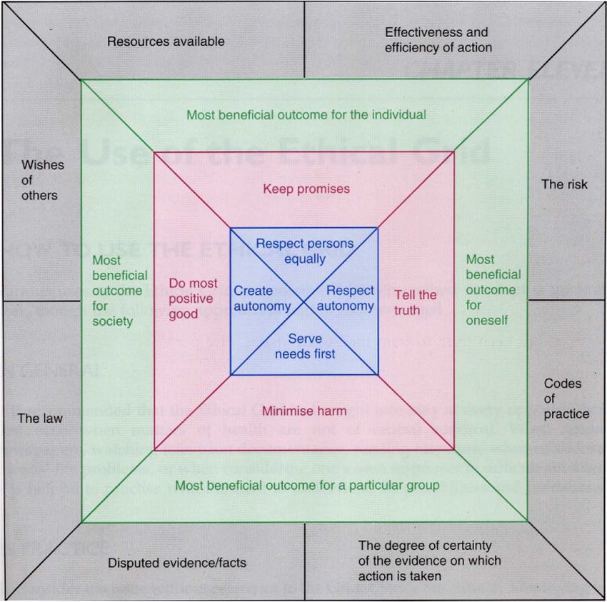

O = Organisational / External (outer layer)
C = Consequential (second layer)
D = Deontological (third layer)
I = Individual (inner layer)

Type of consideration | Reflective questions
1. What happened / nature of the incident
O | Do I have a clear understanding of what happened?
O, I | If any information is disputed, have I sought all the required evidence by:  - Speaking to everyone involved to understand their experience and their feelings about it?  - Obtained supporting evidence (e.g. by speaking to witnesses, or watching recorded footage)?  - Have I separated facts from the opinions of those involved?
O | Is this an isolated incident, or is it part of a wider pattern?
O | Have we encountered this sort of incident before? IF YES:  - What was our previous response?  - Was this effective?  - Is the same response appropriate here, or is something else needed?
2. Why did this happen?
O | What was happening immediately prior to the incident?
O, I | Does this child have identified SEND?
O, I | YES  - Do I know what provision is outlined in their graduated approach / EHCP?  - Was the identified provision in place? If not, why not?  - Is the stated provision still appropriate / effective?  - Has the child’s routine or provision changed recently? | NO  - Is there an unidentified need?  - Does the incident reflect a wider pattern of needs or behaviour?  - Do we need to implement a graduated approach?
3. Resources
O | What resources have I made use of so far:  - within school?  - from the trust?  - from the Local Authority?  - from elsewhere?
O | Which resources could be used next?
O, C | What is needed now to enable things to move forward positively?
4. Legal context
O | Have I consulted:  - the trust exclusion policy?  - the statutory guidance on suspensions and exclusions?
O | Do I have any unanswered questions about my legal position or responsibilities?
5. Impact and consequences
C, D, I | If I choose to suspend/exclude, what will be the impact on:  - The child?  - The family?  - The class?  - The teacher?  - The wider school community?  - The reputation of my school and my leadership? |  | Consider:  - If I choose to suspend, how will the period of suspension be spent?  - What decision would do the greatest good for the most people?  - Is there a risk of harm from either decision?  - Is there a way to minimise harm?
C, D, I | If I choose not to suspend/exclude, what will be the impact on:  - The child?  - The family?  - The class?  - The teacher?  - The wider school community?  - The reputation of my school and my leadership?
 | Have I sought peer support from another Principal?

Following the decision:
1) Have I, in line with trust policy, informed all relevant personnel / bodies of my decision?

Relevant personnel to inform are: | Suspensions | PEX
Parents, in writing | ✓ | ✓
Academy Development Officer | ✓ | ✓
Local Authority | ✓ | ✓
Child’s Social Worker (if applicable) | ✓ | ✓
The Virtual School (if applicable) | ✓ | ✓
Chair of the AIC | If between 5.5 and 15 days in one term | ✓
Chair of the AIC and the Clerk Judy Thorpe j.thorpe@eltacademy.org | If over 15 days in one term | ✓
Rachel Cooper – Vulnerable Pupils Lead | ✓ | ✓

2) Do I need professional supervision or a reflective discussion about the impact of this case on me and my team?

3) Do any other members of staff need professional supervision or a reflective discussion about the impact of this case on them?
Appendix E – The Academy Improvement Committee duty to consider a suspension or exclusion

