Document History
CREATED: | September 2025
By: | Principal
Version: | 1
REVIEW FREQUENCY: | Bi-Annually
NEXT REVIEW DATE: | September 2027

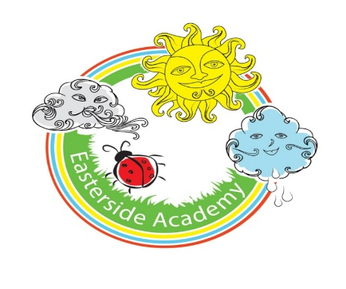

History Policy

Curriculum Aims
Our History curriculum aims to inspire pupils to become curious and analytical thinkers with a broad understanding of the past – in other words, to think like historians. The intention is for pupils to develop the confidence to question and investigate evidence, explore different perspectives and build informed interpretations of events, people and societies.
We aim to build pupils’ awareness of how History shapes identities, cultures and communities over time. The goal is to inspire them to become reflective, active citizens who can draw on historical understanding to make sense of the present and contribute thoughtfully to the future.
The curriculum is designed to be both accessible and ambitious, ensuring all pupils’ participation and achievement.

National curriculum
Our history curriculum fulfils the expectations of the National History Curriculum found here.

The five strands
Based on the aims of the National curriculum, the following five strands have been identified, which run throughout our History curriculum:
- Topic knowledge.
- Chronological awareness.
- Substantive (abstract) concepts.
- Disciplinary concepts.
- Historical enquiry.
Our History curriculum has been planned with these strands running through each topic, ensuring balanced coverage of the different areas of History and both substantive and disciplinary knowledge.

Progression
Our History progression documents provide an overview of the skills and knowledge covered in each phase and strand. It explains how History skills and knowledge are developed to support our pupils in reaching the key stage outcomes as outlined in the National curriculum.

Spiral curriculum
Our History curriculum has been designed as a spiral curriculum with the following key principles in mind:
- Cyclical – pupils return to the key knowledge and skills again and again during their time in primary school.
- Increasing depth – each time a skill is revisited, it is covered with greater complexity.
- Prior knowledge – pupils build upon previous foundations rather than starting again.

Broadening horizons
Building on the principles of the spiral curriculum, learning is designed to take the pupils at Easterside on a historical journey that begins with the personal and familiar before expanding to encompass broader narratives.
By starting with topics that are closely related to children’s lives and communities, pupils can anchor their learning in real-world experiences and begin to see themselves as part of history.
As they revisit key concepts over time, the context broadens from local and national histories to global developments, enabling pupils to understand how their own story fits into wider patterns of change and continuity.
This progression not only supports cognitive development but helps pupils develop a sense of identity, heritage and historical perspective. It enables them to appreciate the complexity of the past, recognise the interconnectedness of human experiences and understand how past events continue to shape the present and influence the future.

Substantive knowledge
Substantive concepts are key concepts, such as ‘empire’, ‘monarchy’ or ‘invasion and settlement’, that pupils learn about during their study of primary History and beyond. Substantive concepts are fundamental elements of historical knowledge; however, they are abstract and therefore, pupils may find them challenging to understand.

Disciplinary knowledge
This refers to knowledge of how historians investigate the past and construct historical claims, arguments and accounts.
- Change and continuity
- Similarities and differences
- Cause and consequence
- Historical significance
- Sources of evidence
- Historical interpretations

Digital literacy
Our Easterside History curriculum integrates technology through digital timelines, research tasks and interactive activities.
This helps develop our pupils’ ability to find, evaluate and use historical sources and information effectively.

The importance of oracy
Learning through talk
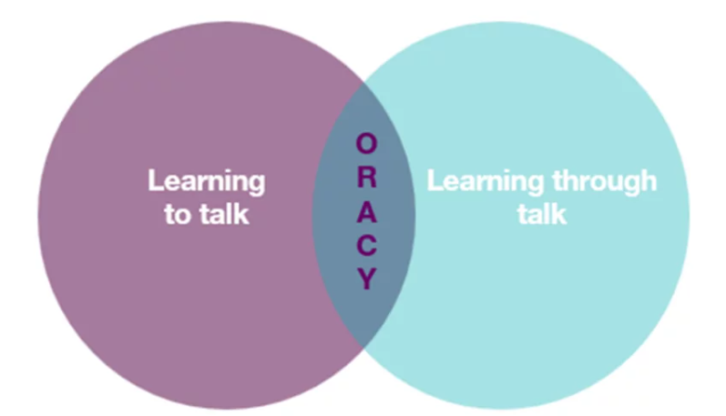
It is crucial to provide our pupils with opportunities for exploratory talk during their learning. This involves thinking aloud, questioning, discussing and collaboratively building ideas.
Learning to talk
Similarly, developing oracy skills is essential for pupils to express and articulate themselves effectively across various contexts and settings, including formal ones such as public speaking, debates and interviews.

Oracy skills in History
Through our History curriculum, our pupils have opportunities to develop their oracy skills by:
- Discussing their understanding of sources and summarising key information.
- Explaining and justifying the conclusions they have reached.
- Persuading their peers about the significance of historical events and people.
- Clarifying and evaluating arguments put forward by their peers and historians.
- Role-playing to gain further insights into historical events and the actions of individuals (e.g. hot seating, conscience alley, freeze-framing).
- Preparing for ‘oral presentations’ such as gallery walks and recorded audio.
- Critiquing the value of different historical sources

Sustainability
Our curriculum promotes awareness of social responsibility and change over time, encouraging pupils to explore key historical themes such as human rights, conflict, inequality and the impact of past decisions on the present and future. Understanding how societies have responded to major challenges, such as war, revolution, migration, and reform, helps our pupils grasp the roots of contemporary issues.
Critical thinking
At Easterside, pupils analyse historical evidence, compare different perspectives and evaluate sources of information. This helps them question assumptions, understand bias and form reasoned conclusions about past events and their impact on the present.

Personal development in History
- SMSC
Our curriculum supports Spiritual, Moral, Social and Cultural (SMSC) development by encouraging pupils to:
- Explore different perspectives.
- Reflect on ethical issues.
- Collaborate with others.
- Appreciate cultural diversity through subject-specific content.

- British Values
promote British values (democracy, the rule of law, individual liberty, mutual respect and tolerance) by incorporating activities that encourage debate, respect for differing opinions and an understanding of societal structures.
- Cultural capital
Our History curriculum broadens pupils’ experiences by introducing them to significant individuals, historical contexts and diverse cultures and traditions. This helps ensure pupils gain the knowledge and skills needed to understand the past and engage meaningfully in society today.

Inclusion and diversity
Our History curriculum has been designed to represent a range of cultures, races and perspectives.
- The content is inclusive and representative of diverse people and histories, challenging stereotypes and outdated ideologies.
- With sensitivity, questions are included to support and reflect pupils’ lived experiences and backgrounds.
- Resources and case studies are carefully selected to encourage pupils to reflect on their role in society and to respect the many ways in which history has shaped people’s lives.

SEND
Our curriculum is designed to be fully adaptable for pupils with SEND. Every lesson includes adaptive teaching to meet the needs of all learners.
Teachers at Easterside include a range of strategies to support and challenge every pupil, such as:
- Scaffolding – tasks are designed with flexibility in mind, allowing for additional support or challenge where needed.
- Multi-sensory approaches – lessons incorporate different elements to engage all learners.
- Clear instructions and structured tasks – ensuring clarity and reducing cognitive load for pupils who benefit from additional support.
- Opportunities for collaborative and independent learning – allowing pupils to work at their own pace while building confidence and independence.
By embedding adaptive teaching throughout, teachers ensure that all pupils, regardless of their starting points, can access and succeed in their learning.
In addition, the curriculum design supports pupils with SEND, avoiding sudden jumps in complexity at transition points and allowing for steady, manageable progression.

Knowledge Retention
Spiral curriculum
Our curriculum incorporates a spiral curriculum model, ensuring that pupils revisit and develop their understanding of key themes and concepts as they progress. This approach allows them to make meaningful connections, reinforce their learning and achieve mastery over time.
- Revisiting key concepts – pupils encounter the same ideas multiple times throughout their education, with each revisit adding more complexity.
- Progressive depth – concepts are not just repeated but expanded upon, helping pupils to make connections and develop a richer understanding over time.
- Knowledge retention – regular exposure to key ideas strengthens memory and prevents knowledge from being forgotten.
- Skill development – pupils refine and apply their skills in different contexts, improving their ability to think critically and solve problems.
- Adaptive learning – by building on prior knowledge, the curriculum meets pupils at their current level and supports all learners, including those who need extra reinforcement and those who are ready for greater challenges.
Knowledge organisers
Every topic has a knowledge organiser which is a structured document designed to support pupils’ learning by clearly outlining the key knowledge, vocabulary and concepts covered in a topic.
It serves as a reference tool for both teachers and pupils, helping to consolidate learning and support knowledge retention.
- Essential knowledge at a glance – summarises the most important facts, concepts and skills that pupils need to learn for a particular topic.
- Key vocabulary – provides a list of subject-specific terms with definitions to develop pupils’ language and understanding.
- Clear and visual layout – organised in a way that makes information easy to digest and revisit, often using diagrams, timelines or key images.
- Support for retrieval practice – helps pupils engage in self-assessment, recall activities and revision, reinforcing long-term memory.
- Teacher and pupil-friendly – acts as a quick reference for teachers when planning lessons and an accessible learning aid for pupils to develop independence in their studies.

Retrieval
Each lesson starts with a retrieval task.
- Activates prior knowledge – helps pupils make connections between new and existing learning, reducing cognitive overload.
- Strengthens memory pathways – retrieval practice has been shown to improve retention more effectively than passive review.
- Identifies gaps in understanding – teachers can quickly assess what pupils remember and address misconceptions before introducing new content.
- Builds confidence – regular recall activities reassure pupils that they can remember key concepts, improving engagement and motivation.
- Promotes spaced learning – revisiting prior learning at regular intervals supports long-term retention, rather than cramming information into a single lesson.

Formative Assessment
Formative assessment is embedded throughout our lessons to ensure that teachers can gauge pupils’ understanding in real time and adapt their teaching accordingly.
- Questioning – lesson plans include targeted and open-ended questions to check understanding, promote critical thinking and address misconceptions.
- Observation – teachers are supported to observe pupils during tasks, noting how they approach activities, collaborate and apply history skills.
- Discussion and peer interaction – pair and group discussions are built into lessons, providing opportunities for pupils to articulate their thinking and for teachers to assess understanding through dialogue.
- Lesson pauses –strategic pause points for checking comprehension, summarising learning and addressing any common errors before progressing.
- Retrieval practice – recap activities such as short recall tasks and oral explanations are embedded to reinforce prior knowledge and assess retention.
- Use of success criteria – success criteria are shared within lessons, allowing pupils to self-assess or peer-assess their work and reflect on their progress.

Summative Assessment
Summative assessment is carried out yearly to indicate if a child is working towards, at or above age-related expectations. Children are assessed against the relevant National Curriculum statements for History which are listed in the subject overview document.
Cross-curricular learning
Our History curriculum supports cross-curricular learning by making clear connections between subjects, helping pupils develop a broader understanding of key concepts and skills.

Produced by: SLT
Reviewed date: December 2025

