 | Autumn1 | Autumn 2 |  | Spring 1 | Spring 2 | Summer 1 |  | Summer 2
English  Texts  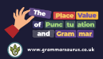 | A Mummy Ate my Homework  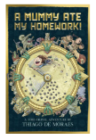 | 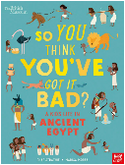  A Kid’s Life in Ancient Egypt |  | World of Food  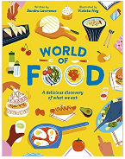 | Time Travel Twins: The Maya Sacrifice  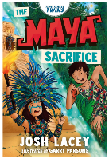 | 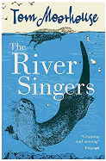  The River Singers |  | 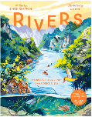  Rivers: An Incredible Journey from Source to Sea
Maths | Place Value  Addition and subtraction  Multiplication and division | Fractions  Measurement  Shape  Statistics |  | Place value  Fractions  Multiplication and division  Addition and subtraction | Shape  Place Value  Measurement  Fractions | Position and direction  Statistics  Addition and subtraction  Measurement |  | Fractions  Place value  Multiplication and division
History & Geography | What did the ancient Egyptians believe?  (9 weeks) |  | Where does our food come from?  (9 weeks) |  | How did the achievements of the Ancient Maya impact their society and beyond? (9 weeks) |  | What are rivers and how are they used? (9 weeks)
Science | Energy: Light and shadows | Animals including humans: Movement and nutrition |  | Materials: Rocks | Animals including humans: Digestion and food | Energy: Electricity and circuits |  | Making connections: How does food affect muscle fatigue?
Art | Craft and design  Egyptian scroll  (5 weeks) |  | Painting  Light and dark  (5 weeks) |  | Drawing  Power prints  (5 weeks) |  | Sculpture and 3d  Mega materials  (5 weeks)
DT | Textiles: Cross stitch and applique – Egyptian collars  (5 weeks) |  | Cooking and nutrition: Eating seasonally  (5 weeks) |  | Structures: Pavilions  (5 weeks) |  | Mechanical systems: cars  (5 weeks)
PE | Tag Rugby | Gymnastics - Symmetry & Asymmetry / Canon and Unison |  | Dance  Y3 - Weather  Y4 - Cats | Handball | Cricket |  | Athletics
Computing  Enquire | Y3 - Multimedia using iMovie  Y4 - Multimedia using Garageband |  |  | Y3/4 - Physical Computing with Micro:Bit | Y3/4 - Physical Computing with Micro:Bit Computer Networks | Y3 - Data Handling using Numbers and Data Loggers  Y4 - Collaboration using email and multimedia using Pages and Keynote
RE | Expressing  L2.5 Why are festivals important to religious communities? (part 1/2) |  |  | Believing  L2.1 What do different people believe about God? |  | Expressing  L2.4 Why do people pray? |  | Living L2.9: What can we learn from religions about deciding what is right and wrong?
PSHE | Family and Relationships | Health & Wellbeing |  | Safety and the changing body | Citizenship | Economic Well-being |  | Transition and Thrive
MFL (French) | The Basics (1) | The Basics (2) |  | The Basics (3) | Animals | Food |  | At School
MFL (French) | Playtime | My Home |  | Describing People | The Body | My Town |  | Sport
Music  Y3  Y4 | Reading Notation 1:  Rhythm and Tempo | Exploring Staff Notation 1:  High and Low  (Glockenspiel) |  | Ensemble Skills 1:  Call & Response  (Glockenspiel OR Recorder) | Composition Skills 1:  Pitch, Rhythm and Structure | Exploring Musical Theatre:  Forte and Piano |  | Becoming Musicians 1:  Dynamics and Tempo
Music  Y3  Y4 | Reading Notation 2:  2, 3 and 4 Time | Exploring Sta Notation 2:  Follow the Score  (Glockenspiel) |  | Ensemble Skills 2:  Melody and Accompaniment  (Glockenspiel OR Recorder) | Composition Skills 2:  Sequences and Pentatonic  Phrases | Exploring Classical Music 1:  Legato and Staccato |  | Becoming Musicians 2:  Major and Minor

