 | Autumn1 | Autumn 2 |  | Spring 1 | Spring 2 | Summer 1 |  | Summer 2
English  Texts   | Holes  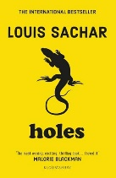 |  |  | Cosmic  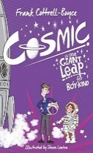 | Pig Heat Boy  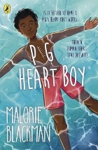 | 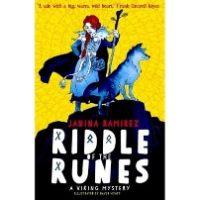  Riddle Of The Runes |  | The Final Year  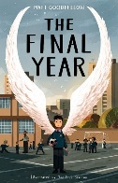
Maths | Place Value  4 operations  Fractions  Measurement  Geometry: Properties of shape & position and direction  Statistics | Place value  Fractions  Multiplication & Division  Geometry: Position and direction |  | Multiplication &Division  Fractions  Ratio and proportion  Measurement | Geometry: Properties of shape  Statistics  Ratio and proportion  Algebra | Place Value  4 operations  Fractions  Measurement  Geometry: Properties of shape & position and direction |  | Statistics  Place Value  4 operations  Fractions  Ratio and proportion  Algebra
History & Geography | What is the legacy of the ancient Greek civilisation?  (9 weeks) |  | Would you like to live in the desert?  (9 weeks) |  | Were the Vikings raiders, traders or something else?  (9 weeks) |  | Where does our energy come from?  (9 weeks)
Science | Mixtures and separation | Materials: Properties and changes |  | Forces and space: Earth and space | Animals including humans: Circulation and health | Energy: Light and reflection |  | Making connections: How reflective are space blankets?
Art | Painting and mixed media  Portraits  (5 weeks) |  | Drawing  I need space (5 weeks) |  | Sculpture and 3D  Making memories (5 weeks) |  | Craft and design  Photo (5 weeks)
DT | Cooking and nutrition – Come dine with me (5 weeks) |  | Textiles: Stuffed toys (5 weeks) |  | Structures: Bridges (5 weeks) |  | Mechanical system –Automata toys (5 weeks)
PE | Hockey | Athletics |  | Dance | Basketball | Rounders |  | Tennis
Computing  Enquire | Podcasting using Pages and GarageBand |  |  | Physical Computing with Micro: Bit | Computer Networks | Stop Motion using iMotion and Augmented Reality using Halo AR.
Computing  Enquire | 3D Modelling using TinkerCAD and App Prototype using KeyNote |  |  | Physical Computing with Micro:Bit | Physical Computing with Micro:Bit Computer Networks | Extended Data Handling using Numbers and Multimedia using ‘All Apps’
RE | Believing  U2.1 Why do some people believe God exists? | Living  U2.6 What does it mean to be a Muslim in Britain today ?  (part 1) |  | Living  U2.7 What matters most to Christians and Humanists? | Believing  U2.2 What would Jesus do? Can we live by the same values of Jesus in the 21st century? | Expressing  U.2.4 If God is everywhere why go to a place of worship?
PSHE | Families and relationships | Health and wellbeing |  | Safety and the changing body | Citizenship | Economic wellbeing |  | Transition
MFL (French) | On Holiday | Eating Out |  | Hobbies | A School Trip | Seasons |  | The Environment
MFL (French) | Actions | In France |  | Family | A Weekend with Friends | The Future |  | Jobs
Music  Y5  Y6 | Reading Notation 3:  Time Signatures | Developing Sight Reading  Skills 1:  Melodies  (Glockenspiel) |  | Pop Music 1:  Arrangements and  Improvisation  (Glockenspiel OR Ukulele) | Creating Music for  Film and TV:  Character, Atmosphere and  Environment | Exploring Classical Music 2:  Ensemble Performance |  | Becoming Musicians 3:  Chords and Triads
Music  Y5  Y6 | Reading Notation 4:  Rhythm Ensemble | Developing Sight Reading  Skills 2:  Note Names and Durations  (Glockenspiel) |  | Pop Music 2:  Chords and Bass Lines  (Glockenspiel OR Ukulele) | Composition Project 1:  Improvisation, Composition  and Notation | Composition Project 2:  Notation, Expression and  Performance |  | Singing with Style

