Document History
CREATED: | September 2025
By: | Principal
Version: | 1
REVIEW FREQUENCY: | Bi-Annually
NEXT REVIEW DATE: | September 2027

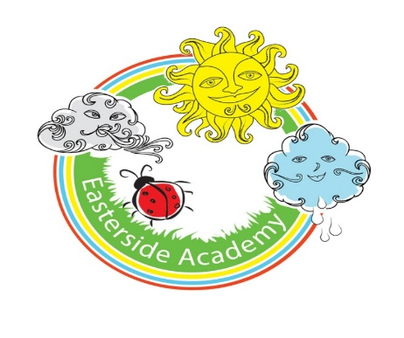

MFL Policy

Curriculum Aims
Our Modern Foreign Languages (MFL) curriculum aims to nurture pupils’ linguistic curiosity, cultural awareness and communication skills, encouraging them to think like language learners and global citizens. The intention is for pupils to develop the confidence to experiment with language, express ideas and communicate meaning in both spoken and written forms.
Our curriculum promotes an appreciation of languages as powerful tools for human connection, helping pupils understand their significance across different cultures, communities and global contexts. It encourages children to value originality, take linguistic risks and reflect critically on their own language use and that of others.
National curriculum
Our MFL curriculum fulfils the expectations of the National Curriculum for Modern Foreign Languages as outlined in the Programmes of Study found here.
The strands
Our MFL curriculum is structured around five strands that run through each unit:
- Listening
- Speaking
- Reading
- Writing
- Intercultural understanding
These strands ensure a balanced coverage of the linguistic, cultural and disciplinary knowledge pupils need to progress in MFL, while supporting the development of both communicative confidence and cultural understanding.

Key areas
The National Curriculum states that pupils should develop their competence in listening, speaking, reading and writing.
To support this, our MFL curriculum returns to these four key skills in every year group. This allows pupils to see their progress with each mode of communication while continuing to build their broader linguistic repertoire over time.
Our curriculum includes a fifth key area: Grammar. This focuses on giving pupils a strong foundation in sentence construction, word classes and language patterns, supporting accuracy and fluency in communication.
Progression
Our Medium-Term Plan gives a clear overview of the linguistic skills and cultural knowledge covered in each phase and strand. It explains how MFL skills and understanding are developed to support pupils in reaching the key stage outcomes as outlined in the National Curriculum.
New learning is weighted toward the start of each key stage, allowing ample opportunity for it to be revisited and applied in later years. As a result, knowledge accumulation may appear heavier in some year groups than others.

Spiral curriculum
Our MFL curriculum has been designed as a spiral curriculum with the following key principles in mind:
- Cyclical – pupils return to the key knowledge and skills again and again during their time in primary school.
- Increasing depth – each time a skill is revisited, it is covered with greater complexity.
- Prior knowledge – pupils build upon previous foundations rather than starting again.

Types of Knowledge
In MFL, knowledge can be understood in three forms:
- Practical (Procedural) knowledge – the skills pupils need to use a language: speaking, listening, reading, writing and pronunciation.
- Theoretical knowledge – vocabulary, grammar rules, sentence structures and cultural information.
- Disciplinary knowledge – understanding how languages are learned, analysed and compared, including noticing patterns and asking questions about meaning.

Practical knowledge
Practical knowledge refers to the hands-on and verbal skills developed through using the target language for communication.

Theoretical knowledge
Theoretical knowledge includes understanding vocabulary, grammar, phonics and cultural contexts that shape how language is used in real life.

Disciplinary knowledge
Disciplinary knowledge includes understanding how languages work, how they relate to English and other languages, and how learners can use strategies to decode and construct meaning.

Digital literacy
Our MFL curriculum integrates technology through activities such as digital pronunciation guides, vocabulary apps and online interactive tasks. This supports the development of confident and effective communicators in an increasingly digital world.

The importance of oracy
Learning through talk
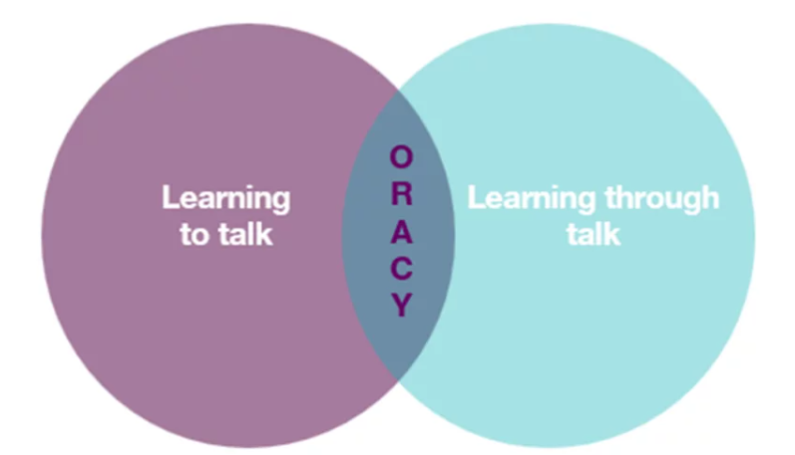
It is crucial to provide our pupils with opportunities for exploratory talk during their learning. This involves thinking aloud, questioning, discussing and collaboratively building ideas.
Learning to talk
Similarly, developing oracy skills is essential for pupils to express and articulate themselves effectively across various contexts and settings, including formal ones such as public speaking, debates and interviews.
Oracy skills in MFL
Through our MFL curriculum, pupils develop oracy skills by:
- Practising pronunciation, intonation and phrasing
- Engaging in paired and group dialogues
- Presenting short speeches or role-plays
- Listening and responding to others in the target language
- Asking and answering questions
- Expressing opinions and justifying ideas
- Participating in discussions about culture and language

Sustainability
Our MFL curriculum supports sustainability education by helping pupils understand global issues such as climate change, fair trade, and environmental responsibility through culturally relevant texts and discussions. This encourages pupils to reflect on their role as global citizens who can communicate, share ideas and collaborate across languages.

Critical thinking
Pupils develop critical thinking by decoding language patterns, analysing texts, making connections between languages and reflecting on cultural similarities and differences. This strengthens their ability to question assumptions, form opinions and understand multiple perspectives.

Personal development in MFL
- SMSC
Our curriculum supports Spiritual, Moral, Social and Cultural development by encouraging pupils to:
- Appreciate cultural diversity
- Reflect on global issues and ethical topics
- Work collaboratively
- Explore the values, traditions and customs of different communities

- British Values
Our lessons promote British Values by encouraging:
- Democratic discussion
- Respect for differing viewpoints
- Understanding how language reflects laws, liberties and societal structures
- Tolerance and appreciation of diverse cultures
  - Cultural capital
Our MFL curriculum broadens pupils’ experiences by introducing them to different cultures, traditions, festivals, geography and ways of life. It ensures pupils develop the linguistic and cultural understanding needed to engage meaningfully with the world beyond their immediate environment.
Inclusion and diversity
Our curriculum has been designed to be inclusive and representative, ensuring all pupils see themselves reflected in the cultures, communities and contexts they encounter.
This approach helps challenge stereotypes, broaden perspectives and celebrate languages as rich, global and human forms of expression.

Timetabling
MFL is taught for 30 minutes per week in Key Stage 2. We also hold additional language days throughout the year.

SEND
Our curriculum is designed to be fully adaptable for pupils with SEND. Every lesson includes adaptive teaching to meet the needs of all learners.
Teachers at Easterside include a range of strategies to support and challenge every pupil, such as:
- Scaffolding – tasks are designed with flexibility in mind, allowing for additional support or challenge where needed.
- Multi-sensory approaches – lessons incorporate different elements to engage all learners.
- Clear instructions and structured tasks – ensuring clarity and reducing cognitive load for pupils who benefit from additional support.
- Opportunities for collaborative and independent learning – allowing pupils to work at their own pace while building confidence and independence.
By embedding adaptive teaching throughout, teachers ensure that all pupils, regardless of their starting points, can access and succeed in their learning.
In addition, the curriculum design supports pupils with SEND, avoiding sudden jumps in complexity at transition points and allowing for steady, manageable progression.

Knowledge Retention
Spiral curriculum
Our curriculum incorporates a spiral curriculum model, ensuring that pupils revisit and develop their understanding of key themes and concepts as they progress. This approach allows them to make meaningful connections, reinforce their learning and achieve mastery over time.
- Revisiting key concepts – pupils encounter the same ideas multiple times throughout their education, with each revisit adding more complexity.
- Progressive depth – concepts are not just repeated but expanded upon, helping pupils to make connections and develop a richer understanding over time.
- Knowledge retention – regular exposure to key ideas strengthens memory and prevents knowledge from being forgotten.
- Skill development – pupils refine and apply their skills in different contexts, improving their ability to think critically and solve problems.
- Adaptive learning – by building on prior knowledge, the curriculum meets pupils at their current level and supports all learners, including those who need extra reinforcement and those who are ready for greater challenges.

Retrieval
Each lesson starts with a retrieval task.
- Activates prior knowledge – helps pupils make connections between new and existing learning, reducing cognitive overload.
- Strengthens memory pathways – retrieval practice has been shown to improve retention more effectively than passive review.
- Identifies gaps in understanding – teachers can quickly assess what pupils remember and address misconceptions before introducing new content.
- Builds confidence – regular recall activities reassure pupils that they can remember key concepts, improving engagement and motivation.
- Promotes spaced learning – revisiting prior learning at regular intervals supports long-term retention, rather than cramming information into a single lesson.

Formative Assessment
Formative assessment is embedded throughout our lessons to ensure that teachers can gauge pupils’ understanding in real time and adapt their teaching accordingly.
- Questioning – lesson plans include targeted and open-ended questions to check understanding, promote critical thinking and address misconceptions.
- Observation – teachers are supported to observe pupils during tasks, noting how they approach activities, collaborate and apply history skills.
- Discussion and peer interaction – pair and group discussions are built into lessons, providing opportunities for pupils to articulate their thinking and for teachers to assess understanding through dialogue.
- Lesson pauses –strategic pause points for checking comprehension, summarising learning and addressing any common errors before progressing.
- Retrieval practice – recap activities such as short recall tasks and oral explanations are embedded to reinforce prior knowledge and assess retention.
- Use of success criteria – success criteria are shared within lessons, allowing pupils to self-assess or peer-assess their work and reflect on their progress.

Summative Assessment
Summative assessment is carried out yearly to indicate if a child is working towards, at or above age-related expectations. Children are assessed against the relevant year group objectives.
Cross-curricular learning
Our MFL curriculum supports cross-curricular learning by connecting language learning with geography, history, literacy, RE, music and PSHE. This helps pupils develop a broader understanding of global cultures, vocabulary patterns and the role of language in society.
Produced by: SLT
Reviewed date: December 2025

