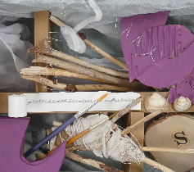
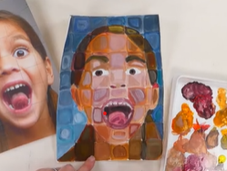
4
Sculpture and 3D
Making Memories
Children will create expressive sculptures and reflect on artistic decisions. Children will learn to represent memories through art, using various materials and techniques, and develop skills in planning, creating, and evaluating 3D sculptures.

ART CURRICULUM ROADMAP
CYCLE 1
Y1&2

Craft and design
Photo opportunity
Children will explore creative photographic techniques, creating new images through photomontage, understanding photorealistic self-portraits, and applying digital photography to art design, enhancing their skills in composition and editing.

Drawing
I need space
Children will focus on retrofuturism, developing skills in evaluating images and creating art through various drawing processes, including collagraph printmaking. Pupils will develop independent artistic skills and their ability to generate, test, and refine ideas in their sketchbooks, leading to a final piece of artwork.

Craft and design
Architecture
Children discover how buildings are created, from early structures to modern masterpieces. They learn how architects use shape, pattern, materials and purpose to bring ideas to life, and experiment with their own designs using drawing, model-making and collaborative construction.

Craft and design
Fabric of nature
The children will learn about the work of William Morris, using subject vocabulary to describe his work and style. They will create their own pattern and consider how their design could be used for a product.

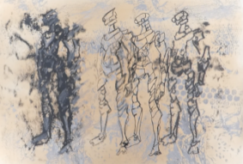
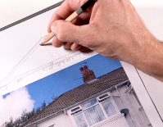
Y5&6

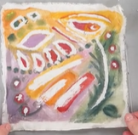
Painting and mixed media
Prehistoric
Children will explore prehistoric art, recreating the style of cave artists using charcoal and natural pigments. Pupils experiment with colour mixing, and creating large-scale artworks, enhancing both artistic skills and historical knowledge.

Drawing
Growing artists
Children will use shapes, shading, and texture in art to enhance their drawing skills. They will develop a sense of light and dark, using frottage for texture, and experimenting with different tools to create expressive and abstract art.

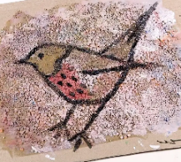
Sculpture and 3D -
Shape and space
Children will learn how to transform 2D card shapes into three-dimensional structures and sculptures. Pupils explore abstract shapes and space, develop skills in constructing 3D objects, and understand the difference between 2D and 3D art.

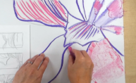
Y3&4

Craft and design - Woven wonders
Children will learn to express opinions about art, use creative techniques like wool wrapping and weaving, and understand the work of artists like Cecilia Vicuña. It emphasises skills such as measuring and choosing materials.

Painting and mixed media - Life in colour
Children will focus on primary and secondary colours, colour mixing, and creating textures using different tools. They will also use collage techniques, to experiment with materials and evaluate their artistic choices.

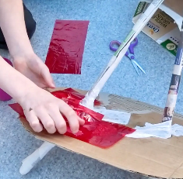
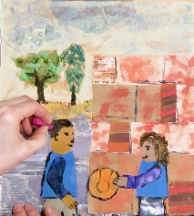

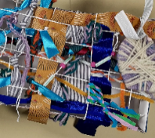

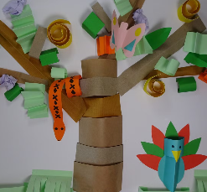
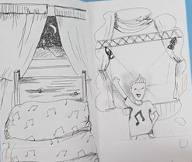
Drawing – Tell a story
Pupils develop their ability to tell a story through drawing. Children will create textures, observational drawings, character expressions. They will be storytelling through illustrations. Children will enhance their mark-making techniques, observational skills, and imagination in art.

Sculpture & 3D - Paper play
Children will be introduced to paper-based 3D art forms. They will focus on techniques like rolling paper tubes, shaping paper strips, and constructing imaginative sculptures. Children develop skills in creating 3D structures and applying painting skills in three-dimensional art, enhancing their understanding of form and construction.

