
4
Mechanical system Automata toys
Pupils explore cams, followers and rotating mechanisms to understand how movement can be created in automata toys. They design and build their own moving toy, combining mechanical components with creative design, before testing and evaluating how effectively their mechanism works.

D&T CURRICULUM ROADMAP
CYCLE 1
Structures
Bridges
Pupils investigate how different types of bridges are designed for strength and stability, then apply this knowledge to create their own bridge using a range of materials and joining techniques. They test, refine and evaluate their structures to see how well they meet the design criteria.

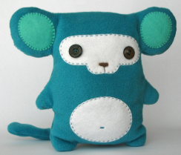
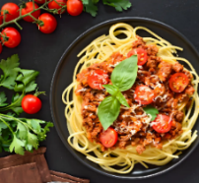
Textiles
Stuffed toys
Pupils design and make their own stuffed toy, exploring construction methods, practising key sewing skills, and evaluating their finished product for quality, function and appeal.

Cooking and nutrition
Come dine with me
Pupils plan, prepare and cook a nutritious two-course meal, learning key kitchen skills and exploring healthy ingredients. They design their own menu, present their dishes, and evaluate taste, appearance and nutritional value—just like on Come Dine With Me!
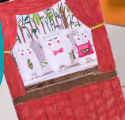

Y5&6
Mechanical system Pneumatic toy volcano
Children will design and make a pneumatic toy volcano. They will explore how air pressure can create movement, use simple mechanisms safely, and evaluate how well their design works.

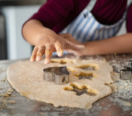
Cooking and nutrition
Adapting a recipe
Children will be able to adapt a simple recipe to make it healthier or to suit different tastes. They will learn about ingredients, follow instructions safely, and evaluate their final product.

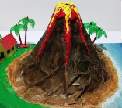
Electrical system
Electric poster
Children will design and make an electric poster using simple circuits. They will learn how to connect batteries, wires, and bulbs safely, and evaluate how well their circuit and design work.

Structures
Constructing a castle
Children will design and build a model castle using a range of materials. They will learn how to make structures strong and stable, explore different joining techniques, and evaluate the effectiveness of their designs.

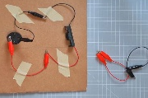
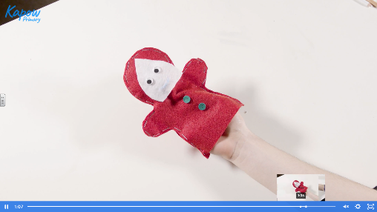

Textiles
Puppets
Children will design and make a simple fabric puppet. They will learn how to join materials using basic sewing techniques, decorate their designs creatively, and evaluate the effectiveness of their finished puppet.

Y3&4

Structures
Constructing a windmill
Children will design and build a model windmill with a rotating structure. They will explore how to make their models strong and stable, use different materials and joining techniques, and evaluate how well their windmill works.

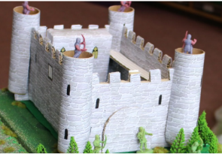

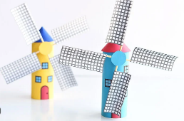

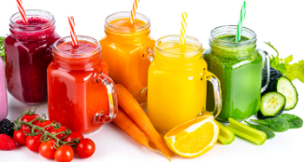
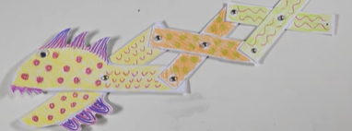
Mechanisms
Making a moving monster
Children will make a moving monster using linkages to connect levers and pivots. They will understand that materials can be selected according to their characteristics. The children will evaluate how functional their monster is and whether it meets the Design Criteria.

Y1&2

Cooking and nutrition
Smoothies
Children will be able to design and make a healthy smoothie using a range of fruits and ingredients. They will learn about where food comes from, the importance of a balanced diet, and how to prepare food safely and hygienically.

