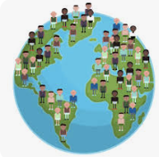
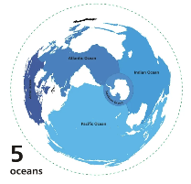
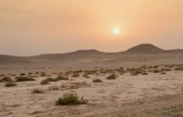
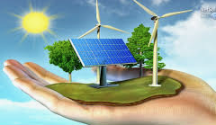
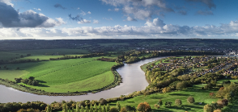
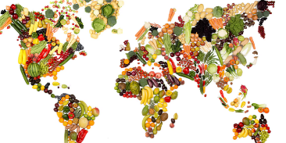
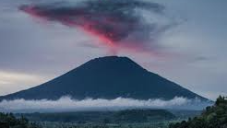
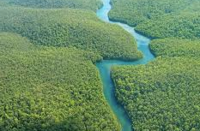

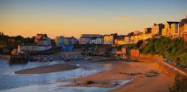
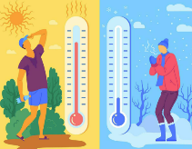
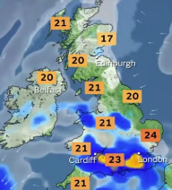
4
GEOGRAPHY CURRICULUM ROADMAP
Y1&2
C2
Where does our food come from?
Knowledge: Explain that food imports can be both helpful and harmful.
Concept: Human and physical
Skills: Identify that different foods grow in different biomes and say why.

Why are rainforests important to us?
Knowledge: Articulate why the Amazon rainforest is important.
Concept: Locational knowledge
Skills: State the location and some key features of the Amazon rainforest.

Why do people live near volcanoes?
Knowledge: Describe how volcanoes form at tectonic plate boundaries.
Concept: Human and physical
Skills: Explain a mix of negative and positive consequences of living near a volcano.

Where does our energy come from?
Knowledge: Define renewable and non-renewable energy.
Concept: Human and physical
Skills: Describe advantages and disadvantages of different energy sources.

What are the rives and how are they used?
Knowledge: Describe human and physical features around a river.
Concept: Human and physical
Skills: Identify the location of a river on an OS map.

Would you like to live in the desert?
Knowledge: Describe the characteristics of a hot desert biome.
Concept: Geographical skills and fieldwork.
Skills: Locate the largest deserts in each continent.

Why do oceans matter?
Knowledge: Describe how humans impact the oceans and the consequences of this.
Concept: Human and physical
Skills: Explain how humans use the ocean and how it helps regulate Earth’s climate.

Why do populations change?
Knowledge: Describe the increase in global population over time.
Concept: Place knowledge
Skills: Explain what migration is and why people move, including push and pull factors.

What is it like to live in Shanghai?
Knowledge: Compare Shanghai to their locality.
Concept: Geographical skills and fieldwork
Skills: Use an atlas to locate the UK, Europe, China and Asia on a world map

What is the weather like in the UK?
Knowledge: Identify the four seasons and the current season and describe some seasonal changes.
Concept: Human and physical
Skills: Observe and describe daily weather patterns.

Would you prefer to live in a hot or cold place?
Knowledge: Name and locate the seven continents on a world map.
Concept: Locational knowledge
Skills: Locate some countries with hot or cold climates on a world map.

What is it like to live by the coast?
Knowledge: Describe how people (& local people) use the coast.
Concept: Place knowledge
Skills: Name and locate the seas and oceans (and coasts) surrounding the UK in an atlas.

Y5&6C2
Y5&6C1
Y3&4
C2
Y3&4
C1
Y1&2
C1

