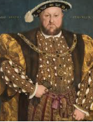
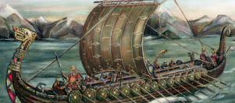
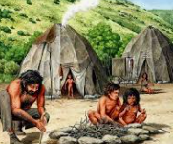
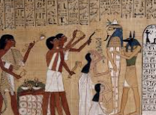
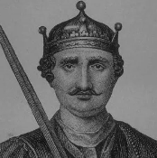
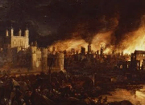
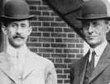
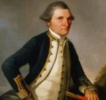
4
What is a Monarch?
Knowledge: Events beyond living memory that are significant nationally or globally
Concept: Chronology, evidence and interpretation
Skills: Sequencing events, identify similarities, differences and reason for change.

How have explorers changed the world?
Knowledge: Significant historical events, people and places in their own locality
Concept: Chronology
Skills: describe simple changes, using artefacts to find out about the past, asking questions and finding out answers.

What did the ancient Egyptians believe?
Knowledge: The achievements of the earliest civilizations – an overview of where and when the first civilizations appeared and a depth study of one of the following: Ancient Sumer; The Indus Valley; Ancient Egypt; The Shang Dynasty of Ancient China
Concept: Evidence and interpretation
Skills: Asking questions, interpreting sources, understanding conclusions.

What was the impact of WW2 on the people of Britain?
Knowledge: A study of an aspect or theme in British history that extends pupils’ chronological knowledge beyond 1066. A local history study
Concept: Chronology. Historical significance.
Skills: Making links between events, explaining reasons for change and events and interpreting sources.

Were the Vikings raiders, traders or something else?
Knowledge: the Viking and Anglo-Saxon struggle for the Kingdom of England to the time of Edward the Confessor
Concept: Evidence and interpretation
Skills: Exploring different representations from the period and evaluating the usefulness of different sources.

How did the achievements of the Ancient Maya impact their society and beyond?
Knowledge: A non-European society that provides contrasts with British history –900; Mayan civilization
Concept: Evidence and interpretation, Change and continuity
Skills: Identifying the links, consequences of events and the actions of people. Identifying reasons for historical events, situations and changes.

What was life like in Tudor England?
Knowledge: A study of an aspect or theme in British history that extends pupils’ chronological knowledge beyond 1066
Concept: Evidence and interpretation
Skills: Using historical evidence and sources, asking questions and making connections.

Would you prefer to have lived in the Stone Age, Bronze Age or Iron Age?
Knowledge: Changes in Britain from the Stone Age to the Iron Age.
Concept: Change and continuity. Similarities and differences.
Skills: Comparing different periods of history, describing change and making links and connections across a period of time.

How did we learn to fly?
Knowledge: The lives of significant individuals in the past who have contributed to national and international achievements.
Concept: Historical significance
Skills: comparing past and present, using sources of information to ask questions, describing past events and people.

Y1&2
C2
Why was the fire great?
Knowledge: Events beyond living memory that are significant nationally or globally
Concept: Chronology, Cause & Consequence
Skills: timeline, identify similarities and differences, asking questions about sources of evidence, recognising why people did things.

What did the Greeks ever do for us?
Knowledge: Ancient Greece – a study of Greek life and achievements and their influence on the western world.
Concept: Change and continuity
Skills: Comparing and making connections between different contexts in the past and explaining the reasons for changes and continuity.

Why did the Romans invade and settle in Britain?
Knowledge: The Roman Empire and its impact on Britain.
Concept: Cause and consequence. Historical significance
Skills: Identifying the consequences of events and the actions of people. Identifying reasons for historical events, situations and changes.

HISTORY CURRICULUM ROADMAP
Y5&6C2
Y5&6C1
Y3&4
C2
Y3&4
C1
Y1&2
C1
