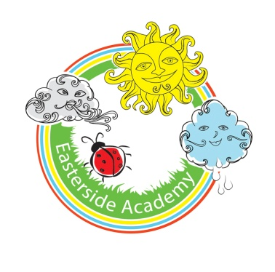
Easterside Academy Experiences and Visits Map

 | Autumn 1 | Autumn 2 | Spring 1 | Spring 2 | Summer 1 | Summer 2
ILP  (Imaginative Learning Project) | Dinosaur Planet | Bright lights & big city | Muck, mess and mixtures | Wriggle and crawl | Towers, tunnels and turrets | Beachcombers
Focus  (Subject) | History | Geography | Art & Design | Science | D & T | Science
Memorable experience | Dinosaur footprints outside – chrn to investigate | Visit from the Queen | Messy session outside | A mini beast hunt | Have a battle on the school field and rescue a princess | Beachcombing in sandpit.  Set up rock pool in class.
Visits | Hancock Museum | Danby Lodge North York Moors |  | Butterfly World | Raby Castle
Outdoor Learning | Fossil hunt and archaeologist dig for bones | Community walk, position and direction (in the school grounds) | All lesson outside | All lessons outside | Den building | Sand building
Innovate Stage | Create a Dinosaur Museum | Plan a trip in London for Marley the Meerkat | Open an Art Gallery | Make a micro habitat – Tees Valley Wild Life | Make a fortress | Create a new and exciting sea creature that could live in a rock pool
Year Group: 1/2 Cycle 1: 2018-19

