Easterside Academy
Nursery & Reception - Home Learning - Weeks beginning 22.6.20/ 29.6.20

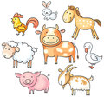 | Are all farm animals the same?
Our Enquiry / Topic question is:

REMEMBER TO SHARE YOUR LEARNING AND ACTIVITIES ON OUR CLASS SEESAW PAGE!
Activity: | Phonics activity ideas:  Most children are working on their early phonics skills; tuning in to environmental sounds around them and beginning to identify initial sounds of words and items.  Some children are beginning to recognise sounds to spell and read simple words. You can encourage your child to write lists and captions containing simple words i.e. cat, mug, hop etc. (CVC words). They can also practice reading these words.  When using Phonics Play start with Phase 1 games and resources. If these are too easy encourage your child to have a go at some of the Phase 2 games and resources.  Login  Username: march20  Password: home  There are also now daily phonics lessons for children who are learning to blend on YouTube;  https://www.youtube.com/playlist?list=PLuGr6z2H2KNGIYp03sdzSGLZquzuQENkx  Nursery  Week One- 22.6.20  - https://www.phonicsbloom.com/uk/game/match-sounds?phase=1  - Guess the sound game-animals  - https://www.phonicsbloom.com/uk/game/whats-behind-the-door?phase=1  - What’s behind the door? Guess the sound.  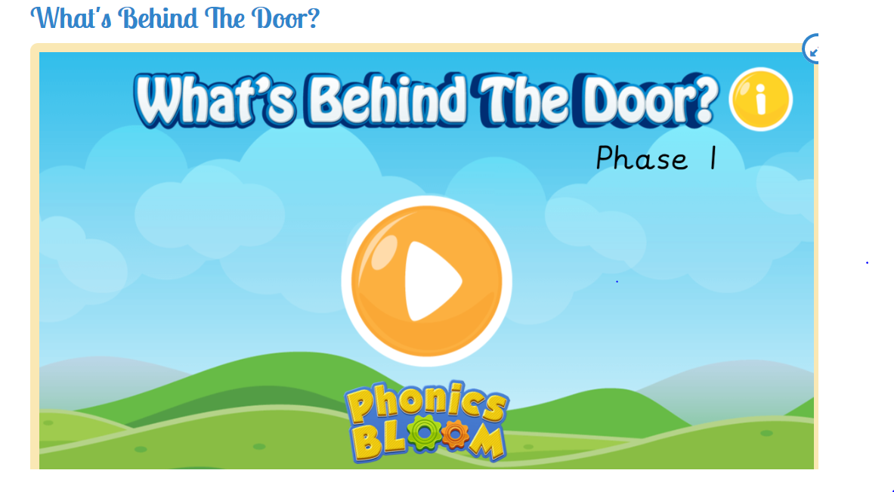  Nursery:  Week Two - 29.6.20  http://www.literactive.com/Download/live.asp?swf=story_files/easel_US.swf  Initial sound game  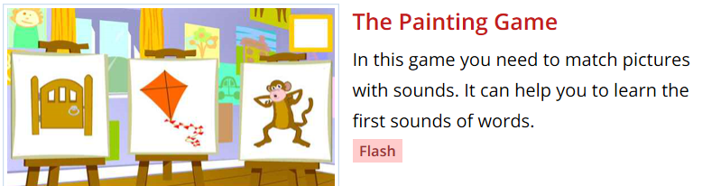  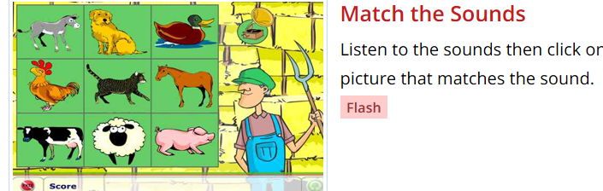  Reception-Week one/two-Website links.  https://www.phonicsbloom.com/uk/game/list/phonics-games-phase-4  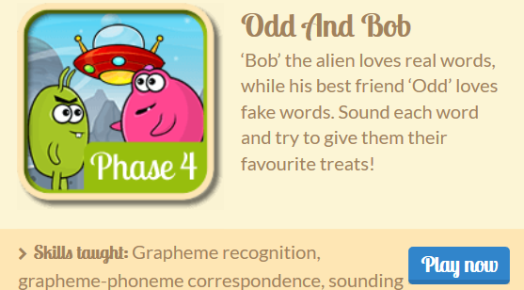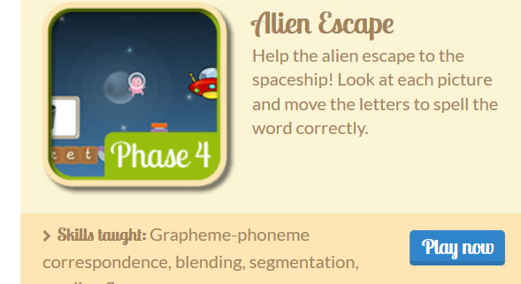  Week One- 22.6.20  Reception Class  Day 1/ 2 -or  Word building using digraph or- cord, port, horn, fork, corn, torn, torch –(use letters from alphabet packs to build the words.)  Tricky CVC words to continue to practise reading and writing- doll, hiss, miss, feel, wheel, seen  Read or dictate the sentence to your child to write – The ship went into the port. I put on a torch in the dark.  Trickier CCVC/CCVC words- lent, dump, thump, went, sink, vest  Read or dictate the sentence to your child to write - The man had a fork to pick up his food. She can skip the best. He went to the pond.  Trickiest CCVCC words – print, tramp, trust, crisp, slept.  Read or dictate the sentence to your child to write - The folk picks up crisp food. The man slept in a tent.  Tricky words;-continue to practise reading by sight- me/ be/we/ you  Day 3 /4  Word building using digraph aw- paw, law, saw, claw, hawk, dawn –(use letters from alphabet packs to build the words.)  Tricky CVC words to continue to practise reading and writing- this, thin, ship, cash, mash  Read or dictate the sentence to your child to write – The dog has paws. I saw the dawn.  Trickier CCVC/CCVC words- melt, hump, flop, frill, drill  Read or dictate the sentence to your child to write - The dog held up his paw. The hawk has claws.  Trickiest CCVCC words – trunk, grasp, blast, blank, graft  Read or dictate the sentence to your child to write - The hawk can grasp the tree with his claws. I saw a tree with a trunk.  Tricky words;-continue to practise reading by sight- me/ be/we/ you  Day 5  recap using or aw – recap spelling words from Day 1-4  Give your child a little challenge – ask them to read / write a selection of words/ sentences used this week  Week Two - 29.6.20  Reception  Day 1/ 2  Digraph – oa ow  Word building using digraph oa boat, coat, moat, goat, toad –(use letters from alphabet packs to build the words.)  Tricky CVC words to continue to practise reading and writing- push, chip, chill, chin, shin,  Read or dictate the sentence to your child to write – The dog has paws. I saw the dawn.  Trickier CCVC/CCVC words- frog, hunt, bent, kept, lump  Read or dictate the sentence to your child to write - The toad sat next to the frog. The boat was on the pond.  Trickiest CCVCC words – drank, thank, grant, prank.  Read or dictate the sentence to your child to write – she drank on the boat. The man did a prank on the goat.  Tricky words;-continue to practise reading by sight- she/he/said  Day 3/ 4 - ow digraph  Word building using digraph ow bow, sow, low, throw, row –(use letters from alphabet packs to build the words.)  Tricky CVC words to continue to practise reading and writing- sill, till, till, will, kill  Read or dictate the sentence to your child to write – She had a bow. I saw him row.  Trickier CCVC/CCVC words- vent, daft, gust, fond, lump  Read or dictate the sentence to your child to write – A gust of wind on her bow. I am fond of how you jump.  Trickiest CCVCC words – frost, stamp, think, swift  Read or dictate the sentence to your child to write - He can stamp on the row of plants. I think I can see frost.  Tricky words;-continue to practise reading by sight- she/he/said  Day 5  recap using oa ow words – recap spelling words from Day 1-4  Give your child a little challenge – ask them to read / write a selection of words/ sentences used this week
Phonics
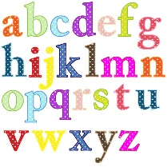

Literacy/Topic | - First name writing daily; if able to write first name independently, encourage to write surname also. Write your name in different ways; with a pencil, in different colours, with water and a paintbrush outside etc.  - Recording the weather daily and practicing the days of the week.  Our Enquiry / Topic question is; Are all farm animals the same?  Week One:  Watch Oh Dear / Farmer Duck  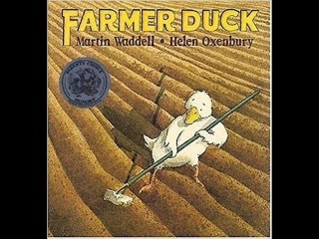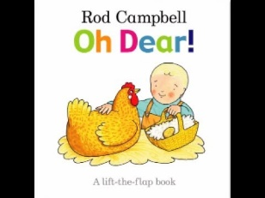  - What animals do you find on a farm? What farm animals do you know?Can you label and describe them. Write a describing sentence.  - Match mother to baby-farm animals and their names.  - Draw and label a farm scene.  - Features of different animals- where do they live? What do they eat? What do they produce e.g. milk from cows.  - Sorting different animals into groups. Write labels and sentences.  - Farm life- what does the farmer do? What is his job? Why do we need farms?- make a list of jobs  - Farmer duck- can you retell the story? What was your favourite part?  - Week Two:  The Little Red Hen  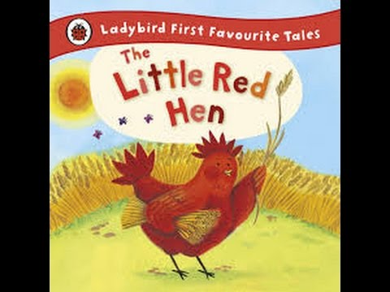  - Order event in the story- what is the story about? Who are the characters? What happened at the beginning? Middle? and end?  - Bread recipe- write a list of ingredients  - Bread recipe-Write some instructions- what do you do first? Next?  - Name the different farm animal characters.  Other topic ideas:  - Singing farm animals songs (see farm song link below)  - Where does different food come from?  - Design and Make your own milk shake- links to cows milk  - Mother and baby match  - What do all animals need- caring for an animal  - Watch Come Outside-On the Farm  - Draw and make different farm animals- what features do they have? What do you notice?  - Draw or make your own scarecrow- what are these used for?  - Make some bread together at home.  - Make a home for a farm animal- how big/small? Wil it need to be? What will it need to have?  - There is a free home learning farm pack available to download here from Twinkl that may have extra ideas for you;  - You can also log in to Espresso and search for Farm activities There are videos, photographs and activities linked to our current topic that you can access.https://www.twinkl.co.uk/resource/t-t-24241-new-eyfs-farm-home-learning-challenge-sheet  https://www.discoveryeducation.co.uk/login/eha/?service=espresso  Username; student7305  Password; animal
Stories and Rhymes | This week’s Stories and Rhymes  As well as reading your own stories this week, here are some links to some lovely stories and rhymes.  What stories and rhymes have you shared this week, can you share them on Seesaw?  Mrs Wishy Washy’s Farm by Joy Cowley  Things to think about…  Who is the author? Who is the illustrator? What do they do?  How many words are in the title? How many letters are in the first word of the title? What can you see on the front cover?  Where is the story set? Who are the characters? What happened at the beginning, middle and end?  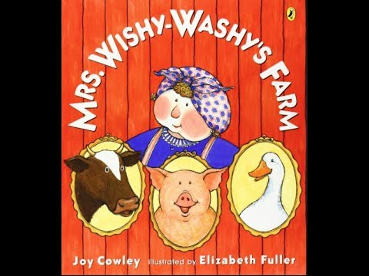  Noisy Farm by Rod Campbell  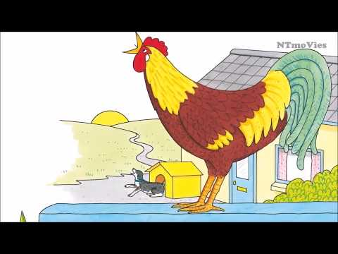  Maisy’s Morning on the Farm by Lucy Cousins  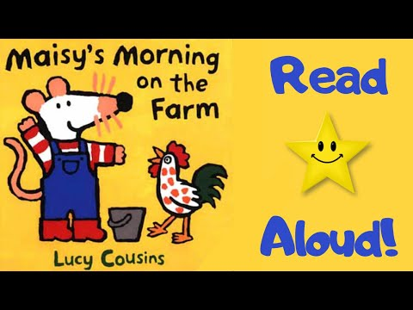  Good Morning Farm Friend by Annie Bach  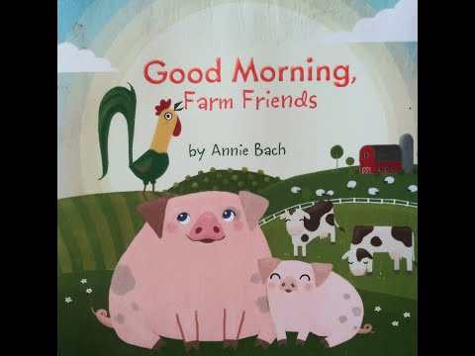  Come Outside-Eggs https://www.youtube.com/watch?v=swQujfPhXd0  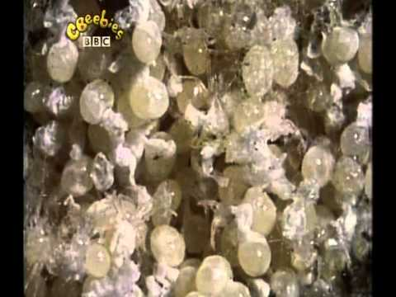  Come outside – A woolly Jumper https://www.youtube.com/watch?v=41jx0Ljy23A  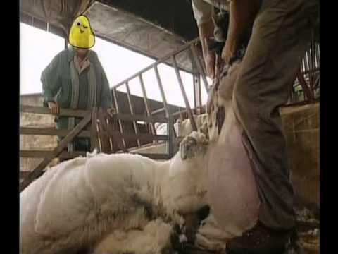  Farm songs- https://www.youtube.com/watch?v=lWhqORImND0  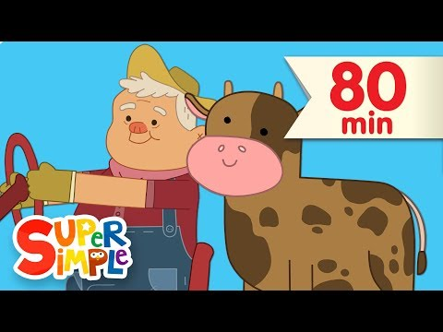
Maths | Maths Learning Focus  Daily learning; Nursery  - Counting to 20 daily (if confident up to 20, count to higher numbers), counting back from 10 daily.  - Number hunt- can you find any numbers arount the home? On the remote control, cooker, washing machine etc- what numbers can you see.  - Show me- Can you show mw 7 on your fingers? 9? Etc.  - Count the movements- can you jump 5 times? Clap 7 times? etc  - Counting songs-  Reception:  - Counting up to 100 daily.  - Missing numbers- can you find the missing number in the number line?  - Counting back from a given number (no more than 30)  - Number recognition to 20 and beyond-write given numbers.  - Counting in 2s/5s/10s  - Double numbers to 10 – using equipment if needed  Week One:  - Sorting Animals – What types of animals do you have at home? How could you sort them? Here are some ideas;  Sorting by size, number of legs, colours, where they live?  Alternatively, if you have access to a printer at home, print out some transport pictures and sort them in various ways.  - I spy animals- Can you count the different animals? You might want to draw a circle around the animal as a strategy when you are counting- how many pigs?  Challenge yourself by writing some number sentences- how many pigs and cows altogether?  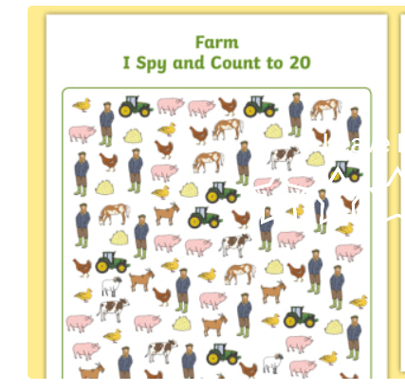  - Week Two:  - Tally- Favourite animals- what is your favourite- ask the people in your home. You might be able to collect other peoples favourites over the phone. Which was the most popular? Least popular?  - Word Problems- practise some addition and subtraction words from together using objects or pictures.  - This can be adapted to add or subtract different amounts of animals in a field if finding one more/one less is too easy. Challenge yourself to write addition and subtraction number sentences.  Additional Ideas;  - Count the different animals you have a home- practise counting stragies e.g. putting objects in a line, touching them as you count and saying how many altogether.  - Make an animal using 2D or 3D shapes-colouring sheets might also be useful for this.-  - Race any animals you have at home; which can first, second, third? Practice using your ordinal numbers or make medals for them for 1st, 2nd and 3rd place.  Counting to 100- farm https://www.youtube.com/watch?v=B5iAW-jnkPw  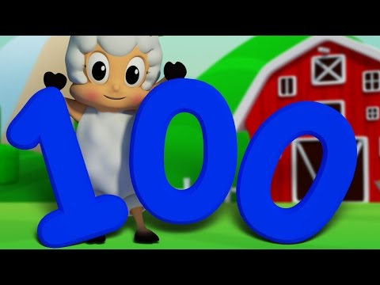  Counting on the Farm- https://www.youtube.com/watch?v=UsbZ-1VmNvw  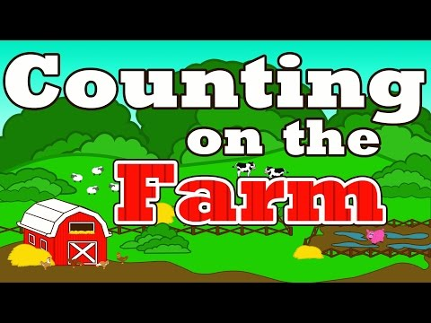  Five Little Sheep https://www.youtube.com/watch?v=Kacd6vvZJVU  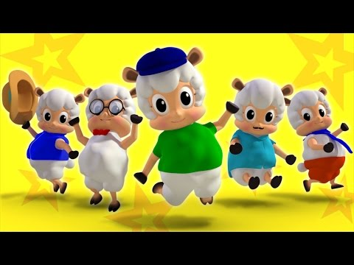  Jack Hartmann Counting Songs  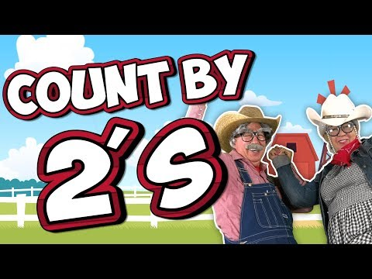
Physical Fun! | Keep your body healthy and be active  Cosmic Kids Yoga – On the Farm https://www.youtube.com/watch?v=YKmRB2Z3g2s  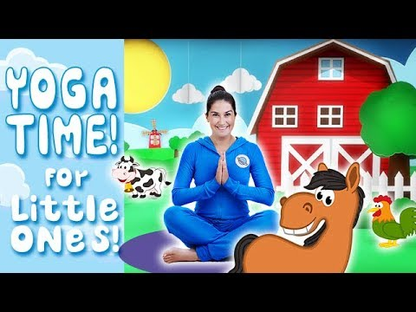  Wake up, Shake up https://www.youtube.com/watch?v=eD7zbsGjFo4  Joe Wicks Workouts – live Monday to Friday at 9:00 am  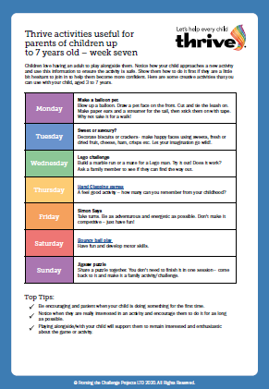  https://youtu.be/o-ZCP91mjeE  Ask yourself: When exercising to keep your body healthy, what changes can you feel? Are you breathing faster? Are you thirsty? Are you hot and sweaty? Did you get tired? Did it help improve how you are feeling?  It is also important to keep your mind healthy during the school closures. Talk to someone at home about how you are feeling every day. If you are feeling happy that is great! It is okay to feel a little sad or worried too so make sure you talk to a grown up about this.  We are also posting weekly THRIVE activities on our class SeeSaw page. THRIVE promotes positive mental health and emotional well-being in children. Completing these activities at home can really help you feel closer to your family and strengthen your relationships with your grown-ups at home.
Final Thoughts | When you get to the end of the week, have a think about what you have learnt.  What can I do now that I found tricky at the beginning of the week?  What did I really enjoy doing this week?  Is there anything I want to find out about more about?  Is there anything I need to practise again?  Encourage your child to keep revisiting their learning.  Have a lovely week and stay safe!

