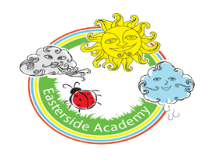
Easterside Academy
Nursery & Reception - Home Learning - Weeks beginning 06.07.20/13.07.20

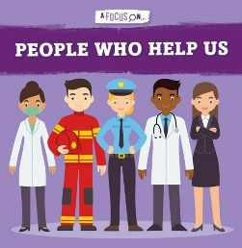 | How do people help us? 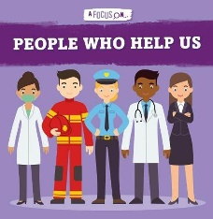
Our Enquiry / Topic question is:

REMEMBER TO SHARE YOUR LEARNING AND ACTIVITIES ON OUR CLASS SEESAW PAGE!
Activity: | Phonics activity ideas:  Most children are working on their early phonics skills; tuning in to environmental sounds around them and beginning to identify initial sounds of words and items.  Some children are beginning to recognise sounds to spell and read simple words. You can encourage your child to write lists and captions containing simple words i.e. cat, mug, hop etc. (CVC words). They can also practice reading these words.  When using Phonics Play start with Phase 1 games and resources. If these are too easy encourage your child to have a go at some of the Phase 2 games and resources.  Login  Username: march20  Password: home  There are also now daily phonics lessons for children who are learning to blend on YouTube;  https://www.youtube.com/playlist?list=PLuGr6z2H2KNGIYp03sdzSGLZquzuQENkx  Nursery  Week One- 6.7.20  http://www.letters-and-sounds.com/phase-1-games.html- a selection of Phase 1 games  • https://new.phonicsplay.co.uk/resources/phase/1/sound-starters  Initial sound sheets https://cleverlearner.com/letter-sounds/beginning-sound-worksheets.html  - I spy something that starts with…. (initial sounds focus)  Nursery:  Week Two 13.7.20  Initial sound game  http://www.letters-and-sounds.com/phase-1-games.html- a selection of Phase 1 games  http://www.letters-and-sounds.com/phase-1-games.html  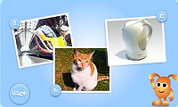  https://www.bbc.co.uk/cbeebies#/lb/razzledazzle/chitchatchest  https://www.phonicsplay.co.uk/resources/phase/1/hickory-dickory-dock  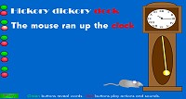  - I spy something that starts with…. (initial sounds focus)  Initial sound sheets https://cleverlearner.com/letter-sounds/beginning-sound-worksheets.html  Reception-Week one/two-Website links.  https://www.phonicsbloom.com/uk/game/list/phonics-games-phase-4  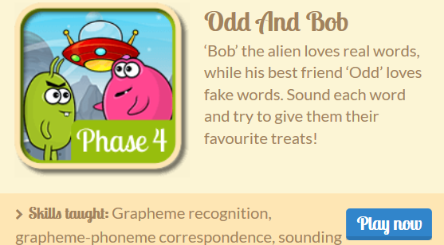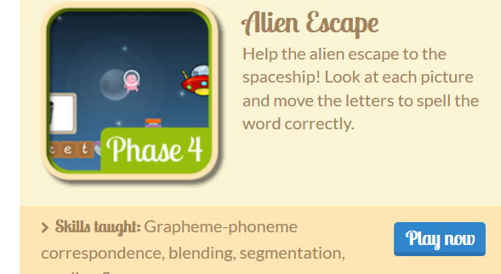  Week One- 6th July  Read/write cvc/ cvcc/ccvc words; recap on words with the sh , ch sounds  CVC red,hill,dig,dog,fog,bit,sit,fit,hit,tan,pan,fuzz, buzz, tell,sell,  CVCC/ CCVC words melt, hump, flop, frill, drill,  Read and write CCVCC words –blank,steps,drift,cramp,drops,skunk,stank,slump,crust.scalp  shop, shut, hush, bush, ship, push, rush, such, shush, shrill, chips, chops, chin, chest punch,  Read/write simple sentences: I can push the crab into the pond. I can spell ……… You and I can jump on the bench. I lost my shell on the path. The chest is on the ship.  . I lost my shell on the path. Mum and Dad are cross  Read/write cvc/ cvcc/ccvc words; recap on words with the th sounds  this, that, path, than, three, thump, moth, bath, cloth, thing, theft, thank  The moth was on the path. The cloth fell in the bath.  Read/write simple sentences: We like to munch food with a fork, It is fun to go and see the cows on the farm. How do you get a coat on? Me and my dad like to go to the park..  Tricky words to read and spell ; said, he, she,go, going, no, me/ be/we/ you, like , some, come  Week Two - 13th.July  Tricky CVC words – fell, sat, get, wet, wag, dog, cat, pop, pat, jet  The dog was in the jet. I fell and got wet.  Trickier CVCC / CCVC words – milk, sent, next, jump, from, sand, crib, sink, pram, snob  The crab was on the cart in the yard. I can push the crab into the pond. My coat is wet and damp. I can munch plums. You and I can help Mum and Dad with the chest.  Trickiest CCVCC words – toast lifts, drift, skunk, melts, strum, crust, trust, grift, scrub, fists  The crust on the toast was black. ……… You and I can jump on the bench I can press the horn. I can spell…. Stan can cross the road.  • Tricky words to read and spell: some, come, are, you, the, my, Dad, Mum, said.  Practise words with the new digraphs – sh, ch,th,or,ai,ng,qu,  Practice reading and spelling er sound hammer, farmer,letter,rocker,ladder,supper,Summer,butter,turner,boxer,better,banner,river,flower,powder,finger,  Tricky CVC words - wet, leg, red, pot, bin, jug, jog, run, jam ,wig  Read/dictate - I can jog up the hill. My leg is wet. The pot and the jug are red,  Trickier - CCVC CVCC words,spin, flag, grip, glad, twin, sniff, drop, swim, clap, clip  Read/dictate The flag fell into the river. I can sniff the flower. I went up the ladder  ,  Trickier- CCVCC words grunt, crept, drift, slept, think, thank, blink, drank, blank, trunk, blend, tramp  Read/ dictate She had toast and butter for her supper. The trunk of the tree was brown. He went up the ladder with his hammer.
Phonics
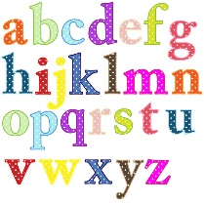

Literacy/Topic | - First name writing daily; Start by ordering the letters in your name, so you are aware of the sequence of letters, move onto practicing to write your name by tracing over the top of your name, then by copying your name, then writing your name independently.  - If able to write first name independently, encourage to write surname also. Write your name in different ways; with a pencil, in different colours, with water and a paintbrush outside etc.  - Recording the weather daily and practicing the days of the week.  Our Enquiry / Topic question is; How do people help us?  Week One:  - Can you name people who help us? What do they do? Can you draw and label people who help us?  - Can you draw and label/write sentence of what equipment people might need and say why.  - Who helps you at home? What do they do to help you? Do you say thank you for these things? Can you write a thank you letter to someone who helps you?  - Younger children can verbally say what they would like to include and say initial/dominate sounds in words.  - How do you help others? Can you write a list of the things that you do to help others? Younger children trace, hear initial sound or dominant sounds in words.  - Also children can write a list giving meaning to the different marks that they make.  Week Two:  - Can you re-enact/role play a job that someone might do to help us? Like a firefighter, police officer, doctor, dentist, nurse, teacher.  - Can you record what you did as part as your ‘job’? Can you make a script to help someone else re-enact it?  - Can you design, label and make a vehicle to help ‘people who help us’ to travel around? E.g. fire engine, police car.  - Can you think of ways you can be more helpful at home and to others? Can you write a list?  - What job would you like to be when you are older? Can you draw and label your picture? Why do you want that job?  Other topic ideas:  - Watch the story Fireman Piggy Wiggy  - Watch videos on Youtube about people who help us.  - Create vehicles linked to people who help us.  - Role play scenarios of people who help us  - Use toy vehicles and people to role play scenes  - Can you make a family chart to show who is helpful around the house or reward chart to encourage you to be more helpful.  - You can also log in to Espresso and search for people who help us.  https://www.discoveryeducation.co.uk/login/eha/?service=espresso  Username; student7305  Password; animal  https://www.activityvillage.co.uk/people-who-help-us
Stories and Rhymes | This week’s Stories and Rhymes  As well as reading your own stories this week, here are some links to some lovely stories and rhymes.  What stories and rhymes have you shared this week, can you share them on Seesaw?  Fireman PiggyWiggy  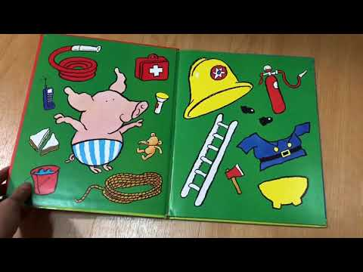  Things to think about…  Who is the author? Who is the illustrator? What do they do?  How many words are in the title? How many letters are in the first word of the title? What can you see on the front cover?  Where is the story set? Who are the characters? What happened at the beginning, middle and end?  https://www.youtube.com/watch?v=HGCOo6Mx_xw  Information about Firefighters  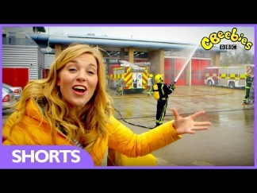  https://www.youtube.com/watch?v=syWonYeJOQU&list=PLQu_7u-A7pyw6mXxin4610866mKHQn-QV  People Who help us Song- Adult will need to read and sing along too  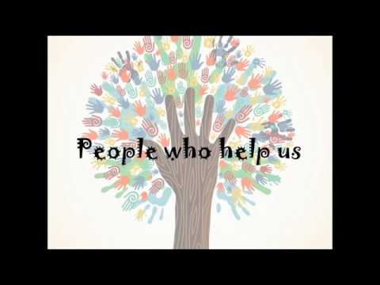  https://www.youtube.com/watch?v=M8Psza6N2Os  I need help…who can help you?  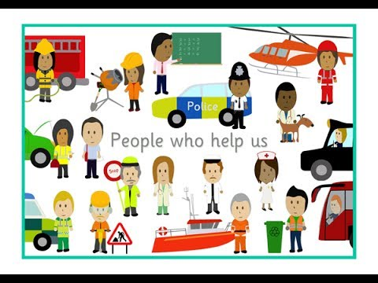  https://www.youtube.com/watch?v=5uTOOQDEMLI  Mr Tumble- People who help us songs  https://www.youtube.com/watch?v=iyIDg6m4gA0&list=PLVvz5Ji9_a2GCCPYLk1HrT0aPX5KGx2Ah
Maths | Maths Learning Focus  Daily learning; Nursery  - Counting to 20 daily (if confident up to 20, count to higher numbers), counting back from 10 daily.  - Order me- find numerals to 10/ 20 and put them in order.  - Show me- Can you show mw 7 on your fingers? 9? Etc.  - Count the movements- can you jump 5 times? Clap 7 times? etc  - Counting songs-  Reception:  - Counting up to 100 daily.  - Counting backwards from a different number.  - Number songs to 100  - Missing numbers- can you find the missing number in the number line?  - Counting back from a given number (no more than 30)  - Number recognition to 20 and beyond-write given numbers.  - Counting in 2s/5s/10s  - Double numbers to 10 – using equipment if needed  Week One:  - 2D/3D shapes- explore different shapes- naming and discussing properties- notice shapes in the environment.  - Addition/subtraction- word problems linked to people who help us. For example: There were 6 fire men on the fire engine, 3 got off. How many now? Encourage the children to write a range of number sentences for addition and subtraction.  Younger children could focus on counting reliably and 1 more/1 less.  - Week Two:  - Doubling and halving- Use toy people cars to double and halve. Discuss the language- what does double/ half mean?  Encourage the children to write numbers sentences for doubling 4+4=8.  - Number bonds to 10- use people/ cars and any practical objects to make number bonds  Younger children- practise counting using different toys- how do we count without making any mistakes?  Additional Ideas;  - Make people and emergency vehicles using different shapes.  - Order people who help us by size.  - Sort people under different criteria- hair colour, eye colour etc.  - People who help us number songs- see links below.  Five Little Firemen https://www.youtube.com/watch?v=9qIAhEtk13M  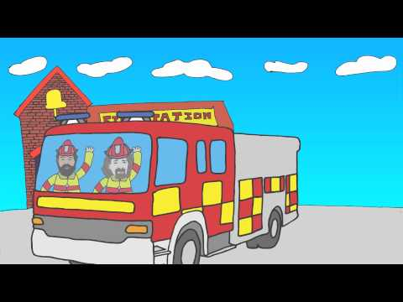  Five little policemen- https://www.youtube.com/watch?v=CZb71BXDDp8  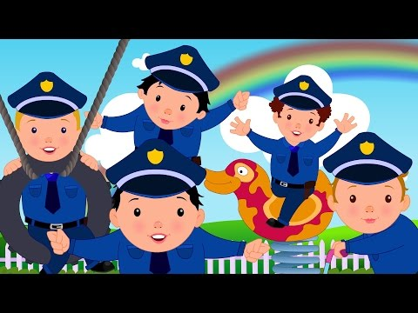  Nuber Jacks-Take away. https://www.youtube.com/watch?v=kkctu5a1pHc  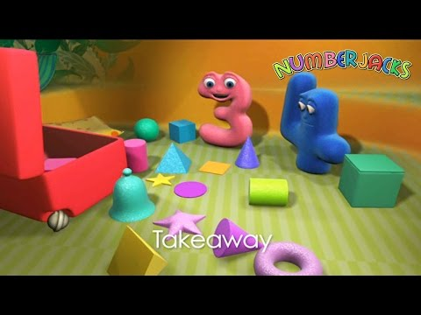  Jack Hartmann Counting Songs  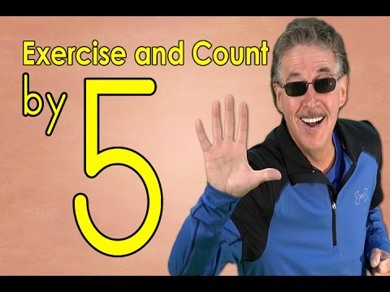
Physical Fun! | Keep your body healthy and be active  Superhero Yoga  https://www.youtube.com/watch?v=7i0tUVNHfLA  The Workers- Playlist of videos of ‘People Who Help Us’ Dances  https://www.youtube.com/watch?v=dW_y2cr1J-U&list=PL8u2dO_ViQBHhgxwLFK9I-0-Bo71EhVzp  Joe Wicks Workouts – live Monday to Friday at 9:00 am  https://youtu.be/o-ZCP91mjeE  Ask yourself: When exercising to keep your body healthy, what changes can you feel? Are you breathing faster? Are you thirsty? Are you hot and sweaty? Did you get tired?  Did it help improve how you are feeling?  It is also important to keep your mind healthy during the school closures. Talk to someone at home about how you are feeling every day. If you are feeling happy that is great  ! It is okay to feel a little sad or worried too so make sure you talk to a grown up about this.  We are also posting weekly THRIVE activities on our class SeeSaw page. THRIVE promotes positive mental health and emotional well-being in children. Completing these  activities at home can really help you feel closer to your family and strengthen your relationships with your grown-ups at home.
Final Thoughts | When you get to the end of the week, have a think about what you have learnt.  What can I do now that I found tricky at the beginning of the week?  What did I really enjoy doing this week?  Is there anything I want to find out about more about?  Is there anything I need to practise again?  Encourage your child to keep revisiting their learning.  Have a lovely week and stay safe!

