Christmas Competition

Have fun with your family and make a Christmas decoration using items in your home.

Photographs of entries can be uploaded to your child’s Seesaw account.

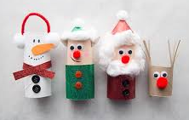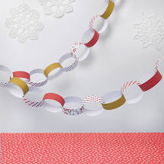

All entries will go into a prize draw!
The first three names to be drawn will win a prize!
Please could entries be uploaded by 15th December.
Enjoy and Good luck!

