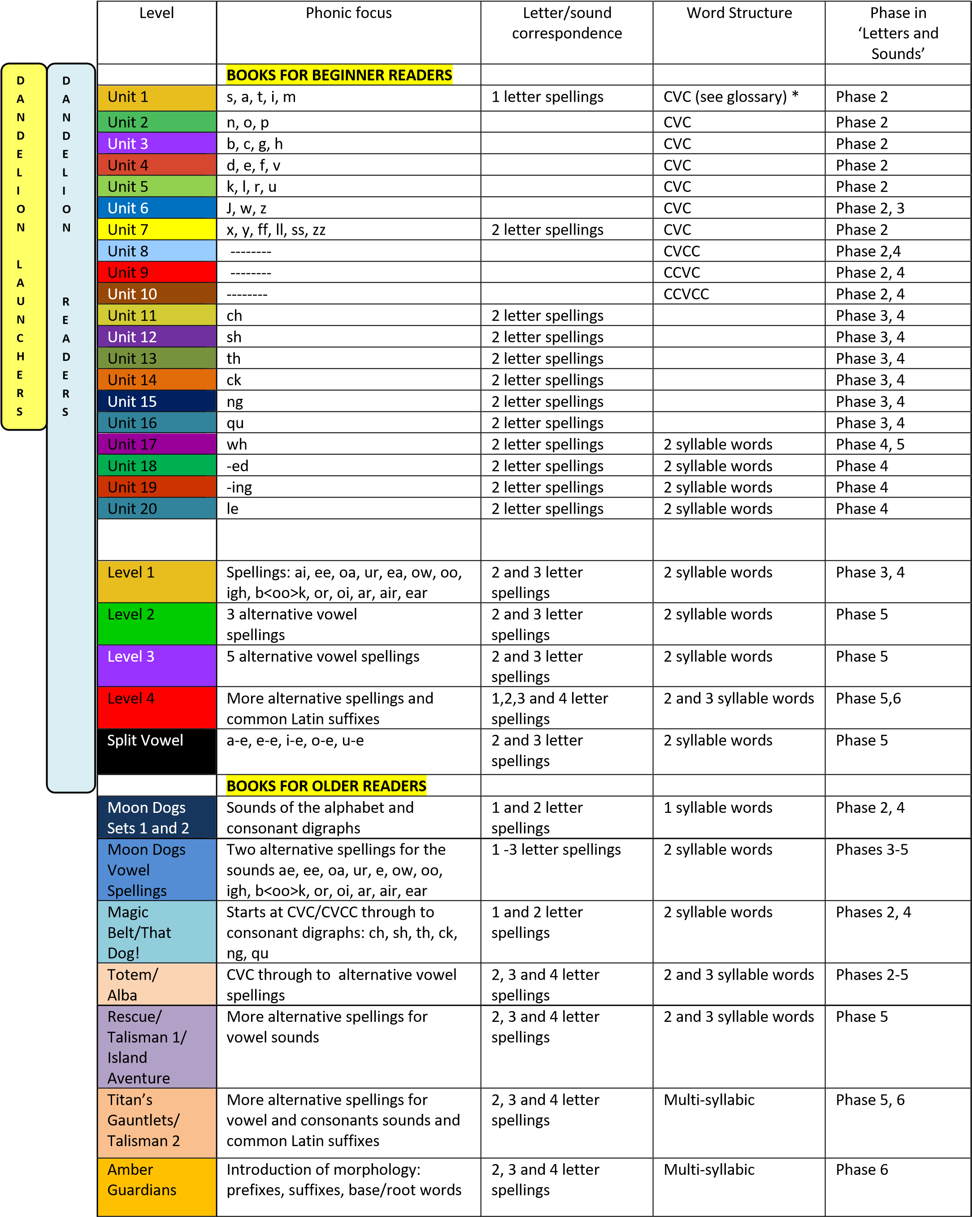

* Glossary:
CVC – acronym for consonant vowel consonant words such as d ‘d-o-g’.
Phoneme – sound in a word, e.g. ‘cat’ has three phonemes ‘c-a-t’.
Grapheme – spelling of a sound in a word e.g. ‘h’ in ‘hat’ is a one-letter spelling; ‘sh’ in ‘ship’ is a two-letter spelling; ‘igh’ in ‘night’ is a three- letter spelling and ‘ough’ in ‘through’ is a four-letter spelling.

