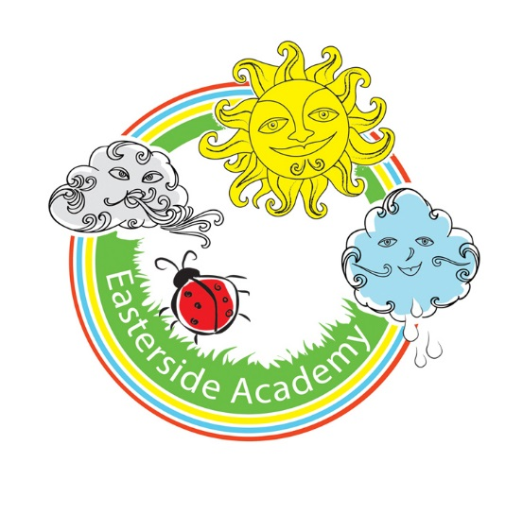

Easterside Academy

Impact of Primary PE and Sports Funding
2019 - 2020

Support for review and reflection - considering the 5 key indicators from DfE, what development needs are a priority for your setting and your students now and why? Use the space below to reflect on previous spend, identify current need and priorities for the future.

Key achievements to date: | Areas for further improvement and baseline evidence of need:
Work with Tees Valley Sport Active Schools.  Improve profile of PE across the school and importance in other curriculum areas e.g. active English and maths.  Employment of highly skilled specific sport coaches to deliver quality inset for teachers.  Improving teacher’s confidence to deliver high quality PE lessons.  Tracking and assessing of progress over time.  Improving resources and equipment.  School games gold award. | How to sustain quality of teaching in specific areas e.g. dance.  Continue to improve profile of PE across the school and importance in other curriculum areas e.g. active English and math.  To raise the profile of the school games values across school.  To work with Lis Greenwell to develop new subject leader and impact of funding on whole school achievement.  To continue to invest in whole school resources.

Meeting national curriculum requirements for swimming and water safety | Please complete all of the below:
What percentage of your Year 6 pupils could swim competently, confidently and proficiently over a distance of at least 25 metres when they left your primary school at the end of last academic year? | N/A due to covid-19
What percentage of your Year 6 pupils could use a range of strokes effectively [for example, front crawl, backstroke and breaststroke] when they left your primary school at the end of last academic year? | N/A due to covid-19
What percentage of your Year 6 pupils could perform safe self-rescue in different water-based situations when they left your primary school at the end of last academic year? | N/A due to covid-19
Schools can choose to use the Primary PE and Sport Premium to provide additional provision for swimming but this must be for activity over and above the national curriculum requirements. Have you used it in this way? | N/A due to covid-19

Action Plan and Budget Tracking
Capture your intended annual spend against the 5 key indicators. Clarify the success criteria and evidence of impact that you intend to measure to evaluate for students today and for the future.

Academic Year: 2019/20 | Total fund allocated: £18,520.00  Balance brought forward due to Covid-19 - £5967.08 |  |  | Date Updated: July 2020
Key indicator 1: The engagement of all pupils in regular physical activity – Chief Medical Officer guidelines recommend that primary school children undertake at least 30 minutes of physical activity a day in school |  |  |  |  | Percentage of total allocation:
 |  |  |  |  | £7,600 (41%)
School focus with clarity on intended impact on pupils: | Actions to achieve: | Funding allocated: | Evidence and impact: |  | Evaluation / Sustainability and suggested next steps:
To increase children’s level of physical activity during playtime and lunchtime. | To employ two coaches (Simon Carson) to deliver different physical activities during lunchtime on KS1/2 yards. | £7,600 | Targeted children engaging in physical activity during lunchtimes. A range of skills and sports being promoted to engage a variety of children.  More children attending after school clubs delivered by same coaches. |  | RS/TS to liaise with Simon Carson coaches to ensure that most children are engaged in physical activity over the week.  Coaches encouraging all children to be active during lunchtimes. Introducing a variety of games and skills. One coach to be reemployed next year. Focus on upcoming competitions.  RS/TS to work with LG to provide opportunities for chrn to increase physical activity during the day.

Key indicator 2: The profile of PE and sport raised across the school as a tool for whole school improvement. |  |  |  | Percentage of total allocation:
 |  |  |  | £404 (2%)
School focus with clarity on intended impact on pupils: | Actions to achieve: | Funding allocated: | Evidence and impact: | Sustainability and suggested next steps:
CPD for new PE lead. | To employ services of L Greenwell to work alongside RS/HS/TS to support development of PE and sport across the school. | £404 |  | To continue this work next academic year.

Key indicator 3: Increased confidence, knowledge and skills of all staff in teaching PE and sport |  |  |  | Percentage of total allocation:
 |  |  |  | £2620 (14%)
School focus with clarity on intended  impact on pupils: | Actions to achieve: | Funding  allocated: | Evidence and impact: | Sustainability and suggested  next steps:
To employ specialist coaches to work alongside teachers to deliver high quality CPD.  - Dance coaches (7 week block for KS2)  - Multi skills coach (6 week block for KS1 pupils) – Not completed due to COVID-19  Purchase resource to support teacher’s planning and whole school assessment | -Ensure coaches deliver high quality lessons so staff feel confident and skills / knowledge improve.  -Children to perform for classes/parents at the end of each unit.  Online resource Get Set 4 PE purchased and rolled out across school. Staff meeting and time given to update assessments. | £1800  £270  £550 | PE lead monitored teachers following coaches sessions and observed all children receiving high quality PE lessons. Chrn were engaged and teacher’s confidence level increased.  N/A – COVID-19  Unable to evidence due to Covid-19. Resource purchased again for next three years. | Staff will work together (team planning) and share good practice which will lead to better confidence all round and more staff keen to get involved thus ensuring the extra activities will not only continue but there will also be an expansion.  To purchase Set4PE scheme to support teacher’s confidence with curriculum planning, delivering lessons and assessment.  Work with Lis Greenwell to upskill new PE leader on how to maximize the sport premium in school.

Key indicator 4: Broader experience of a range of sports and activities offered to all pupils |  |  |  | Percentage of total allocation:
 |  |  |  | £179.95 (1%)
School focus with clarity on intended  impact on pupils: | Actions to achieve: | Funding  allocated: | Evidence and impact: | Sustainability and suggested  next steps:
Additional achievements:  To purchase resources to support the PE and Sport Curriculum. | To purchase a range of new resources to ensure a wide variety of inclusive sports are taught. | £179.95 | A range of new sports being taught (focus on inclusive sports e.g. Boccia and new age kurling). | We will continue to invest in high quality resources to ensure all children can be active during PE lessons and other curriculum areas. Staff CPD on equipment and resources needed.  Train new members of staff to deliver change4life clubs to target the least active children.

Key indicator 5: Increased participation in competitive sport |  |  |  | Percentage of total allocation:
 |  |  |  | £1465.60 8%
School focus with clarity on intended  impact on pupils: | Actions to achieve: | Funding  allocated: | Evidence and impact: | Sustainability and suggested  next steps:
Membership to the Middlesbrough Alliance for competitive sport  To provide transport which enables children to travel to a range of sporting events. | Children to access wide range of competitive sports including A, B and C teams (Gold Award).  To arrange coaches as and when needed. | £1000  £465.60 | Entered a range of competitive sport and increased levels of engagement for different groups of children.  Chrn attended a range of sporting events.  The children are developing their sense of being a part of a team and competing against their peers. Increased sense of teamwork. | Attended competitions within the Middlesbrough Sport Alliance. Entered B and a C teams. Increased SEND opportunities for pupils. Continue funding.  Aim to attend a wider range of competitions next year and make links within the trust for further opportunities at all levels

