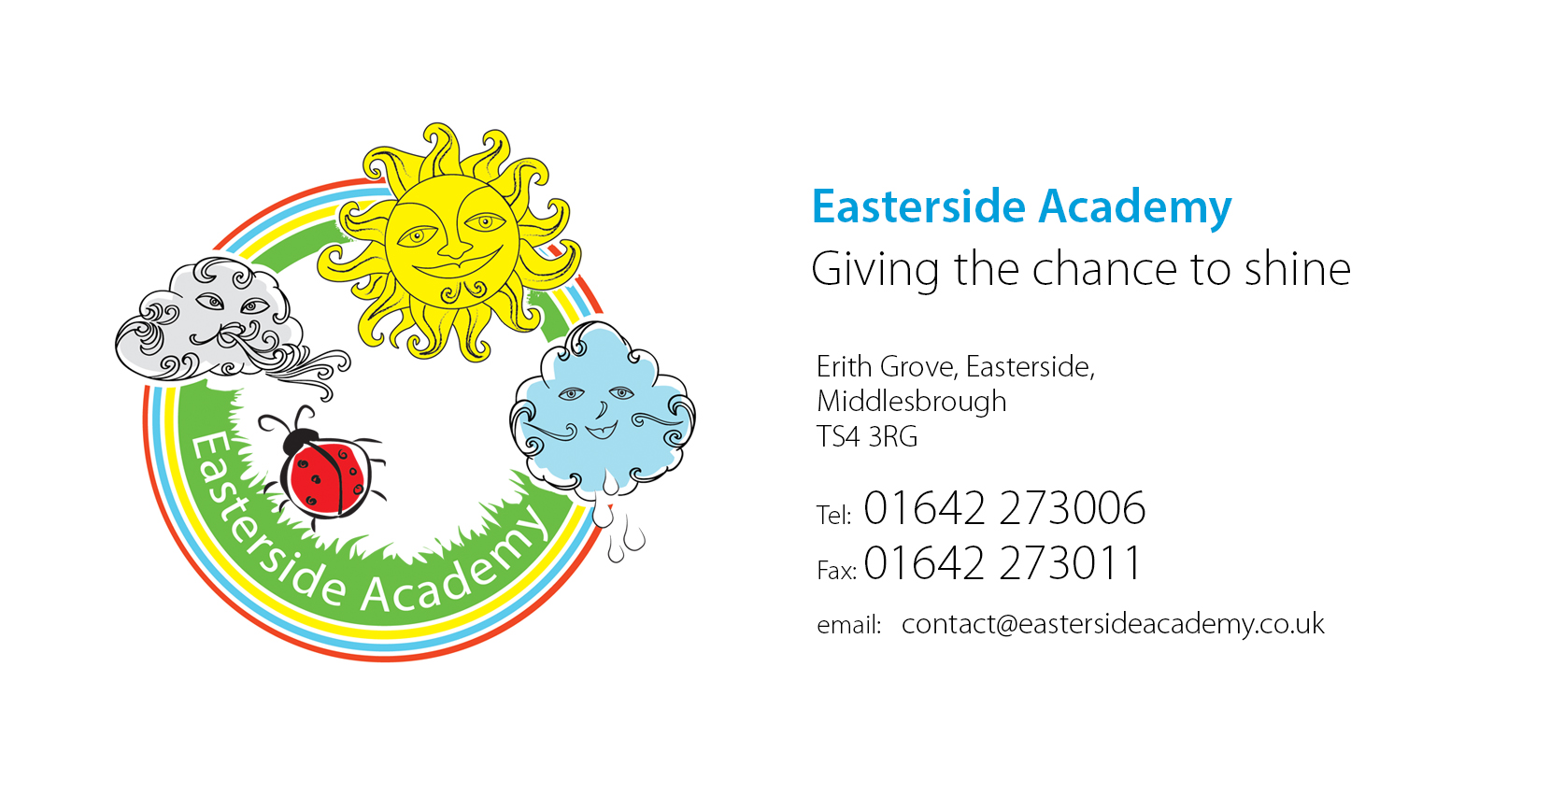

Wednesday 7th October 2020

New Early Years Framework – ‘Adopter School’

Dear Parents and Carers,

As we get into the new academic year we would like to inform you about the curriculum which we follow in the Early Years Foundation Stage.

The EYFS is guided by a framework called ‘Development Matters’ which sets out the learning, development and assessment requirements for all children until the end of Reception. All early years practitioners are required, on a daily basis, to carry out rich activities to support each child’s educational development across seven areas of learning. This guidance / framework has been reviewed and the goals for the end of Reception have been updated.

At Easterside Academy, we are always keen to be at the forefront of any changes in education and are excited to become an ‘Early Adopter’ school before the statutory implementation of the new Early Years Framework in September 2021.

The EYFS framework has never prescribed a particular teaching approach and the new framework holds true to this value. Our philosophy remains the same, with play and wellbeing at the heart of everything we do.

As an ‘Early Adopter’ school of the new Early Years Framework, at the end of the academic year (2020/21) we will be required to complete the EYFS Profile as set out in the EYFS reforms early adopter framework for all children in the reception cohort in your school.

You can find the detailed ‘EYFS Early Adopter Framework’ and new ‘Development Matters’ documents on our website by going into ‘Important Information’ – ‘Curriculum’ – ‘Early Years’.

We hope that this letter has provided you with the relevant information regarding the early adopter year. If you have any questions, please do not hesitate to contact the EYFS team.

Yours sincerely,

D. Linacre

Mrs D Linacre
Principal


