Document History
CREATED: | September 2025
By: | Principal
Version: | 1
REVIEW FREQUENCY: | Bi-Annually
NEXT REVIEW DATE: | September 2027

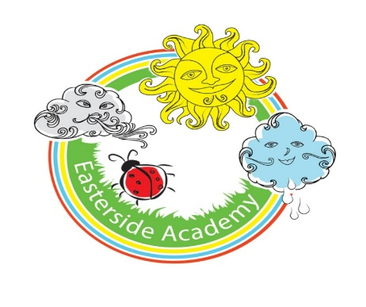

Geography Policy

Curriculum Aims
Our Geography curriculum aims to inspire pupils to become curious and explorative thinkers with a diverse knowledge of the world – in other words, to think like geographers. The intention is for pupils to develop the confidence to question and observe places, measure and record necessary data in a variety of ways and analyse and present their findings.
Our curriculum aims to build an awareness of how Geography shapes lives at multiple scales and over time. At Easterside, our hope is to encourage pupils to become resourceful, active citizens who will have the skills to contribute to and improve the world around them.
The curriculum is designed to be both accessible and ambitious, ensuring all learners’ full participation and potential achievement.

National curriculum
Our Geography curriculum fulfils the expectations of the National Geography Programmes of Study found here.

The four strands
The National curriculum organises the attainment targets for Geography under:
- Locational knowledge.
- Place knowledge.
- Human and physical geography.
- Geographical skills and fieldwork.
Our curriculum has been planned with these strands running through each topic, ensuring balanced coverage of the different areas of Geography and both substantive and disciplinary knowledge.

Progression
Our Progression of skills and knowledge document provides an overview of the skills and knowledge covered in each phase and strand. It explains how Geography skills and knowledge are developed to support pupils in reaching the key stage outcomes as outlined in the National curriculum.

Progression of geographical concepts
Our Progression of geographical concepts document outlines how our curriculum builds pupils’ understanding of:
- Place.
- Space.
- Scale.
- Interdependence.
- Physical and human processes.
- Environmental impact.
- Sustainable development.
- Cultural awareness and diversity.


Spiral curriculum
Our Geography curriculum has been designed as a spiral curriculum with the following key principles in mind:
- Cyclical – pupils return to the key knowledge and skills again and again during their time in primary school.
- Increasing depth – each time a skill is revisited, it is covered with greater complexity.
- Prior knowledge – pupils build upon previous foundations rather than starting again.

Broadening horizons
Building on the principles of the spiral curriculum, our topics are designed to take pupils on a geographical journey that starts with the familiar and gradually extends outward.
By beginning with their local area, pupils can ground new learning in their own experiences and make meaningful connections.
As they revisit key concepts over time, the context broadens from local to national and eventually to global scales. This enables pupils to understand how their own environment relates to wider geographical patterns and processes.
This progression not only supports cognitive development but also helps pupils develop a sense of place, identity and global citizenship. It enables them to see themselves as part of a connected world, to appreciate the diversity of people and environments and to understand how local actions can have a global impact.

Types of Knowledge
Knowledge is defined differently depending on the subject in question. Ofsted’s Geography research review helps to define these Geography knowledge strands as:
- Disciplinary knowledge.
- Substantive knowledge.
- Procedural knowledge.

Substantive knowledge
Substantive knowledge is the content that pupils will learn through studying the Geography curriculum: the recognised knowledge of the world and the human and physical processes that affect the people and environments within it.
This content is separated into the following areas in the National curriculum and within the Geography scheme of work:
- Locational knowledge.
- Place knowledge.
- Human and physical geography.
- Geographical skills and fieldwork.

Disciplinary knowledge
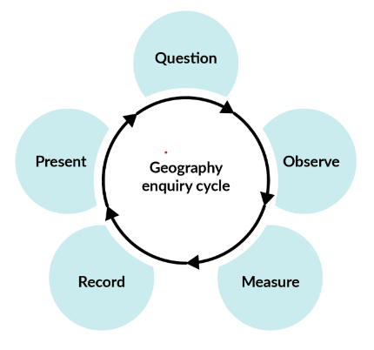
Pupils gain knowledge of the subject as a discipline, considering how geographical knowledge (such as the substantive knowledge they study) originates through geographical practice.
Fieldwork enquiries in each topic give pupils the opportunity to understand and follow the same processes that geographers follow to find and evaluate answers to enquiry questions. See image (right) of the enquiry cycle.
- Question the environment to find a line of enquiry (physical or human).
- Observe and plan how to answer the question, drawing on knowledge of previous data and collection methods.
- Measure data(qualitative or quantitative) that will answer the question using planned methods.
- Record data in various ways (questionnaires, surveys, charts, tables) to support analysis and interpretation.
- Present findings and suggest further actions to make improvements and reflect on the process.
The Geographical skills and fieldwork strand shows progression in disciplinary knowledge. However, it is important to understand that geographers must draw on their substantive and procedural knowledge to carry out an effective enquiry.
Procedural knowledge
Pupils gain procedural knowledge primarily through the Geographical skills and fieldwork strand.
Pupils learn knowledge of how to collect, analyse and communicate data and geographical information from fieldwork, maps and other sources. In addition, they consider how to interpret this range of sources to answer enquiry questions.

Digital literacy
Our curriculum integrates technology through digital maps, research tasks and interactive activities. This helps develop the children’s ability to find, evaluate and use geographical information effectively.

The importance of oracy
Learning through talk
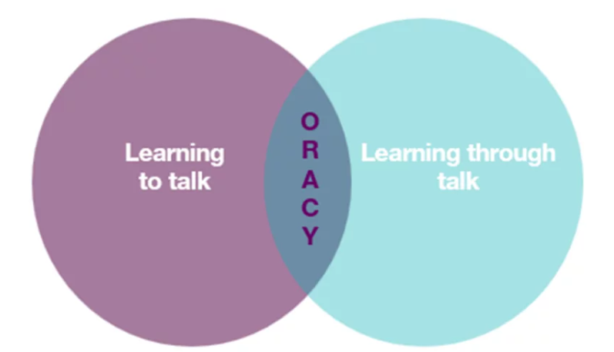
It is crucial to provide our pupils with opportunities for exploratory talk during their learning. This involves thinking aloud, questioning, discussing and collaboratively building ideas.
Learning to talk
Similarly, developing oracy skills is essential for pupils to express and articulate themselves effectively across various contexts and settings, including formal ones such as public speaking, debates and interviews.

Oracy skills in Geography
Lessons encourage discussion, debate, and presentations on geographical topics, allowing the children to articulate their understanding, justify opinions and engage in collaborative learning.
The children will use oracy to enhance their learning by thinking aloud, questioning and discussing activities. They will develop essential skills such as choosing appropriate vocabulary, organising their ideas and listening effectively.

Sustainability
The Geography curriculum promotes awareness of environmental issues, encouraging children to develop a sense of responsibility for the planet by exploring concepts such as climate change, resource use, and conservation.
Engaging our pupils with environmental issues can spark enthusiasm for positive change, broaden their understanding of sustainability, alleviate climate-related anxieties and instil pride in their educational settings.

Critical thinking
At Easterside, pupils analyse geographical data, compare different perspectives and evaluate sources of information. This helps them in questioning assumptions and forming reasoned conclusions on global and local issues.

Personal development in Geography
- SMSC
Our curriculum supports Spiritual, Moral, Social and Cultural (SMSC) development by encouraging pupils to:
- Explore different perspectives.
- Reflect on ethical issues.
- Collaborate with others.
- Appreciate cultural diversity through subject-specific content.

- British Values
Our lessons promote British values (democracy, the rule of law, individual liberty, mutual respect and tolerance) by incorporating activities that encourage debate, respect for differing opinions and an understanding of societal structures.
- Cultural capital
Our curriculum broadens children’s experiences by introducing them to key figures, historical and geographical contexts and diverse traditions. It ensures they gain the knowledge and skills needed to engage meaningfully in society.

Inclusion and diversity
Our curriculum has been designed to represent a range of cultures and races.
- Where appropriate, colonial choices and their impact on geographical issues are explored.
- Visual representation is inclusive and representative of a variety of people and places, challenging stereotypes or historical ideologies.
- Within sensitive topics, questions have been included to support children’s lived experiences and backgrounds.
- Resources and case studies are carefully considered to encourage the children to think about their role in society and to respect the many ways in which people’s lives have been influenced.
The curriculum supports children in appreciating the complexity of people’s lives, the diversity of societies and the relationships between different groups.

Timetabling
Geography is taught for 1.5 hours per week, alternating with History every 9 weeks. Timetabling Geography in this way ensures the needs of the National curriculum are met.

The enquiry cycle
It is important that pupils begin to ‘think like geographers’ by considering the ways that geographers question and explain the world.
Accordingly, our curriculum uses an enquiry cycle to support planning fieldwork. This encourages our pupils to ask geographical questions and learn how geographers reach their answers through enquiry.

Fieldwork
Fieldwork provides pupils at EastersidechildrenEasterside with hands-on experience and encourages them to apply geographical concepts to their surroundings.
Fieldwork skills do not have to be developed on school trips alone: local fieldwork opportunities can make the subject matter relevant and support teachers in fostering a sense of community and environmental awareness amongst pupils.
Fieldwork on the school grounds and the local area is an important element of our curriculum: it is often more practical, engaging and meaningful for our pupils.

SEND
Our curriculum is designed to be fully adaptable for pupils with SEND. Every lesson includes adaptive teaching to meet the needs of all learners.
Teachers at Easterside include a range of strategies to support and challenge every pupil, such as:
- Scaffolding – tasks are designed with flexibility in mind, allowing for additional support or challenge where needed.
- Multi-sensory approaches – lessons incorporate different elements to engage all learners.
- Clear instructions and structured tasks – ensuring clarity and reducing cognitive load for pupils who benefit from additional support.
- Opportunities for collaborative and independent learning – allowing pupils to work at their own pace while building confidence and independence.
By embedding adaptive teaching throughout, teachers ensure that all pupils, regardless of their starting points, can access and succeed in their learning.
In addition, the curriculum design supports pupils with SEND, avoiding sudden jumps in complexity at transition points and allowing for steady, manageable progression.

Knowledge Retention
Spiral curriculum
Our curriculum incorporates a spiral curriculum model, ensuring that pupils revisit and develop their understanding of key themes and concepts as they progress. This approach allows them to make meaningful connections, reinforce their learning and achieve mastery over time.
- Revisiting key concepts – pupils encounter the same ideas multiple times throughout their education, with each revisit adding more complexity.
- Progressive depth – concepts are not just repeated but expanded upon, helping pupils to make connections and develop a richer understanding over time.
- Knowledge retention – regular exposure to key ideas strengthens memory and prevents knowledge from being forgotten.
- Skill development – pupils refine and apply their skills in different contexts, improving their ability to think critically and solve problems.
- Adaptive learning – by building on prior knowledge, the curriculum meets pupils at their current level and supports all learners, including those who need extra reinforcement and those who are ready for greater challenges.

Knowledge organisers
Every topic has a knowledge organiser which is a structured document designed to support pupils’ learning by clearly outlining the key knowledge, vocabulary and concepts covered in a topic.
It serves as a reference tool for both teachers and pupils, helping to consolidate learning and support knowledge retention.
- Essential knowledge at a glance – summarises the most important facts, concepts and skills that pupils need to learn for a particular topic.
- Key vocabulary – provides a list of subject-specific terms with definitions to develop pupils’ language and understanding.
- Clear and visual layout – organised in a way that makes information easy to digest and revisit, often using diagrams, timelines or key images.
- Support for retrieval practice – helps pupils engage in self-assessment, recall activities and revision, reinforcing long-term memory.
- Teacher and pupil-friendly – acts as a quick reference for teachers when planning lessons and an accessible learning aid for pupils to develop independence in their studies.

Retrieval
Each lesson starts with a retrieval task.
- Activates prior knowledge – helps pupils make connections between new and existing learning, reducing cognitive overload.
- Strengthens memory pathways – retrieval practice has been shown to improve retention more effectively than passive review.
- Identifies gaps in understanding – teachers can quickly assess what pupils remember and address misconceptions before introducing new content.
- Builds confidence – regular recall activities reassure pupils that they can remember key concepts, improving engagement and motivation.
- Promotes spaced learning – revisiting prior learning at regular intervals supports long-term retention, rather than cramming information into a single lesson.

Formative Assessment
Formative assessment is embedded throughout our lessons to ensure that teachers can gauge pupils’ understanding in real time and adapt their teaching accordingly.
- Questioning – lesson plans include targeted and open-ended questions to check understanding, promote critical thinking and address misconceptions.
- Observation – teachers are supported to observe pupils during tasks, noting how they approach activities, collaborate and apply history skills.
- Discussion and peer interaction – pair and group discussions are built into lessons, providing opportunities for pupils to articulate their thinking and for teachers to assess understanding through dialogue.
- Lesson pauses –strategic pause points for checking comprehension, summarising learning and addressing any common errors before progressing.
- Retrieval practice – recap activities such as short recall tasks and oral explanations are embedded to reinforce prior knowledge and assess retention.
- Use of success criteria – success criteria are shared within lessons, allowing pupils to self-assess or peer-assess their work and reflect on their progress.

Summative Assessment
Summative assessment is carried out yearly to indicate if a child is working towards, at or above age-related expectations. Children are assessed against the relevant National Curriculum statements for Geography which are listed in the subject overview document.

Cross-curricular learning
Our Geography curriculum supports cross-curricular learning by making clear connections between subjects, helping pupils develop a broader understanding of key concepts and skills.

Produced by: SLT
Reviewed date: December 2025

