1

*is getting ready for nursery!*

Dear Parents/Carers,

Starting nursery is both exciting and daunting for your child and the people who love them. This pack will help you and your child get ready for their new adventure. It is also something you can share with me during their induction.

It is recommended that you and your child work through this pack a little bit at a time and make it lots of fun! If your child finds things tricky and can’t do everything yet, do not worry! Your child is unique and will achieve things when they are ready. Give them lots of encouragement and praise for the things they CAN do and help them through the parts that they find more difficult.

Complete it in an order that suits you and your child. Feel inspired to search for your own ways to extend your child’s learning. Enjoy this pack with your child and make it lovely one to one time.

Yours Sincerely,

Mrs Southern



**Meet the nursery staff**



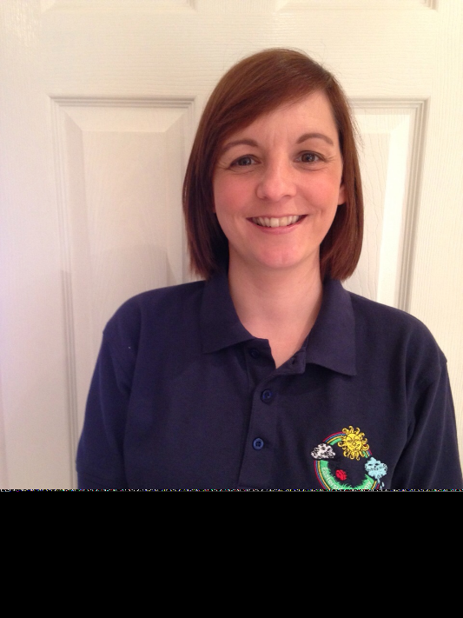

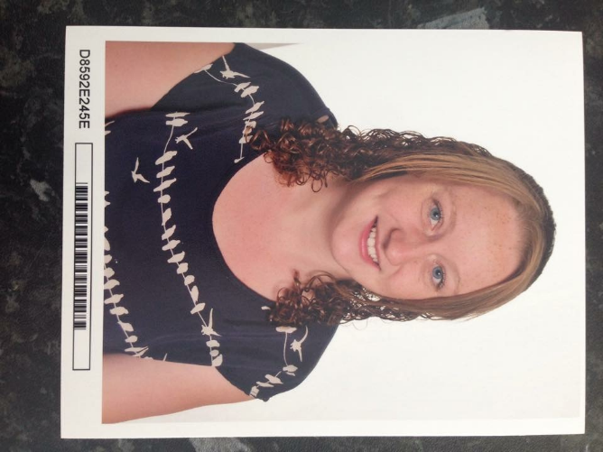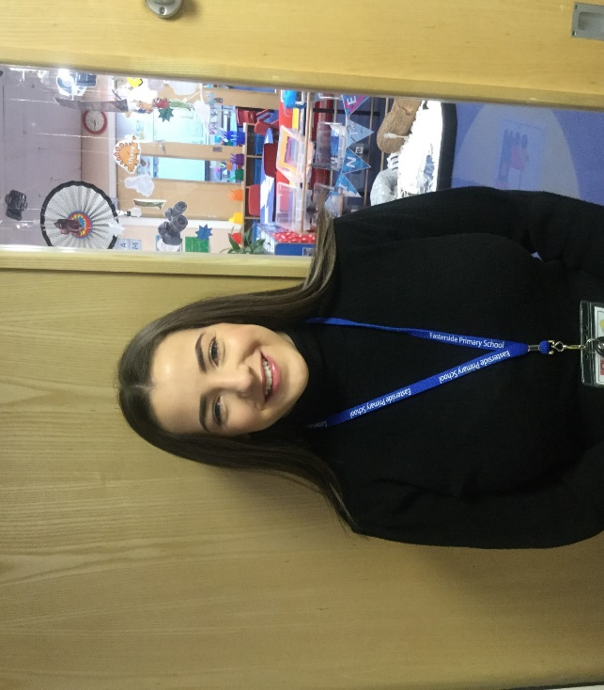

Miss Welford

Teaching Assistant

Miss Swalwell

Teaching Assistant

Mrs Southern

Nursery Class Teacher

Mrs Bazanek

Higher Level Teaching Assistant

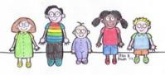

All About Me

My diet is (eg. vegetarian)

At home we speak

I am

years old.

At home we celebrate

* We have pets at home and they are
* I know someone else’s pets well and they are
* I haven’t spent much time around animals.

I live with

My full name is

I like to be called

My birthday is

These people are also special to me, but they live somewhere else

My favourite toys are

My favourite books are

My favourite songs are

My favourite places are

My favourite activity is

All About Me



The technology I have access to at home is

When I am outside, I like to

The things that scare me/the things I don’t like are

# This is Me

.

Parent/Carer – Ask your child to draw a picture of themselves and maybe add a photograph.

Encourage your child to talk about their features and ask questions to help them. It’s a good idea to do this with a mirror. If they find drawing tricky, start by encouraging them to make marks, then draw lines and circles.

Help them to develop this mark making into faces and objects by drawing alongside them so they can copy – this is called guided drawing. There are lots of ways to draw beyond paper and pens – use sticks with mud, chalks, water and brushes – anything goes and keep it fun! Start big and scale down as your child’s skills improve.

# This is my family

.

Parent/Carer – Ask your child to draw a picture of your family and maybe add a photograph. Encourage them to talk about similarities and differences, such as who is the tallest, what colour eyes does everyone have? See the previous page for tips on helping your child to first make marks and then move onto drawing.

# See the source image

**Reading stories together**

Here are some benefits to sharing stories regularly with your child.

* Stories help your child develop their imagination and creativity.
* Stories help your child to develop their language and thinking, especially when they hear or read them in their home languages.
* Stories provide examples to your child of how people meet the challenges that face them.
* Even fifteen minutes of reading with your child each day can expose them to one million written words in a year.
* Being told stories and being read to at home are the things most likely to help make your child successful learners at school.
* Children who have enjoyable storytelling and reading experiences at home are more likely to be motivated to read.
* Reading aloud with children is known to be the single most important activity for building the knowledge and skills they will eventually require for learning to read.
* Books contain many words that children are unlikely to encounter frequently in spoken language.
* The single most significant factor influencing a child’s early educational success is an introduction to books and being read to at home prior to beginning school.
* Children who read a lot as opposed to watching television, develop longer attention spans.
* When reading feels good to children, they become readers. We all repeat things that are pleasurable.
* Children are more likely to continue to be readers in homes where books and reading are valued.

**Take a trip to the local library so you and your child can choose and borrow some new books.**

**Singing nursery rhymes together**

* Research has found that when a child knows eight or more nursery rhymes by heart by the age of 4, they are usually one of the best at reading and spelling in their class by the age of 8.
* Nursery rhymes are easy to repeat so become part of your child’s first sentences.
* Nursery rhymes are a great way to develop early phonic skills.
* Nursery rhymes expand children’s imagination.
* Nursery rhymes teach early maths skills.
* Nursery rhymes improve vocabulary.
* Nursery rhymes are fun and transportable.

**Enjoy reading and singing together!**

# See the source image

# See the source image

# See the source image

# I can count

|  |  |  |  |  |  |  |  |  |  |
| --- | --- | --- | --- | --- | --- | --- | --- | --- | --- |
| 1 | 2 | 3 | 4 | 5 | 6 | 7 | 8 | 9 | 10 |
|  |  |  |  |  |  |  |  |  |  |

Parent/Carer – Find some counters/pennies/little toys and give your child a small quantity (up to 10) at a time and ask them to count them out. To help your child achieve this, encourage them to touch each object with their

‘counting finger’ and say the number at the same time. Remember to count slowly. The table above maybe useful for this and will help with number recognition - ask your child to put each object in the box and count them. Always ask your child “how many” when they finish counting, so they know that the last number they say, is how many that they have. You can extend your child’s counting practice by counting anything and everything – count the stairs up to bed, how many pairs of shoes are by the front door. How many plates do you need for dinner? How many jumps can they do? How many apples are left? How many blue/red/etc cars can you see whilst you’re out and about? The possibilities are endless!

# I can count from 1-5

Parent/Carer – Ask your child to count each group of coloured circles. Encourage them to use their ‘counting finger’ (see previous page). To extend the activity, ask them to pick out the matching number on the previous page if they can.

Perhaps write the number next to each group.

# I can count 6-10

Parent/Carer – Ask your child to count each group of coloured circles. To extend the activity, ask them to pick out the matching number on the previous page if they can. Write the number they say next to each group.

# I can recognise colours

*Parent/Carer – Ask your child to find each colour. Next, you point to each colour and ask your child to name it. To extend the activity, ask them to go on a colour hunt at home and fetch items of a certain colour. Go on a colour walk and chat about all the colours you can see in nature!*

# I can name colours

Parent/Carer – This is a blank colours sheet that you and your child can colour together. Can you say a colour, can they find the correct colour?

# I can name the shapes

**Key Words**

circle

triangle

rectangle

square

pentagon

Parent/Carer – Ask your child to find each shape in turn. Next, point to each shape and ask your child to name it. To extend the activity, ask them to colour each shape a different colour, go on a shape hunt at home or when you’re out and about. Ask your child to fetch objects that are different shapes around your home. Build a model, what shapes can you see.

# I can follow lines

Parent/Carer – Ask your child to follow each line with their finger. Once they can do this, ask them to copy over with a pencil crayon/felt tip. They can go over the lines lots of times with different colours. To extend this activity, create your own patterns for your child to follow or take it outside and recreate on a big scale in chalk. Ask your child to ‘follow the paths’ or use water and a paintbrush to trace over the lines and rub them out. Let your child have the chalk and encourage them to create their own patterns.

I can use scissors

Parent/Carer – Cut this sheet into strips, so your child can tackle one line at a time.

Encourage them to hold the paper with one hand and the scissors with the other. To extend this activity, let your child cuts snips in paper, or chop it up little bits then let them use glue and make their own pictures. Draw large simple shapes for them to cut out by themselves – can they make a shape picture?

# I can order things by size

1

|  |  |  |
| --- | --- | --- |
|  |  |  |

|  |  |  |  |  |
| --- | --- | --- | --- | --- |
|  |  |  |  |  |

*Parent/Carer – Cut out each set of animals and ask your child to arrange them in size order from smallest to biggest, then try from biggest to smallest. To extend this activity, ask your child to size order things that you have at home, for example soft toys, building blocks, shoes, etc. Encourage your child to use vocabulary linked to the activities such as small, smaller, smallest, big, bigger and biggest.*

# I can use positional language



*Parent/Carer – Cut out the duck and place it in different positions around the bath – on, in, under, next to etc and ask your child to describe the position of the duck.*

Next, ask your child to place the duck around the bath using the same language. To extend this activity, use objects around the home such as a favourite soft toy or make it large scale and ask your child to position themselves around furniture or ask them to tell you where to go.



# I can listen and respond

Clap out a simple rhythm and ask your child to copy.

1

Parent/Carer – Your child’s listening skills are incredibly important on so many levels. As well as the obvious following instructions and making good choices, they help your child learn to speak and develop their language skills which leads to learning sounds and reading.

You can help them with lots of listening and responding activities using the objects you have available at home.

Introduce different rhythms and ask your child to copy.

Mix it up and use different objects at home, use spoons to bang on pans and pieces of furniture- talk about the differences in sounds.



Go outside and explore sounds in nature – use sticks to bang on railings, listen to the birds. Can your child make the same sounds? What can they hear?

I can write my name

Write your

child’s name.

Write your child’s name in a light felt

tip and ask them to trace over it.

Ask your child to copy their name.

Parent/Carer – As with all new skills, teaching your child to write their name will require lots of practice, encouragement and inventive ways to keep it fun. They can use their fingers to write in trays of salt or sand. You can use chalk outside and ask them to brush it away with water and a paintbrush, write it with mud and sticks. Please see the following page to help with the letter formation. At Easterside Academy we use cursive script for our handwriting.

It’s also important that your child develops a comfortable pencil grip too, they may still swap hands, but try and encourage a tripod grip rather than full fist or overhand.

Activities to help with fine motor skills like playdough and threading beads/pasta will help strengthen their fingers.

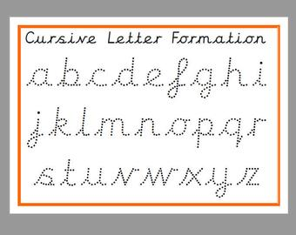

# I can move around



I can climb around safely on playground equipment.

I can say when things are too tricky and I need to ask a grown up to help me climb to the next part.



I can jump up and down with two feet together.

I can climb up and down the stairs.



I can stand on one leg*.*



I can take risks when moving around and like to try new things.

I can catch a big ball.



I can run like the wind*.*



Parent/Carer – When your child moves around using their whole body, they are using their gross motor skills. There are lots of ways you can support them to develop these skills and improve their balance, co-ordination, stamina and confidence. Get them out and about as much as possible and get involved too to show them how it’s done and how fun it is! Visit the park, set up an obstacle in the garden or in your front room with the sofa cushions.

.

I can move around in different ways– slither like a snake, hop like a rabbit, gallop like a horse.

# I can look after myself

I know when I need the toilet and I can manage my clothes by myself or with a little bit of help.

I can use a fork and a spoon to eat my food.



I can do up and undo the zip on my coat.

I can take my coat off and put it back on.

Parent/Carer – Your child will always get lots of help and support at nursery, especially during the first few weeks whilst they are settling in, so do not worry! You can help your child settle in quickly by teaching them these skills and encouraging them to be independent. If they are able to attend to their own basic needs, they will be able to spend *more of their nursery session playing and exploring! Continued next page.*



I can wash

and dry my hands.

I can tell you when I

need to wash and dry my hands.



I can recognise my name.

I can drink using a cup without spilling.

I can use a knife to cut up my food.

# I can look after myself

I can take off my shoes and put them on again.

I can take my clothes off and put my pyjamas on.



I can ask for help*.*



I can tell a trusted grown up what my name is.



I can share things with others or ask them to wait until I have finished my turn.



I can brush my teeth carefully.

I can put objects back where they belong. I can help to tidy.

Parent/Carer – Maybe get your child to colour in each skill as they achieve it!



I can wait my turn.

I can use my manners:

* I can say please and thank you.
* I can say ‘pardon me’ if I do a burp or a trump.
* I can say ‘excuse me’ if I need

to get past someone.

**My Wish for Nursery**

Make a wish upon a star – what do you wish for in nursery?

What would you like to do when you are at nursery? What would you like to get even better at? What would you like to learn about? Draw a picture of your wish inside the star.

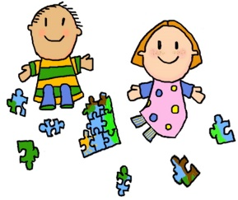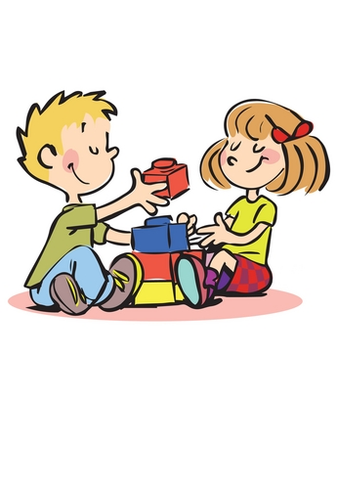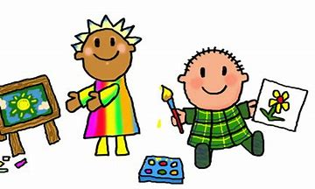





*Superstar is ready for nursery!*

# Signed Date