The Head Teacher’s

Fortnightly Newsletter
Monday 4th October 2021





Dear Parents / Carers,

This year one of our key priorities is strengthening the opportunities we give our children in school through curriculum enrichment, our ‘101 Things to do before you leave Easterside Academy’ and after school activities. We are currently putting together a timetable of extra-curricular activities and clubs for the year which we will share with you very shortly. As part of our curriculum enrichment our Key Stage 2 pupils have already had some exciting opportunities taking learning outside the classroom (LOtC) with a Year 3 and 4 visit to the Roman Fort Segedunum; and Year 5 and 6 experience, sleeping overnight on the school field! Both experiences have been a success – see some of the photographs below. We look forward to many more over the coming months.

This year we’re also bringing back our ‘Parent Open Mornings’ and can’t wait to have families back in school to see what their children are learning and join in with some of our fun packed curriculum learning. Prior to Covid these mornings were a HUGE success, with over 40 parents joining in per session. We really hope that you’ll take the opportunity to join us again when you’re invited later this term. As always, it’s important to remember that children do best when parents and school work together ☺

Best Wishes
Mrs D Linacre

Attendance

Week Beg: 20//09/21 and 27/09/21

The information below tells you the attendance % for each class, for the last two weeks.

Class | % | %
1 | 93 | 93
2 | 97 | 92
3 | 90 | 91
4 | 99 | 96
5 | 96 | 94
6 | 98 | 97
7 | 95 | 93
8 | 92 | 90
9 | 96 | 83
10 | 100 | 97
11 | 88 | 89
12 | 95 | 96

The classes have been coded against the national average.
Red – Way below average
Yellow – Below average
Green – Average or above
Please ensure your child comes to school every day unless they are poorly. All the children have lots to catch up on this year due to COVID and we can only do this best when they are in school.

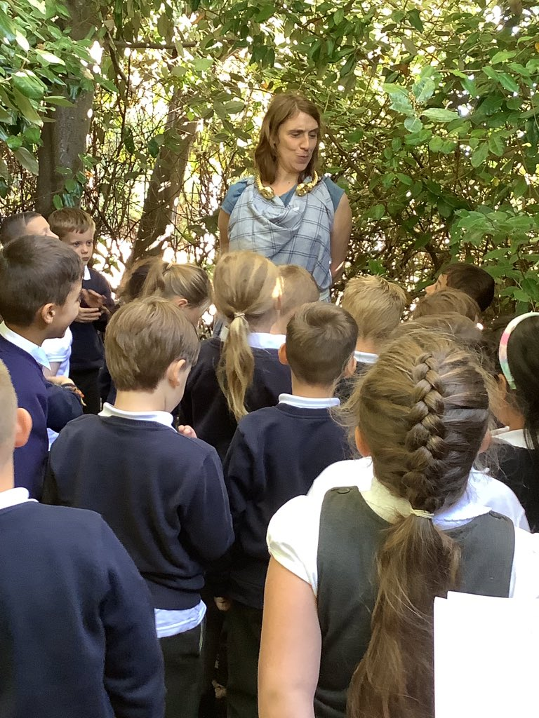
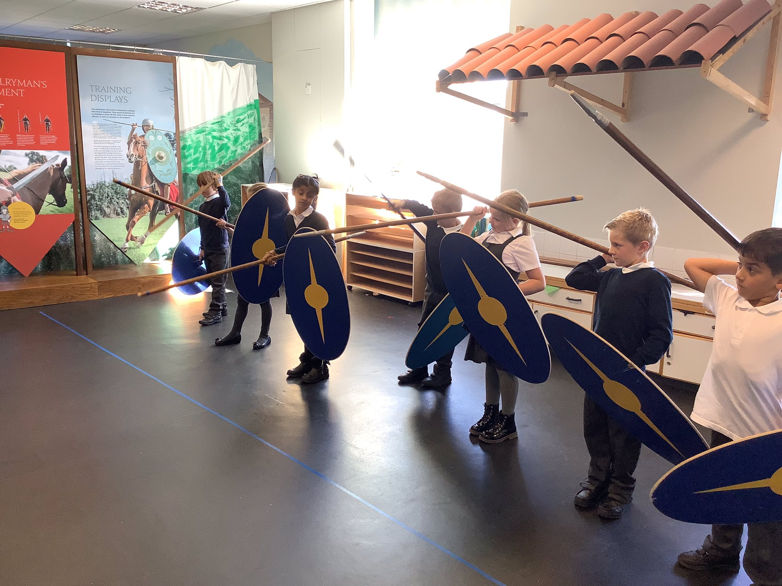
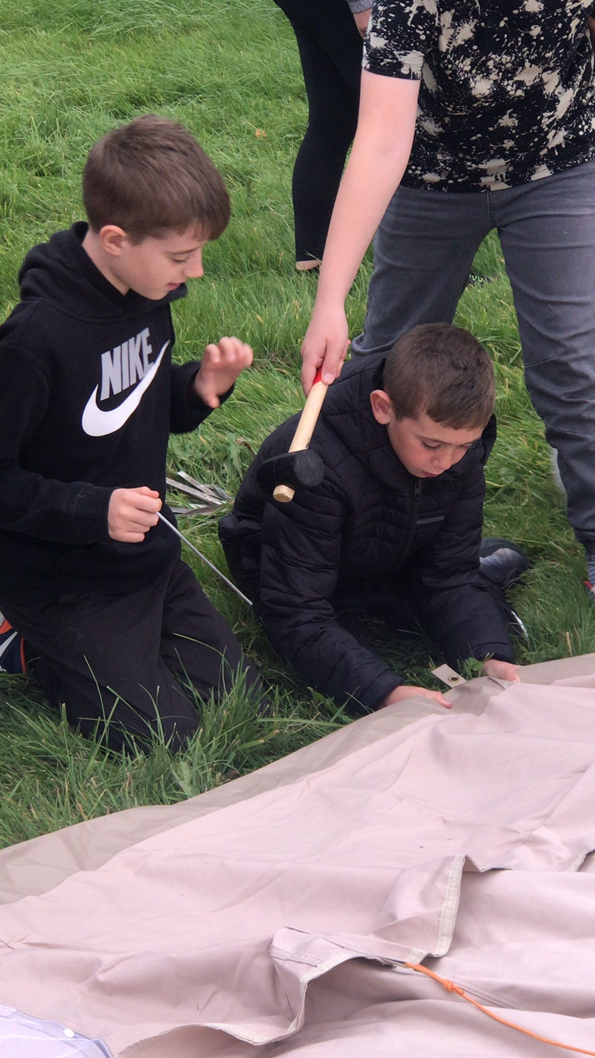
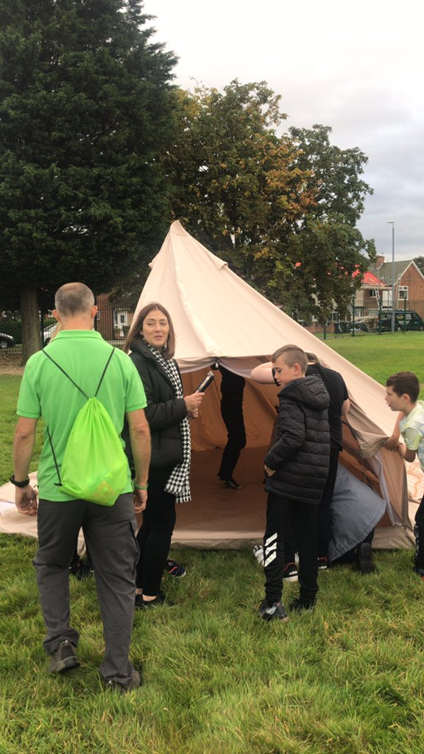
Year 5 & 6
Camping on the school field Overnight

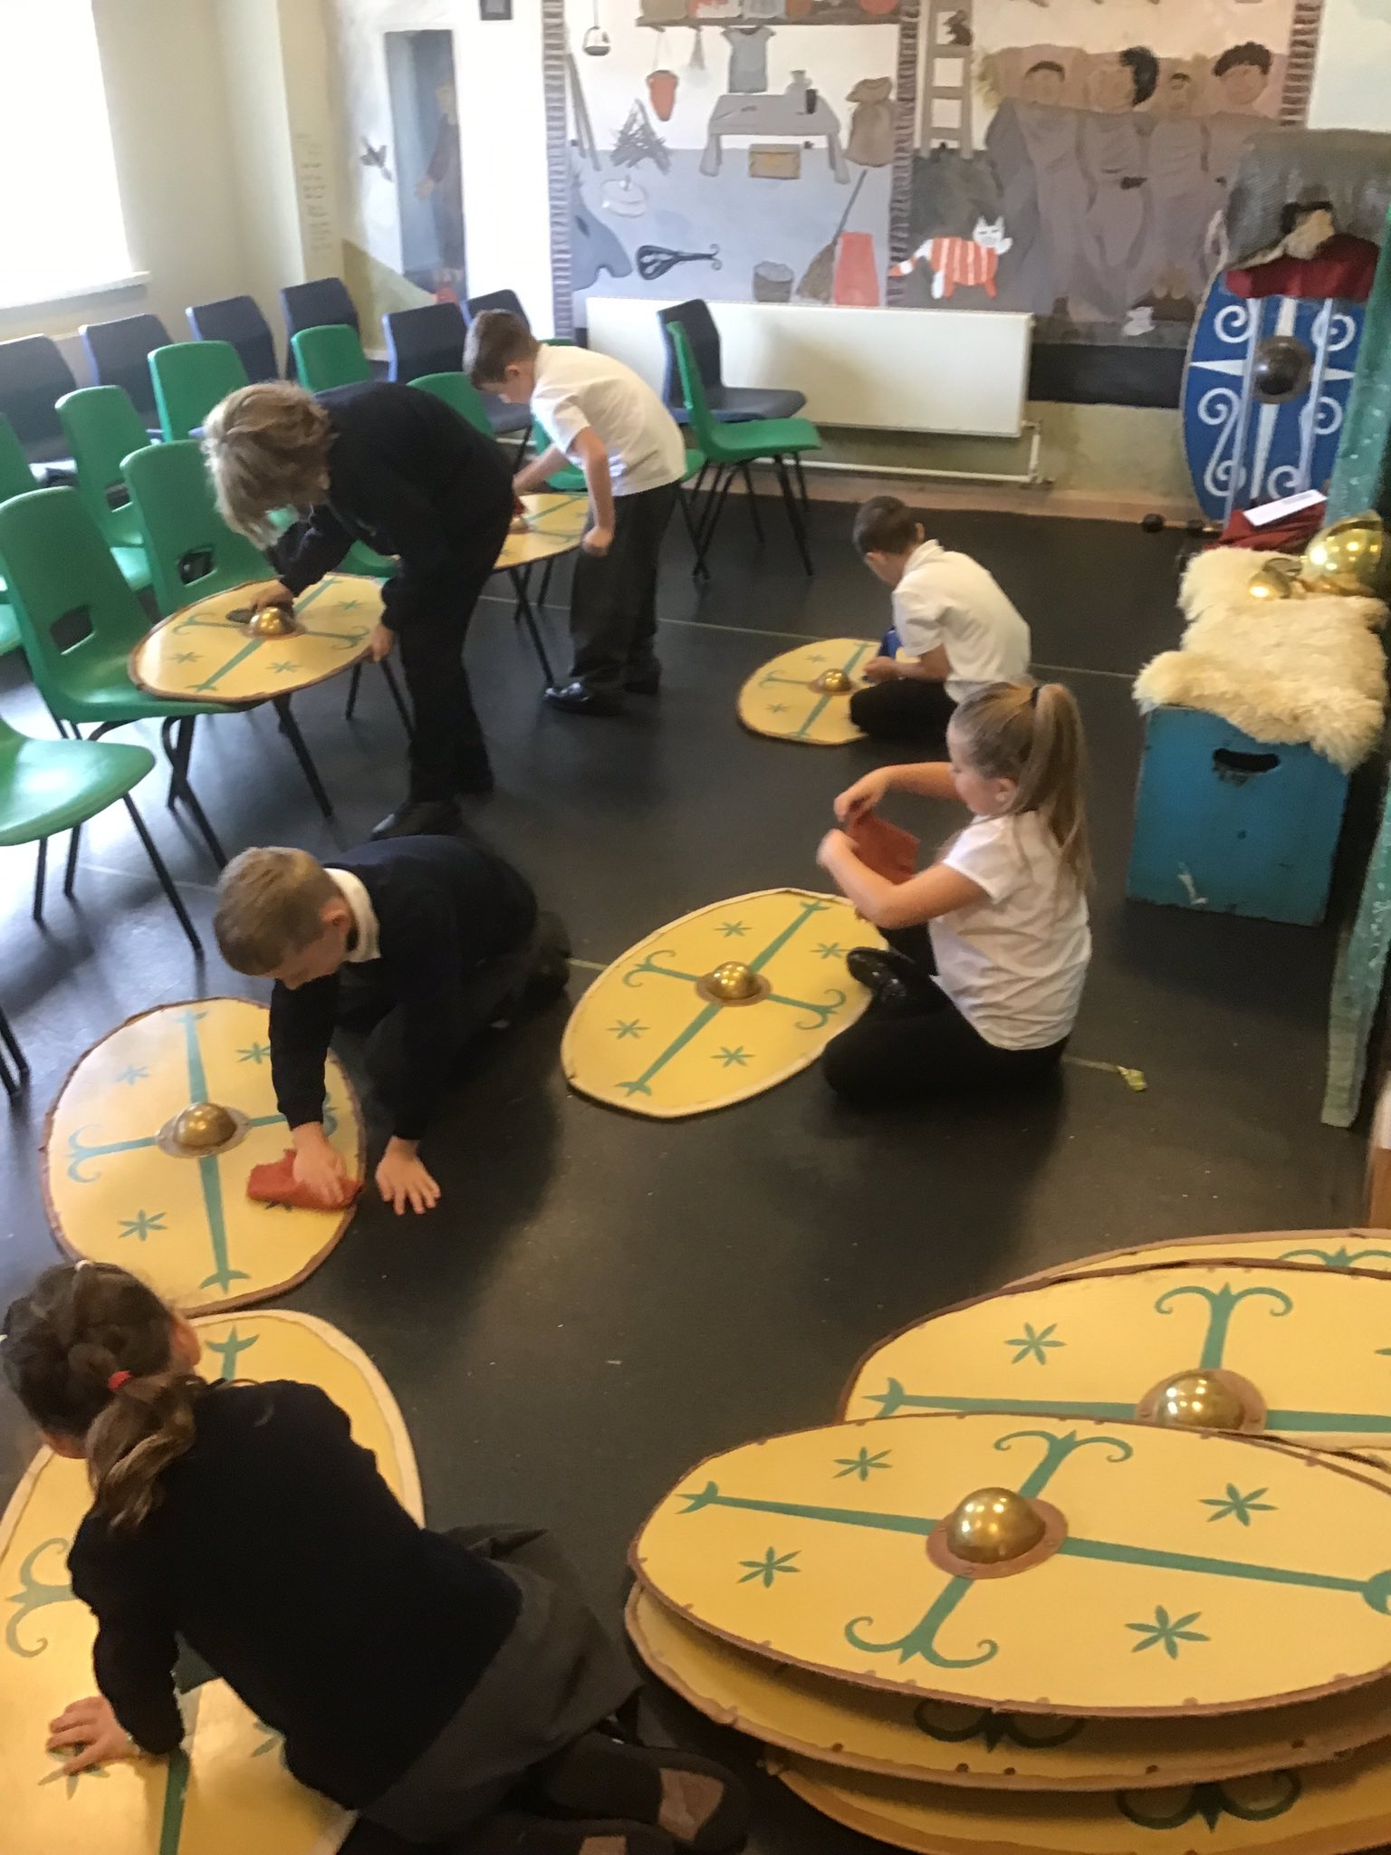
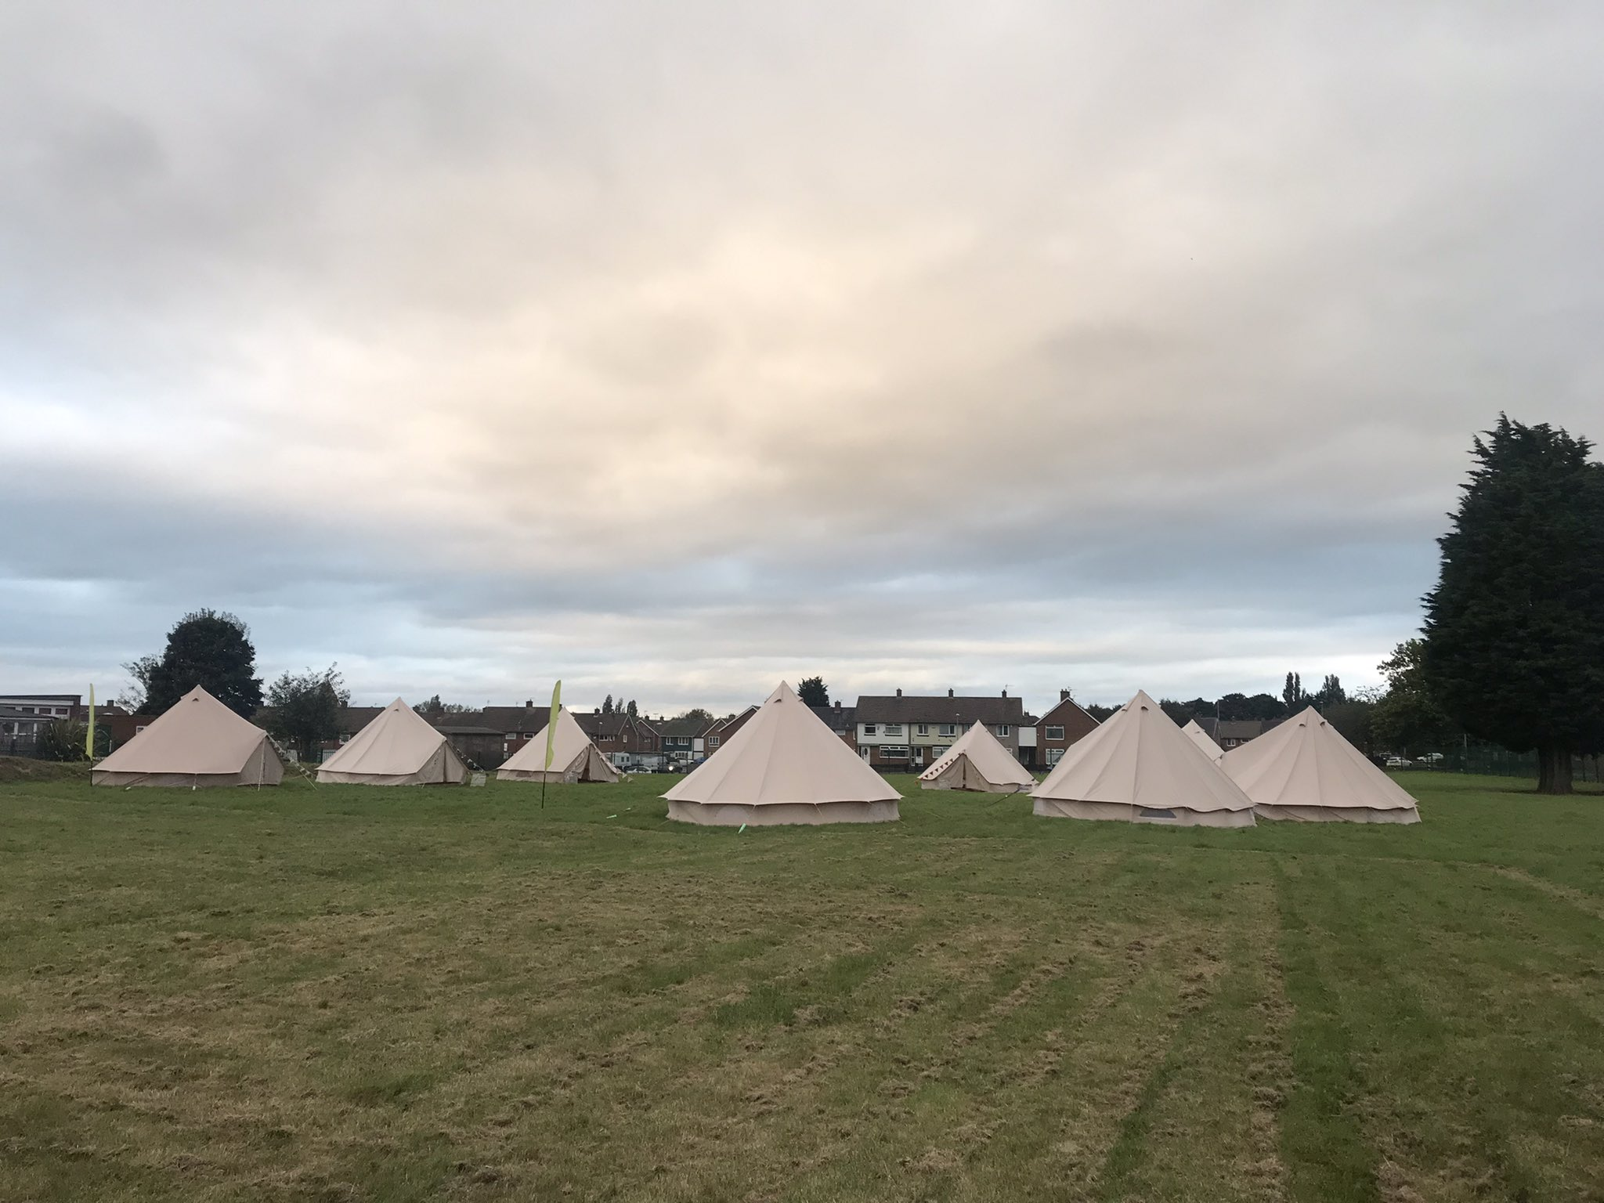
Year 3 / 4
Visit to
Segedumum
This experience is one of our ‘101 Things to do before you leave Easterside Academy!’
Reminder:
Monday 11th October
PD Day – no pupils in school










Academy dates are on our APP / Website
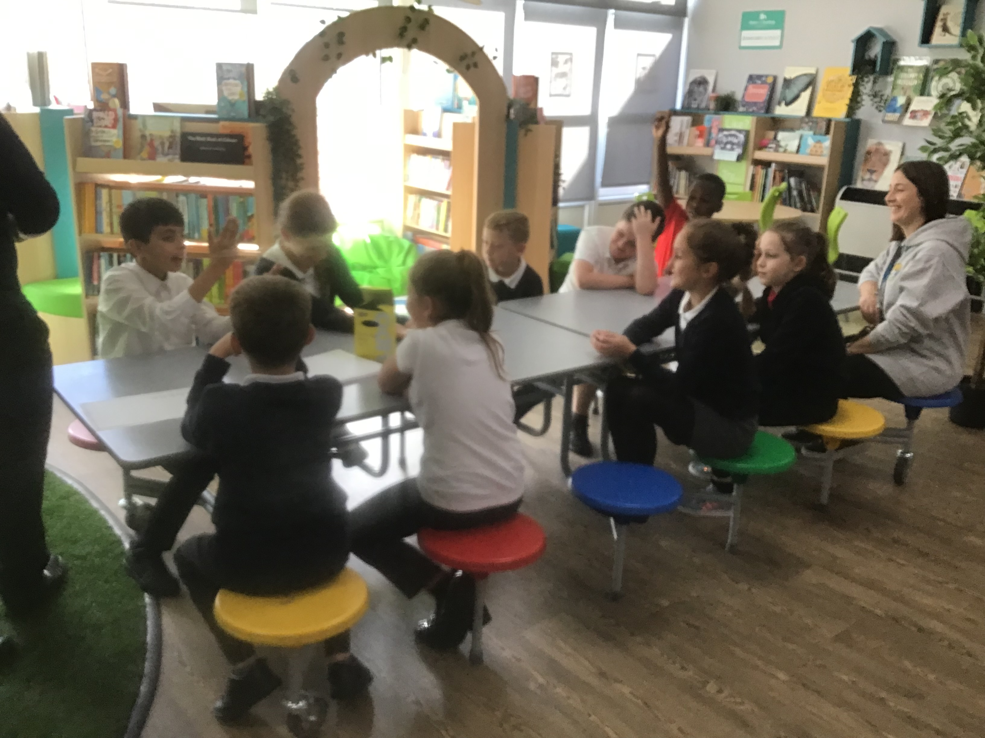
HeadStarters
Our ‘HeadStarters’ have started their training with HeadStart and once completed will become the mental health & wellbeing advocates for the children in school. We’ll keep you posted as to what they get up to this year!

