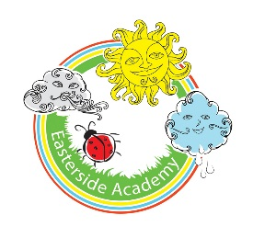
Key Stage 1 Homework Project Activities

Design, draw, and paint a picture of a beach hut. Bring it into class and display everyone’s beach huts next to each other.
Make a 3-D sea animal. You could use any material you like – perhaps papier-mâché, fabric, plastic bottles, clay, play dough or Lego pieces.

Bring pictures from home of yourself or family members at the seaside or swimming in the sea.
What is it like to live by the sea?
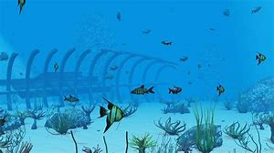

Make a word search with names of sea creatures. Ask your family and friends to have a go!
Visit your local library to browse or borrow story and information books about the seaside. Write or film a book review about your favourite.

Make a miniature seashore garden, using natural materials such as pebbles, twigs, sand and shells.

Can you learn the names of the five oceans?
Create a food chain diagram of an animal that lives under the sea.

Information for children and parents
Well done on starting your homework project!
Over the next six weeks you have been tasked with completing as many of these seaside inspired homework activities as you would like. Please bring in your work or post a picture on seesaw.

