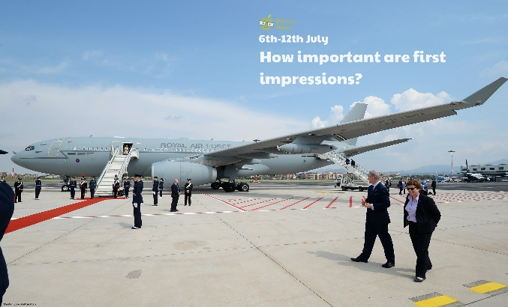

Think about a time when you were asked to represent somebody or something. If you haven’t represented anyone or anything before, think about what or who you would like to represent. What was it? What did you have to do? What did you wear? How did it make you feel? Write a paragraph to describe your experience. Remember to include interesting vocabulary and vary your sentence structure and punctuation.

Think back to when you first met somebody. Describe your first impression of them. What do you think of them now?

Pictures, symbols and letters can represent a number. In maths, we call this algebra. Work out what number the symbol represents:

* 5 + = 21
* - 6 = 13
* 4 x = 28
* ÷ 2 = 12

Now try to create some of your own number sentences with a symbol representing the number. Can you get someone to work them out?

The RAF Voyager is a plane used by the Prime Minister and members of the Royal Family for official visits around the world. Make a list of as many different modes of transport as possible. Which would be best for travelling to different parts of the world? Which is your favourite?

Use a map of the world to locate a country. Can you find out what the flag that represents that country looks like?

Design a smart outfit to wear! What occasion is your outfit going to be worn to? What colours will you use? Will you have a pattern on your outfit? What will the shoes look like? Will you have any accessories such as jewellery, a hat, scarf, bag, watch, glasses?

**Learning from Home**

Use the ideas below, alongside this week’s resource, to support your home learning.