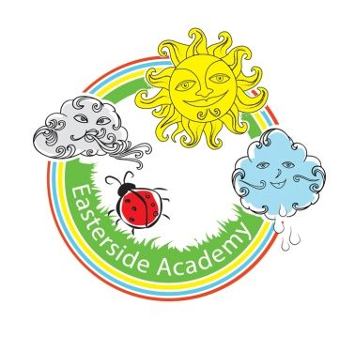
Early Years-PSE
 | Autumn  Changes | Spring  Once Upon a Time | Summer  Off We Go
Nursery | Making relationships  Seeks out others to share experiences.  Self Confidence and self awareness  Expresses own preferences and interests.  Can select and use activities and resources with help.  Managing feelings and behaviour  Can express their own feelings such as sad, happy, cross,  Shows understanding and cooperates with some boundaries and routines.  Responds to the feelings and wishes of others  Aware that some actions can hurt or harm others. | Making relationships  Interested in others’ play and starting to join in.  May form a special friendship with another child.  Self Confidence and self awareness  Expresses own preferences and interests  Confident to talk to other children when playing, and will communicate freely about own home and community.  Managing feelings and behaviour  Tries to help or give comfort when others are distressed.  Growing ability to distract self when upset, e.g. by engaging in a new play activity  Can inhibit own actions/behaviours, e.g. stop themselves from doing something they shouldn’t do  Aware of own feelings, and knows that some actions and words can hurt others’ feelings. | Making relationships  Shows affection and concern for people who are special tothem.  Can play in a group, extending and elaborating play ideas,  Self Confidence and self awareness  Enjoys responsibility of carrying out small tasks.  Confident to talk to other children when playing, and will communicate freely about own home and community.  Managing feelings and behaviour  Begins to accept the needs of others and can take turns and share resources, sometimes with support from others.  Aware of own feelings, and knows that some actions and words can hurt others’ feelings.
Reception | Making relationships  · Demonstrates friendly behaviour, initiating conversations and forming good relationships with peers and familiar adults.  · Keeps play going by responding to what others are saying or doing.  Self Confidence and self awareness  · Confident to talk to other children when playing, and will communicate freely about own home and community. (L4)  · Shows confidence in asking adults for help  Managing feelings and behaviour  · Aware of own feelings, and knows that some actions and words can hurt others’ feelings. (R1)(H4 H5)  · Begins to accept the needs of others and can take turns and share resources, sometimes with support from others. (L2 L3-School rules)  · Can usually adapt behaviour to different events, social situations and changes in routine. | Making relationships & See ELGs  • Initiates conversations, attends to and takes account of what others say.  • Explains own knowledge and understanding, and asks appropriate questions of others.  Self Confidence and self awareness  • Confident to speak to others about own needs, wants, interests and opinions  • Can describe self in positive terms and talk about abilities. (H3)  Managing feelings and behaviour  • Understands that own actions affect other people, for example, becomes upset or tries to comfort another child when they realise they have upset them.  • Aware of the boundaries set, and of behavioural expectations in the setting.(H12-safety-emotionally/physically/online safety)  (L2 L3-School rules) | Making relationships  • ELG:Children play co-operatively, taking turns with others. They take account of one another’s ideas about how to organise their activity. They show sensitivity to others’ needs and feelings, and form positive relationships with adults and other children. (R5) L4  Self Confidence and self awareness  • Can describe self in positive terms and talk about abilities.  • ELG-Children are confident to try new activities, and say why they like some activities more than others. They are confident to speak in a familiar group, will talk about their ideas, and will choose the resources they need for their chosen activities. They say when they do or don’t need help. (R5 R7) (H2)  Managing feelings and behaviour  • Beginning to be able to negotiate and solve problems without aggression, e.g. when someone has taken their toy.  • ELG-Children talk about how they and others show feelings, talk about their own and others’ behaviour, and its consequences, and know that some behaviour is unacceptable. They work as part of a group or class, and understand and follow the rules. They adjust their behaviour to different situations, and take changes of routine in their stride. (R2 R4 R6) (H5)  .(H12-safety-emotionally/physically/online safety)  (L2 L3-School rules)  H1/H6- LINK WITH Health and Self Care ELG

