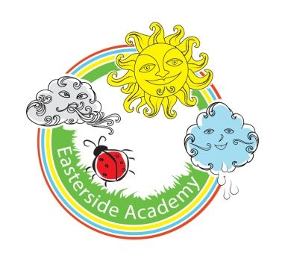
Early Years
Medium Term Curriculum Map
Autumn Term-Changes
 | Power of Reading Books | Topic Books | Possible books and rhymes to read for pleasure: | Key Questions | Vocabulary | Our Beautiful Piece
Nursery | My Grandpa  So Much  The Acorn  The Gruffalo (BB)  We're Going on a Bear Hunt/ Lion Hunt  My First Book of Nature  Avocado Baby  Dear Zoo | My History My Shadow  All about Me Bear Hunt  My week The growing story  How do you feel Titch  Seasons  Weather  Goldilock’s & the 3 Bears  Interest stories-Peppa’s Birthday | Rhymes  - Humpty Dumpty  - Baa Baa Black Sheep  - Twinkle Twinkle  - Hickory Dickory  - One, Two, Buckle my shoe  - Jack and Jill  - Incy Wincy  Books:  - Each Peach, Pear Plum  - Dear zoo  - Peepo  - Leaf Hunt  - Elf Chase  - Dear Santa | What would happen if you did not have feelings?  What if you never brushed your teeth?  What makes your heart beat fast?  What would happen if you didn’t have one of your senses?  What is your favourite feeling?  What if there were no colourful leaves?  What makes the weather change?  Can we make it snow?  What makes something your favourite?  Why are you so loved?  What would happen if you were always a baby?  Can you fix a melted snowman? | Old/new  Same/different  Change  Happy/sad (emotions)  Now/then  Hard/soft/rough/smooth(senses)  Colour  Big/little  Loud/quiet | All About me:  Our Portraits  My favourite Things  Natural object models-Autumn links  Share a story- links to current topic  (Stay and Play)
Reception |  |  | Rhymes  - Doctor Foster  - Here we go round the Mulberry Bush  - Little Jack Horner  - Old Mother Hubbard  - Polly Put the Kettle on  - Rock-a-bye-Baby  - 10 Fat sausages.  Books:  - Hairy Maclary  - This is our house  - The Gruffalo  - Room on the Broom  - The Tiger who came to Tea  - Not Now Bernard  - Guess How Much I love you  - Leaf Hunt  - Elf Chase  Class Novel: Fantastic Mr Fox  The Magic Finger (Roald Dahl) |  | Original/Similar  Like/unlike/Dissimilar  Unique  Altered  Cheerful/gloomy/miserable  Present/past  Firm/solid/squashy/spongy/supple/  uneven/coarse/silky/shiny.  Light/dark/tone  Tall/short/long  Noisy/deafening/still/calm/peaceful | All About me:  Our Portraits  My Favourite Things.  -sharing writing about ourselves  Natural object models-Autumn links  Share a story- links to current topic  (Stay and Play)

