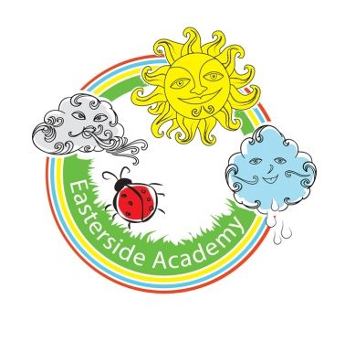
Early Years
Medium Term Curriculum Map
Summer Term - Off We Go!
 | Power of  Reading Books | Topic Books | Possible books and rhymes to read for pleasure | Key Questions | Vocabulary | Our Beautiful Piece
Nursery | - Down by the Station (BB)  - The Train Ride (BB)  - Walking through the Jungle (BB)  - Driving My Tractor  - We're Going on a Picnic! | - The Train Ride BB  - Homes BB  - Olivers Vegetables BB  - Let’s go by Bus  - Farmer Duck BB  - Firefighters BB  - Oliver’s FruitSalad  - Minibeasts BB  - Oliver’s Milkshake  - Whatever Next BB  - I love animals BB  - The Very Hungry Caterpillar BB  - Jaspers Beanstalk  - Don’t forget the bacon  - Pass the Jim Jam  - The Growing Story  - Runaway Train | Rhymes  - Miss Polly had a Dolly  - Wheels on the Bus  - Old McDonald had a farm  - Pat-a-cake  - Mary, Mary  - Round and Round the Garden  - Wind the Bobbin Up.  Books:  - Peace at Last  - The snail and the Whale  - Polar Bear, Polar Bear.  - Rumble in the Jungle. | What would you do if you were the size of an ant?  What if there were no bees?  Do all insects look the same?  Why do spiders make webs?  What if wheel’s were square?  Do all plants need water?  Why do caterpillars create a chrysalis?  How do you fill a rock pool?  How do you build the perfect sandcastle? | Same/different Like/unlike  Change  Move/fast/slow/crawl/fly Scuttle  Insect / minibeast / insect/arachnid  Travel / Move / Journey / Transport / destination / vehicle  Round/ Square/ Straight / Roll / curved / circular  Water/ feed/ leaf/ stem/ bud / seed/ bulb/ soil  Chrysalis / life cycle / pupae  Waves/ sand/ tide/ sink/ float/ wet/ dry | Transport models / testing  Minibeast models /drawings/paintings using natural materials  Creating Life cycles  Sandcastle competition
Reception |  |  | Rhymes  - London Bridge is falling Down  - Oranges and Lemons  - Lucy Locket  - This Old Man  - The Queen of Hearts  - The Farmers in the Den.  Books:  - The Bad Tempered Ladybird  - Elmer  - The Rainbow Fish  - Funnybones  - Doggar  - Five Minutes Peace  - Super Worm  - The Very Noisy Cricket  - Esio Trot  - Roald Dahl’s Revolting Rhymes |  |  | Transport models / testing  Minibeast models /drawings/paintings using natural materials  Creating Life cycles  Sandcastle competition

